CALIFORNIA STATE UNIVERSITY, LONG BEACH
COLLEGE OF HEALTH AND HUMAN SERVICES
DEPARTMENT OF FAMILY AND CONSUMER SCIENCES
CDFS 410 OR
CDF 490; OR CDFS 497/FCS 597
DECEMBER 20th to JANUARY 16th, WINTER 2021 - 2022
Short-Term Study Abroad Course in the Balkan Region in Europe

“An Introduction to the Social, Economic, and Political Conditions that Effect Children and Families in Croatia, Bosnia-Herzegovina, Montenegro, and Slovenia”

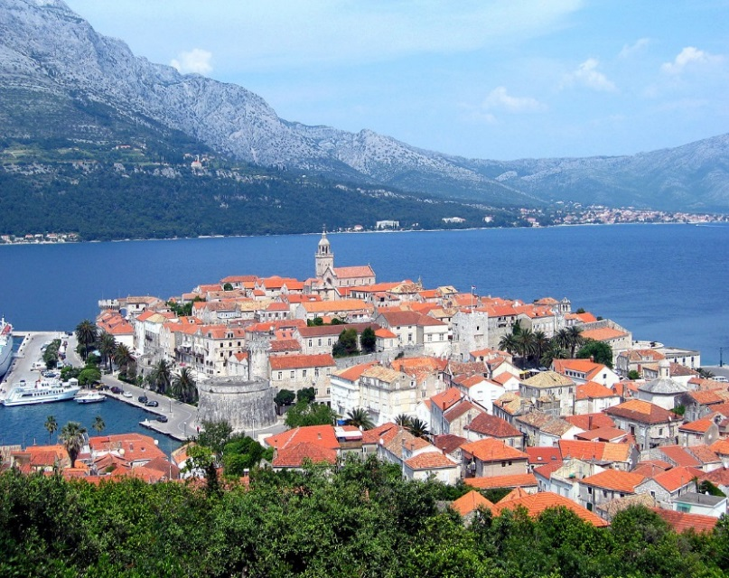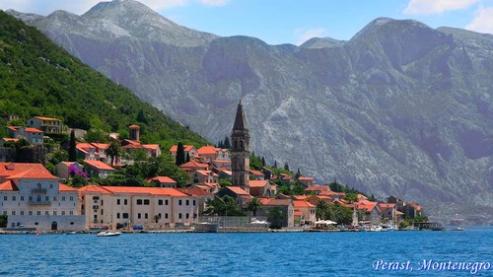
Croatia
Montenegro

Professor: Nilufer P. Medora
Office: FCS 101
Phone: (562) 985-4488
e-mail: medora@csulb.edu

“For the born traveler, travelling is a besetting vice. Like other vices, it is imperious, demanding its victim's time, money, energy and the sacrifice of comfort” – Aldous Huxley.
“Twenty years from now you will be more disappointed by the things you didn't do than by the ones you did. So throw off the bowlines, sail away from the safe harbor. Catch the trade winds in you sail. Explore. Dream. Discover” – Mark Twain.
“To get away from one's working environment is, in a sense, to get away from one's self; and this is often the chief advantage of travel and change” – Charles Horton Cooley.
“Travel and change of place impart new vigor to the mind” – Seneca.
.
COURSE DESCRIPTION: a 28 day short-term study abroad course that will focus attention on how immigration, social, cultural, religious, political, technological, and historical factors influenced and changed the lives of children and families in Croatia, Bosnia-Herzegovina, Montenegro, and Slovenia. The different teaching methods that will be used in the course will include lectures, power-point slides, DVD presentations, tourism, visits to local museums, experiential learning activities, service- learning activities, utilization of guest speakers, and founders of non-governmental organizations. Visits to NGO offices, orphanages, places of religious worship, universities, historic sites and other iconic places will be an integral part of this course. The assignments for the course will be based on lectures, readings, visits to various historical and cultural sites and guest speaker presentations.

EXPECTED OUTCOMES:

Upon completion of the course, the student will be able to:

- Describe the historical, religious, and cultural factors that have influenced the lives of children and families in Croatia, Bosnia, Montenegro, and Slovenia.

- Compare and contrast the immigration trends in terms of the influence they have had on the food, dress, recreational patterns, marriage, and culture, etc. in Croatia, Bosnia-Herzegovina, Montenegro, and Slovenia.

- Discuss the horrific war of the 1990s and the effects the war had on children and families in Croatia, Bosnia-Herzegovina, Montenegro, and Slovenia.

- Compare and contrast the culture and people in Croatia, Bosnia-Herzegovina, Montenegro, and Slovenia.

- Visit schools, social service agencies, NGOs that assist low-income families in Croatia, Bosnia-Herzegovina, Montenegro, and Slovenia.

- Compare and Contrast the beliefs and rituals of Catholics, Orthodox Christians, Muslims, and Jews.

- Visit the War Memorial Museum, the Love Story Museum, the Museum of Broken Relationships, the Museum of Illusions, Mimara Museum, and the Technical Museum of Nikola Tesla.

- Hear oral accounts from police, soldiers, clergy, and army officers about the genocide and mass killings that occurred in the “Homeland War”.

- Visualize by visiting “The Tunnel of Hopehow hundreds of Bosnians survived without food for three years when the city of Sarajevo was under siege and people were completely cut off from getting out of their homes, no groceries, no visits to the hospitals, and no medical aid.

- Enjoy the pristine natural beauty of this region including visits to parks, and Plitvice Falls

REQUIRED TEXTBOOK:
Course Packet of book chapters and journal articles developed by the Instructor (2019). Both the textbook and packet of articles are available from Innovative Print, which is located at 1785 H. Palo Verde Avenue, Long Beach, Ca 90815. Telephone Number: (562) 431-9974.
COURSE REQUIREMENTS:
1. Attend 9 -3 hour lectures given by the instructor ----Pre-departure.
2. Attend 4 Orientation Meetings presented by the instructor at CSULB before
departure;

3. Attend the orientation meeting presented by API (Academic Programs International)

4. Attend all the lectures given by the instructor in the U.S., in Croatia, Bosnia,
Montenegro, and Slovenia on the scheduled days.

5. Read the 15 articles from the “Packet of Short Readings” for the course.

6. Attend all the places of interest with group members to the selected destinations;

7. Ensure that you are punctual and ready to start the day at the designated
times on all days.

8. Complete the Reflection Paper.

9. Have a positive attitude, get along with group members, and do not form
cliques within the larger group of students enrolled in the program;

10. Complete a 66-item quiz in Long Beach before the start of the program.
11. Complete the International, Croatia, Bosnia, Montenegro, and Slovenia General
Knowledge/ Fact Sheet.

12. Complete the written short term-paper as per instructions.
13. Complete a Final exam that will be based on the lectures and the readings.

COURSE ASSIGNMENTS:
READINGS: You must read the assigned readings from the required text, and internet articles from the Short Readings Packet. You must attend all the lectures designated on the class syllabus.
EXAMINATION: You will have to complete one quiz before you leave the U.S. You will also take the final exam and a reflection paper at the end of the program before you leave Zagreb. The exam will include a combination of multiple-choice questions, matching questions, and short essay questions.
COMPLETE THE INTERNATIONAL, CROATIA, BOSNIA, MONTENEGRO, AND SLOVENIA FACT SHEET: You will complete a Fact Sheet/General Knowledge Fact Sheet regarding International Facts and Figures, general knowledge and issues that you must know about the world and more specifically about the countries you will be visiting: Croatia, Bosnia, Montenegro, and Slovenia. This is an open book assignment. You must turn in this assignment before we leave the U.S. to receive credit for it.
SHORT PAPER ON TWO GUEST SPEAKERS OR EXCURSIONS: Each “Report” that you describe should be approximately 1 to 2-typed written page (double-spaced). This assignment will prove to be a very unique, interesting, worthwhile, reflective, and learning experience. From the following, pick any two of your choice and respond to some of the questions that pertain to your specific walk. You do not need to respond to all the questions.
- Visit to Social Service Agency --Bonsai
- Visit to the Child Orphanage in Dubrovnik
- MoSPY – Ministry of Social Policy and Youth
- Sarajevo War Tunnel (Tunnel of Hope), Bosnia & Herzegovina
- Social Service Agency in Kotor
- Guest Speaker from the University
- Visit to the Tunnel of Hope
- Visit to the War Museum
- Lecture Given by Imam
- Visit to Synagogue and lecture given by Rabbi
- Head of NGO, film producer, and acting therapist
- CFSH –Children, Families, and Social Hub

- (All papers must address this specific bullet) Did the particular “visit to the social service agency/guest speaker focus of children and families?”

- A very brief description of the “the visit to the place or the speaker that you are writing about:

- A brief description of the places that the “walk” included:

- What made you decide to write about this particular topic:

- What are three issues that appealed to you the most about the “guest
speaker” or the “social service agency”;

- What did you learn after you completed the “visit to the social service agency or heard the guest speaker”?

- What are three things that you thought the speaker could have covered as part of his/her presentation. Also, point out three things that you did not think would be covered as part of the presentation, but the speaker covered these issues.

- What was your opinion about the speaker? Did you think that he/she had
adequate knowledge about the topic?

GRADES: Grades will be given on the bases of attendance, the short paper, the quiz, 2 walks paper, and the final exam. The final grade will be based on the number of points that you earn out of a possible 700:
Attendance 100 Points
2 Short 2-3 Page Papers 200 Points
International, General Knowledge Fact Sheet 100 Points
Attitude, Curiousness, and Behavior During the Program 100 Points
Short Quiz 100 Points
Final Exam: 100 points
Reflection Paper: 100 Points

Total 800 Points

Out of 700 possible points: The following grading system will be followed:
90% and above A 720 60% and above D 480
80% and above B 640 F is Less than 480 Points
70% and above C 560
****PLEASE NOTE: The students will be having five or six (3) hour classes from 6:00 to 8:45p.m. in FCS 106 before we leave the U.S. for Croatia The students will also be completing the following before we take off for Croatia.

• A General Knowledge and International Fact Sheet
• A 2-4 Page Term Paper
• EXAM I

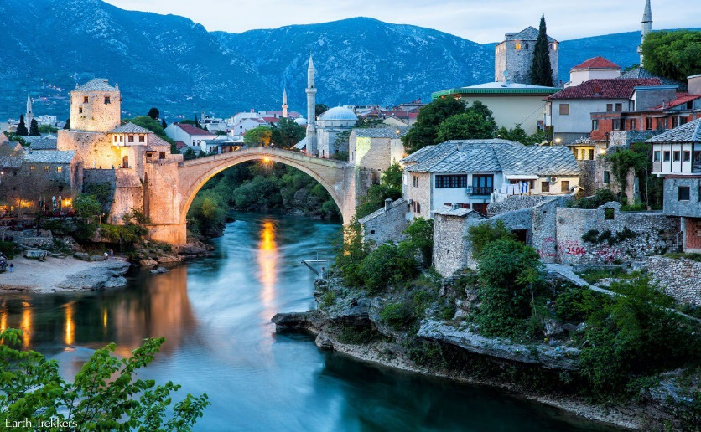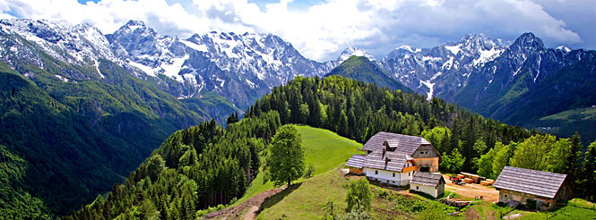
Slovenia
Bosnia

TENTATIVE ITINERARY FOR
CALIFORNIA STATE UNIVERSITY, LONG BEACH
CHILD DEVELOPMENT & FAMILY STUDIES
December 20th to January 16^{h} 2020 to 2021
Mon, Dec 20th
Depart LAX for Croatia
Sleep on the Plane

Tue Dec 21st
Arrive in Zagreb, Croatia
Hotel Check-in
Group lunch with API staff members in the hotel
API Staff Meets and Greets the Group Members.
API Safety and Cultural Orientation/Class
Dinner on Own
Overnight in Zagreb Croatia
Wed Dec 22nd Orientation to Croatia, Bosnia, Montenegro, and Slovenia
Sightseeing tour of Zagreb
Visit the Museum of Illusions, and the Museum of Broken
Relationships
Lunch on Your Own/ Class
Welcome Dinner
Overnight in Zagreb, Croatia
Thu Dec 23rd
Drive to Plitvice Falls
Visit the Plitvice Falls
Lunch on Your Own
Dinner on Own
Overnight at Plitvice Falls

TENTATIVE ITINERARY FOR
CALIFORNIA STATE UNIVERSITY, LONG BEACH
CHILD & FAMILY STUDIES
December 20th to January 16th 2021 to 2022

Fri, Dec 24th
Christmas Eve, Walk around Old
Town/Enjoy the Christmas Markets and free Musicals
Lunch on Your Own
Night in Dubrovnik, Croatia.
Sat, Dec 25th
CHRISTMAS DAY
Lunch on Your Own
Dinner Provided
Night in Dubrovnik, Croatia

Sun, Dec 26th
Class/Visit to a Social Service Agency
Lunch on Your Own
Christmas Dinner
Night in Dubrovnik, Croatia.

Mon, Dec 27th Visit Havar OR Korcula
Lunch on Your Own
Dinner on Your Own
Night in Dubrovnik, Croatia

Tue, Dec 28th Visit the War Memorial/Class
Enjoy Christmas Markets
Lunch on Your Own
Dinner on Your Own
Night in Dubrovnik

TENTATIVE ITINERARY FOR
CALIFORNIA STATE UNIVERSITY, LONG BEACH
CHILD & FAMILY STUDIES
December 20th to January 16th 2021 to 2022

Wed, Dec 29th
City tour of Dubrovnik/
Croatia/Visit the Museum of Love/Class
Meeting with Professor and Catholic Minister
Lunch on Your Own
Dinner on Your Own
Night in Dubrovnik, Croatia

Thu, Dec 30th
Visit an Orthodox church, a Catholic church, a Mosque,
And a synagogue. Hear the clergy discuss their religion.
Lunch on Your Own
Participate in a Volunteer Service-
Learning Activity
Lunch on Your Own
Dinner on Your own
Overnight in Dubrovnik, Croatia

Fri, Dec 31st
New Year’s Eve
Visit the orphanage to spend some quality time with
Children who lost their parents during the War of the 1990s.
Make sure you have a Gift for Them
Lunch on Your Own
Class/Free Afternoon and Evening
Dinner on Your own
Overnight in Dubrovnik, Croatia

Sat, Jan 01st HAPPY NEW YEAR!!!
Visit Korcula Island. Visit the home of Marco Polo
Lunch on Your Own
Dinner on Your Own
Overnight in Dubrovnik, Croatia

TENTATIVE ITINERARY FOR
CALIFORNIA STATE UNIVERSITY, LONG BEACH
CHILD & FAMILY STUDIES
December 20th to January 16th 2021 to 2022
Sun, Jan 02nd
Leave for Bosnia and Herzegovina
Visit a social service agency that cares for low-
income Muslim families/OR a Soup Kitchen
Lunch on Your Own
Visit the Marketplace and Buy Souvenirs
Dinner on Your own
Overnight in Bosnia and Herzegovina, Bosnia

Mon, Jan 3rd Drive Around Bosnia and Herzegovina
Visit the Underground Caves
Dinner Included
Overnight in Bosnia

Tue, Jan 4th
Transfer to Montenegro (Approx 3 Hour Drive)
Guided Tour of Montenegro.
Guest Speaker from Government Social Service Agency
Lunch on Your Own
Visit Kotor Square on Your Own
Dinner on Your Own
Overnight in Montenegro

Wed, Jan 5th
Leave for Sarajevo, Bosnia Speaker:
City Tour of Sarajevo
Visit the Place where the Arch Duke of Austria was Killed
Lunch included
Dinner on Your Own

Visit the War Tunnel in Dubrovnik. Visit to the
War Memorial Museum on the Mountain by Cable Car
Speaker: General from the Croatian Army who defended
Service-Learning Activity

TENTATIVE ITINERARY FOR
CALIFORNIA STATE UNIVERSITY, LONG BEACH
CHILD & FAMILY STUDIES
December 20th to January 16th 2021 to 2022

Thu, Jan 6th Dubrovnik and Croatia API Directors will share their
Experiences about the War
Lunch on Your Own
Dinner on Your Own
Overnight in Sarajevo, Bosnia

Fri, Jan 7th FREE Day to explore the city, visit the tramway,
Go to the Market, etc.
Lunch on Your Own
Dinner on Your own
Overnight in Sarajevo, Bosnia

Sat, Jan 8th Visit a High School in Sarajevo
Lunch on Your Own
Dinner on Your own
Overnight in Sarajevo, Bosnia

Sun, Jan 9th
See the 1984 Winter Olympics Stadium
Visit the Tunnel of Hope Museum
Visit the Museum and see How the War of the Homeland Started.
Lunch on Your Own
Dinner on Your own
Overnight in Sarajevo, Bosnia

Mon, Jan 10th Visit the city, Visit the Square, Visit the Malls,
Visit the Museums.
Lunch on Your Own
Dinner on Your own
Overnight in Sarajevo, Bosnia

Tue, Jan11th
Drive to Ljubljana and Bled, Slovenia for a guided tour
Visit the Church, the square, and handicraft stalls.
Lunch on Your Own
Dinner on Your own
Overnight in Ljubljana
TENTATIVE ITINERARY FOR
CALIFORNIA STATE UNIVERSITY, LONG BEACH
CHILD & FAMILY STUDIES
December 19th to January 16th 2021 to 2022

Wed, Jan 12th Take Walks through the town of Bled and stroll the
Mountains Of Slovenia
Lunch on Your Own on the Way
Free time to Explore Bled
Dinner on Your own
Overnight in Bled, Slovenia

Thu, Jan 13th
Transfer back to Zagreb
Last Day to shop for Souvenirs
Chocolates, lavender Sachets,
Lunch on Your Own
Overnight in Zagreb, Croatia

Fri, Jan 14th Last Day in Zagreb. Last Minute shopping for souvenirs,
Chocolates, lavender sachets, etc.
Final Exam/Reflection Paper
Dinner on Your own
Overnight in Zagreb, Croatia

Sat, Jan 15th
API will Arrange Return to the Airport
Departure from Zagreb to the U.S.

Sun, Jan 16th ARRIVAL IN THE U.S.

