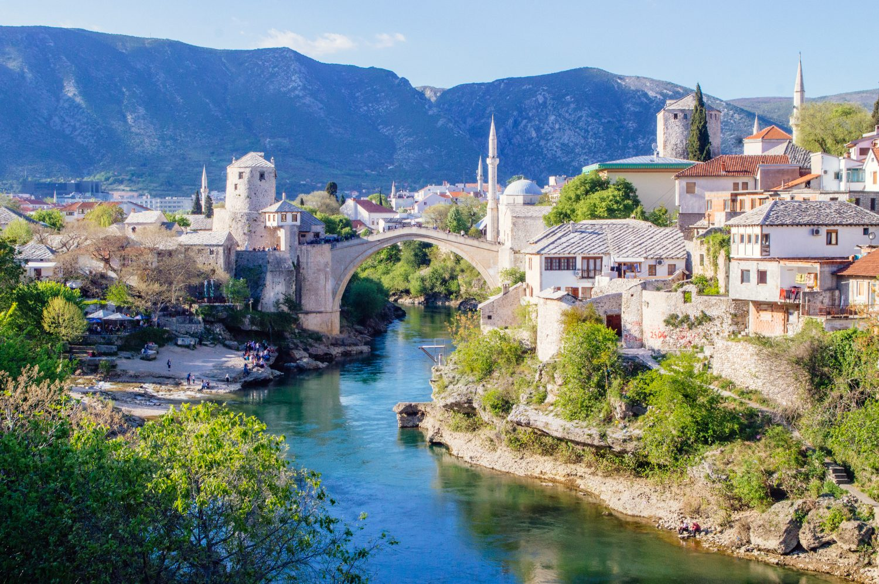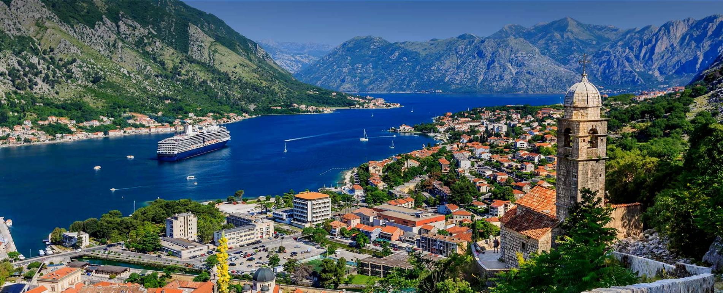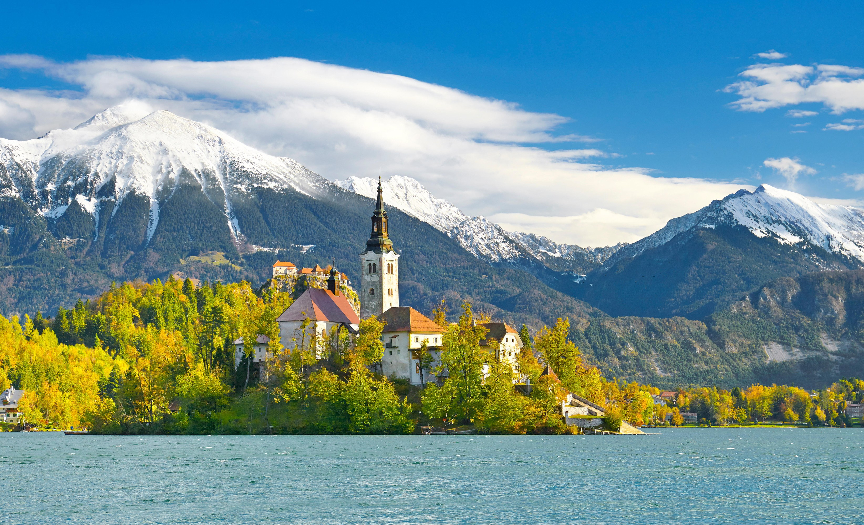
HAVE FUN, LEARN AND GET ACADEMIC CREDIT FOR 3 UNITS DURING A 3-WEEK STUDY-ABROAD PROGRAM TO VISIT CROATIA, BOSNIA, MONTENEGRO, & SLOVENIA IN THE SUMMER OF 2019

Total Cost for the 3 Weeks: Approximately $5,300.00 (this includes airfare, CSULB summer tuition fees, medical insurance, travel to all four countries to admire the pristine, beautiful shoreline of the Balkan region, lodging for 23 days, 23 breakfasts and activities mentioned below.
EXPLORE THE HISTORY AND CULTURE OF CROATIA, BOSNIA, MONTENEGRO, AND SLOVENIA
LEARN AND EARN ACADEMIC CREDIT.
Some Highlights of the Itinerary Include

Travel to the Four Countries
In Europe and …….

- Spend 2 Nights in Zagreb
- 2 Nights in Historic Sarajevo
- 12 Nights in Dubrovnik
- Day Trip to Bosnia
- Day Trip to Montenegro
- Day Trip to Slovenia
- Day Trip to the War Tunnel of
Hope Museum
________________________

Travel deposit for the program, can be paid on-line directly to API via credit card.
- Visit various Museums
- Historical and Cultural Medieval Building
- Happy Hour with the Students
- Local Experts Speak about the War Years
- Visit to Lokrum Island
- Visit a High School in Dubrovnik
- Participate in Service-Learning Project
- Visit a Church; a Mosque; and a Synagogue
- Enjoy the picnic at Mljet
- View the Majestic Julian Alps, and Lake Bled
- Visit Historic Sarajevo
- See the War Tunnel of Hope and see How People Survived

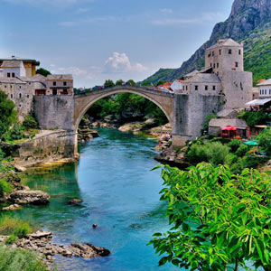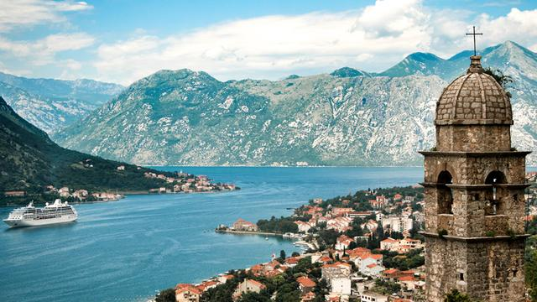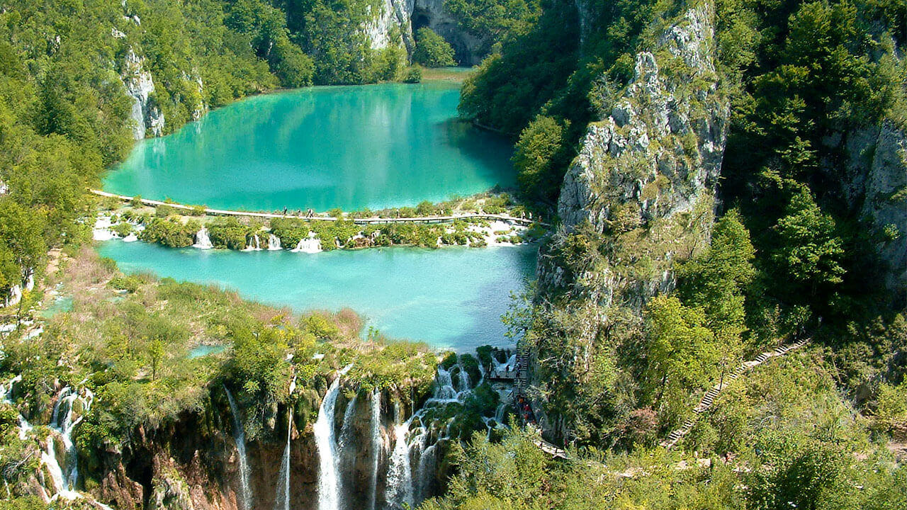

Don’t Miss this Wonderful Opportunity!
Travel, Learn, and Earn University Credits

HIGHLIGHTS OF SOME OTHER EXCURIONS THAT ARE INCLUDED
IN THE COURSE

- Visit to Walled City of Dubrovnik
- Tour the Historic Square in Dubrovnik
- See the Magnificent Plitvice Lakes National Park with breath-taking beauty, hundreds of waterfalls, and lots of splendor
- Interesting Guest Speakers
- Visit to Orphanages
- A Visit to the War Tunnel
- Visit to National Park Mljet
- Visit to Lokrum Island
- Visit to Bosnia-Mostar and Blagaj
- Visit Kotor in Montenegro
- Visits to Social Service Agencies & NGOS
- Visit the museums, churches, and
art galleries in Zagreb
- Drive to Slovenia and Enjoy the
Julian Alps
- Visit to Korčula Island

Learn about the history, culture, the war years, the recovery, the ethnic diversity of the
Families in Central Europe.
Personally see the plight of children and families, the tremendous challenges
they suffered, and hear stories of survival and endurance.
Visit a church, a mosque, and a synagogue

Take the CDFS 490 : Learning about Children and Families Living in Europe: A Visit to Croatia, Bosnia, Montenegro, and Slovenia (3 Units) course.
Substitute Study Abroad Course For One of the Following Courses:
CDFS 410: International Families OR
FCS 497: Independent Study (3 Units)
FCS 597: Directed Studies
FCS 490: Special Topics
Substitute the Study Abroad Course for any Elective in Your Major
Contact Information:
Professor: Dr. Nilufer Medora
Department of Family and Consumer Science (Opposite Brotman Hall)
FCS-101: (562)985-4488
Medora@csulb.edu

