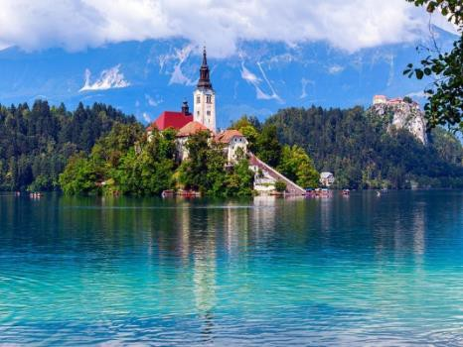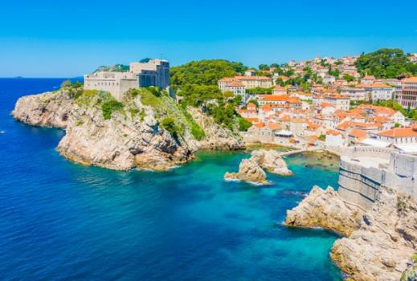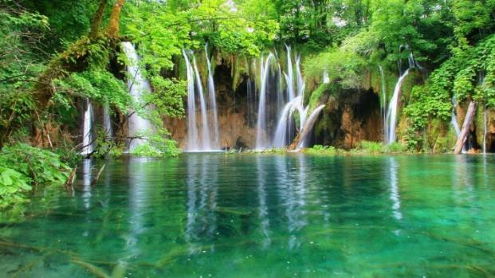
ENROLL in CDFS 490, 410, 597
EXPLORE THE HISTORY AND CULTURE OF CROATIA, BOSNIA, MONTENEGRO & SLOVENIA FOR A MONTH IN THE
WINTER OF 2021-2022 (for 21 days!)

Total Cost for the 3 Weeks: Approximately $5,000.00 (this includes airfare, CSULB Winter tuition fees, medical insurance, travel within Croatia, Bosnia, Montenegro, and Slovenia, lodging for 21 days, 21 breakfasts, some dinners and some lunches.

LEARN AND EARN ACADEMIC CREDIT: SPEND TIME WITH CHILDREN AND FAMILIES AND LEARN ABOUT HOW THE WAR IN THE 1990’S AFFECTED THEM. WHAT ARE THE SIMILARITIES & DIFFERENCES BETWEEN THESE COUNTRIES, THAT WERE ONCE PART OF YUGOSLAVIA, BUT ARE NOW INDEPENDENT COUNTRIES.

Some Itinerary Highlights Include:
Unlimited use of local buses and trams for the 21 days
- 3 Nights in Zagreb  - 5 Days in Dubrovnik  - 2 Days in Pula  - 2 Days in Split | - 4 Days in Sarajevo  - 1 Day in Plitvice Falls  - 2 Days in Zadar  - 2 Days in Bosnia

Contact Information: Professor: Dr. Nilufer Medora
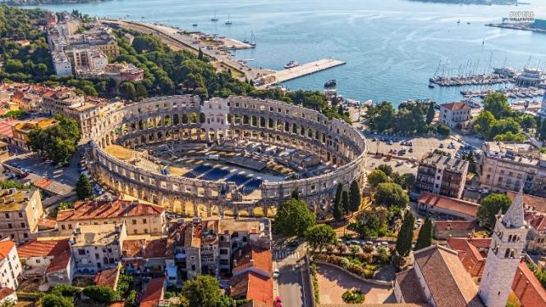

Department of Family and Consumer Science
(Opposite Brotman Hall) FCS-101: (562)985-4488
Medora@csulb.edu

A ONCE IN A LIFE TIME EXPERIENCE! SPEND
CHRISTMAS AND NEW YEAR IN EUROPE!
ENJOY THE CHRISTMAS SPIRIT,
CHRISTMAS BAZAARS, AND AMAZING CHRISTMAS MARKETS IN ZAGREB, DUBROVNIK, SPLIT, LJUBLJANA, AND
LAKE BLED.

HIGHLIGHTS OF SOME OTHER EXCURIONS
THAT ARE INCLUDED IN THE COURSE

- Take the cable car and see the  beauty of Sarajevo from the very top.  - Spend two days at the beautiful Plitvice Falls.  - Attend the presentations of several guest speakers.  - Visit social service agencies.  - Visit an orphanage and spend quality time with the children.  - Visit to the Roman arena in Pula.  - Visit Mostar Bridge in Bosnia.  - Visit the marketplaces in Sarajevo | - Visit the Tunnel of Hope  - Enjoy the spectacular. Christmas Markets in Zagreb, Split, and in Dubrovnik.  - Walk along the old cobblestone streets of Dubrovnik.  - Stroll through the winding alley ways of Old Town Square in Dubrovnik.  - Visit an Orthodox church, a Catholic church, a Protestant church, an Islamic mosque, and a Sephardic synagogue.  - Attend free classical music concerts in the Old Square.
Take the CDFS 490D: Children and Families in Croatia, Bosnia, Slovenia (3 Units) course.
Substitute Study Abroad Course for One of the Following Courses: FCS 497: Independent Study (3 Units)
UNIV 301: Global Studies (3 Units) CDFS 410: International Families OR Substitute the Study Abroad Course for any Elective in Your Major.

