Accommodation Request Using MyBMAC

Step 1: Login to Single Sign On
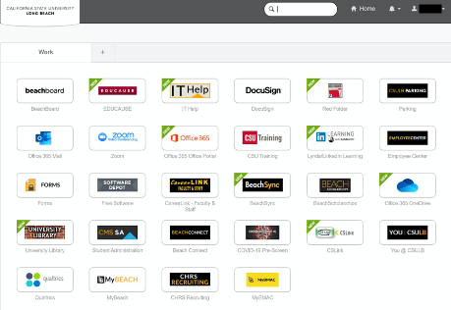

Step 2: Click on MyBMAC Chiclet
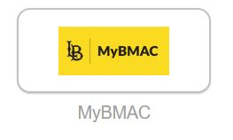

The MyBMAC Chiclet will bring you to the MyBMAC Homepage
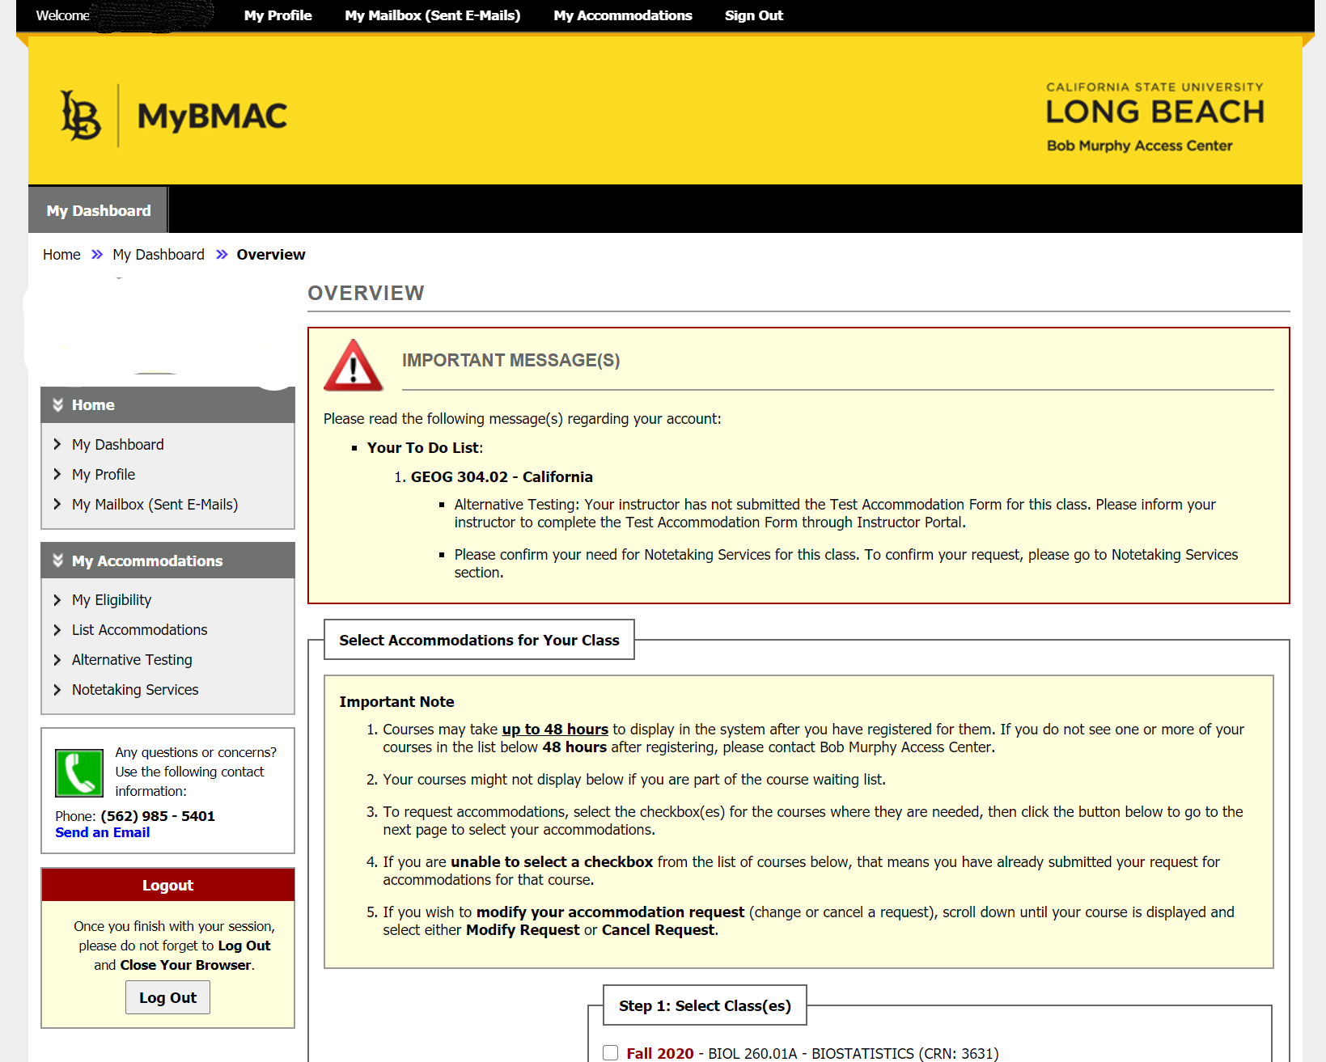
Step 3: Click on My Eligibility
Click on My Eligibility to check the status of approved accommodations. If you are missing a previously approved accommodation or would like to make changes to your accommodations, please contact: bmac@csulb.edu
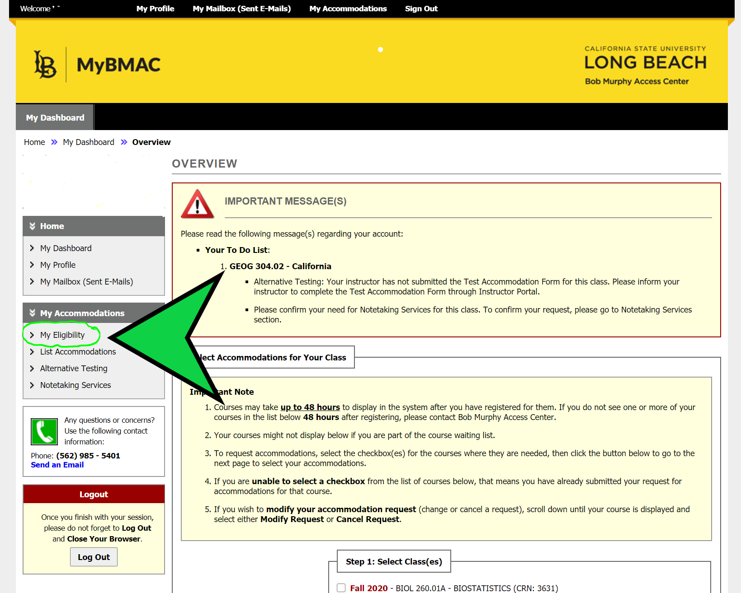

Step 4: Check Approved Eligibilities
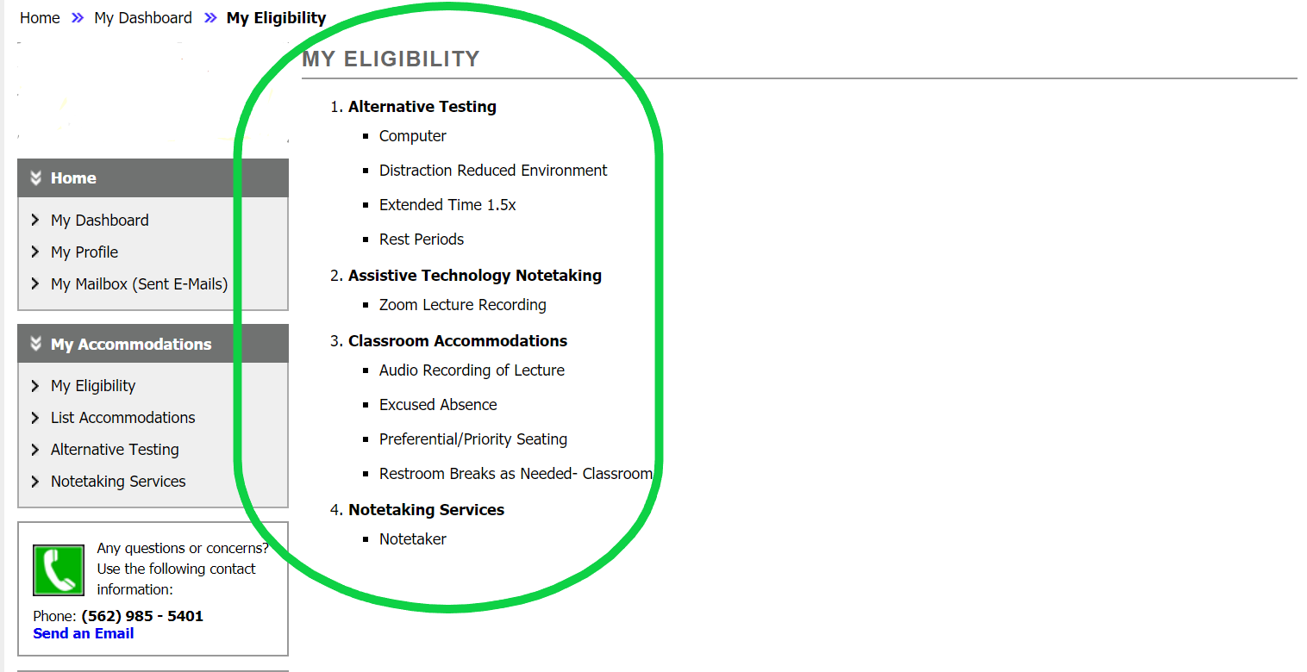

Step 5: Click on List Accommodations
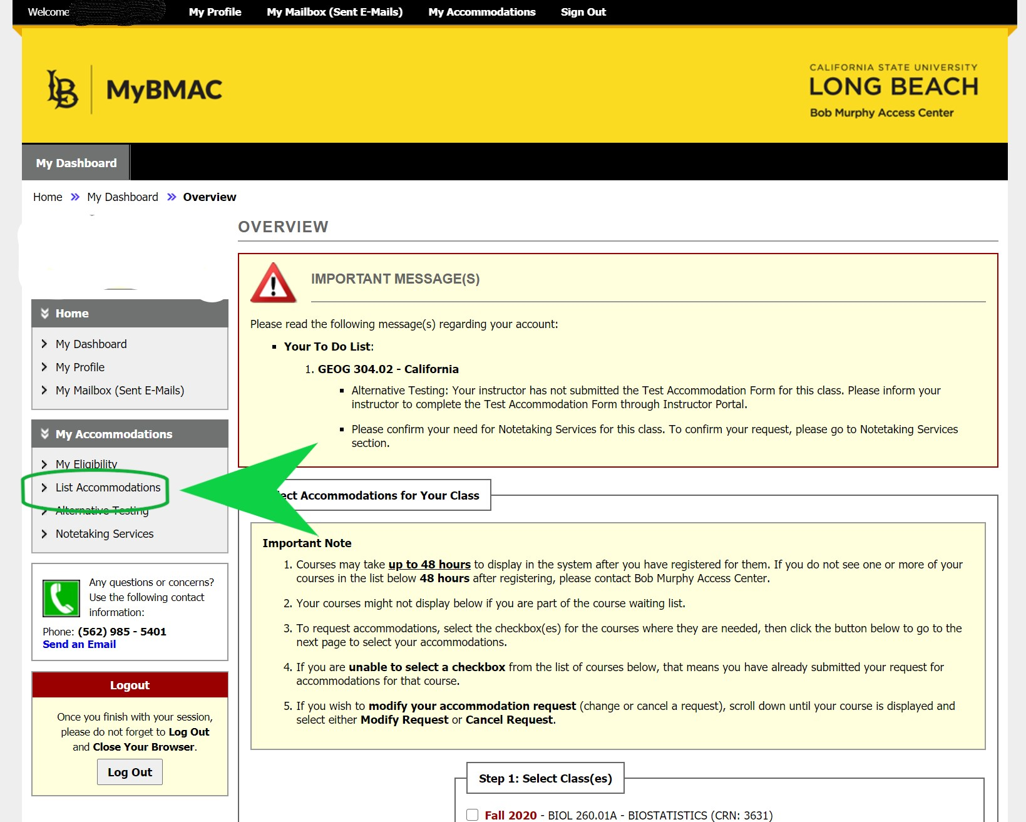

Step 6: Select Accommodations For Your Class
Select Accommodations For Your Class and then click Continue to Customize Accommodations
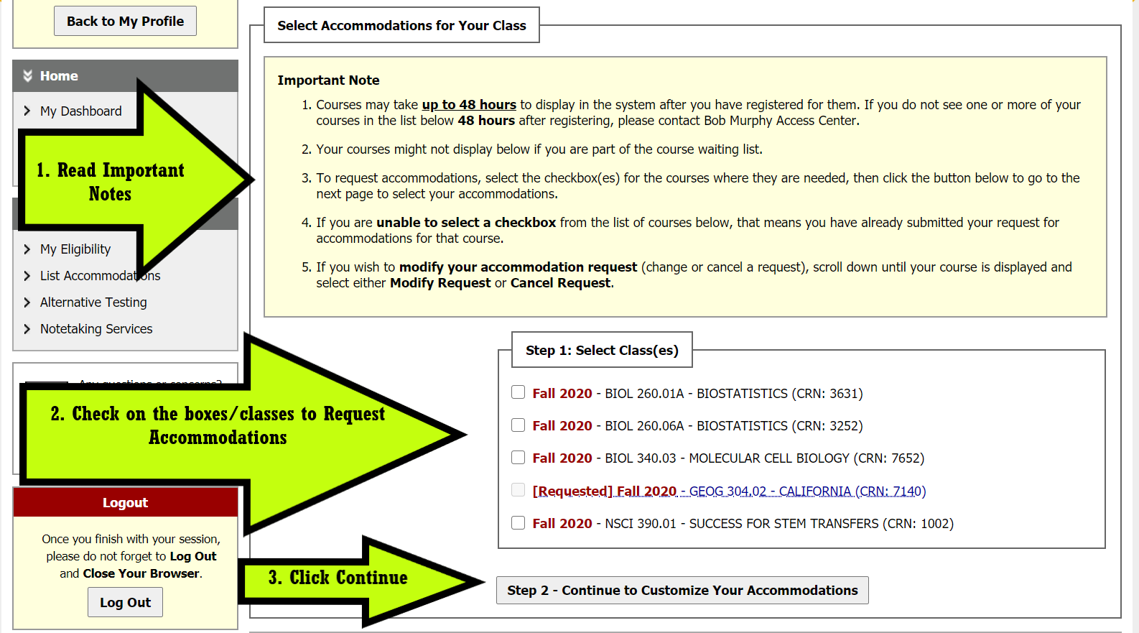
Figure 1 Steps to request accommodations.
- Read Important Notes.
- Check on the boxes/classes to Request Accommodations.
- Click Continue.

Step 7: Customize Accommodations for Each Class
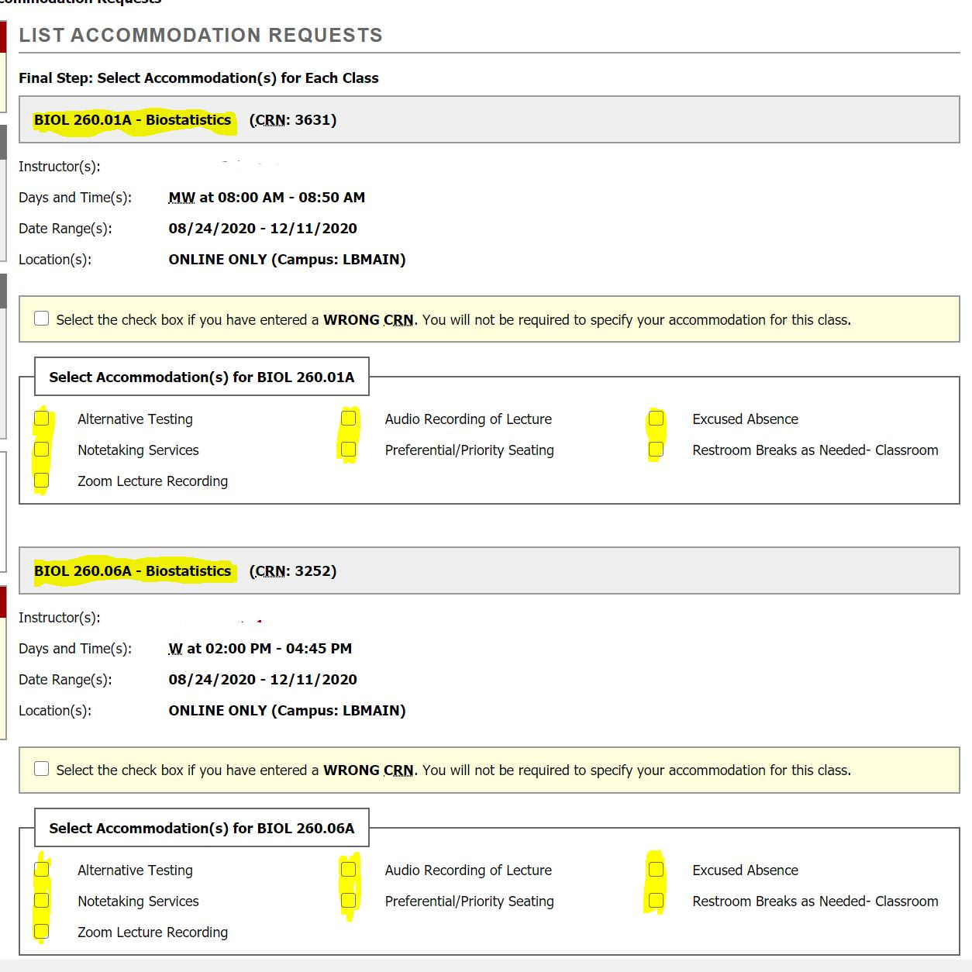

Step 8: Click Submit to Complete Accommodations Requests
