ERFSA
Emeriti and Retired Faculty & Staff Association
CSU Long Beach Chapter
an affiliate of CSU-ERFSA
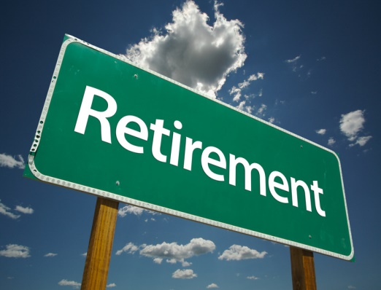
Resources for Retiring/Retired CSULB Faculty and Staff
Revised 05/21/2021

1. Check out the CSULB ERFSA web page and its links: https://www.csulb.edu/emeriti-retired-faculty-and-staff-erfas (or google CSULB ERFSA) Click on “Resources” and find links to:

- The CalPERS web site (sign up for “MyCalPERS” for personalized information). You can talk on the phone (888-225-7377) with a CalPERS representative or ask a question through a secure email service and receive a written response within a day or so.
- The statewide ERFSA web site provides access to a wealth of information and resources including current and past issues of the CSU-ERFA Reporter which has articles like “Are Health Benefits a Vested Right for CSU Retirees?” and “Pre- and Post-Retirement Concerns: Additional Useful Websites”
- Comprehensive list of CSULB emeriti
- Criteria, rights, and privileges for CSULB emeriti
…and much more

2. In addition, these resource people and offices can offer help and advice:
- CalPERS Regional Office, 500 N. State College Blvd., Orange 92868, phone (888) 225-7377
- CSU-ERFSA statewide resource people (reach them at csuerfsa@csun.edu or (818) 677-6522):
  - David Wagner (CSU Sacramento) Health Benefits Committee Chair
  - Robert Girling (CSU Sonoma) Chair, Legislative Affairs Committee
- CSULB Benefits Director Nikco Moore, Manager, Benefits Services nikco.mooe@csulb.edu (562) 985-2120 (note that, for those who are in retired status, most questions about benefits are resolved by CalPERS, not the CSULB Benefits Office)

