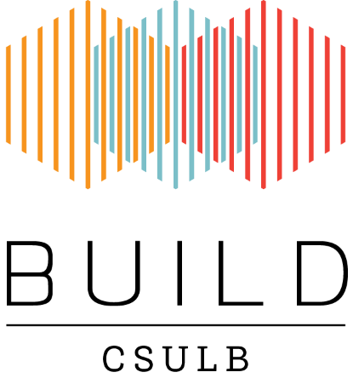
BUILD Mass Spectrometry of Small Molecules and Proteins workshop
Registration
Please complete, sign and return this form to Jesus A. Reyes (Jesus.Reyes@csulb.edu) to register for the Dissecting Microscope/Embryology workshop

Registration form must be received by Friday March 16th 2018. Confirmation of registration will be sent by email.

I hereby register for the Introduction using Mass spectrometry to detect small molecules and proteins workshop,
March 30th, 2018 from 130pm-330pm @ UCI
- THIS WORKSHOP WILL BE HELD AT UNIVERSITY OF CALIFORNIA, IRVINE
FULL NAME
Title ____________
First Name ___________________________________________________________________
Last Name ___________________________________________________________________
ADDRESS
Street Address 1 ______________________________________________________________
Street Address 2 ______________________________________________________________
City ______________________________________________________________
State ______________
Zip code _______________
E-Mail Address _____________________________________________________________
Phone Number _____________________________________________________________
Name | Signature | Date
Please complete and return this form by email (subject: Mass spectrometry 2018)
to: jesus.reyes@csulb.edu

Questions
Jesus A. Reyes
Jesus.Reyes@csulb.edu
CSULB BUILD Program
California State University Long Beach
1250 Bellflower Blvd, Long Beach, CA 90840-4501

