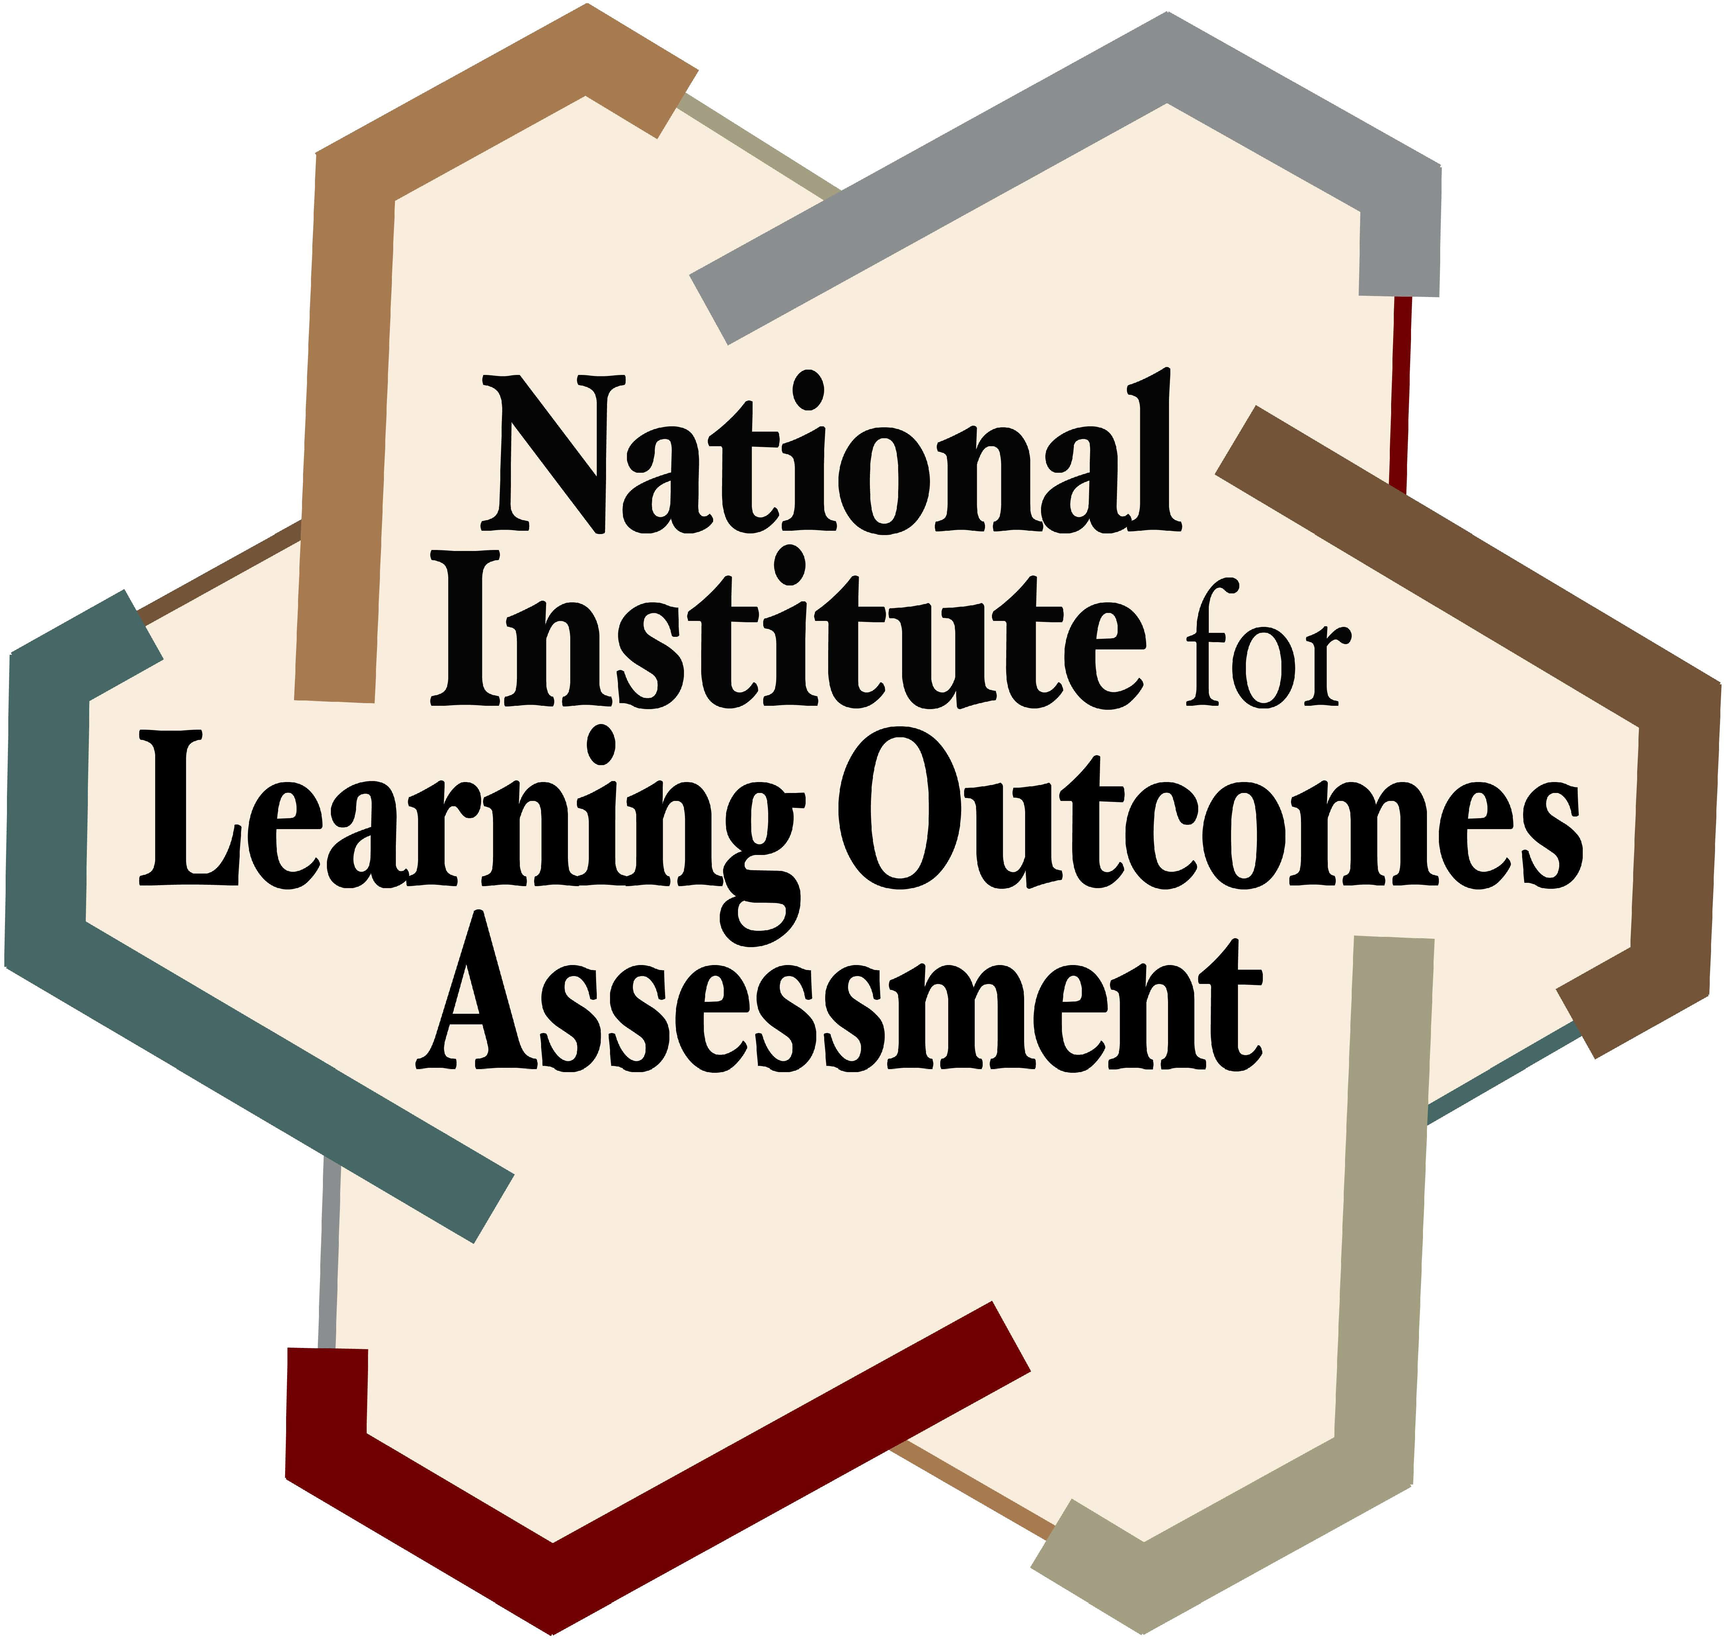
Philosophical Statements |  | Do Not Agree = 0 to  Absolutely Agree = 4
1. | Assessment of student learning is a necessary element of effective classroom teaching. |  | TL
2. | Results of assessment of student learning are used to improve teaching processes and practices. |  | TL
3. | Assessment of student learning should be held to the same evidentiary standards as objective, empirical research. |  | M
4. | Assessment of student learning does not provide evidence to improve teaching and learning. |  | C
5. | Assessment measures should be responsive to different student populations. |  | SC
6. | Assessment of student learning is for reporting to external entities. |  | C
7. | Assessment of student learning is not a faculty responsibility. |  | C
8. | Principles of scientific measurement (i.e., reliability, validity, sample size) should drive assessment of student learning measures. |  | M
9. | Involving students in assessment (beyond completing an assessment) makes the results inherently invalid. |  | M
10. | The only reason to assess student learning is to meet accreditation or programmatic requirements. |  | C
11. | Assessment of student learning is a waste of faculty time. |  | C
12. | Evidence of student learning is used to inform students about their learning. |  | SC
13. | Assessment of student learning is a shared responsibility of faculty, staff, and students. |  | TL
14. | Students are active participants in assessment processes. |  | SC
15. | Assessment is a part of the teaching and learning process whereby faculty learn about their own practice. |  | TL
16. | Students, when appropriate, should be able to provide their own evidence of learning outcome attainment. |  | SC
17. | Assessment of student learning is an integral part of faculty responsibilities. |  | TL
18. | To determine if learning has occurred, pre‐ and post‐measures are necessary. |  | M
19. | Students should co‐design learning outcomes and related assessments with faculty and staff. |  | SC
20. | Assessment evidence is composed of embedded assignments in courses. |  | TL
21. | Consistency in assessment measures is the most important element of assessment practices. |  | M
22. | Student learning can only be assessed through tests or exams. |  | M
23. | Students are a valuable source of information on what could be improved to advance student learning. |  | SC
24. | There is one, right way to assess student learning, for reporting purposes. |  | C

For each of the statements on the prior page, indicate your level of agreement ranging from 0-4. Add your score for each of the following statement types.
Results Table

Statement Types | Total (0‐24)
Teaching and Learning (TL)
Measurement (M)
Compliance/Reporting (C)
Student‐Centered (SC)
For each of the statement types, the closer your score is to 24, the stronger you agree with the statements in that group. The statement groupings are related to different philosophical views on the purpose and function of assessment of student learning as well as the best means by which to measure student learning.

Teaching and Learning: For those with higher scores on teaching and learning, assessment is viewed as part of pedagogy and student learning, driven by faculty questions about their classroom and programmatic practices in ways that guide future developments in both teaching and learning. The purpose of assessment is formative, and to enhance faculty teaching and student learning. Thus, the process of assessment is viewed as one of learning and as embedded within teaching and learning.

Measurement: For those with higher scores on measurement, concerns about determining valid and reliable approaches to gathering data on student learning drive decisions and discussions on assessing student learning. Assessment is about measurement and determining the most appropriate and accurate measures to document and record learning as well as programmatic or institutional impact on learning. Comparisons, longitudinal data, and controls are viewed as an integral part of measurement issues.

Compliance/Reporting: For those with higher scores on compliance and reporting, assessment is viewed as undertaken solely to meet the requirements and demands of administrators, accrediting bodies, and state agencies. Assessment is simply about meeting the needs and requirements of external entities for purposes of reporting. It is about doing what is asked, checking a box, and moving on with your day.

Student‐Centered: For those with higher scores on student‐centered, assessment is viewed as a mechanism by which students can learn about their own learning by being an active participant in the assessment process. Assessment here is about a reflective and engaged process in which students learn about themselves as learners, how they learn, what they know, and are actively involved in and an agent of their own learning process. Students are not simply the object of assessment, but the primary beneficiaries.

To read more about the different types, see Jankowski, N. A. (2017). Moving towards a philosophy of assessment. Assessment Update, 29(3), p. 10‐11. https://onlinelibrary.wiley.com/doi/10.1002/au.30096

