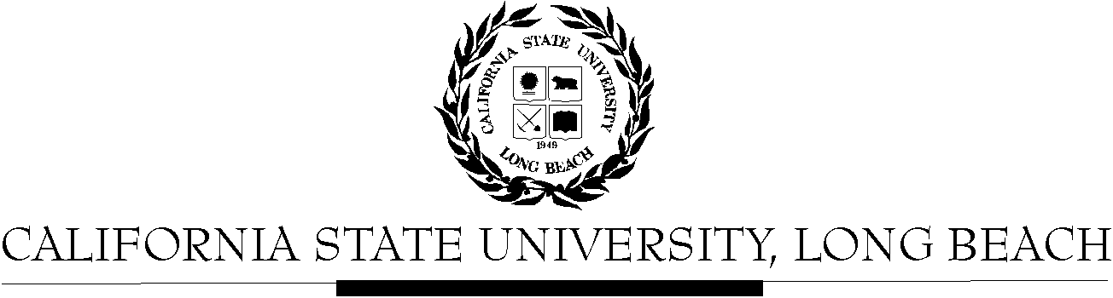

General Education Governing Committee
Agenda
November 23, 2020 via Zoom
2:00pm – 4:00pm

Zoom Information posted in Beachboard (Waiting Room enabled).

Please notify a member of the GEGC Executive Committee (Colleen.Dunagan@csulb.edu Chair, Peter Kreysa Vice-Chair, Ruth Piker (Secretary), Danny.Paskin@csulb.edu GE Coordinator, Annel.Estrada@csulb.edu), if you are unable to attend.

Members in Attendance:

- Call to Order

- Approval of Agenda – posted in Beachboard

- Approval of Minutes – November 9, 2020 - posted in Beachboard

- Announcements

  - This is our last meeting for Fall 2020.
  - Courses approved by Exec: ENGR 201
  - Update on UNIV 310
  - Update on procedural changes

- Review of New Course Proposals (proposals posted in Beachboard in Course Proposals folder/New Courses)
  - CWL 115 (tentative)
  - CWL 206
  - CWL 225
  - CWL 265
  - CWL 405

- Adjournment

