CALIFORNIA STATE UNIVERSITY, LONG BEACH
COLLEGE OF HEALTH AND HUMAN SERVICES
DEPARTMENT OF FAMILY AND CONSUMER SCIENCES
(Pick One) CDFS 410, FCS 490, FCS 497/FCS 597
3 Units of Credit will be given for ONE Class Only
JUNE 2nd to JUNE 21st, SUMMER 2019
Short-Term Study Abroad Course to Croatia, Bosnia, Montenegro, and Slovenia
“Learning about Children and Families in Europe: Croatia, Bosnia, Montenegro, and Slovenia”

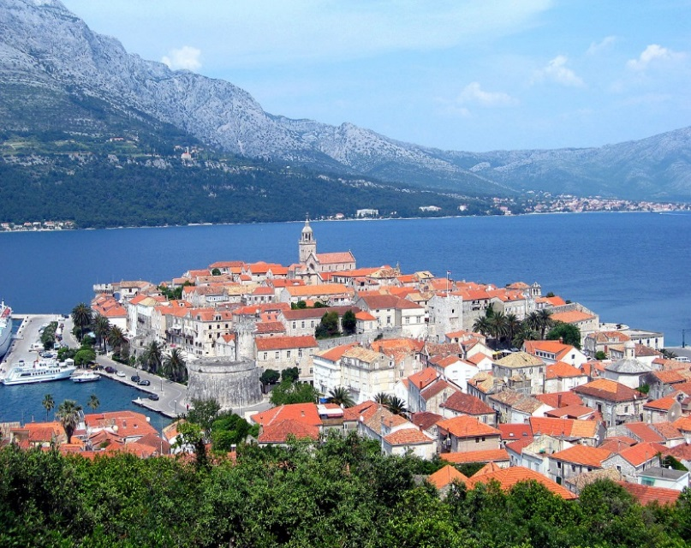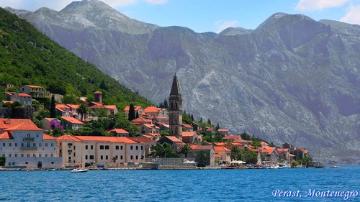
Croatia
Montenegro

Professor: Nilufer P. Medora
Office: FCS 101
Phone: (562) 985-4488
e-mail: medora@csulb.edu

“For the born traveler, travelling is a besetting vice. Like other vices, it is imperious, demanding its victim's time, money, energy and the sacrifice of comfort” – Aldous Huxley.
“Twenty years from now you will be more disappointed by the things you didn't do than by the ones you did. So throw off the bowlines, sail away from the safe harbor. Catch the trade winds in you sail. Explore. Dream. Discover” – Mark Twain.
“To get away from one's working environment is, in a sense, to get away from one's self; and this is often the chief advantage of travel and change” – Charles Horton Cooley.
“Travel and change of place impart new vigor to the mind” – Seneca.

COURSE DESCRIPTION: a 23 day short-term study abroad course will focus attention on how immigration, social, cultural, religious, political, technological, and historical factors have influenced and changed the lives of children and families in the U.S., in Croatia, Bosnia, Montenegro, and Slovenia. The different teaching methods that will be used in the course will include lectures, DVDs, tourism, visits to local museums, experiential learning activities, service learning activities, utilization of guest speakers, and founders of non-governmental organizations. NGO offices, orphanages, universities, historic sites and iconic places will also be visited. Assignments for the course will be based on visits to these various sites. This course meets the intensive writing requirements that are needed by the GE writing courses.

NOTE TO GRADUATE STUDENTS:

This short-term study abroad program course is approved for graduate credit which implies that graduate students may use this course toward meeting the requirements for their Master’s degree program unless it has been used to meet undergraduate requirements for graduation, the following policy has been adopted by the California State University system and is being implemented in this course.

- Performance expectations for graduate students require them to complete two additional assignments;
- The quality of written and oral presentations in the course requires that they be at least one grade point higher than that of an undergraduate;
- If you are a graduate student, you are required to contact the instructor within the first few days of class for specifications on meeting the course requirements. Not doing so will result in
Lowering the grade that you earn for the course.

EXPECTED OUTCOMES:

Upon completion of the course, the student will be able to:

- Describe the historical, religious, and cultural factors that have influenced the lives of children and families in Croatia, Bosnia, Montenegro, and Slovenia.

- Compare and contrast the immigration trends in terms of the influence they have had on the food, dress, recreational patterns, marriage, and culture, etc. in Croatia, Bosnia, Montenegro, and Slovenia.

- Discuss the horrific war of the 1990s and its effect the war had on children and families in Croatia, Bosnia, Montenegro, and Slovenia.

- Compare and contrast the culture and people in Croatia, Bosnia, Montenegro, and Slovenia.

- Visit schools, social service agencies, NGOs that assist low-income families in Croatia, Bosnia, Montenegro, and Slovenia.

- Compare and Contrast the beliefs and rituals of Catholics, Orthodox Christians, Muslims, and Jews.

- Analyze oral case studies of courage, endurance, and survival from guest speakers.

- Hear oral accounts from police, clergy, and army officers about the genocide and mass killings that occurred in the 1990s.

- Visit the “Tunnel of Hope” and visualize how hundreds of Bosnians survived without food for three years when the city of Sarajevo was surrounded and Bosnians were completely cut off from getting out of their homes and neighborhoods.

- Enjoy the pristine natural beauty of this region.

REQUIRED TEXTBOOK:
Course Packet of book chapters and journal articles developed by the Instructor (2019). Both the textbook and packet of articles are available from Copy Pro Copy Center, which is located at 1785 H. Palo Verde Avenue, Long Beach, Ca 90815. Telephone Number: (562) 431-9974.
COURSE REQUIREMENTS:
1. Attend four 8-hour lectures given by the instructor ----Pre-departure.
2. Attend 4 Orientation Meetings presented by the instructor at CSULB before
Departure;

3. Attend the orientation meeting presented by API (Academic Programs International)

4. Attend all the lectures given by the instructor in the U.S., in Croatia, Bosnia,
Montenegro, and Slovenia on the scheduled days.

5. Read the 15 articles from the “Packet of Short Readings” for the designated
course.

6. Attend all the places of interest with group members in the identified destinations;

7. Ensure that you are punctual and ready to start the day at the designated
times on all days.

8. Complete the Short-Term Paper.

9. Have a positive attitude, get along with group members, and do not form
cliques within the larger group of students enrolled in the program;

10. Complete a 66-item quiz in Long Beach before the start of the program.
11. Complete the International, Croatia, Bosnia, Montenegro, and Slovenia
General Knowledge/ Fact Sheet.

12. Complete the written short term paper as per instructions.
13. Complete a Final exam that will be based on the lectures and the readings.
COURSE ASSIGNMENTS:
READINGS: You must read the assigned readings from the required text, and internet articles from the Short Readings Packet. You must attend all the lectures designated on the class syllabus.
EXAMINATION: You will have to complete one quiz before you leave the U.S. You will also take the final exam at the end of the program before you leave Zagreb. The exam will include a combination of multiple-choice questions, matching questions, and short essay questions.
COMPLETE THE INTERNATIONAL, CROATIA, BOSNIA, MONTENEGRO, AND SLOVENIA FACT SHEET: You will complete a Fact Sheet/General Knowledge Fact Sheet regarding International Facts and Figures, general knowledge and issues that you must know about the world and more specifically about the countries you will be visiting: Croatia, Bosnia, Montenegro, and Slovenia. This is an open book assignment. You must turn in this assignment before we leave the U.S. to receive credit for it.
SHORT PAPER ON TWO GUEST SPEAKERS OR EXCURSIONS: Each “Report” that you describe should be approximately 1 to 2-typed written page (double-spaced). This assignment will prove to be a very unique, interesting, worthwhile, reflective, and learning experience for the students. From the following, pick any two of your choice and respond to some of the questions that pertain to your specific walk. You do not need to respond to all the questions.
- Visit to Social Service Agency --Bonsai
- Visit to the Child Orphanage in Dubrovnik
- MoSPY – Ministry of Social Policy and Youth
- Sarajevo War Tunnel (Tunnel of Hope), Bosnia & Herzegovina
- Social Service Agency in Kotor
- Guest Speaker from School in Montenegro
- Lecture Given by Imam
- Visit to Synagogue and lecture given by Rabbi
- Head of NGO, film producer, and acting therapist
- CFSH –Children, Families, and Social Hub

- (All papers must address this specific bullet) Did the particular “visit to the social service agency/guest speaker focus of children and families?”

- A very brief description of the “ the visit to the place or the speaker that you are writing about:

- What made you decide to write about this particular topic;

- What are three issues that appealed to you the most about the “guest
speaker” or the “social service agency”;

- What did you learn after you completed the “visit to the social service agency or heard the guest speaker”?;

- What are three things that you thought the speaker could have covered as part of his/her presentation. Also, point out three things that you did not think would be covered as part of the presentation, but the speaker covered these issues;

- What was your opinion about the speaker? Did you think that he/she had
adequate knowledge about the topic?

- We visited, three different islands during this short-term study abroad
program, which island did you like best and why? What was the
specialty of each of the three islands?

A SHORT TERM PAPER ON ANY ONE OF THE FOLLOWING TOPICS:

This paper should be about 4-5 typed pages (double spaced) with at least 4-6 citations from scientific journal articles. You can use books as well. The paper should follow the APA style.

- The Tunnel of Hope.

- Family Life during the War Years.

- How did Children Survive during the War Years?

- Life in the Orphanages in Croatia, Bosnia, and/or Montenegro.

- How does the Culture of Bosnia Differ from the Culture of Croatia?

- Discuss the Differences Between the Religions of Croatia, Bosnia,Serbia, Slovenia.

- Pick any three social service agencies that assist children and families in either Croatia. Bosnia, Montenegro, and/or Slovenia and briefly summarize the services that they provide children and families. How did these social service agencies function during the War Years?

GRADES: Grades will be given on the bases of attendance, the short paper, the quiz, 2 walks paper, and the final exam. The final grade will be based on the number of points that you earn out of a possible 700:
Attendance 100 Points
2 Short 2-3 Page Papers 200 Points
International, General Knowledge Fact Sheet 100 Points
Attitude, Curiousness, and Behavior During the Program 100 Points
Short Quiz 100 Points
Final Exam: 100 Points

Total 700 Points

Out of 700 possible points: The following grading system will be followed:
90% and above A 630 60% and above D 420
80% and above B 560 F is Less than 420 Points
70% and above C 490
****PLEASE NOTE: The students will be having five or six (3) hour classes from 6:00 to 8:45p.m. in FCS 106 before we leave the U.S. for Croatia The students will also be completing the following before we take off for Croatia.

• A General Knowledge and International Fact Sheet
• A 2-4 Page Term Paper
• EXAM I

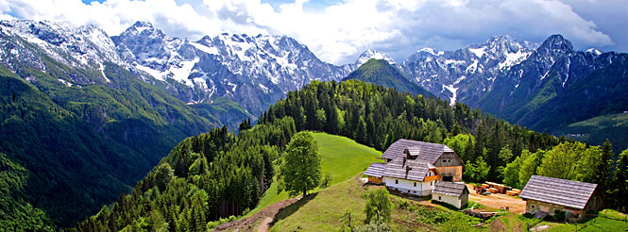
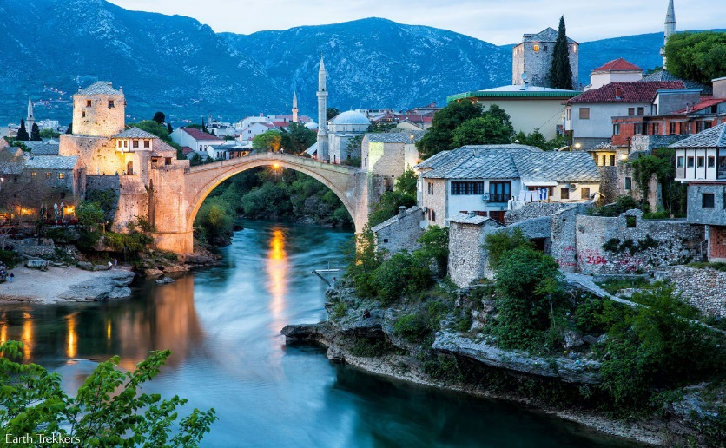
Slovenia
Bosnia

TENTATIVE ITINERARY FOR
CALIFORNIA STATE UNIVERSITY, LONG BEACH
CHILD DEVELOPMENT & FAMILY STUDIES
June 2- June 21, 2019
Sun, June 2
Depart LAX for Croatia

Mon, June 3
Arrive in Croatia
Hotel Check-in
Group lunch with API staff members in the hotel
API Staff Meets and Greets the Group Members.
API Safety and Cultural Orientation
Dinner on Own
Overnight in Zagreb Croatia
Tue, June 4
Orientation to Croatia, Bosnia, Montenegro, and Slovenia
Sightseeing tour of Zagreb
Visit the Museum of Illusions and the Museum of Broken
Relationships
Lunch on Your Own
Welcome Dinner
Night in Zagreb, Croatia
Wed, June 5 Transfer to see the Beautiful Plitvice Lakes
Guided Tour of Plitvice Lakes National Park---
Upper and Lower Lakes
Lunch on Your Own
Transfer to Dubrovnik
Dinner on Your Own
Overnight in Dubrovnik, Croatia

TENTATIVE ITINERARY FOR
CALIFORNIA STATE UNIVERSITY, LONG BEACH
CHILD & FAMILY STUDIES
June 2- June 21, 2019

Thu, June 6 City Orientation Tour
Lunch on Your Own
Dinner on Your Own
Overnight in Dubrovnik, Croatia
Fri, June 7
“Happy Hour” Mixer with the Libertas University Students

Visit to Bonsai (social service agency)
Visit to social service agency
Lunch on Your Own
Dinner on Your Own
Overnight in Dubrovnik, Croatia

Sat, June 8
FREE Day for Students to Engage in Optional
Activities
Lunch on Your Own
Dinner on Your Own
Overnight in Dubrovnik, Croatia

Sun, June 9
Speaker: War about Recent War in Croatia
Visit to the War Museum on the Mountain by Cable Car
Speaker: General from Croatian Army who defended
Dubrovnik and Croatia and API Directors will share
Experiences about the War
Lunch on Your Own
Dinner on Your Own
Overnight in Dubrovnik, Croatia
Mon, June 10
Guest Speaker—Catholic Priest will Address the
Similarities and Differences in everyday life activities
Between People Living in the United States and Former
Yugoslavian Countries.
Lunch on Your Own
Class:
Dinner on Your Own
Overnight in Dubrovnik, Croatia

TENTATIVE ITINERARY FOR
CALIFORNIA STATE UNIVERSITY, LONG BEACH
CHILD & FAMILY STUDIES
June 2- June 21, 2019

Tue, June 11 Visit to Lokrum Island. Admire the island’s
Natural Beauty. Meet and spend quality time
with Croatian family
Lunch on Your Own
Free Evening
Dinner with Host Family
Overnight in Dubrovnik, Croatia

Wed, June 12 Visit a local high school in Dubrovnik
Lunch on Your Own
Participate in a Volunteer Activity
Lunch on Your Own
Volunteer Project
Dinner on Your own
Overnight in Dubrovnik, Croatia

Thu, June 13
Visit the orphanage to spend some quality time with
Children who lost their parents during the War of the 1990s.
Lunch on Your Own
Free Afternoon and Evening
Dinner on Your own
Overnight in Dubrovnik, Croatia
Fri, June 14
Transfer to Montenegro (Approx. 3 Hour Drive)
Guided Tour of Montenegro
Guest Speaker from Government Social s
Service Agency
Lunch on Your Own
Visit to Kotor –Social Service Agency
Return to Dubrovnik
Dinner on Your own
Overnight in Dubrovnik, Croatia

TENTATIVE ITINERARY FOR
CALIFORNIA STATE UNIVERSITY, LONG BEACH
CHILD & FAMILY STUDIES
June 2- June 21, 2019
Sat, June 15
Visit a Jesuit Church
Visit a Mosque: Lecture given by Dubrovnik Imam
Lunch on Your Own
Visit a Synagogue: Rabbi will Discuss the Migration of
Jews in this Region
Dinner on Your own
Overnight in Dubrovnik, Croatia

Sun, June 16 Visit Mljet Island
Enjoy a picnic lunch (Provided)
Dinner on Your own
Overnight in Dubrovnik, Croatia

Mon, June 17 Transfer to Bosnia
Guided Tour of Historical sites and Visit to Nansen
Dialog Network
Lunch on Your Own
Explore the local Square in Bosnia and shop
Transfer to Sarajevo
Dinner on Your own
Overnight in Sarajevo, Bosnia

Tue, June 18
Sarajevo City Tour
See the 1984 Winter Olympics Stadium
Visit the Tunnel of Hope Museum
Lunch on Your Own
Dinner on Your own
Overnight in Sarajevo, Bosnia

Wed, June 19
Transfer to go to Zagreb
Lunch on Your Own on the Way
Free time to Explore Zagreb
Dinner on Your own
Overnight in Zagreb, Croatia

TENTATIVE ITINERARY FOR
CALIFORNIA STATE UNIVERSITY, LONG BEACH
CHILD & FAMILY STUDIES
June 2- June 21, 2019
Thu, June 20
Transfer to Slovenia
Drive to Ljubljana for a guided tour
Lunch at the Square
Transfer to Bled
Free time to explore Bled
Transfer back to Zagreb
Group farewell dinner (included in the program)
Overnight in Zagreb

Fri, June 21
API will Arrange Return to the Airport
Departure from Zagreb to the U.S.

Fly back home and share memories with family members and friend.

