Brain Expander Side One

Two Models of Technology Integration:
Adding Some “TEC-VARIETY”

Curt Bonk, Indiana University, July 1, 2020
 | Ideas Definitely Can Use | Ideas  Might Use | Ideas  Can’t Use | Questions and Comments
- Tone and Climate
- Encouragement and Feedback
- Curiosity and Intrigue
- Variety and Novelty
- Autonomy and Choice
- Relevance, Meaningful, Authentic, and Interesting |  |  |  | 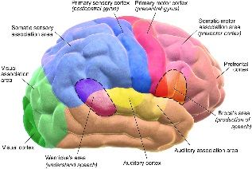
- Interactive and Collaborative
- Engagement and Involvement
- Tension and Challenge
- Yielding Products, Goals, and Purpose
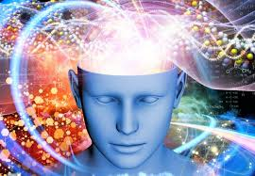
Brain Expander Side Two

Two Models of Technology Integration:
Where are you “R2D2?”

Curt Bonk, Indiana University, July 1, 2020
 | Ideas Definitely Can Use | Ideas  Might Use | Ideas  Can’t Use | Questions and Comments
- Read
- Reflect
- Display
- Do
Across Phases

