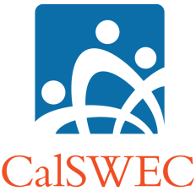
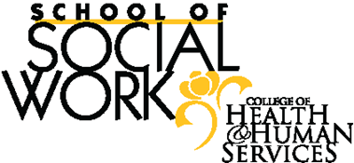
CALIFORNIA STATE UNIVERSITY, LONG BEACH
SCHOOL OF SOCIAL WORK

2020-2021
CalSWEC MSW Student Intern Title IV-E Eligibility
Case Log

In order for the university to meet Federal financial guidelines all CalSWEC students must meet the Title IV-E training regulations. During completion of the first-year internship MSW interns should have caseloads that are 100% Title IV-E eligible children and clients/families.

Title IV-E eligibility includes:

• 1 – Income: Children whose family is eligible for CalFresh or CalWORKs
(formerly referred to as AFDC)
• 2 – Service: Children who are receiving Title IV-E, child welfare-related services
• 3 – Risk: Children and/or their families who are at risk of placement such as court-ordered or possible placement, in the absence of services.

**Each semester please list the initials of each case receiving services from the intern and how the client meets the criteria of Title IV-E eligibility by number (1, 2 or 3).

Case Initials Title IV-E Criteria

____________ ______________________________________________________

____________ ______________________________________________________

____________ ______________________________________________________

____________ ______________________________________________________

____________ ______________________________________________________

____________ ______________________________________________________

___________ ______________________________________________________
___________ ______________________________________________________

MSW Intern ______________________________ Date ________________________

Agency Name____________________________________________________________

Field Instructor Name____________________________________________________

