Captioning Help and Resources
  - Companion Video: Caption Help and Resources

Captioning Not Generating
Once a video is uploaded, it can take up to two days to generate captions. When the captions are generated, the ‘CC’ icon will appear in the Kaltura video player.
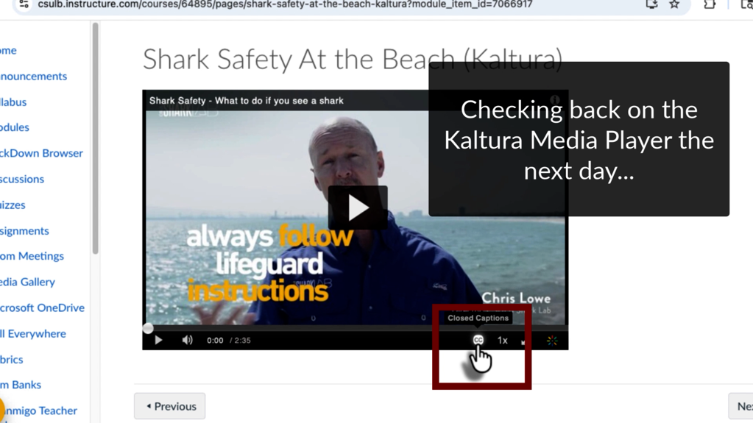
If captions have not been generated, it is possible an error has occurred. You can remedy the situation by doing any of the following:

Uploading to Kaltura Again
Follow the video upload process again for the video that is giving you captioning errors. Sometimes the reupload allows the captioning to run for the new video. Be sure to delete your old video with the caption generating error to prevent linking the non-captioned video in your courses. You can delete the old video by going to your ‘My Media’ and selecting the trash can icon to the right of the video you would like to delete.
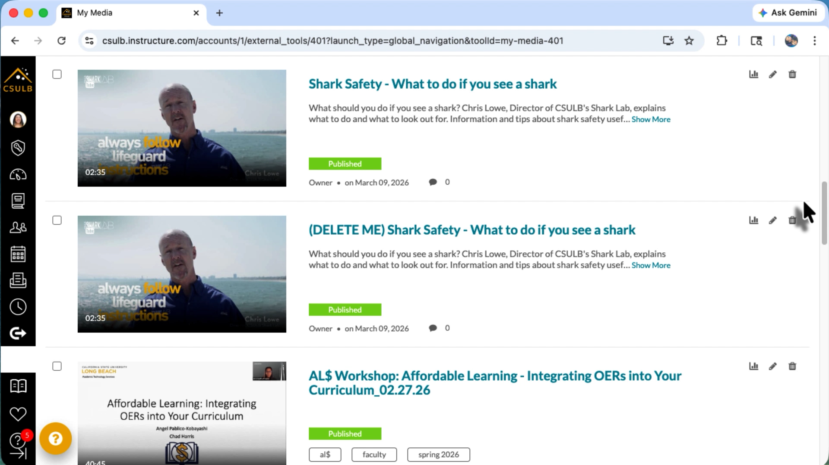
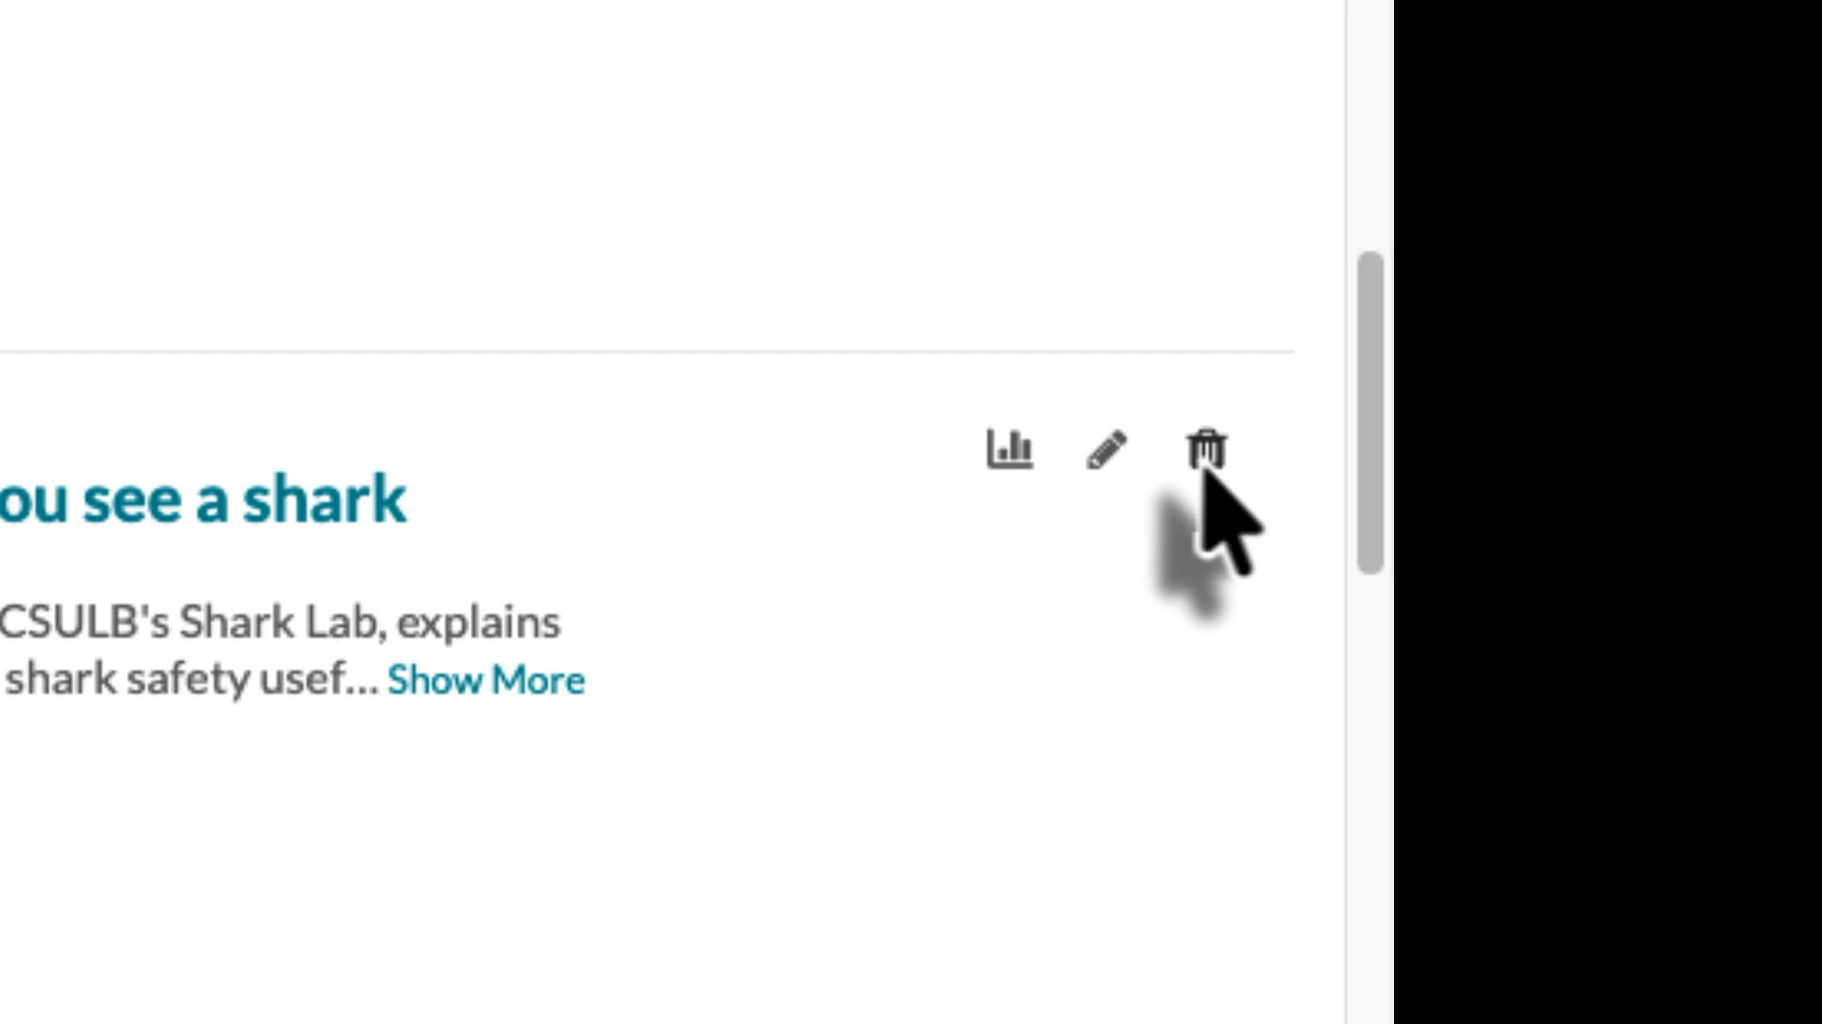

Ordering Captions
You can order new captions manually for your videos by doing the following:
- Going to ‘My Media’ from the Canvas global navigation bar
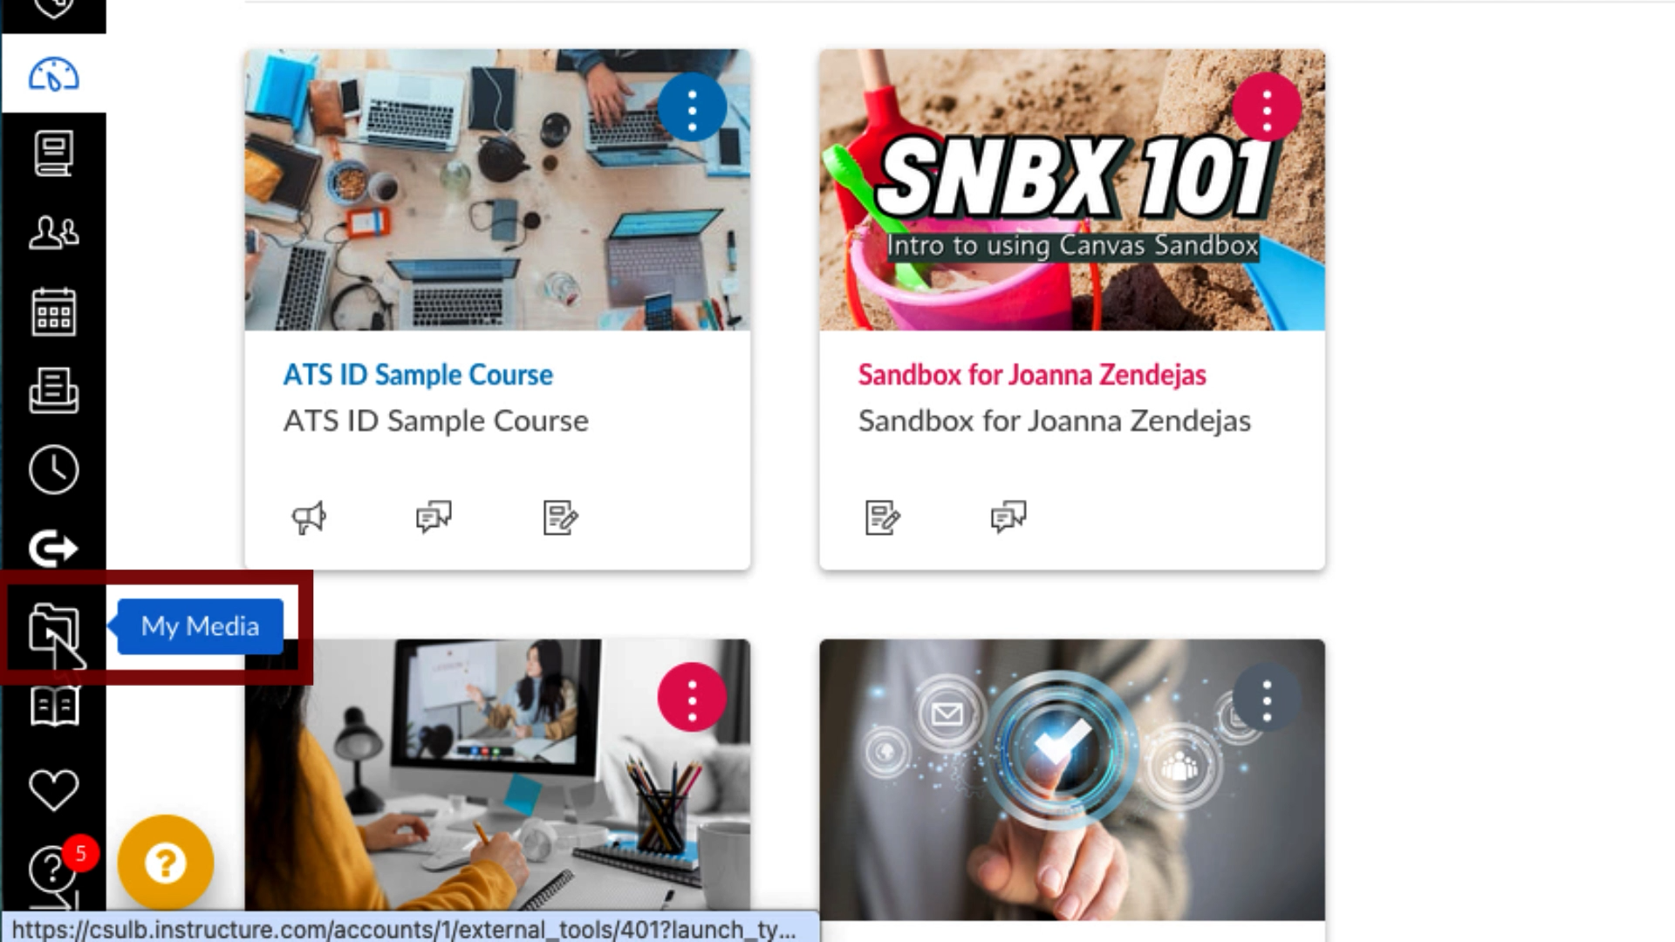
- From your media library, select the media that you want to order captions for to get to the media page
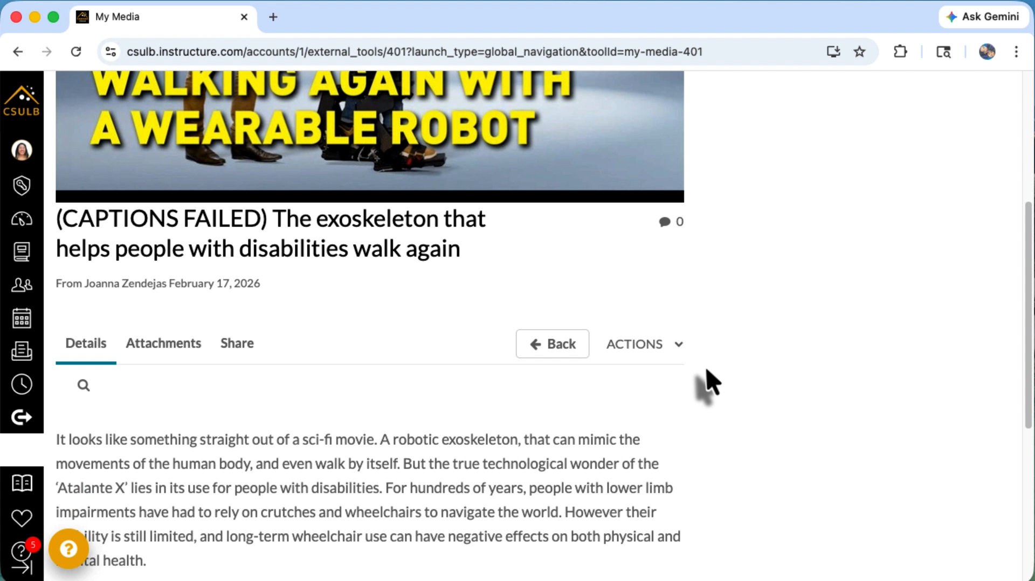
- Select the ‘Actions’ button then ‘+ Captions & Enrich’ to get to the caption ordering menu
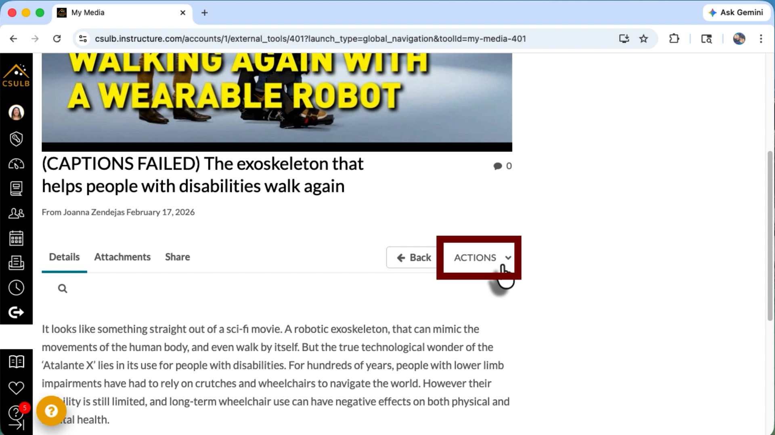
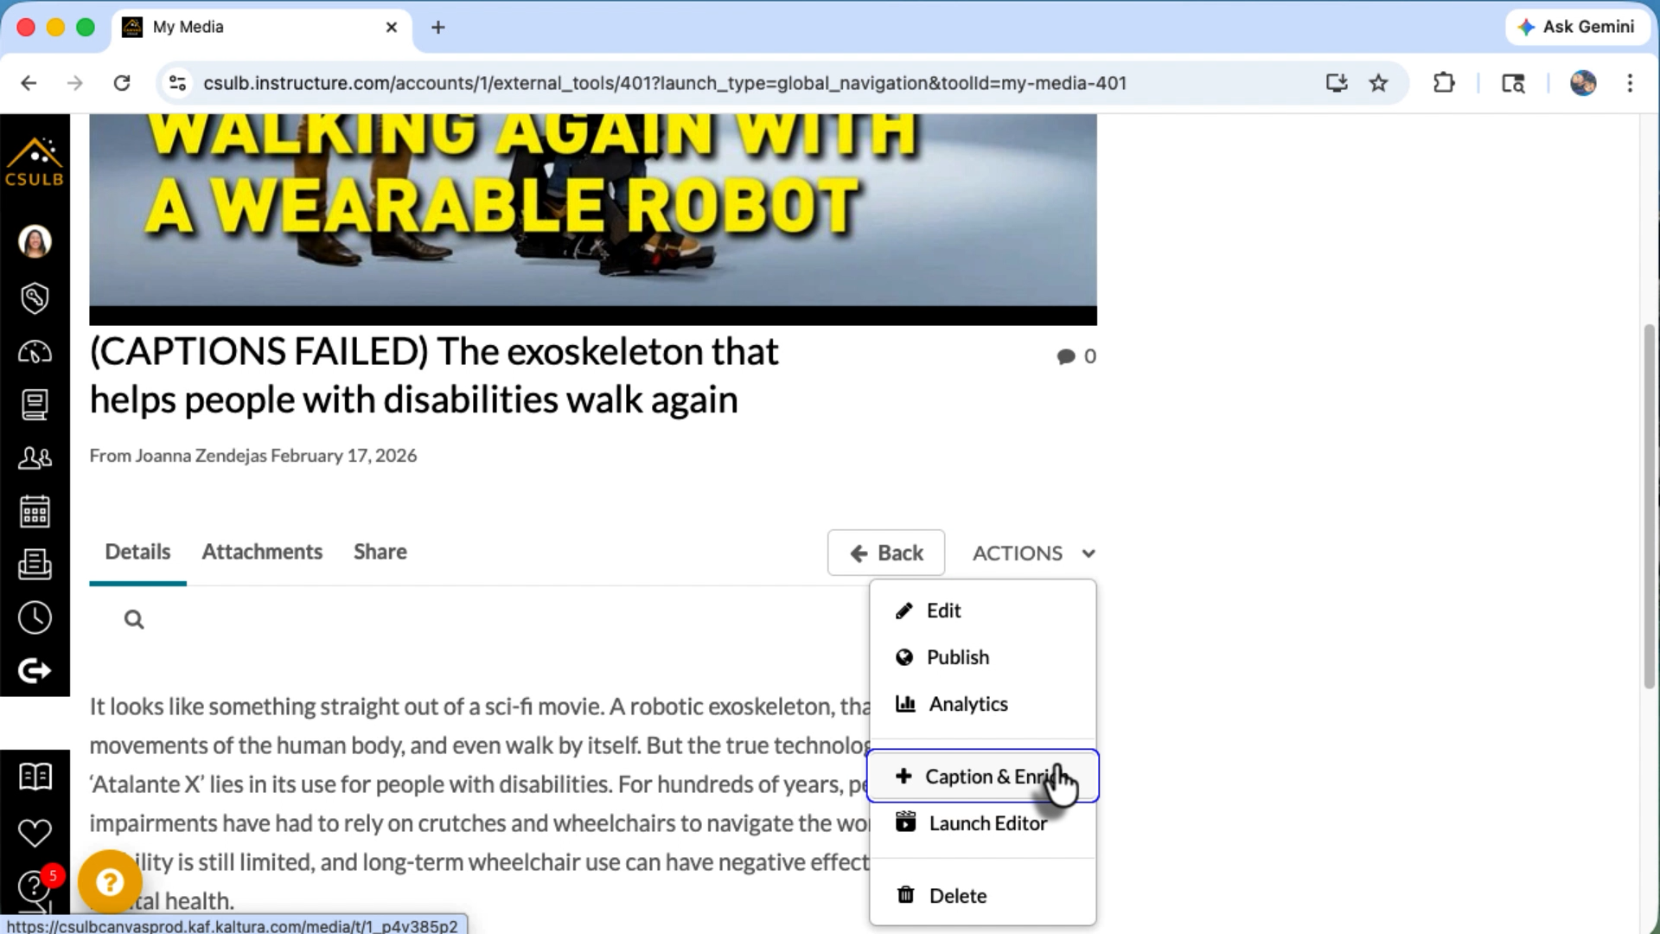
- From the order caption menu select the blue ‘+ Order’ button
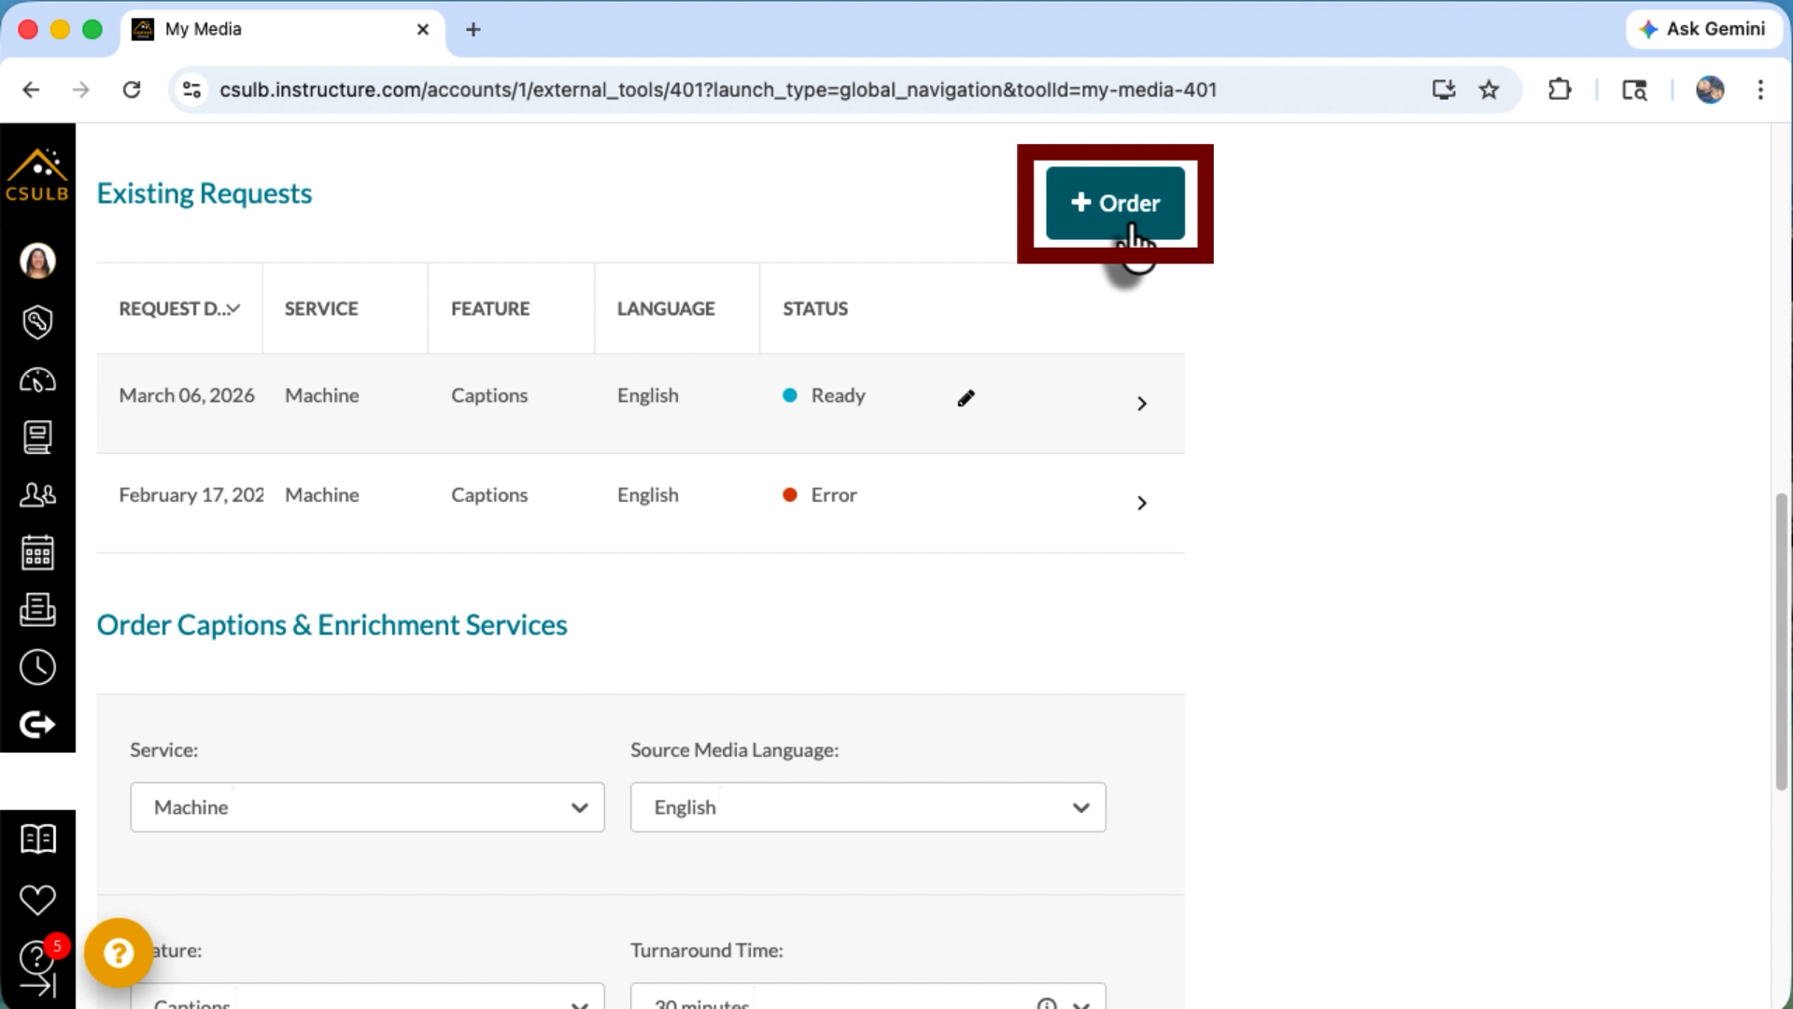
- Take note of the options for ordering captions. You can keep the default settings of machine, English, captions, and turnaround time. Please note that the turnaround time is estimated for a 15 minute video. If your video is longer than 15 minutes then the captioning may take longer.
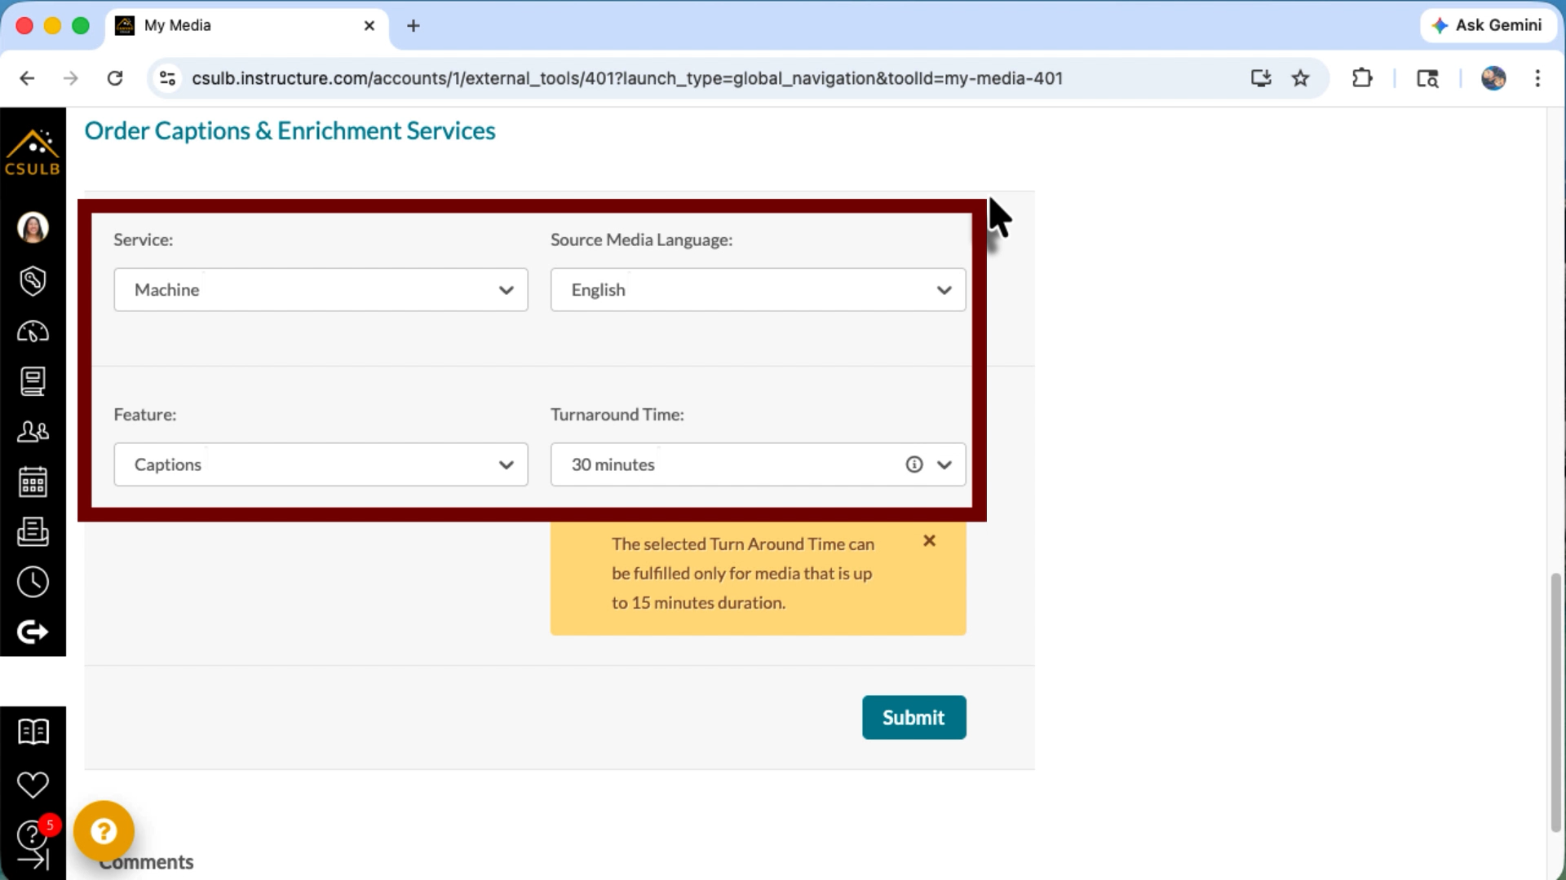
- Select the blue ‘Submit’ button to submit the request for captioning
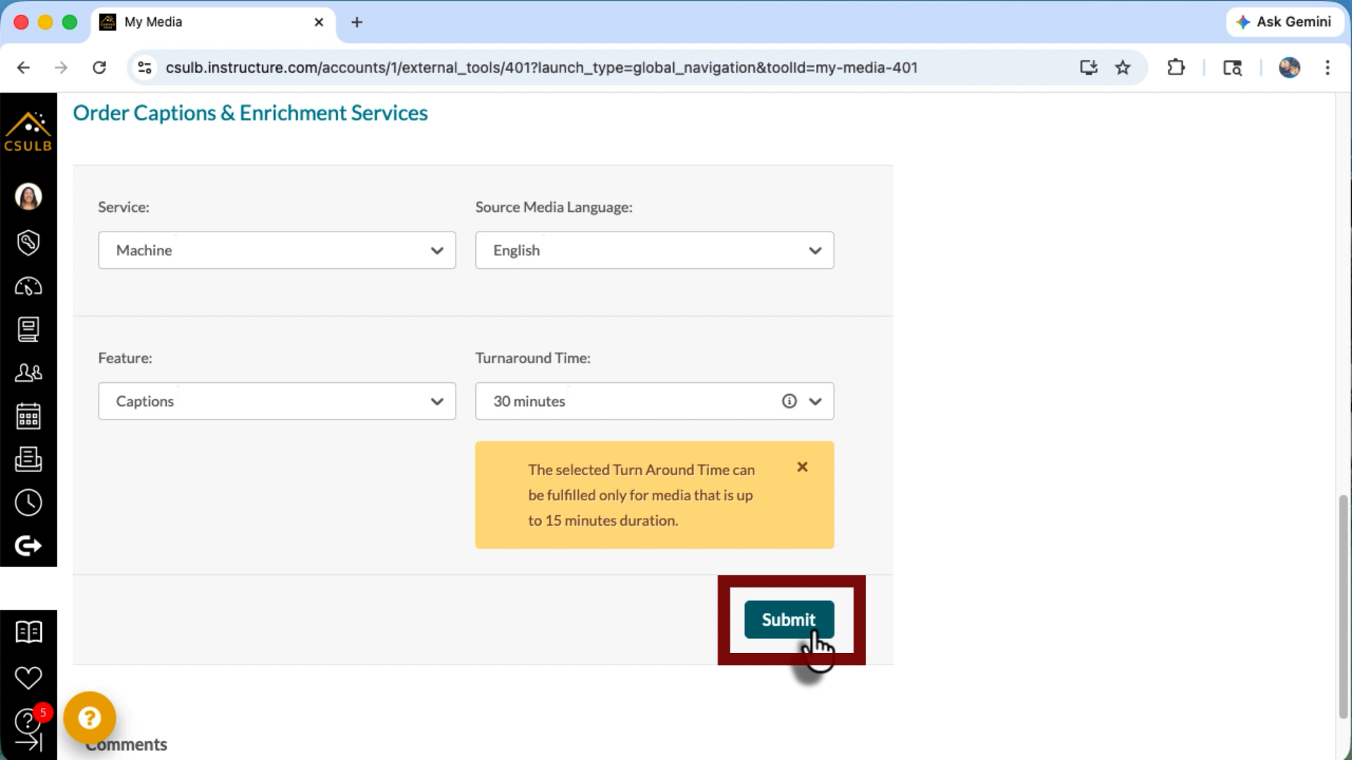
- Once submitted, you will see the captioning progress in the request menu
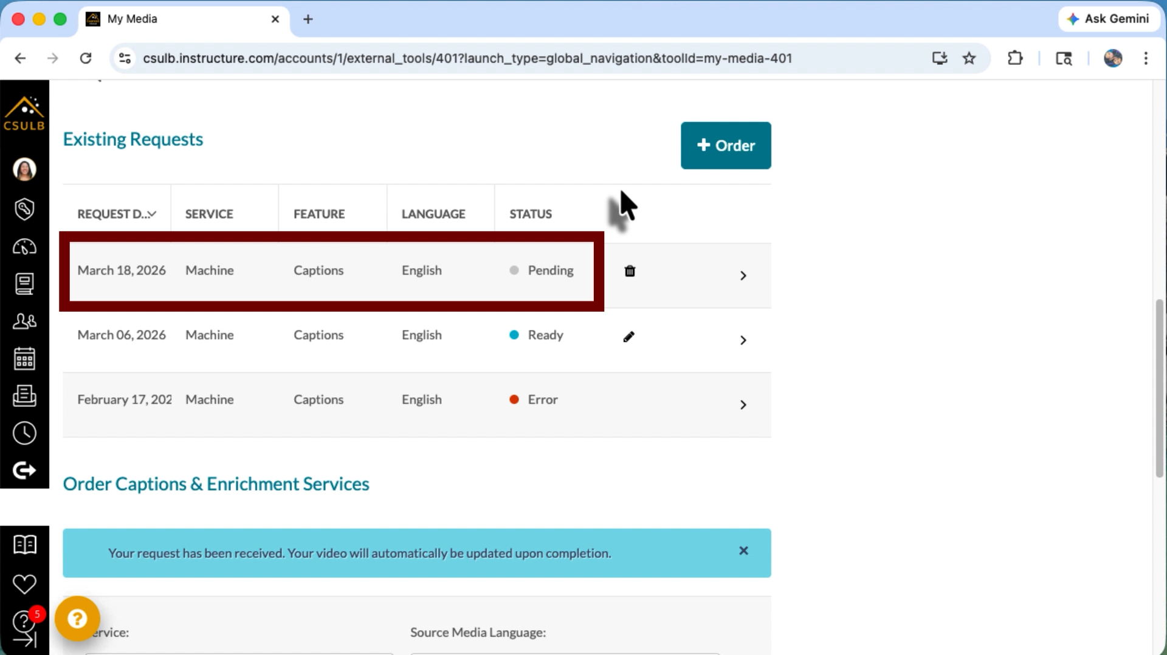
Once the request has been completed, the captions will be available for your video!

Beach Captions
Beach Captions is a tool created to help our community caption YouTube videos.

Accessing Beach Captions
You can access Beach captions by signing into your CSULB SSO account and selecting the ‘Beach Captions’ tile.
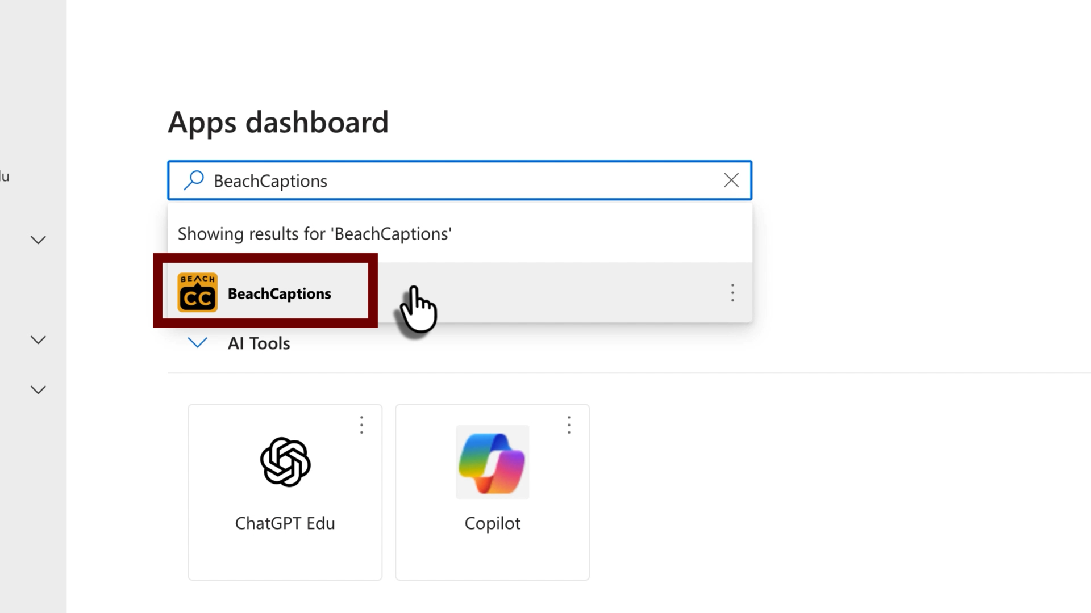

Requesting Captions
- In the Beach Captions site, select ‘+ Add URLS’ button in the top left of the page
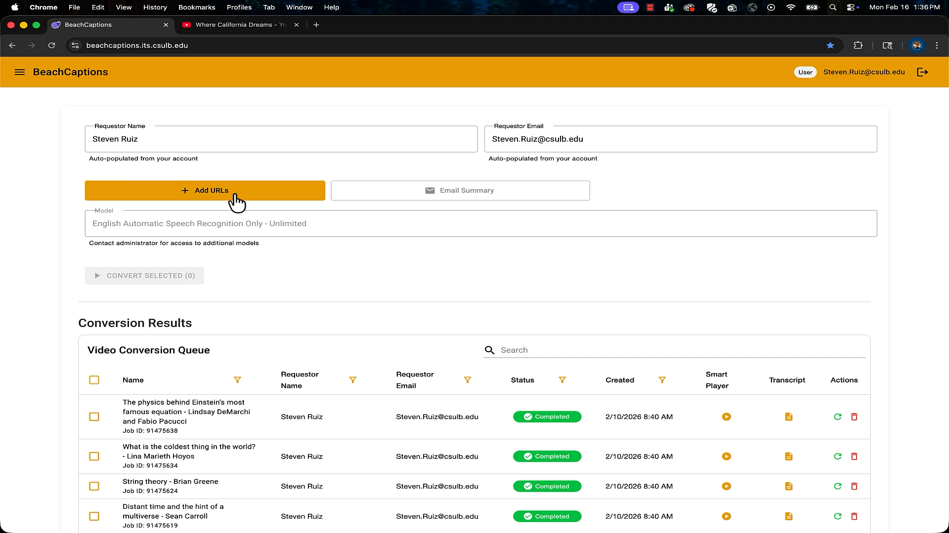
- In the Add URLs menu paste in each YouTube video that you want captions for on their own separate line
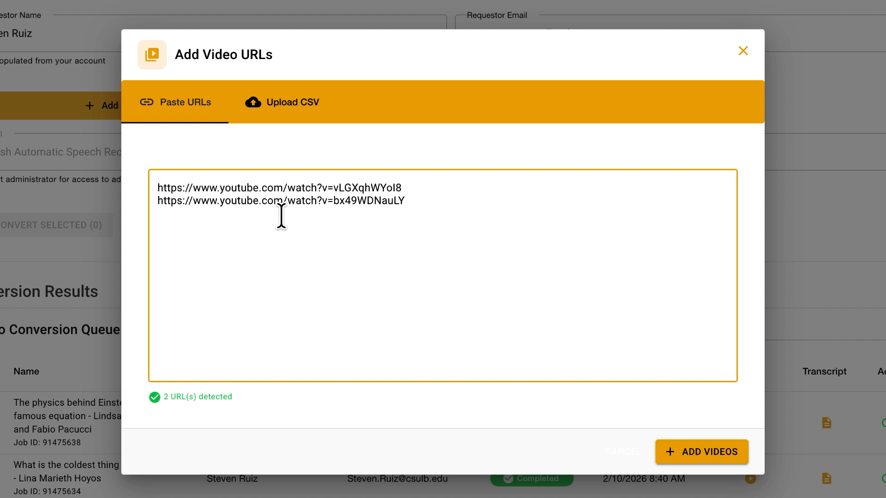
- Select the ‘Add Videos’ button in the bottom right of the menu to submit the caption request
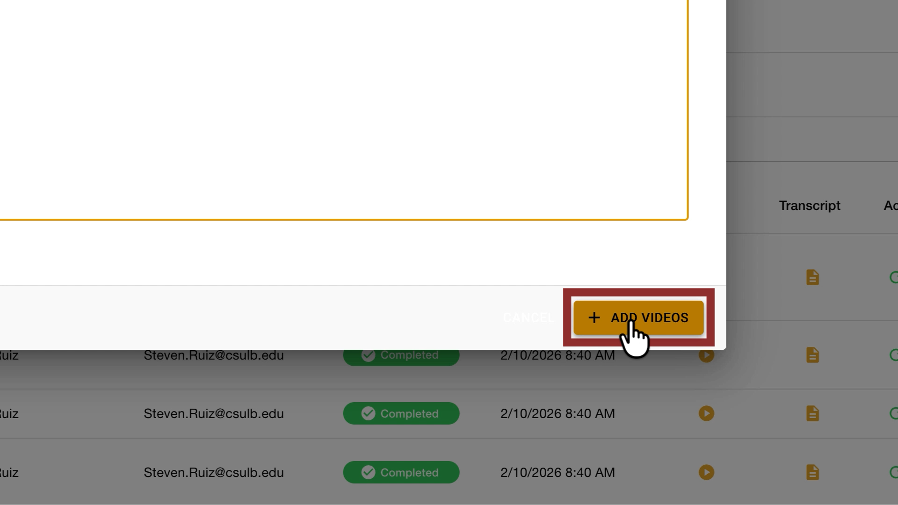
The page will show you a confirmation of how many video requests you sent in.
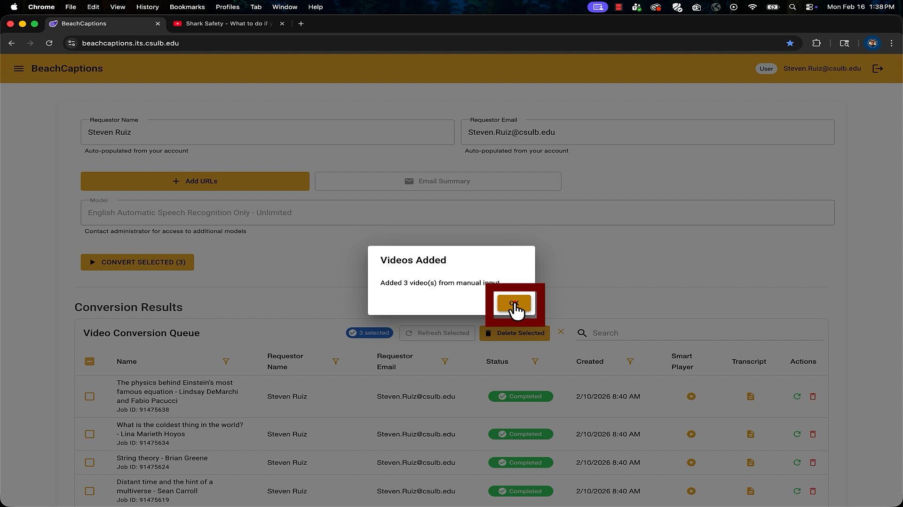

Downloading Captioning File
Once the captions have finished processing, you can download the caption file known as an SRT file.
To download the SRT file you go to the video you want under ‘Video Conversion Queue’ and select the paper icon underneath the ‘Transcript’ column.
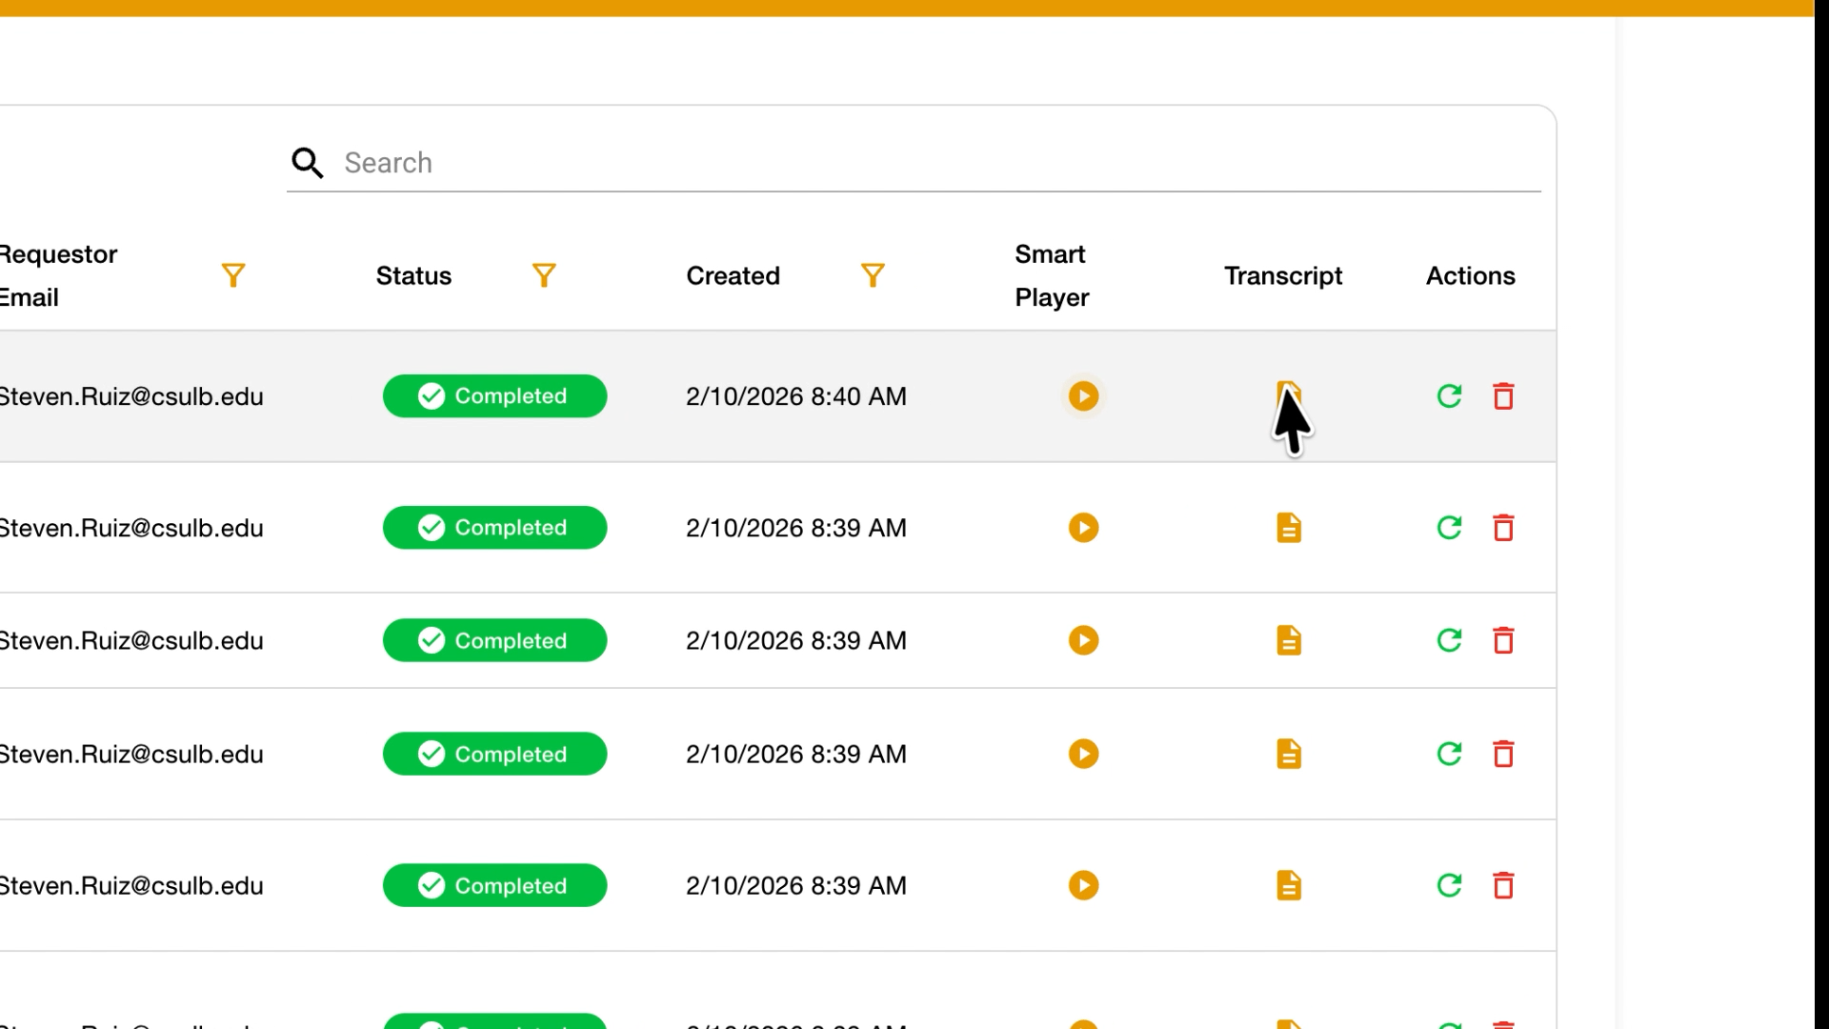
The SRT file will be downloaded to your computer. Please do not make any edits to the file.
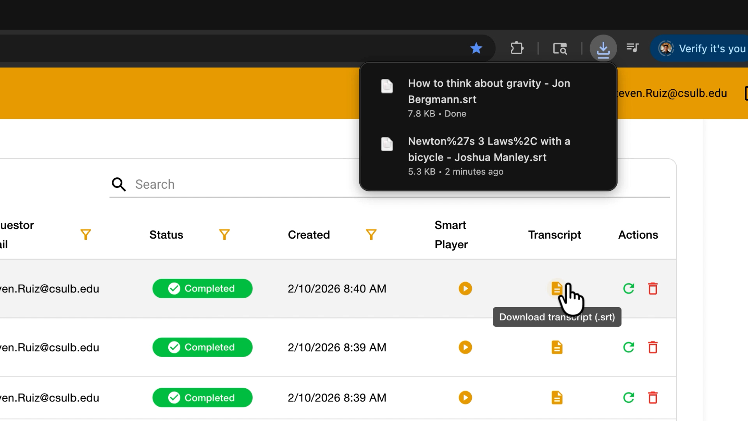

Using a SRT File in Kaltura
- Go to your ‘My Media’ in Kaltura and find the video you made the SRT file for and select the ‘pencil’ edit icon
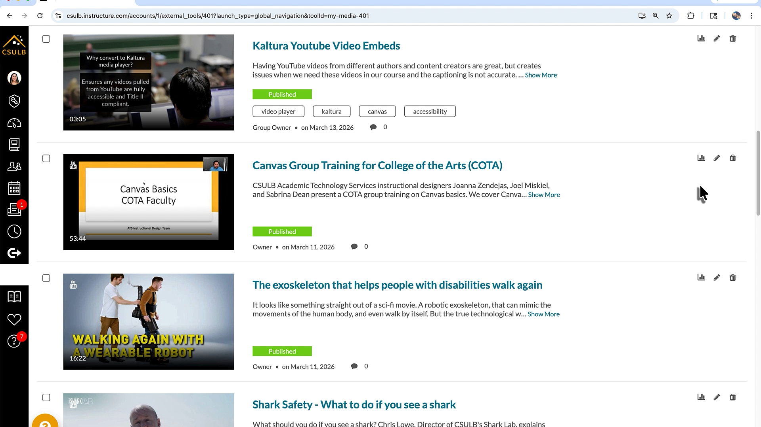
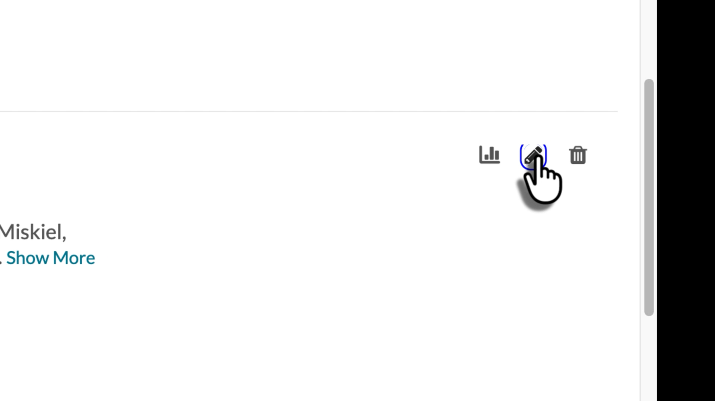
- Select the ‘Captions’ tab
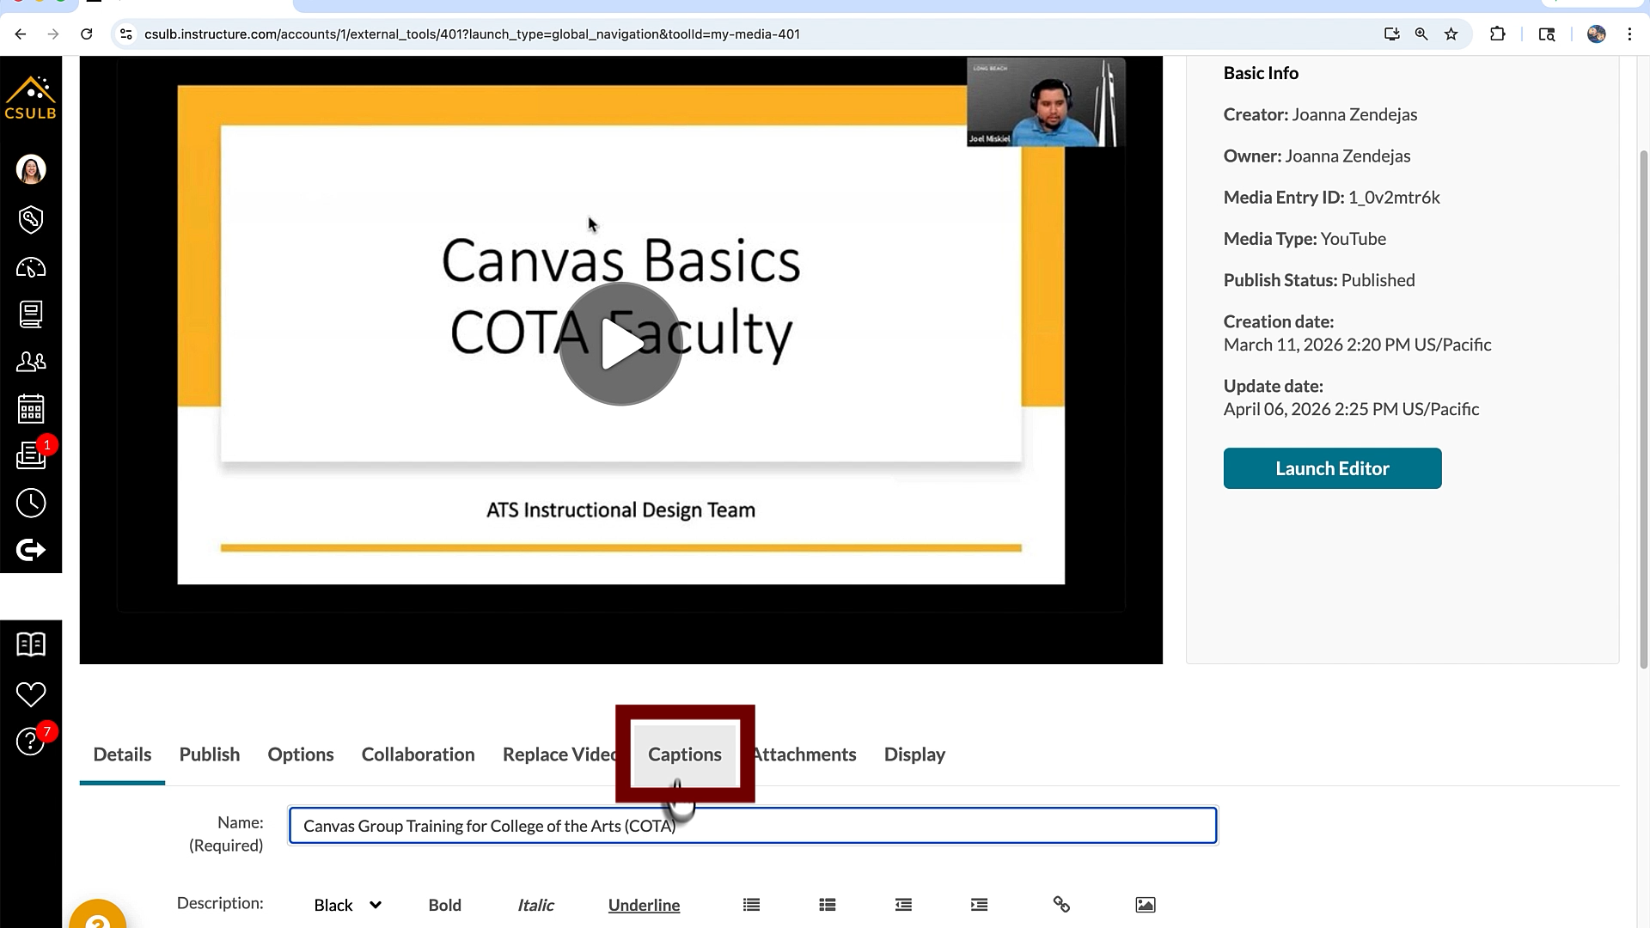
- Select ‘Upload captions file’
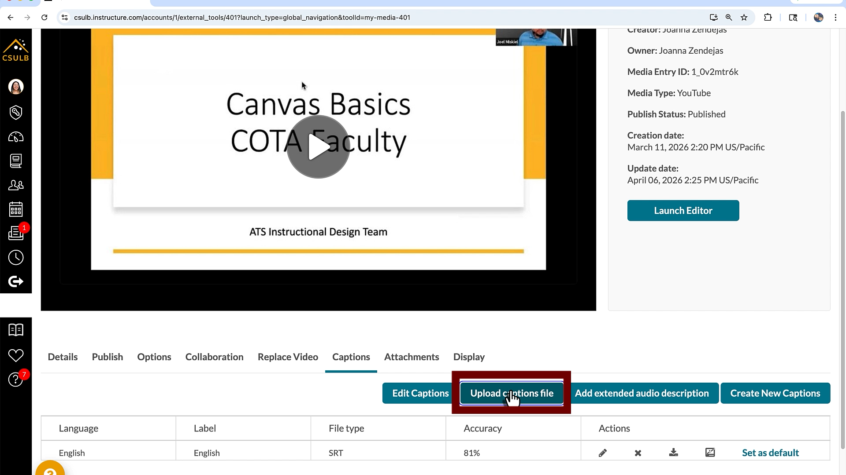
- Select the ‘Browse’ button and upload the SRT file from your computer
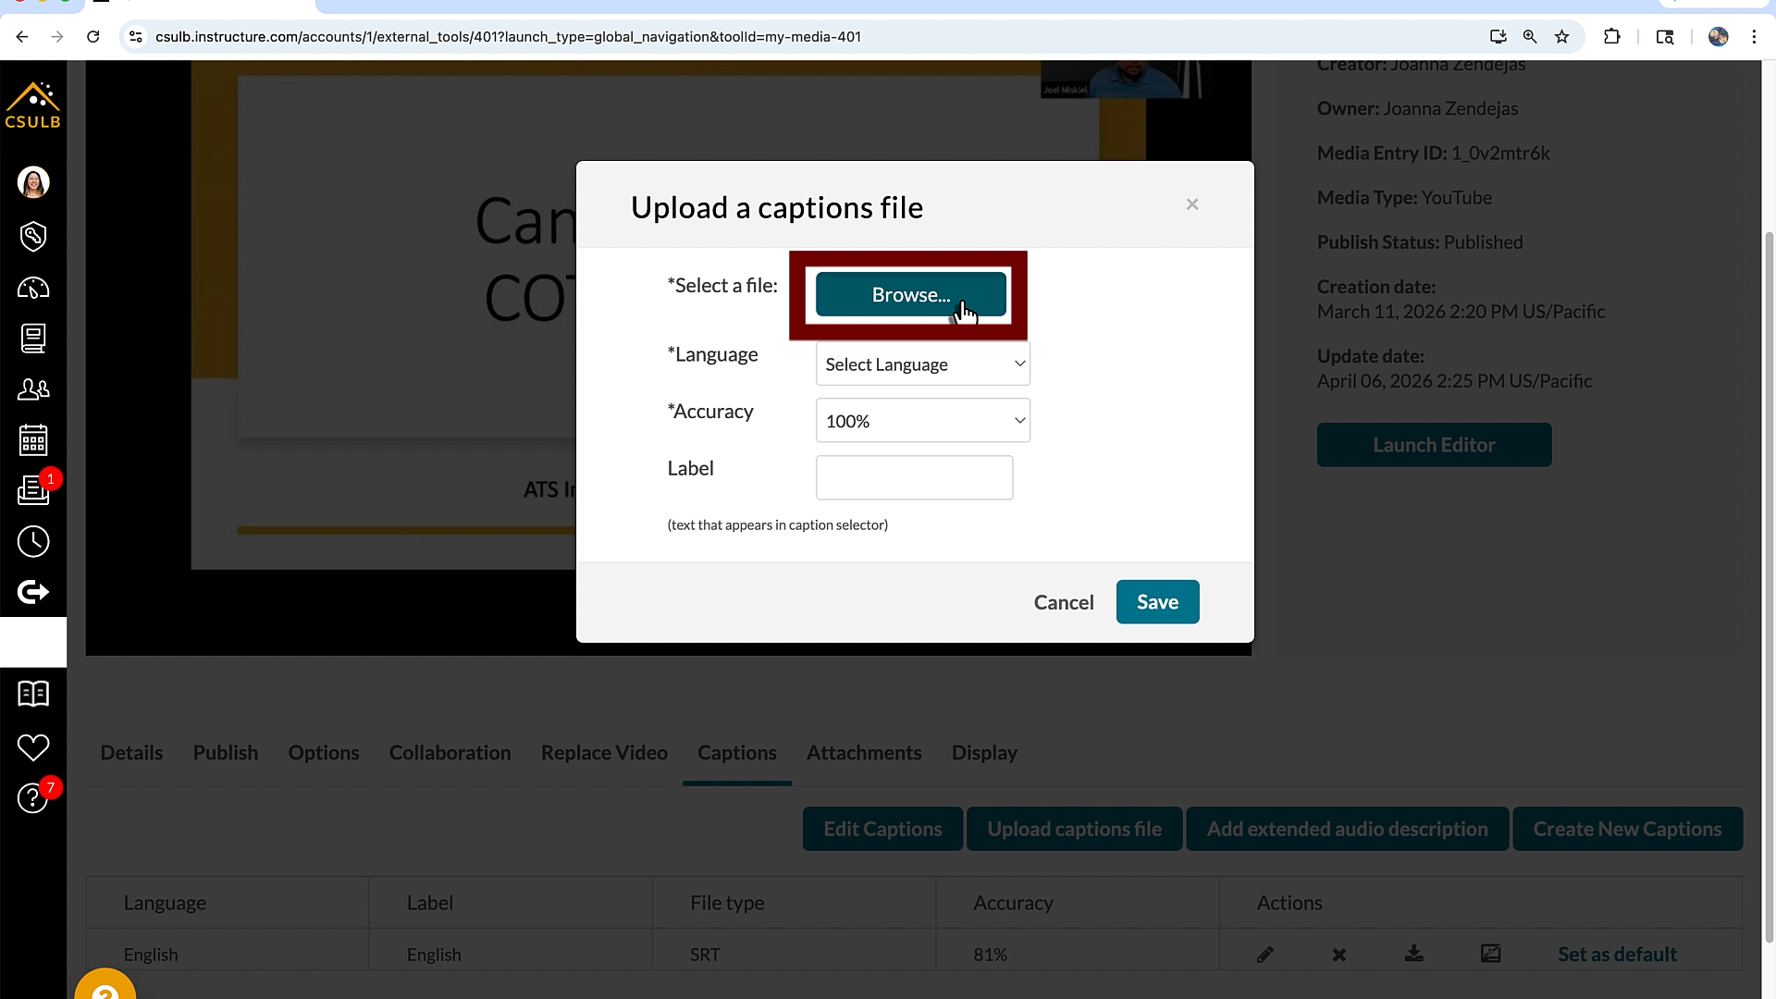
- Change the language to the language the captions are in, typically, English
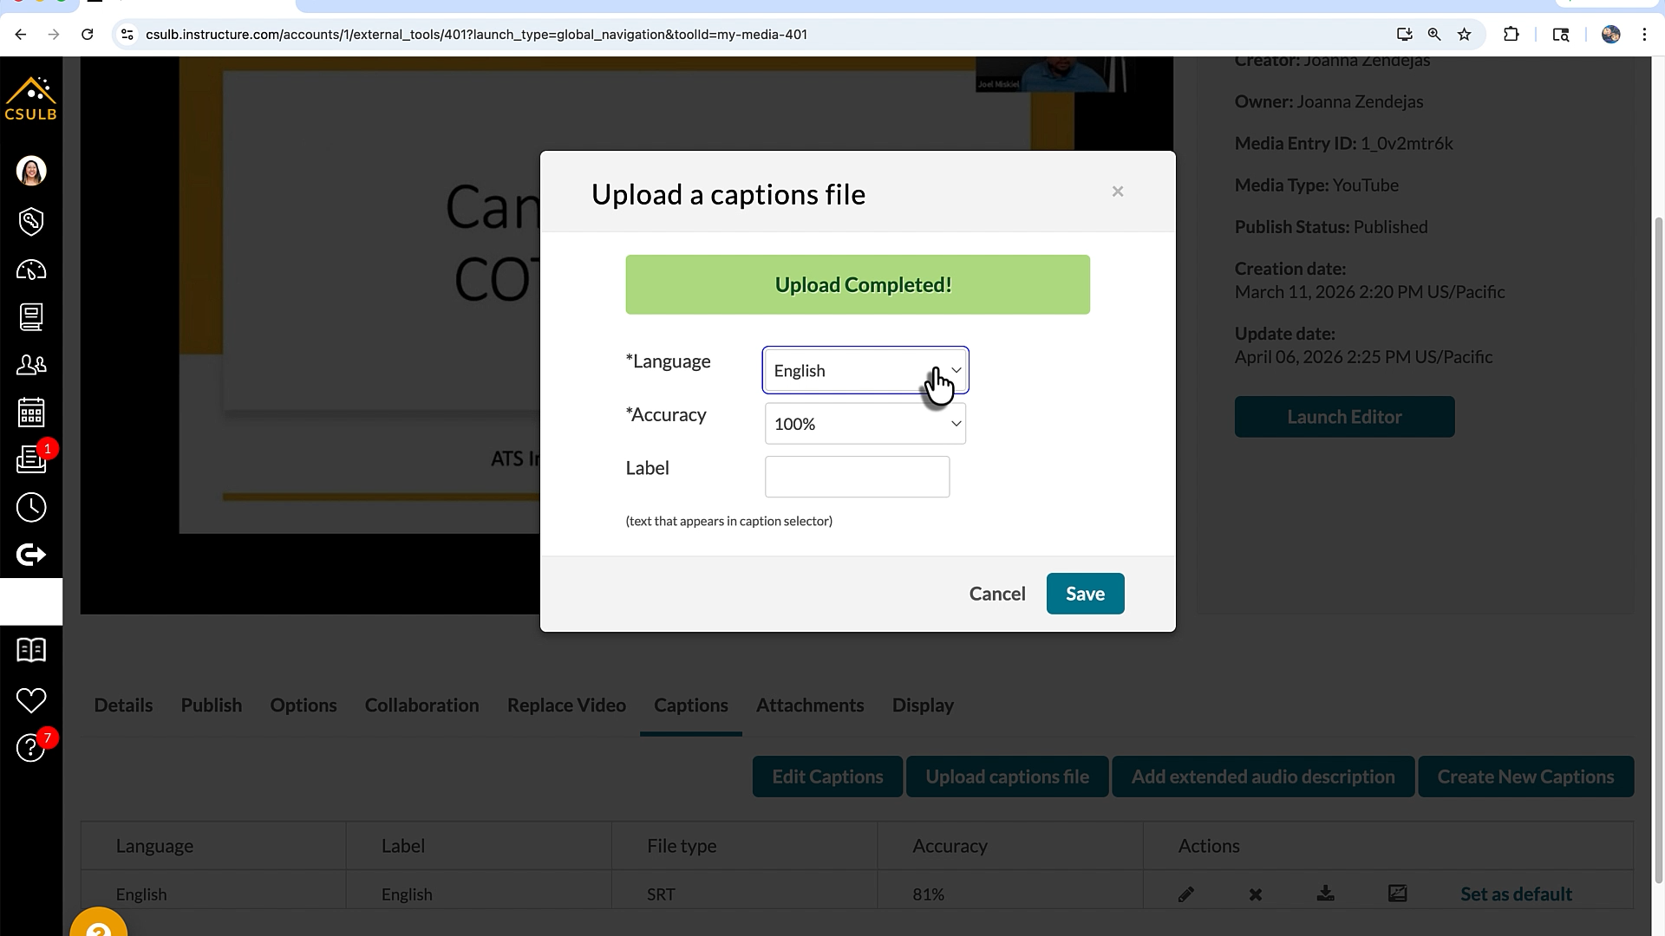
- Since the captions may not be 100% accurate set the captioning accuracy to 85% (You can change the accuracy after editing the captions)
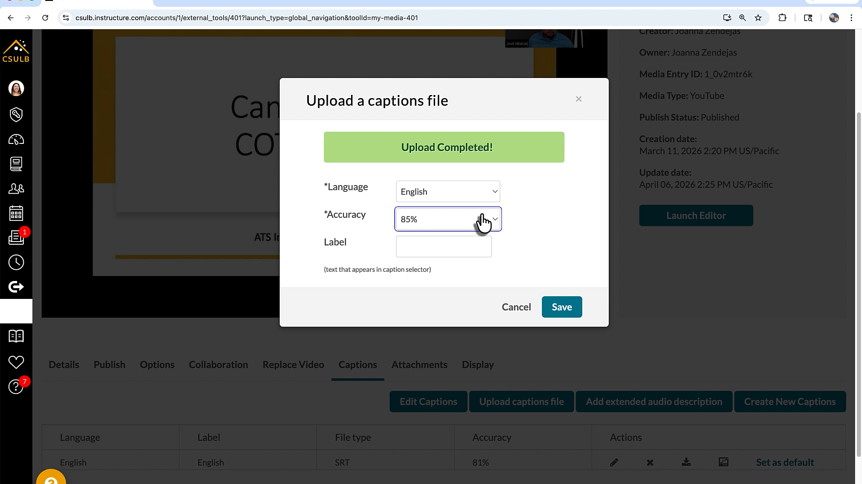
- Label the captions ‘Beach Captions’ so you know the captions are from BeachCaptions
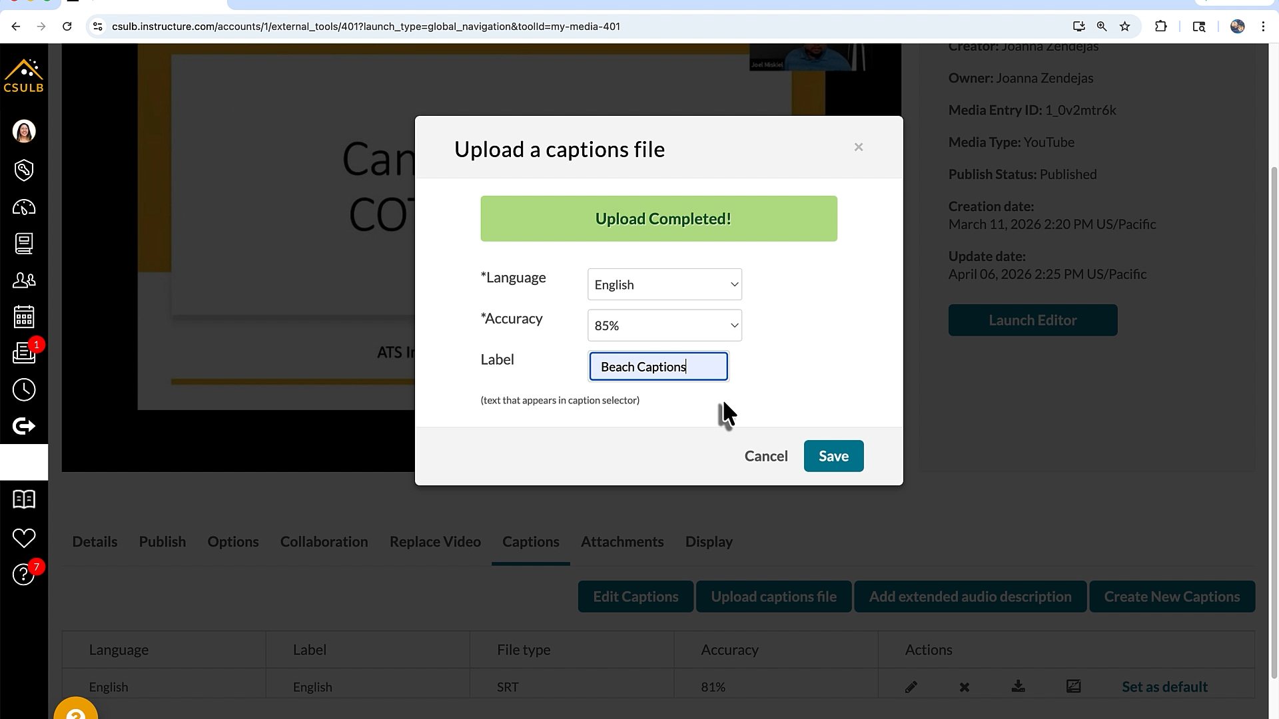
- Select the blue ‘Save’ button to save the changes
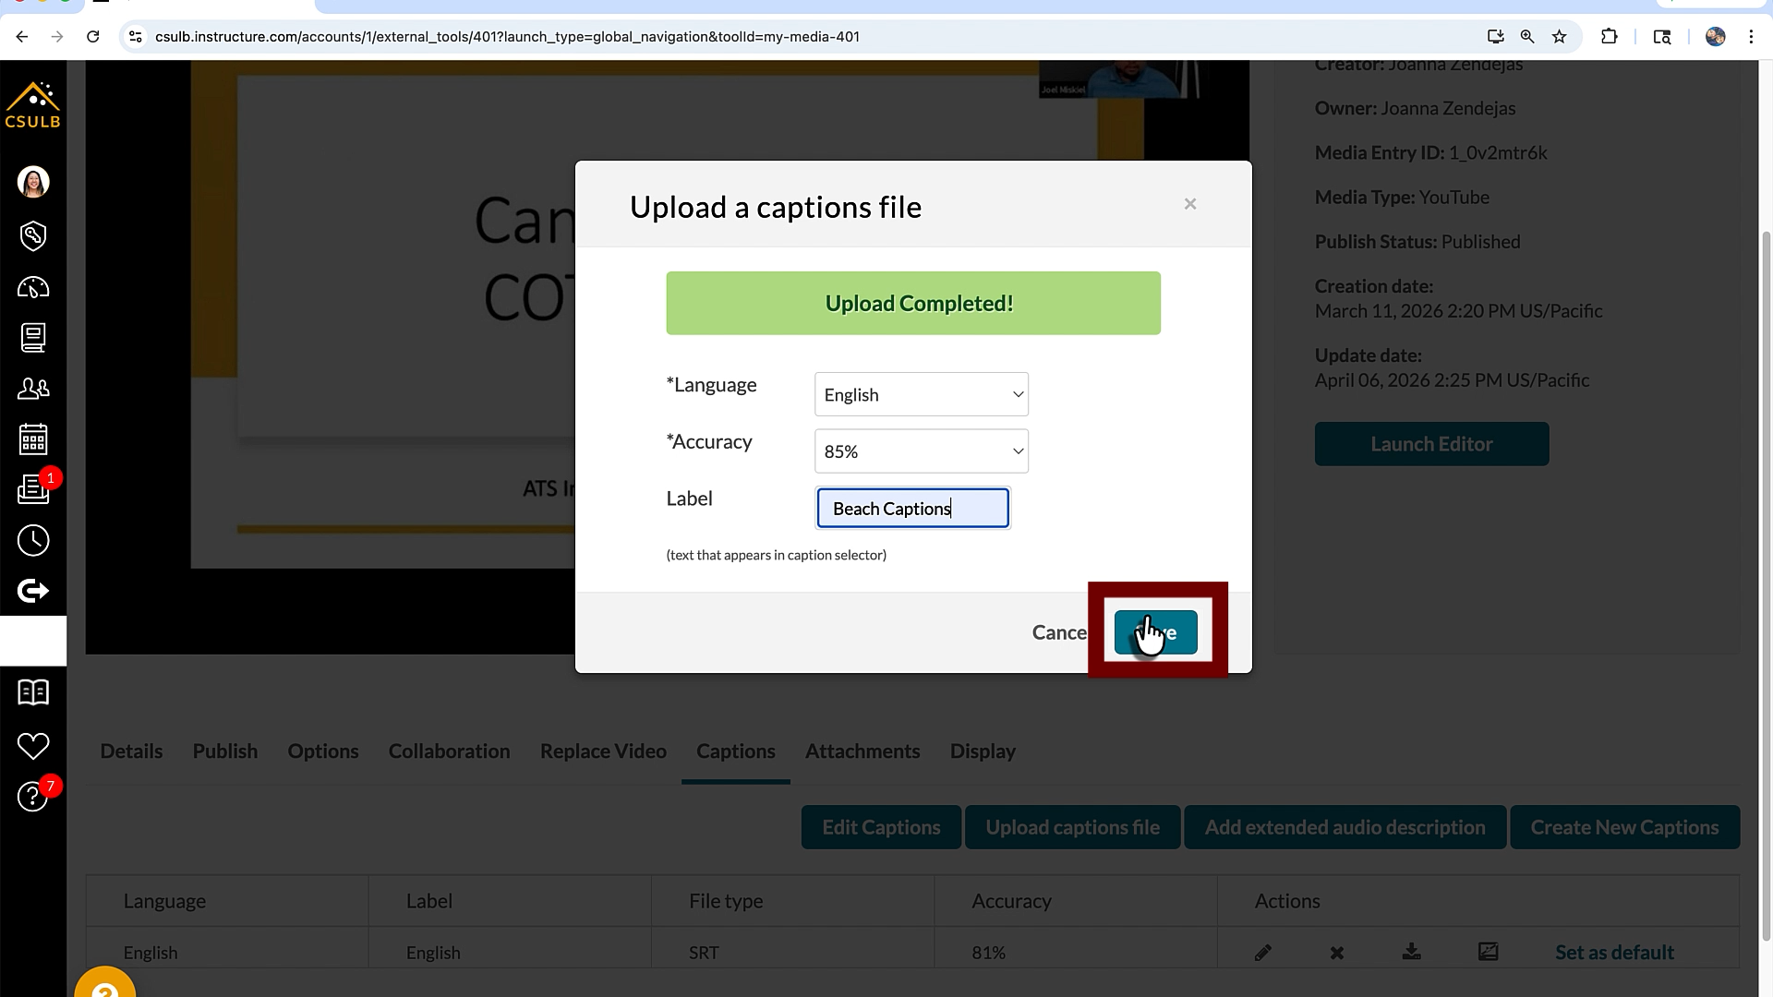
- Set the Beach Captions as the default by selecting the ‘Set as default’ button next to the correct captions
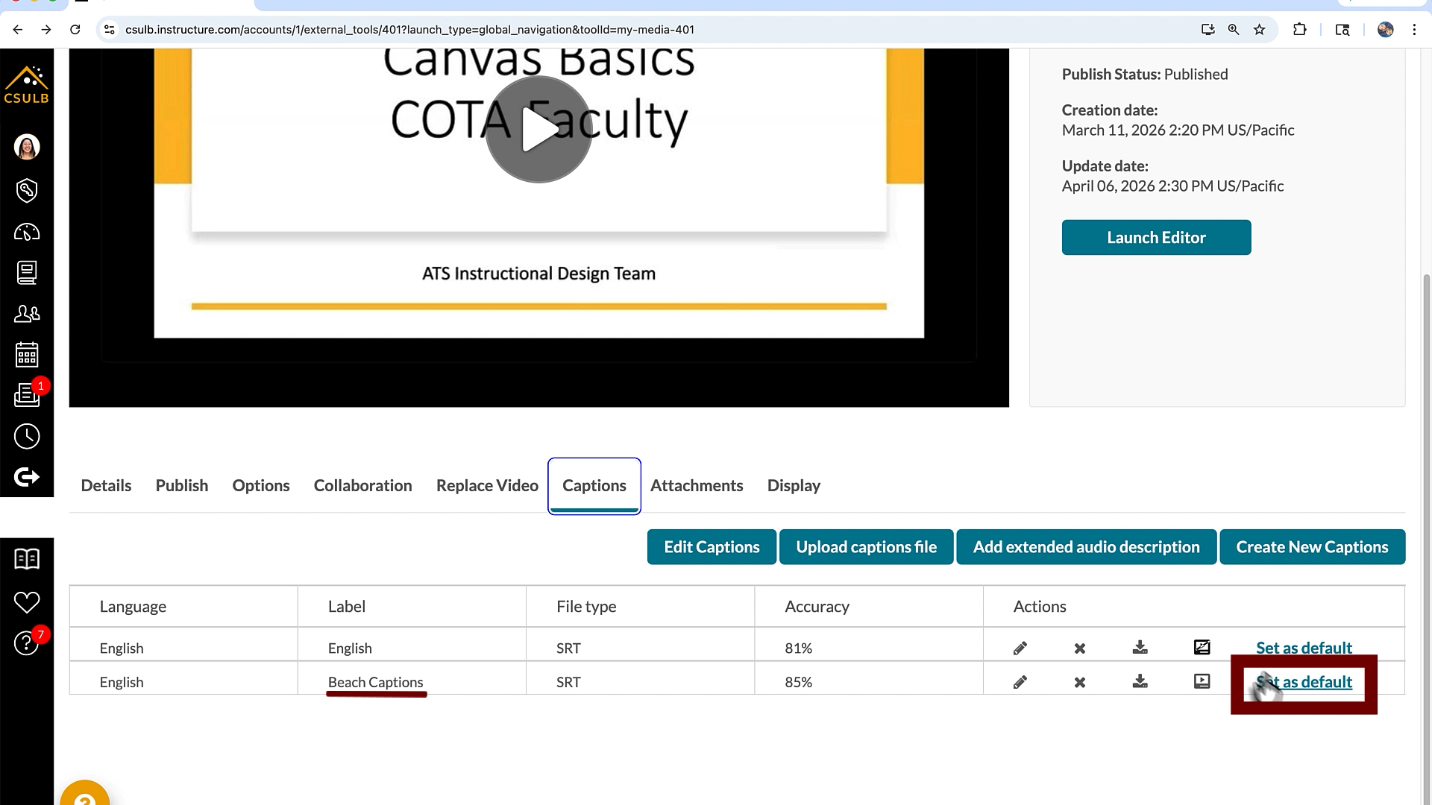
- Select the ‘Edit Captions’ button
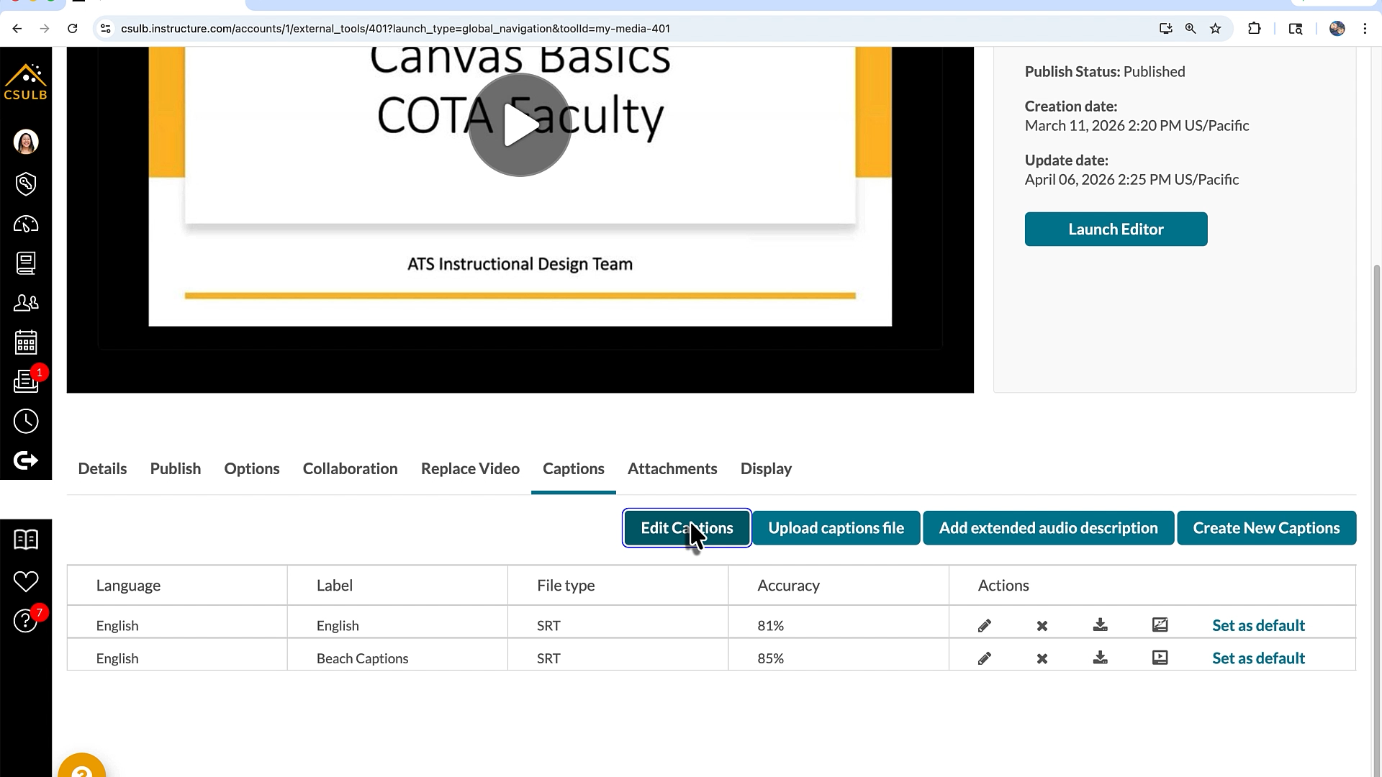
- In the caption editor make sure you are editing the Beach Caption captions
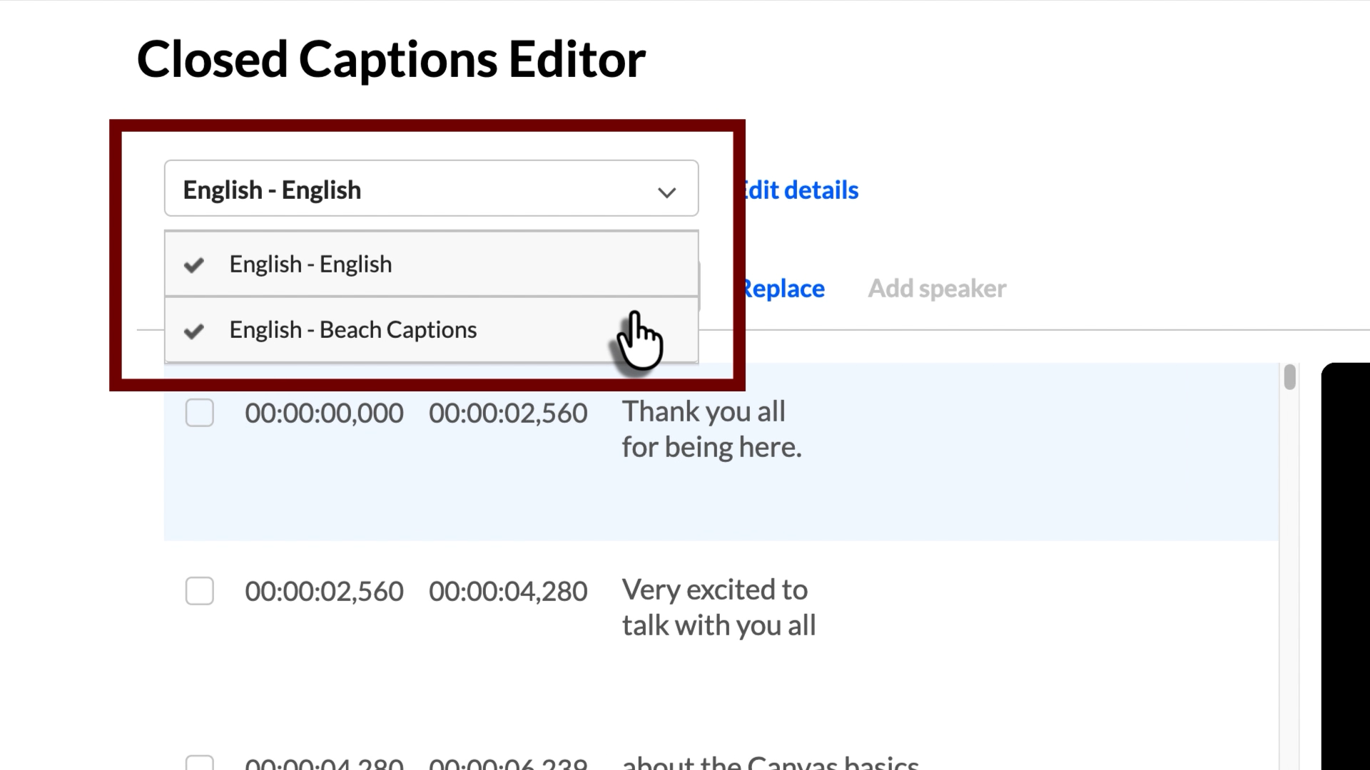
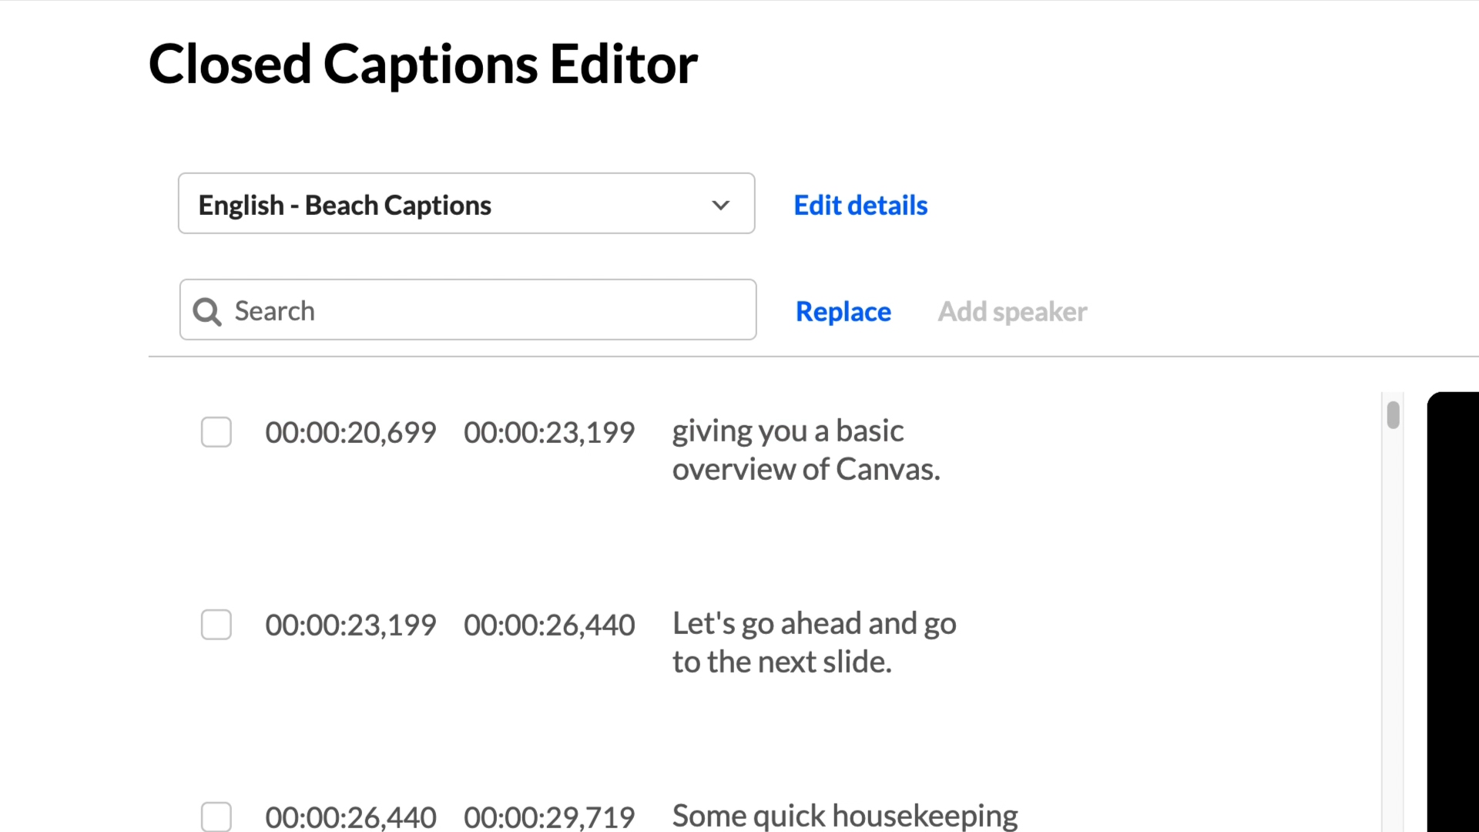
- Proceed editing the captions as needed as shown in our editing caption guide
- It is recommended to delete unused caption files in the ‘Captions’ tab to prevent confusion in the ‘CC’ icon in the video player.
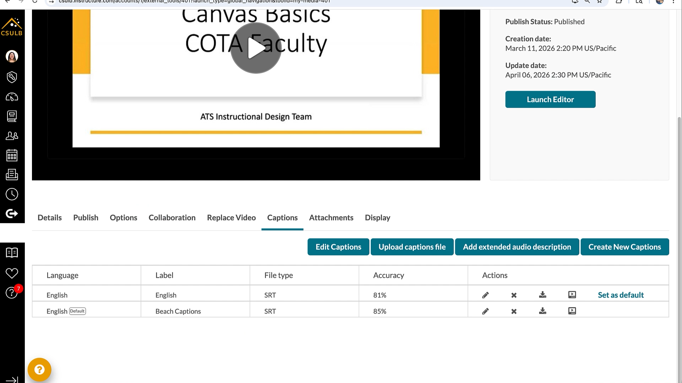
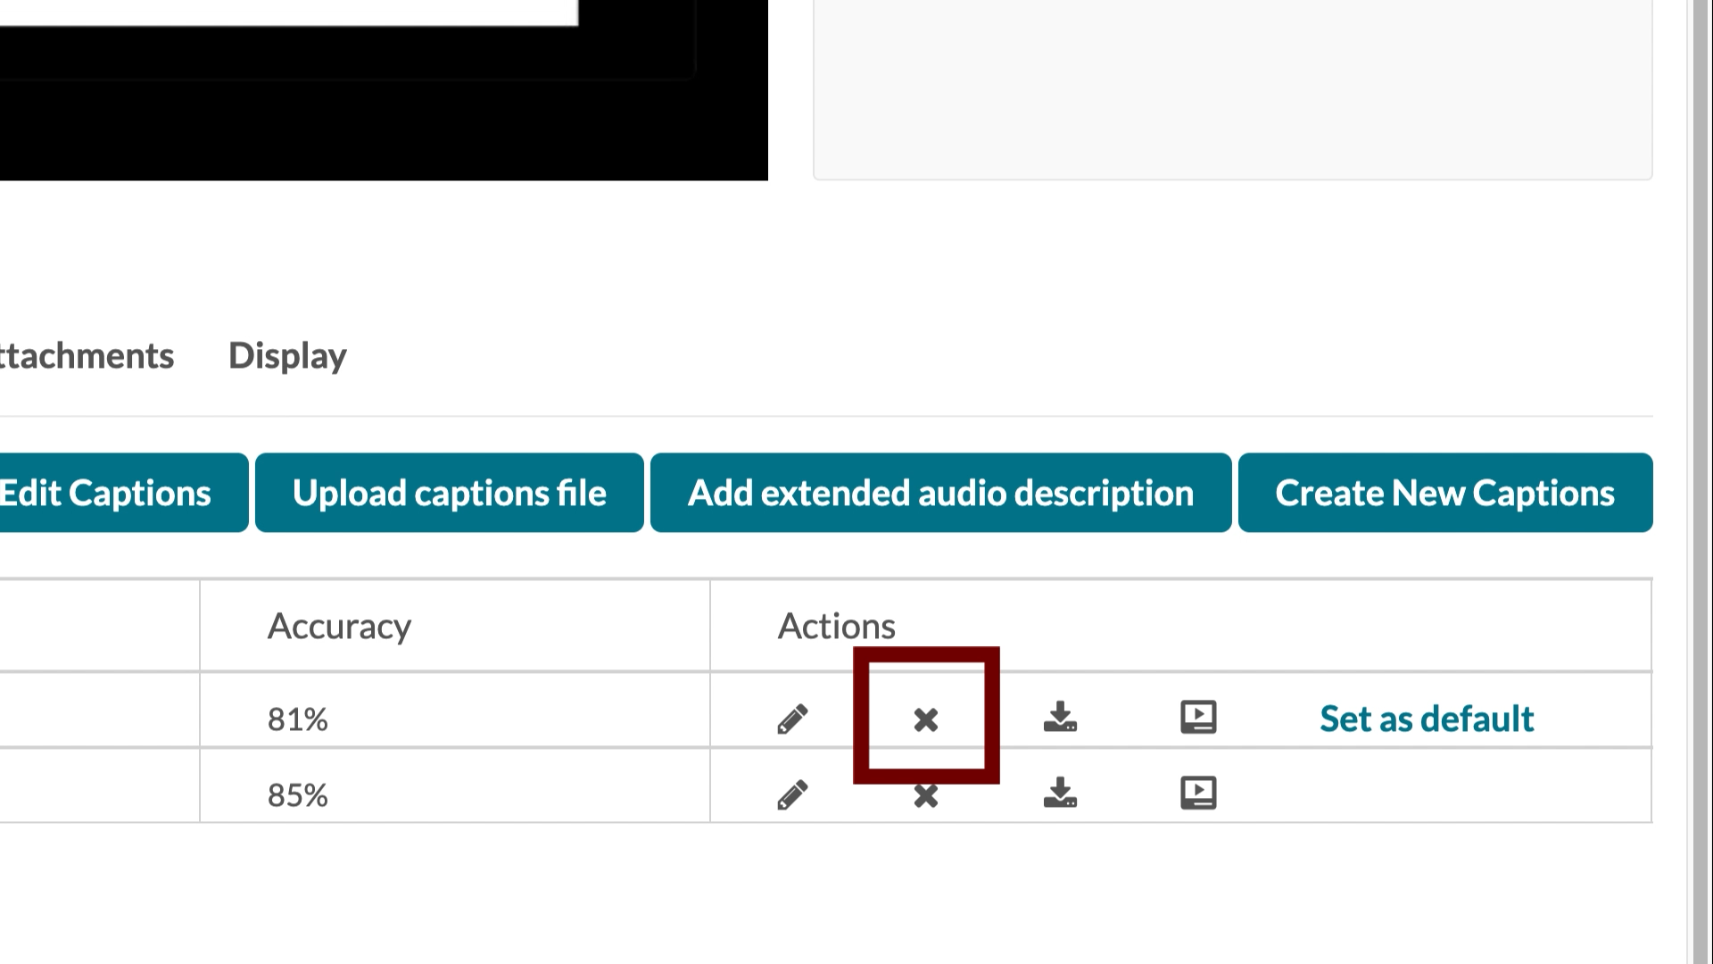
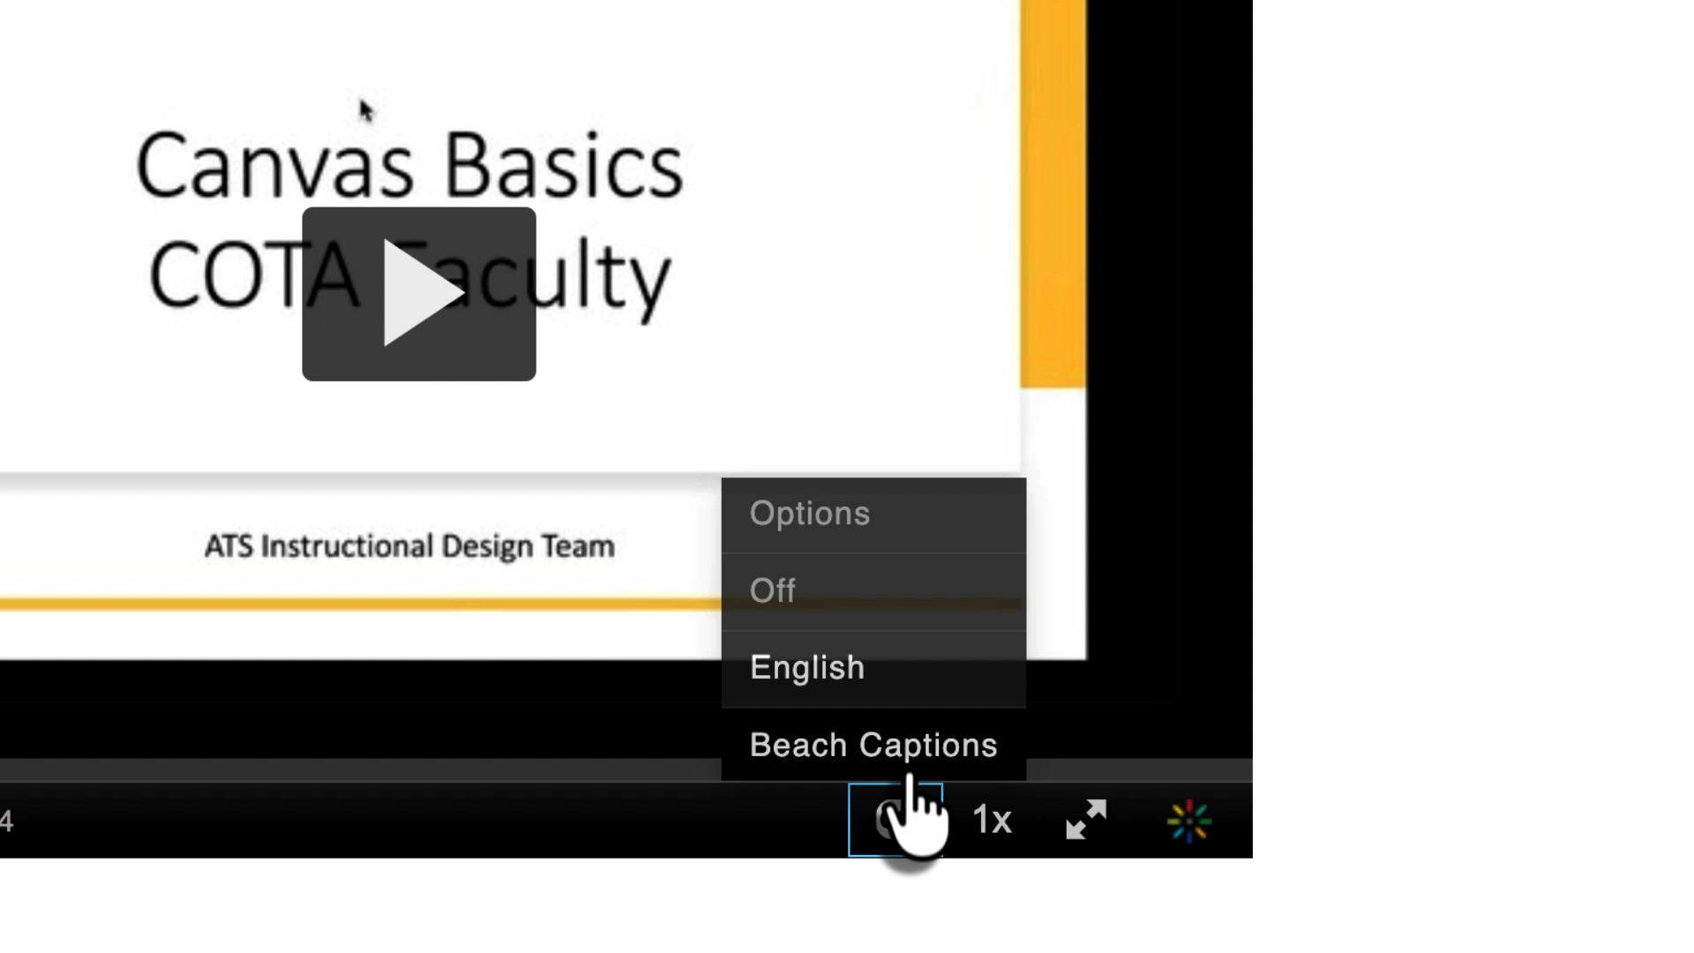
- Make sure to change the Label of your Beach Captions to English or the language it is captioned for by selecting the pencil icon to the right of the captions. The language label will ensure users can select the correct option the video player
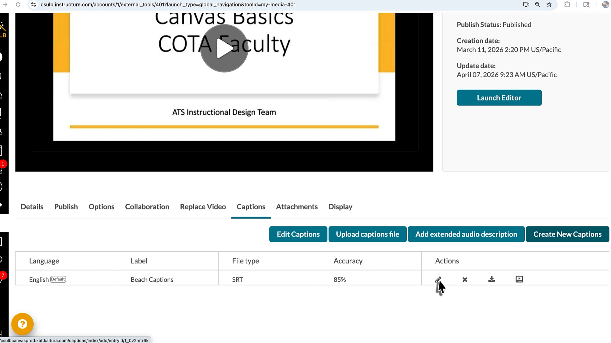
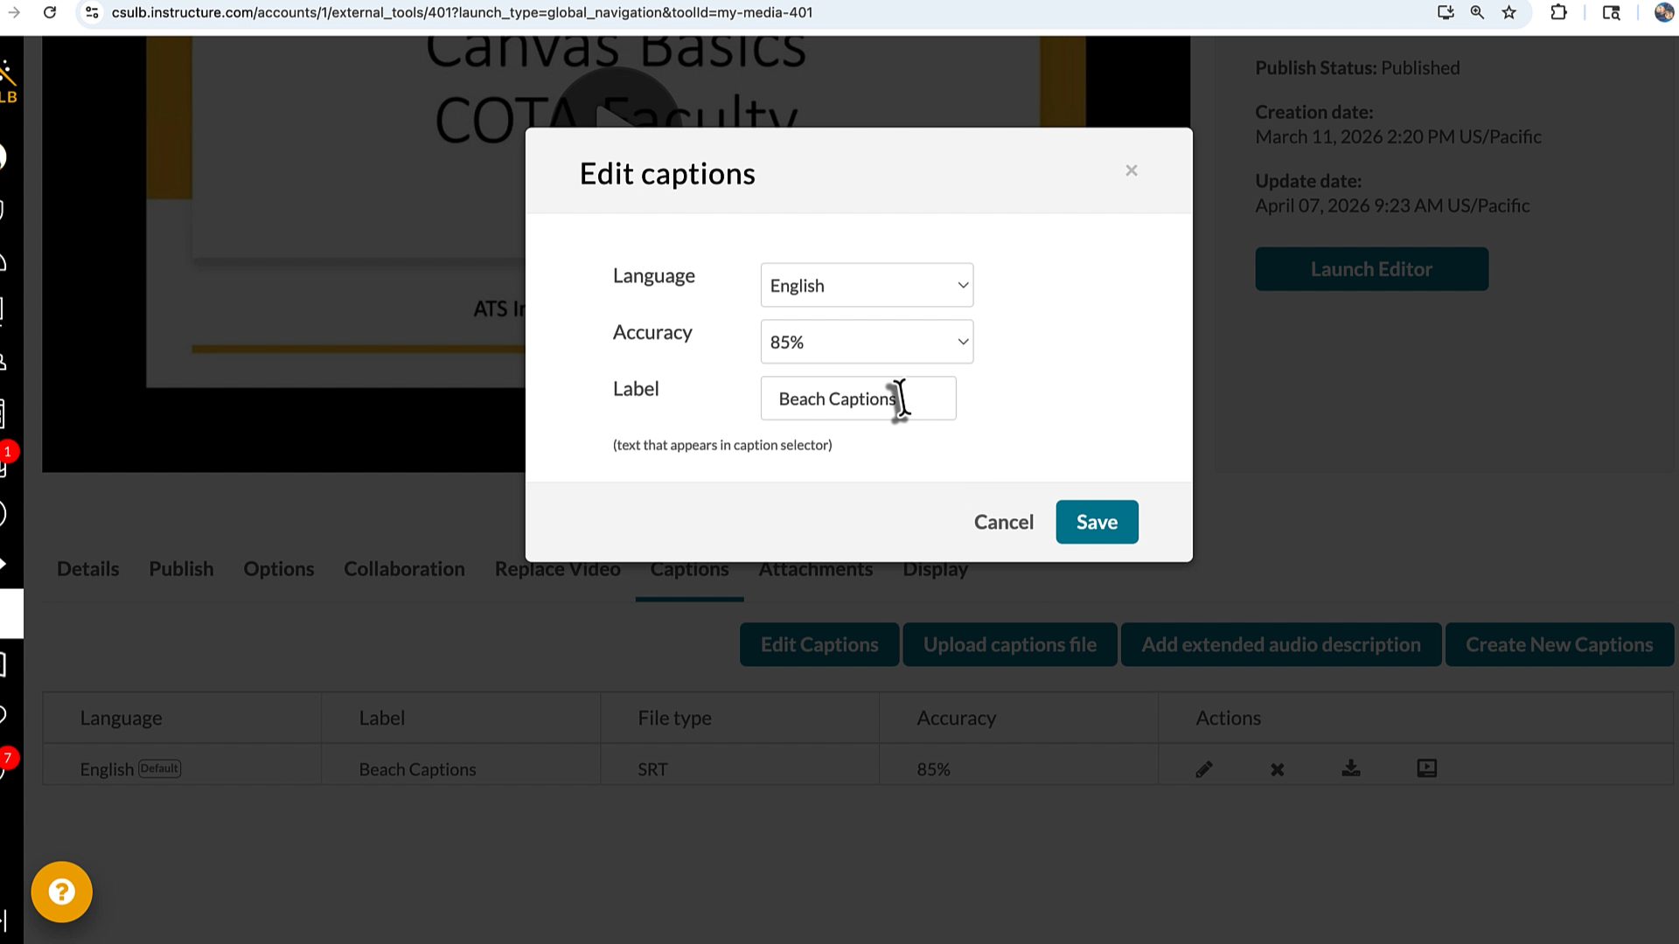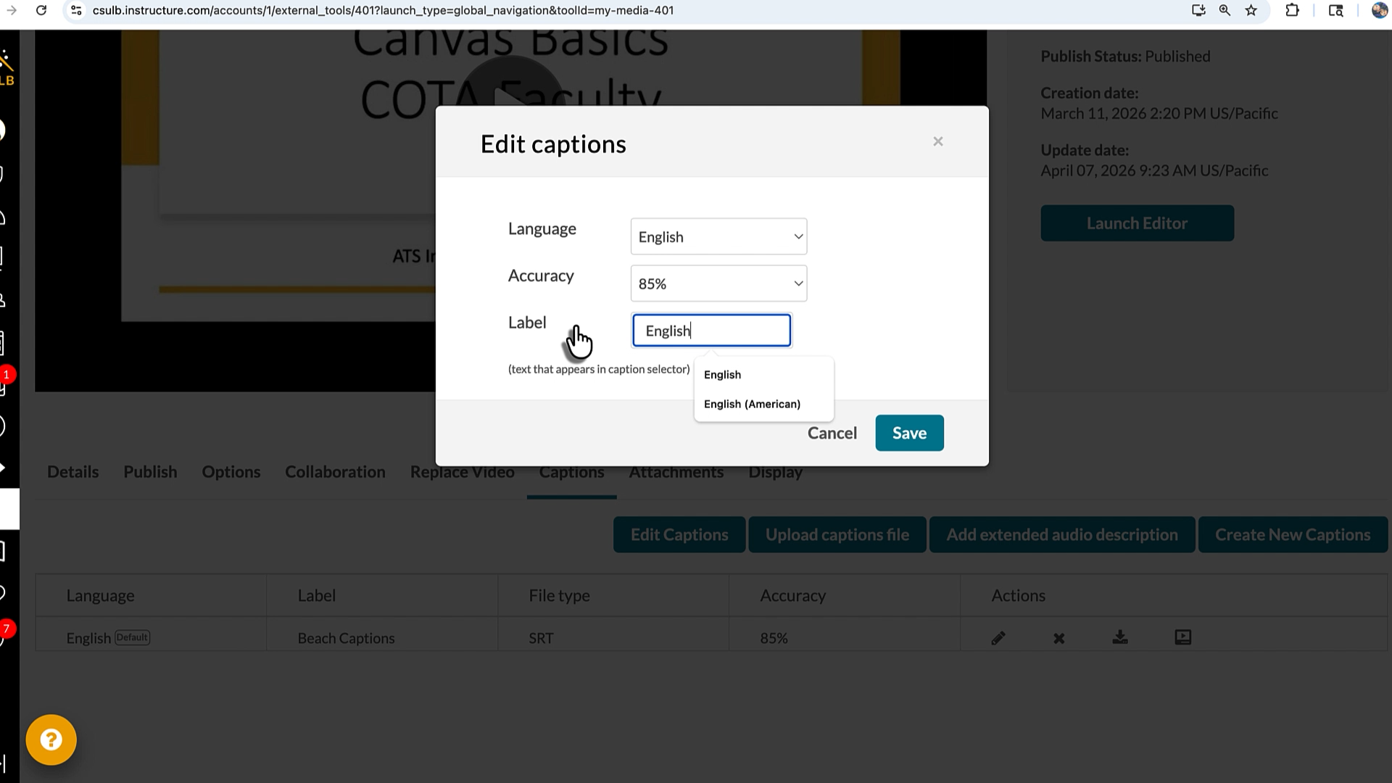

Instructional Design Help
Our team of instructional designers are available to assist you with your Kaltura and caption needs if you run into issues with these steps.
To connect with an instructional designer, please email us with your issue at AST-ID@csulb.edu.

