Quick Start Checklist
Use this checklist alongside the UDOIT training videos to efficiently clean and organize your Canvas course.

☐ Welcome Page
Access UDOIT from your Canvas course navigation; the following welcome page will appear for users who have accessed UDOIT in a course for the first time.

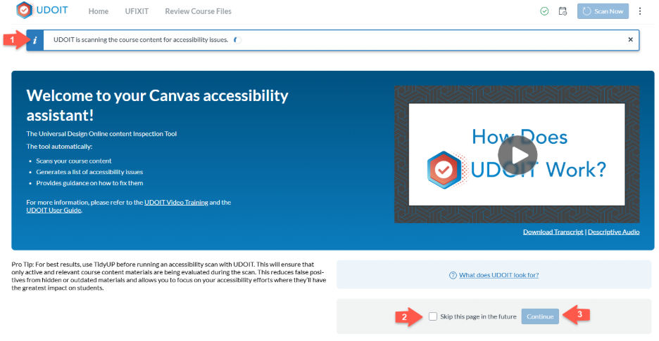
- Wait for UDOIT to scan your course for accessibility.
- Make sure to check the "Skip this page in the future” box
- Click Continue.
You will be guided to the UDOIT main Score page

☐ Understanding Your Score
- The Accessibility Score: It is a percentage grade (from 0% to 100%) reflecting how accessible your Canvas course is to students with disabilities. A higher score means your course content is more accessible.

- The Scorecard: This interactive scorecard provides an overall accessibility score for a Canvas course and highlights specific areas. UDOIT checks your Canvas content and files for several accessibility issues, and assigns them varying severity levels behind the scenes, based on their impact on users.
Based on severity of the accessibility issues, they are sorted into three Impact Categories:
- High
- Medium
- Low

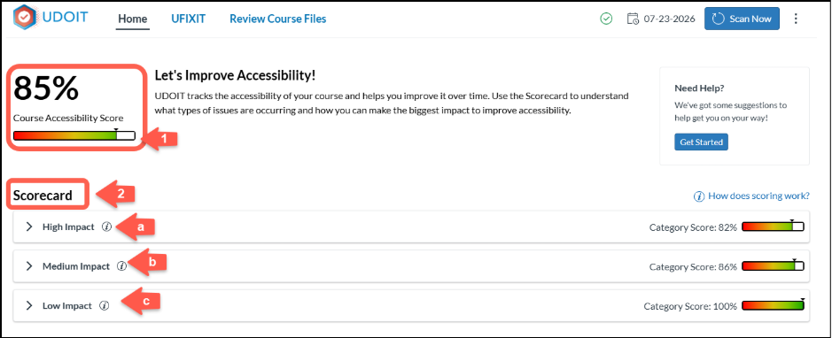

Each Impact category, High, Medium and Low is consisted of the following elements:
- Category Score: Reflects how effectively a Canvas course complies with accessibility standards.
- Issue Type: Displays the different types of accessibility issues detected by UDOIT.
- Issue Count: Lists number of issue types that exist in a Canvas course.
- Score: Lists the accessibility score for each Issue type.
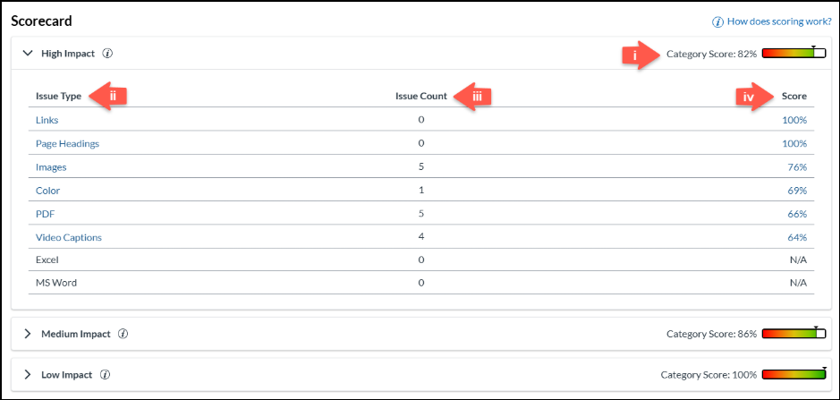

☐ Different Ways to Get Started with UDOIT
There are several ways to fix the accessibility issues detected by UDOIT. This section shows you different ways to filter and prioritize accessibility issues in your course.

- Navigate to the Need Help section of your UDOIT dashboard and click Get Started.

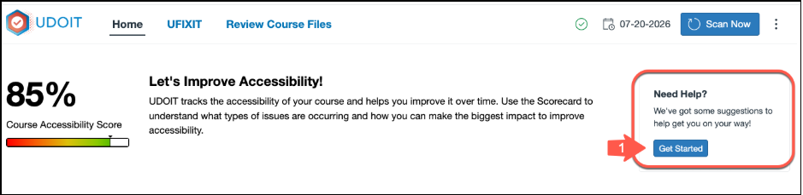

- Under Ways to Get Started, choose one of the following quick-start options:

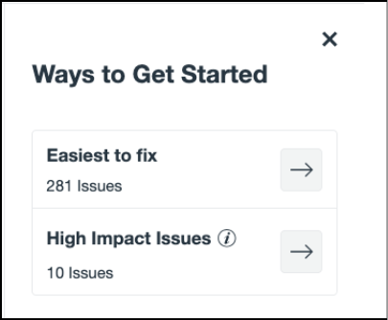

  - Easiest to Fix – Focus on issues that are typically quick to resolve, such as:
    - Missing alternative (alt) text for images
    - Non-descriptive link text
    - Skipped heading levels
    - Other simple accessibility fixes
  - High-Impact Issues – Prioritize issues that have the greatest impact on accessibility, including:
    - Links
    - Page headings
    - Images
    - Color contrast
    - PDFs
    - Video captions
    - Microsoft Word documents

- You can also use UDOIT's filtering options to fix accessibility issues by issue type, impact, or content type.

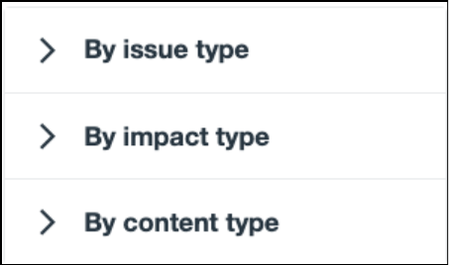

- By issue type - This filter allows you to prioritize specific types of accessibility issues, such as: color, embedded media, images, links, or more.

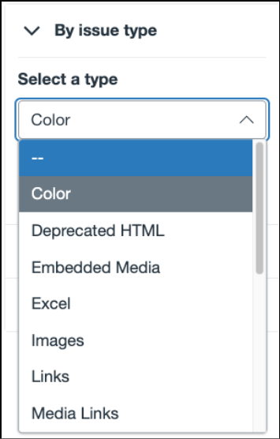

- By impact type - This filter allows you to prioritize issues based on the type of accessibility impact, including: visual, auditory, cognitive, or motor.
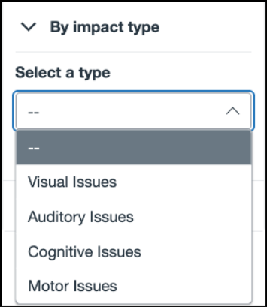

- By content type - this filter enables you to select whichever type of content you want to fix in your course, including: announcements, assignments, discussions, quizzes, pages, or syllabus.
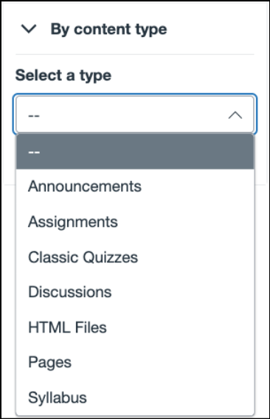

☐ UFIXIT
Whether you select Easiest to Fix, High Impact Issues, or any other filter, you will be taken to the UFIXIT Dashboard.
By default, the UFIXIT Dashboard displays all active accessibility issues found in your published or in-use content, along with the filter you selected. In the example below, the dashboard is filtered to show all active issues that are the easiest to fix.
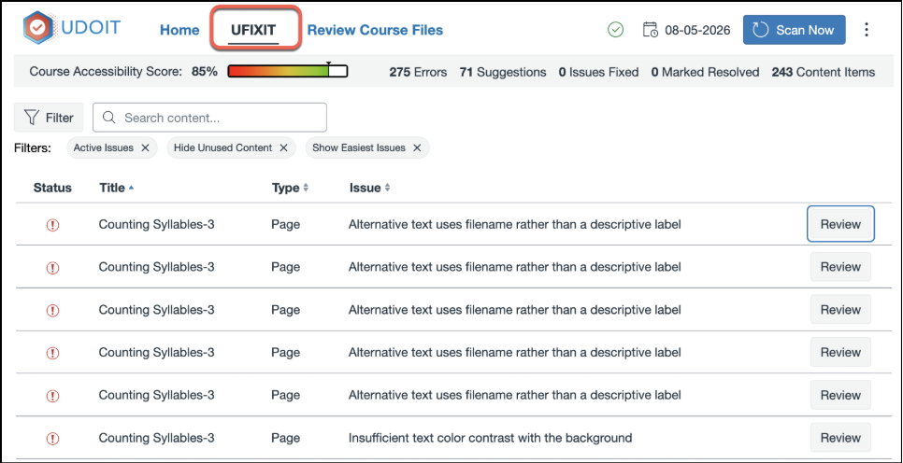

Status Guide
- 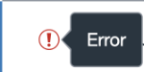 - An accessibility error that must be fixed to improve accessibility.
- 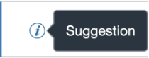 - An item that is accessible but could be improved.

☐ How to Fix Active Issues
Follow these steps to review and resolve accessibility issues from the UFIXIT Dashboard:
- Select Review next to the issue you want to address.
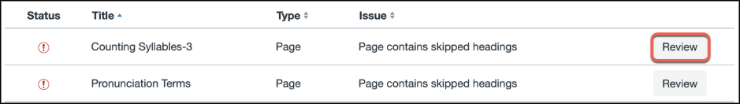
- Read the explanation to understand the accessibility concern, and then apply the recommended solution provided.
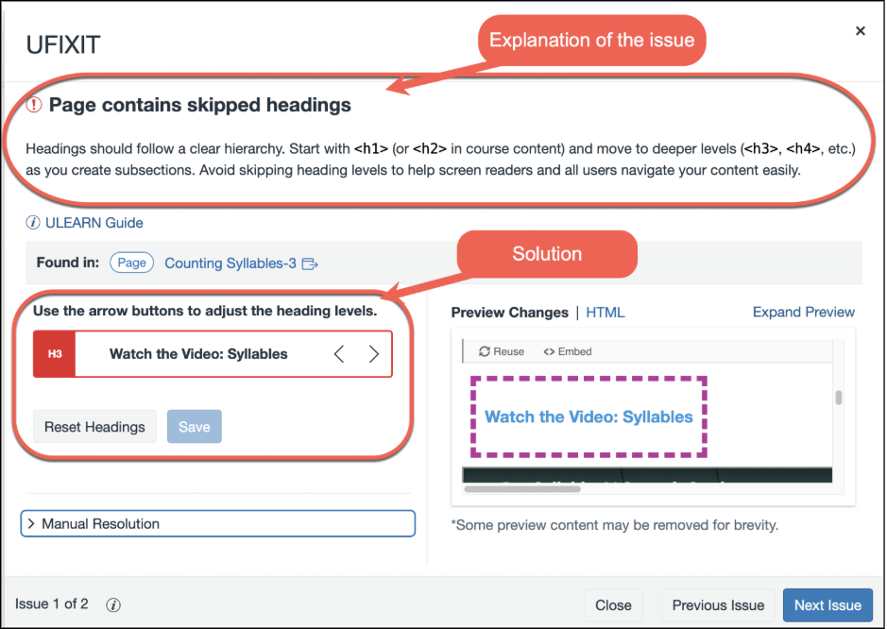

☐ Manually Resolve an Issue
If you prefer to fix the issue directly in Canvas:
- Select the hyperlinked page title. The page containing the issue will open in a new browser tab.
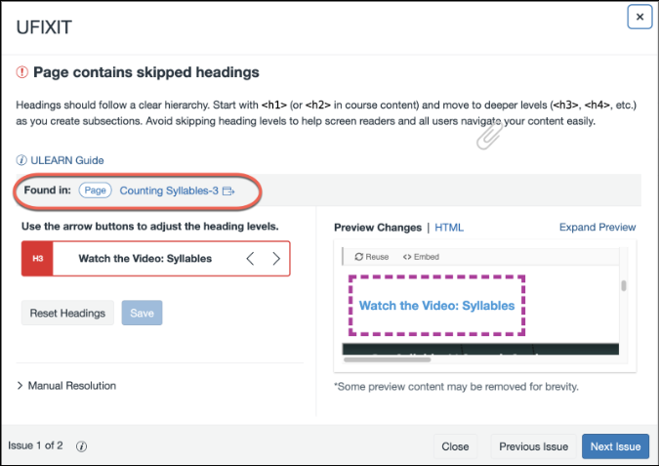

- Use the Rich Content Editor in Canvas to make the necessary accessibility corrections.
- After saving your changes, return to UFIXIT and select Scan Now to update the accessibility scan and verify that the issue has been resolved.


☐ Mark an Issue as Manually Resolved
If you review an item and determine that it is already accessible (for example, auto-generated captions are accurate), you can mark the issue as resolved without making changes.
- Select Manual Resolution
- Confirm that you have reviewed the content and determined that it meets accessibility requirements.
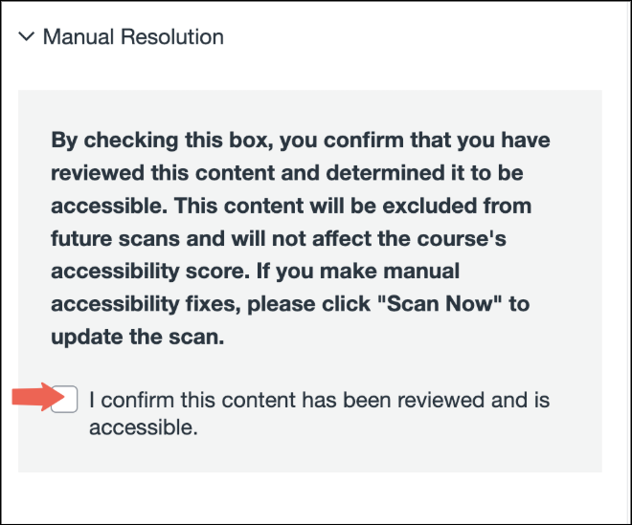

☐ ULEARN Accessibility Guide
For guidance on resolving specific issues, review the individual guides below:
- Color
- Depreciated HTML
- Embedded Media
- Images
- Links
- Media Links
- Page Headings
- Page Structure
- Styled Headings
- Table Headers
- Video Captions
- Video Connections

