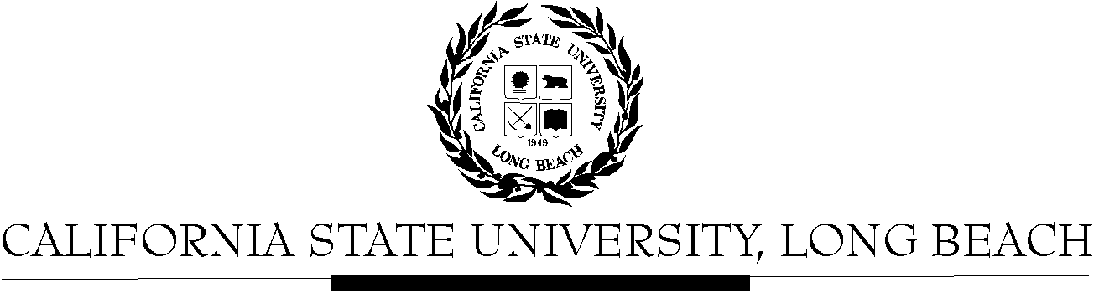

General Education Evaluation Committee
February 10, 2026
11:00am – 1:00 pm
Zoom Link for this Meeting: https://csulb.zoom.us/j/84921132427

AGENDA
- Call to Order
- Approval of Agenda
- Approval of the Minutes of January 27, 2026
- Discussion of Assessment (Sharlene)
  - Rubric Norming Example
- Recertification
  - Ann on file names and organization
  - Assignments for Further Review
    - Anthropology (9)
    - Dance (8)
    - Design (2)
  - Approvals and Second Rounds
    - Discussion of Norming
    - What to do next
      - Approve:
        - KIN 338 (minor rev), ENGL 206, CWL 220, CHLS 101, ITAL 345, GEOG 130, ENGL 250B, CWL 161, CWL 412, CHLS 411,
KIN 156, ENGL 250A, GEOG 355, KIN 157, PHIL 204, PHIL 156, GEOG 319, PHIL 402 (mr), CHLS 105, CWL 225, PHIL 101 (mr), GEOG 304, HDEV 180
      - Request for Second Review
        - CHLS 350, CLSC 300, ENGL 386, ENG 205, LAT 101A, GEOG 306

      - Post Second Review
        - Mismatch
          - CRJU 101 – Seung-Joon & Nathan
          - GEOG 301 – Zak & Yada
          - GEOG 140 – Mortaza & Josh
          - NRSG 402 – Kerry & Ava
        - Back to Department
          - BLAW 400 – Danny & Ann
          - ECON 300 – Zak & Josh
- Adjourn

  - Submitted Recertification Forms
    - HSC 210 & HSC 425 (Danny) – Yes, Yes with revisions
    - GEOG 140 & ECON 300 (Josh) -
    - LING 472 & HSC 407 (Charles) – Yes & No
    - IS 100 & HSC 423 (Babs) – Yes & Yes
    - NRSG 402 (Kerry) – No & No
    - CRJU 325 & ECON 306 (Ava) – No & No
    - GEOG 354 & EMER 301 (Swarna) – Yes & Yes
    - BLAW 400 & GERN 200 (Ann) - No & Yes (1 syllabus)
    - GERN 401 & HSC 250 (Yada) – Yes & No
- LING 329 & GEOG 301 (Zak) – Yes & No
- NRSG 450 & GEOG 101 (Mortaza)
- CRJU 101 & LING 101 (Seung-hoon) – No & No
- LS 111 & MGMT 425 (Sharlene) – Yes & Yes
- (David) - No

