Quick Start Guide

Purpose
Content on your Canvas pages provides your audience with vasts amounts of information that have various relationships with each other. Headings are a tool that provides structure to your content that shows the relationships of your different sections of content. Headers are essential for audience members that utilize screen readers because headers help the screen reading tool show the relationship of the content the audience needs to consume. Through using headers, you create an organized content page that is easily digestible by your audience.

What Are Headings
Headings are a hierarchal structure that make a piece of text the title or ‘head’ of the content that is below it until the next header of the same level. Headers range from heading 1 through as many heading levels are needed, commonly up to heading 6. You may have experience heading structure through reading academic research papers or even chapter books. Chapter books are a great example of how the heading structure works. Below is an example of a chapter book with its associated heading level.

Chapter Book Heading:
- Book Title | Heading 1
  - Chapter 1 | Heading 2
    - Sub Chapter 1 | Heading 3
    - Sub Chapter 2 | Heading 3
  - Chapter 2 | Heading 2

How To Use Headings
Unlike chapter books, your content will have material where a chapter title will not provide the audience with enough context of the upcoming content. In Canvas you want to use your headings to describe what the audience will be reading about. Canvas automatically uses Heading 1 for a page’s title, so your page title should describe in total what your content will be about. For example, a helpful page title can be Lesson 1 | Regions of the Brain. That descriptive title informs the audience of what will be the content of the page. From there you can create heading levels lower than heading 1 like having a header 2 that is labeled The Cerebellum, with the content under that talking about that specific brain region. If you have a specific section of content that talks about a specific part of the cerebellum then you can move up to heading 3 for that content. You can ultimately think of headings like the bullet points of an outline for each of your pages.

Headings In Canvas
You can uses headings in Canvas with any page that has the Rich Content Editor (RCE) available. In the RCE, you have access to heading levels 2-6, with heading level 1 automatically being taken by the title of the page.

Steps For Creating Headings
In the RCE, the text you type defaults to the ‘Paragraph’ tag.
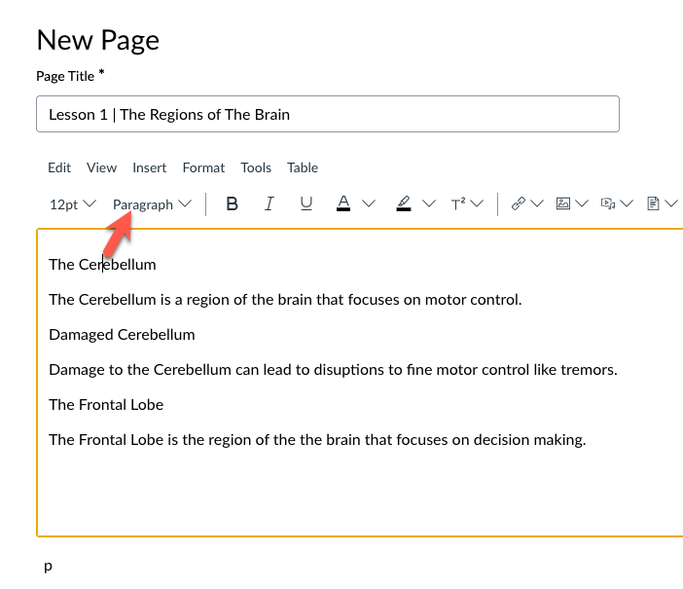
To change the text to be a header you want to select the ‘Paragraph’ part of the menu and select the header of your choice. For this example, I will have ‘The Cerebellum’ be heading 2.

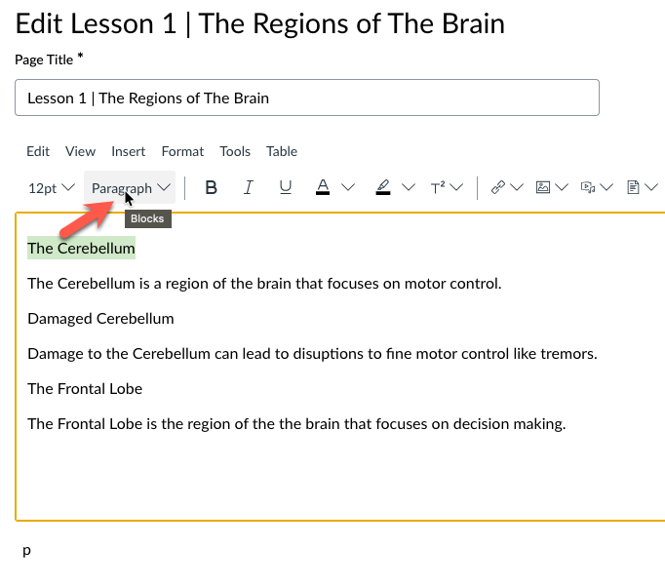
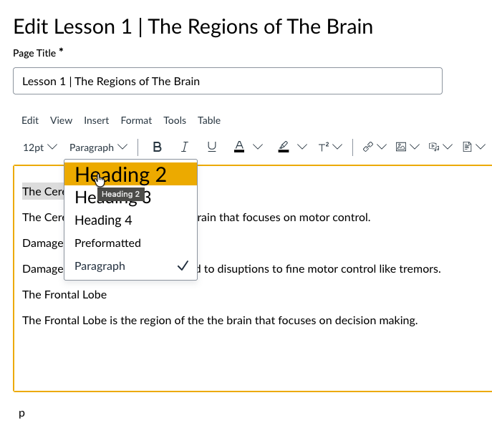
Once you select the heading type, the text you highlighted or what you begin to type will be considered tagged as that header. You can confirm if your text is tagged as a header by highlighting the text and seeing what shows up in the block menu that is next to font size or by looking at the html tag that is located at the bottom left of the RCE.
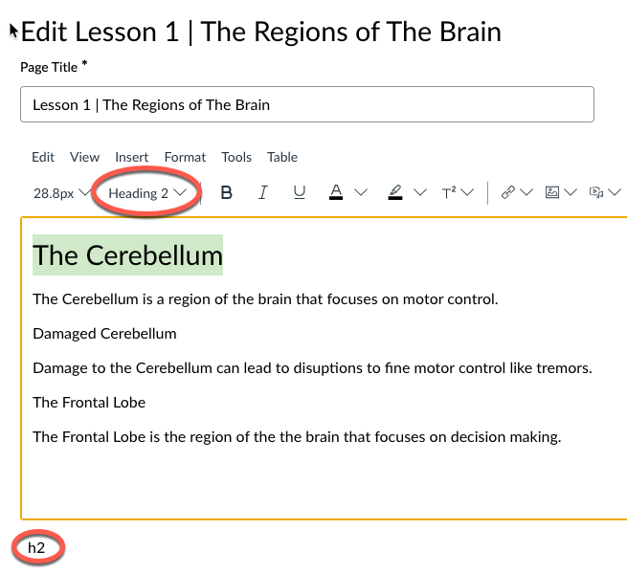
The block menu only goes up to heading 4. If you have a reason to use heading 5 or 6, you can access those heading options by selecting the Format tab and selecting the Formats menu and then the Headings menu and selecting your necessary heading from there.
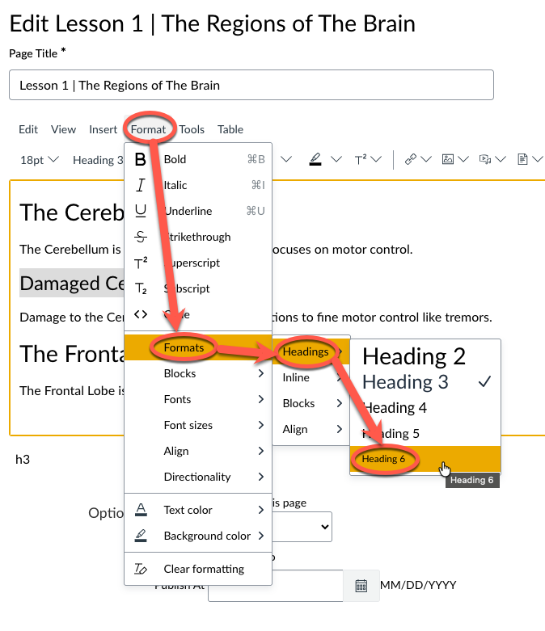
Tech Tip: Do not skip heading levels throughout your content. The content should have a consistent header flow like heading 1, heading 2, heading 3, etc. Skipping heading levels can cause confusions for users.

Images

Why it Matters
Providing alternative text (or “alt text”) for images ensures that those with visual impairments can easily understand the purpose of an image on a page or website. Screen readers will read all alternative text provided for an image, so it’s important that alternative text be understandable. Providing alternative text also makes for a more inclusive experience for all users.

What to Do
There is a simple process for ensuring that any images uploaded into Canvas are accessible with alt text. There is also an easy process for checking and retrofitting images by adding alt text to make them accessible.

Avoid
- External links on a page (to OneDrive or another cloud source)
- Module file attachment – not recommended, no alt text
- Module link (to an external file)

The methods listed above do not give you control over the alt text within Canvas, or do not display alt text and are not accessible. The best method is to “embed” an image onto a Canvas page.

Below are instructions for embedding an image onto a Canvas page and adding alt text to make the image fully accessible.

Uploading new images

First of all, images can be embedded on Canvas pages by simply copying the image file onto your “clipboard” by right clicking, and then right click/pasting the image directly on the page in edit mode. Canvas will treat this as an embedded image and allow you to edit alt text and other image attributes as described below.

The other method is to use the html editor and the image embed tool. First, create a new page in Canvas (either in Pages or on the Module page), or navigate your cursor to an existing page where you want to insert an image.

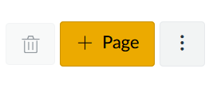
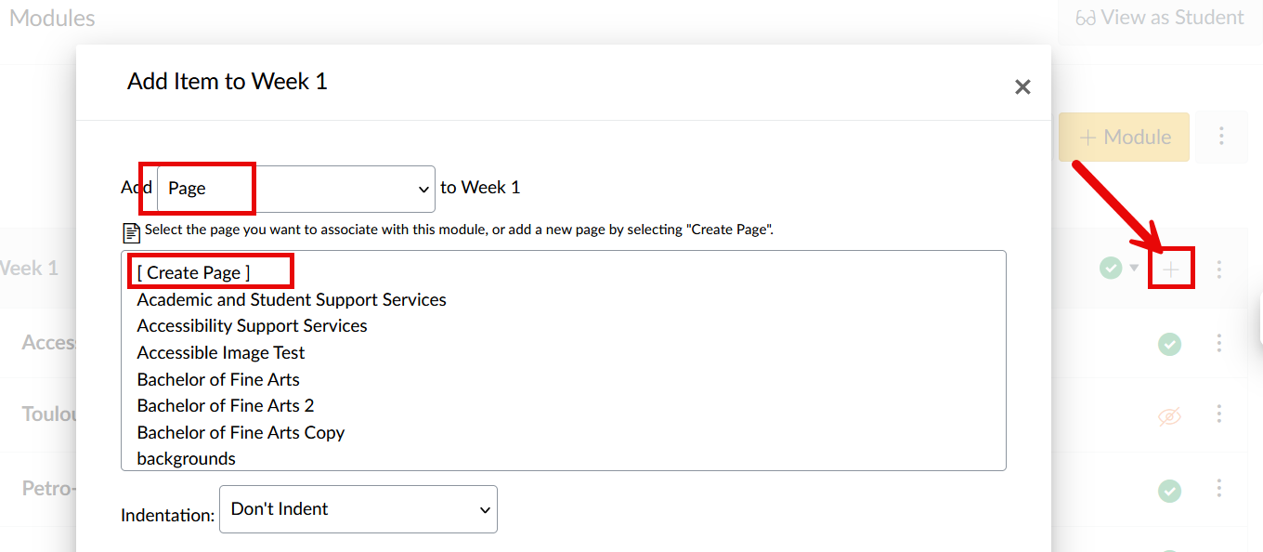

Find the Image embed tool, click the drop down, then choose “Upload Image” (Course Images gives you access to images you’ve already uploaded previously):
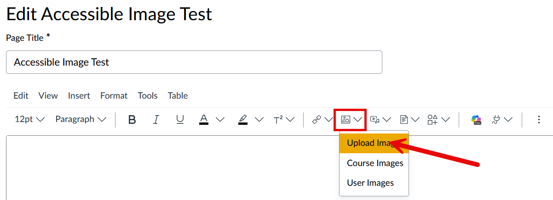
This pops up the image upload window. Note how you can add the “alt text” here directly, or you can mark the image as decorative. Then simply hit “submit.”

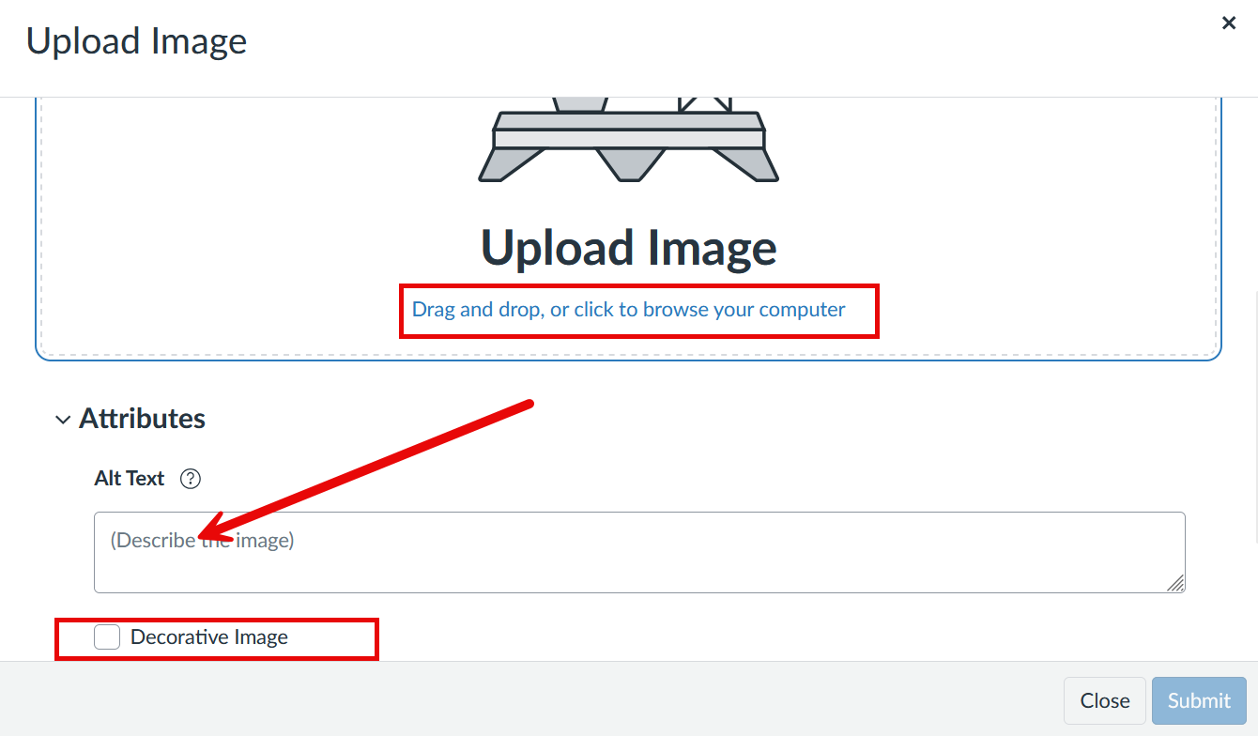

Checking Existing Images
At this point, the process is the same whether you are starting with a new image or editing the attributes of an existing image. We will start with an image already embedded on a page. In page edit mode, simply click on the image to select it (Canvas will give it a blue border if image is selected), which pops up an “image options” tag:
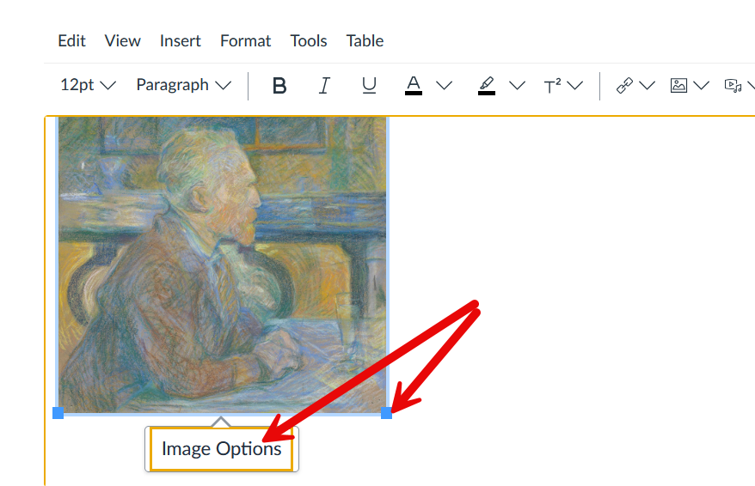

Clicking the tag opens the Image Options side panel. Note how the alt text defaults to the file name. Whether you also want to describe what is in the image depends on the context and why the image is there. If the file name is enough to describe the purpose of the image, you will want to delete the “.jpeg” file name suffix, which is just clutter for screen readers.

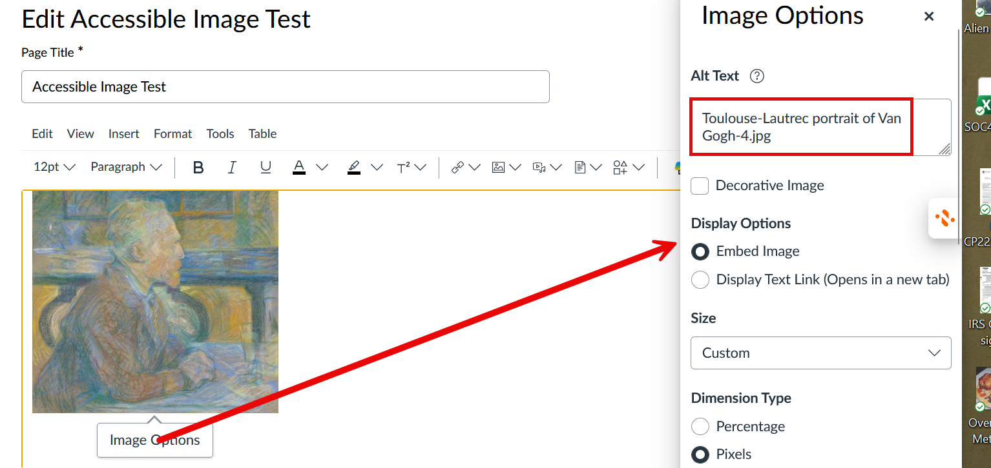

Videos

Purpose
Videos are a vital source of content in your Canvas courses. Video utilizes both visuals and audio, so it is important that your audience gets equitiable access to both mediums.

Accessible Video
An essential way to create accessible video is by having accurate captions for your videos so that your audience can read what is being said. One of the best ways to get captions for your videos is to upload your videos to Kaltura. We have several guides that can inform you on Kaltura’s captioning process. Kaltura is embeddable into your Canvas courses, so your audience can easily access those captions.
To help your videos be digestible by audience members who may have visual impairments, it is advisable to use descriptive language in your videos to describe what an audience member may be seeing and to describe what you may be doing in the video. An example of describing what you are doing would be walking your audience through your screen share and explaining the different important areas of your screenshare.
By incorporating these techniques into your videos, your audience will have a consistent and engaging experience with your content media.

Resources
For in depth assistance with making your videos accessibile please check out the following resources:
- Video Captioning guide (Joel and Afifa’s accessibility document when ready)
- Kaltura Captioning playlist

Color Contrast

Why it Matters
Sufficient color contrast makes text easier to read for everyone, including students with low vision, color blindness, or those viewing content on mobile devices or in bright lighting.

What to Do
- Use dark text on a light background or light text on a dark background.
- Ensure regular-sized text has a minimum 4.5:1 contrast ratio.
- Ensure large text (18 pt or 14 pt bold) has at least a 3:1 contrast ratio.
- Use a color contrast checker before publishing your content.

Avoid
- Light gray text on a white background.
- Yellow text on white.
- Color combinations that are difficult to distinguish, such as red and green.
- Using color alone to communicate meaning (for example, "Assignments in red are overdue.").

Quick Tip
When in doubt, black text on a white background provides excellent readability and typically meets contrast requirements.

Resources
- WebAIM Contrast Checker
- Accessible Web Color Contrast Checker
- Understanding Success Criterion 1.4.3 - Contrast (Minimum)

Canvas Tools/Additional Support
- Canvas Accessibility Checker
- TidyUP and UDOIT

