(Projected) 2027 Summer Intensive Courses*  (Enhancement) | 2026-27 Fall Hybrid Language Mentor Courses  (Sustainment)
* If funding becomes available the CSULB LTC program will offer 16-day, 80-hour online intensive courses in June and July summer of 2027. Dates to be determined in the coming months. | Fall 2026 Hybrid Courses: 24 Aug – 11 Dec 2026  - Arabic Hybrid Course: Standby  - Chinese Hybrid Course: 3 seats available  - French Hybrid Course: Standby  - Russian Hybrid Course: 2 seats available  - Spanish Hybrid Course: 2 seats available  - Persian Farsi Hybrid Course: Standby  Spring 2027 Hybrid Courses: 25 Jan - 14 May 2027  - Arabic Hybrid Course: 6 seats available  - Russian Hybrid Course: 6 seats available  - Chinese Hybrid Course: 6 seats available  - French Hybrid Course: 6 seats available  - Spanish Hybrid Course: 6 seats available
Enrollment and Eligibility | DOD Partners and Contact Information
Max course capacities:  - 4-8 linguists per Hybrid Language Mentor course.  - 8 linguists per Intensive course  Intensive Course Eligibility  - Minimum 2/2 ILR; 2+/2+ preferred  - Copy of latest (redacted, NO PII) DLPT  Hybrid Course Eligibility  - Range: 1/1 to 3+/3+  - Copy of latest (redacted, NO PII) DLPT  Please review the online application instructions and click on the application link. | DOD Partners  - Military Intelligence Readiness Command  - US Army Civil Affairs and Psyops Command  - State Army National Guard MI Battalions  - USN, USAF, and USA FAO proponent offices  - Defense Intelligence Agency  - Special Operations Forces  Contact Information  - CSULB LTC Website https://cla.csulb.edu/programs/ltc/  - Enrollment Management email  csulbltc@gmail.com  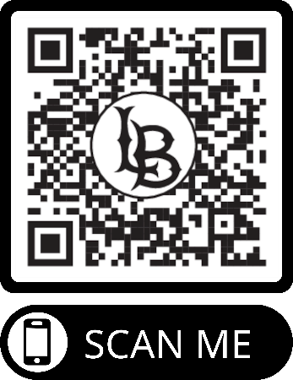  - Director’s email  Patrick.orourke@csulb.edu


