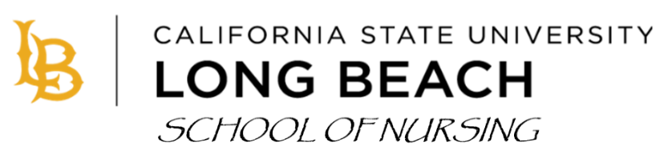
COVID-19 VACCINE DECLINATION

California State Long Beach School of Nursing believes in the effectiveness of the Covid-19 vaccinations and support the Los Angeles County Health Department’s recommendation for continued Covid-19 vaccinations for healthcare providers and students. However, we also respect the autonomy of individuals and their right to decide whether to receive the Covid-19 vaccination.
Some clinical agencies are still requiring a Covid vaccine to be placed in their facility and CSULB School of Nursing must adhere to their requirements. As such, students should be aware that CSULB School of Nursing will work with students but cannot guarantee placement of students who choose not to follow the clinical agency requirements. Students may not be able to complete their program of study if clinical placements are not possible.
As we move to a new respiratory infection season, students are permitted to decline receipt of the Covid-19 vaccine. Students must follow agency guidelines as such, e.g., wearing a mask between November 1st and April 30th of each year. Additionally, students much complete this declination every year if they choose not to be vaccinated.

I, _____________________________, have opted to decline this year’s seasonal Covid-19 vaccine.

_____________________________________________ ________________
Signature Date

**You must clearly sign and date this form to be valid. Ultimately, you will need to upload this form to Castlebranch medical document manager.

