SERIOUS ADVERSE EVENT / SERIOUS UNANTICIPATED PROBLEM REPORT

You should complete and submit this form only if the problem in your research meets the criteria of a Serious Adverse Event (SAE) or a Serious Unanticipated Problem (SUP) as described below.

Serious Adverse Events (SAEs) or Serious Unanticipated Problems (SUPs) that occur in projects overseen by the CSULB IRB should be reported to the IRB within 5 working days that the PI became aware of the SAE/SUP by submitting this completed Report form in IRBNet. In IRBNet create a subsequent package and select an Adverse Event Report or Unanticipated Problem Report under Document Type. Any death, life-threatening event or problem should also be reported to the CSULB IRB within 48 hours to IRB@csulb.edu.

A Serious Adverse Event is any serious “undesirable and unintended” incident, experience, or outcome, although not unexpected effect of the research interaction or intervention that:
1. Causes a participant’s death or is life-threatening;
2. results in hospitalization;
3. results in a significant disability/incapacity;
4. contributes to a participant’s drug dependency or abuse; or
5. directly places a participant at risk of criminal or civil liability or is damaging to the participant’s financial standing, employability, educational advancement, or reputation.

A Serious Unanticipated Problem is any serious incident, experience, or outcome for a participant that meets all the following criteria:
- Is unexpected (in terms of nature, severity, or frequency) and is not described in the IRB-approved protocol or in the informed consent; and the characteristics of the population being studied;
- is related or possibly related to an individual’s participation in the research; and
- suggests that the research has directly placed participants or others at a greater risk of harm (including risk of criminal or civil liability or be damaging to the participant’s financial standing, employability, educational advancement, or reputation) than was previously known.

Complete the algorithm below to determine if submission of the SAE/SUP Report is required.

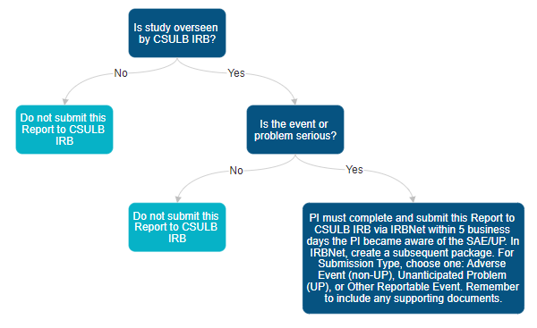
SERIOUS ADVERSE EVENT / SERIOUS UNANTICIPATED PROBLEM REPORT

- BASIC INFORMATION

PI’s Name (Last, First, Degree):
Affiliation: | ☐ Student* ☐ Faculty ☐ Staff ☐ External PI
Department:
Faculty Advisor Name (if applicable):
Study Title:
IRBNet ID:

- SAE/SUP INFORMATION

Type of Report: | ☐ Initial report ☐ Follow-up report ☐ Final report
Date of SAE/SUP:
Did SAE or SUP occur at CSULB? | ☐ Yes (Please name campus location):  ☐ No (Please name location):
The adverse event or unanticipated problem was: | ☐ Serious ☐ Unexpected ☐ Both Serious and Unexpected  ☐ Other (please specify):

- Briefly describe the research activities when the SAE or SUP occurred:

- Briefly describe details of the SAE/SUP including any interventions provided:
NOTE: This section must be completed.

- PROTOCOL AND INFORMED CONSENT INFORMATION

Any relationship of the SAE/SUP  to the research activities approved by the IRB? | ☐ Definitely related ☐ Probably related ☐ Possibly related  ☐ Unlikely related ☐ Not related ☐ Unknown
Is the event possibility described in the following?
IRB Approved Protocol | ☐ Yes ☐ No
Informed Consent | ☐ Yes ☐ No

- CHANGE IN PROTOCOL:

In your judgment, is a change in your protocol necessary to reduce or eliminate risk to subjects?
☐ Yes (Please attach revised proposal as in IRBNet as support documentation to the Serious Adverse Event (SAE), Serious Unanticipated Problem (SUP), or Other Reportable Event submission.)
☐ No (Please check appropriate box below):
☐ Protocol procedures are in place to reduce/eliminate risk.
☐ Other (please specify rationale below):

- CHANGE IN INFORMED CONSENT/ASSENT DOCUMENT(S):

Are any changes required in the informed consent/assent document(s) to better inform and protect the rights and welfare of subjects?
☐ Yes (Please submit the revised documents in IRBNet as support documentation to the Serious Adverse Event (SAE), Serious Unanticipated Problem (SUP), or Other Reportable Event submission).
☐ No (Please check appropriate box below):
☐ Event already noted in the current informed consent.
☐ Other (please specify rationale):

