2023 Academic Senate Legacy Lecture and Reception

Speaker: Dr. Jeffrey Cohlberg
Chemistry & Biochemistry

Presents:
“My Path in Research and Teaching”

CSULB Anatol Center,
Thursday, April 13, 2023, 2:00-5:00pm

RSVP Here

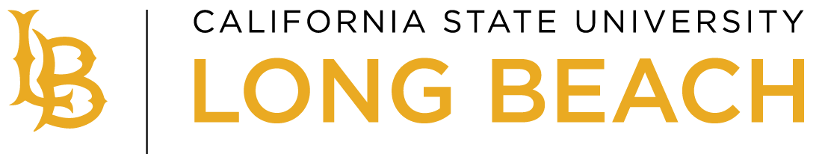
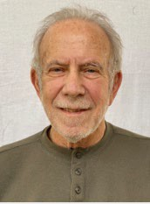
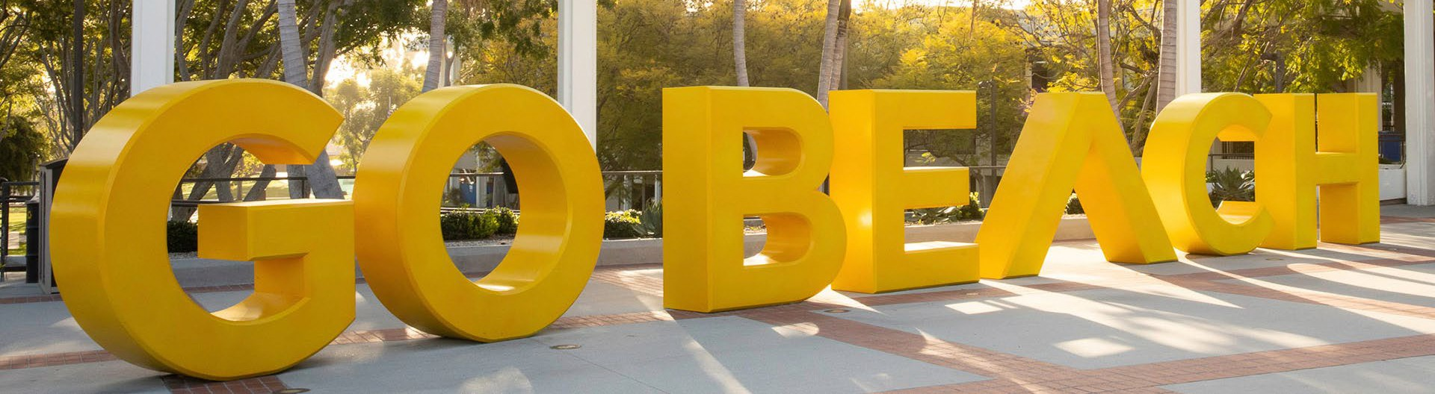
Academic Senate
CO-SPONSORED BY THE OFFICE OF THE PRESIDENT

