Date: June 17, 2022

To: Members of the Finance and Investment Committee
Mr. Scott Apel Dr. Beth Lesen
Dr. Praveen Soni Ms. Mitali Jain
Mr. Milton Ordoñez

From: Tom Collier, Accounting Manager

Subject: Operating Statement – May, 2022

May results came in better than plan overall, primarily due to Bookstore outperforming expectations for the month.

Total sales were 30% higher than budget at $2,204,776. The Bookstore sales of $1,271,535 accounted for more than half of the company’s total sales. Total sales of $117,572 came from graduation ceremony activity at Angel Stadium, with another $384,569 graduation-related commissions earned. Overall margins beat budgeted amounts by 2.1 points.

Operating Expenses ran only slightly above plan by 3.8% due to activity above and beyond expectation, while maintaining reduced staffing. Total operating expenses were $1,028,555 or $37,455 larger than budget. Credits & Revenues came in at $473,367 or $138,264 above budget with the key contributors being the graduation commissions and quarterly Amazon rent. The above resulted in a strong Operating Income of $649,712 which was $414,376 better than planned.

G&A expense were right on target at $229,106 due to continued minimal support staffing. Investment results for the month showed a gain for the first time since December at $34,869 for the month, with another downturn coming soon after month end.

There were no capital expenditures during the month, which resulted in a positive cash flow of $552,929K.

Tables 1 through 4 below highlight the May and Year-to-Date Operating Statement summary vs Budget and vs Prior Year including divisional breakdowns:

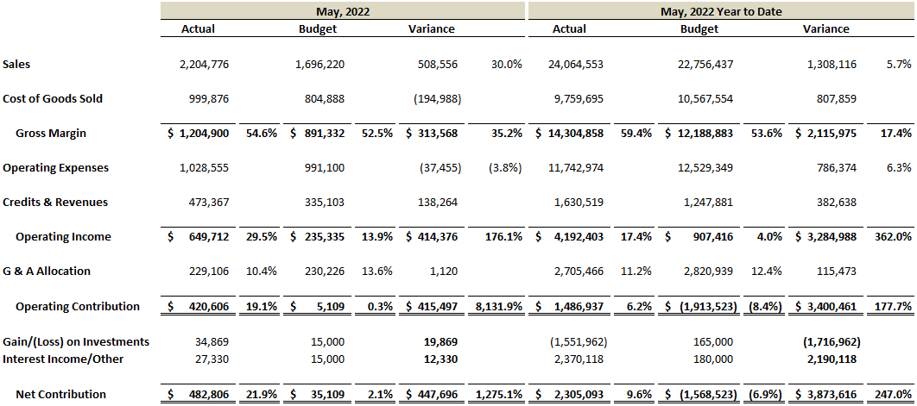

Table 1: Current Month and Year-to-Date vs Budget

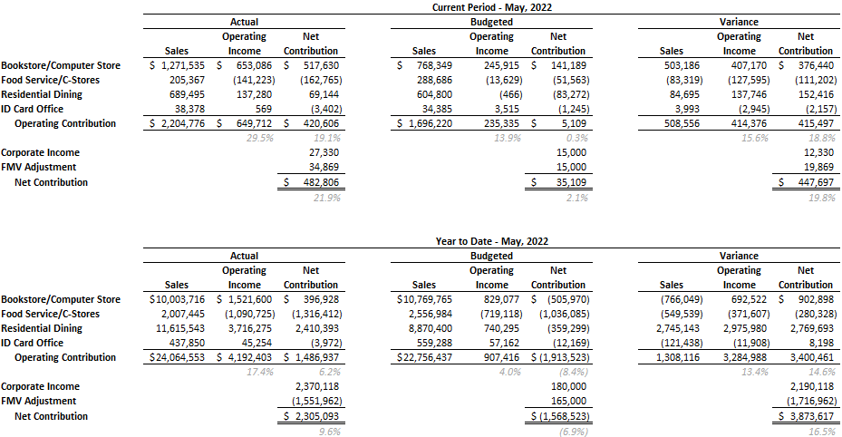

Table 2: Current Month and Year-to-Date vs Budget by Division

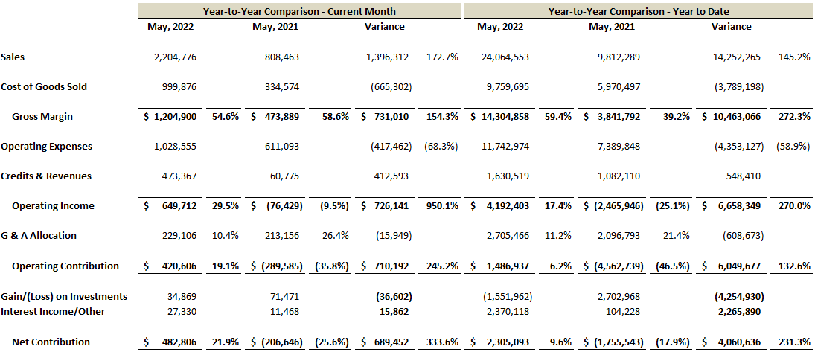

Table 3: Current Month and Year-to-Date vs Prior Year

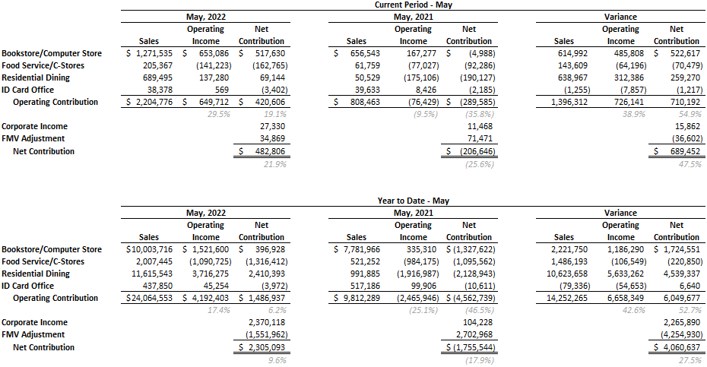

Table 4: Current Month and Year-to-Date vs Prior Year by Division

