Date: August 2, 2022

To: Members of the Finance and Investment Committee
Mr. Scott Apel Dr. Beth Lesen
Dr. Praveen Soni Ms. Mitali Jain
Mr. Milton Ordoñez Mr. Miles Nevin

From: Tom Collier, Accounting Manager

Subject: Operating Statement – June, 2022

June financial results are based on pre-audit data, with final results pending audit completion in September. General and Administrative costs are heavily influenced by large year-end non-cash accounting adjustments, resulting in a net expense decrease of $5,806,370 as follows:

- CalPERS Unfunded Liability actuarial projection decrease of $3,112,920
- Post Retirement Benefit actuarial projection decrease of $2,696,450

These adjustments are both the result of investment gains, which mitigate the long-term liability. However note that the actuarial projections are based on data from June, 2021 when the financial market was in a much different place. We anticipate these adjustments reversing in the coming fiscal year due to market downturns. The CalPERS adjustment is also affected by the Shops’ liability paydown plan approved by the board in 2019. This paydown plan includes a $500,000 additional payment per year through 2025.

Operationally, results came in better than plan overall with both Bookstore and Residential Dining outperforming budgeted sales amounts. Company-wide total sales exceeded budget by $413,527 due in part to conservative budgeting of Residential Dining. Bookstore’s graduation-related commissions earned came in $100,000 higher than anticipated. In comparison to prior year, sales volume is up $490K while holding operating expenses at nearly the same level.

Tables 1 through 4 below highlight the May and Year-to-Date Operating Statement summary vs Budget and vs Prior Year including divisional breakdowns:

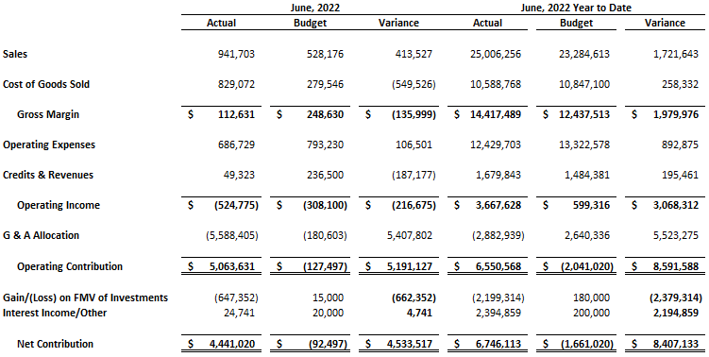
Table 1: Current Month and Year-to-Date vs Budget

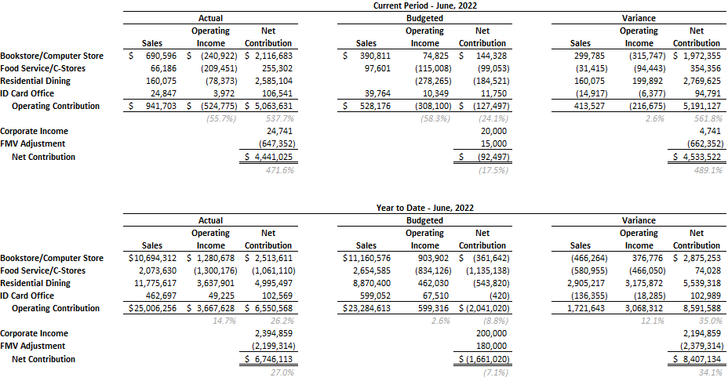
Table 2: Current Month and Year-to-Date vs Budget by Division

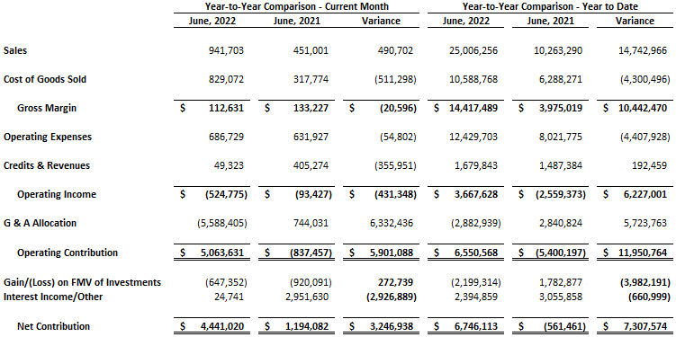
Table 3: Current Month and Year-to-Date vs Prior Year

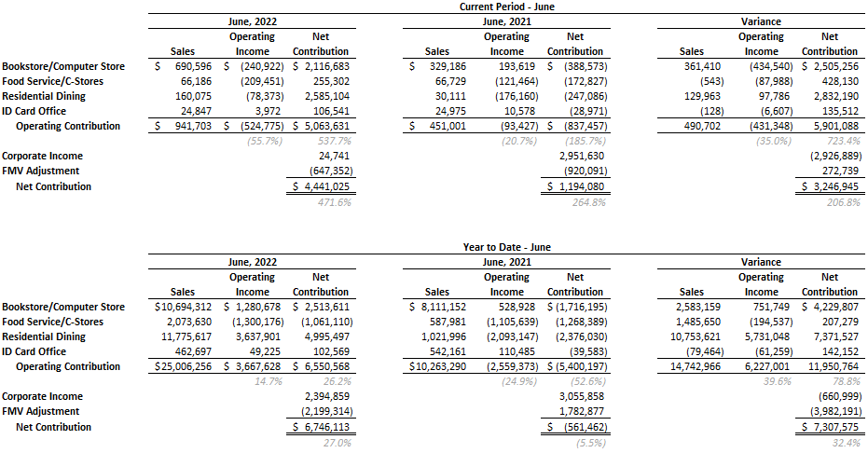
Table 4: Current Month and Year-to-Date vs Prior Year by Division

