NEWSLETTER

of the

Chinese Language Teachers Association

Volume 29 December 2005 Number 3


________________________________________________________________________________________________________________
CLTA Home Page: http://clta.osu.edu
For the electronic version of this newsletter and news updates before the next issue, visit our website: http://www.csulb.edu/~txie/CLTANews/
Calligraphy Education Group (CEG) of CLTA website: http://www.unc.edu/~wli/CEG/
Chinese Language Teachers Association

CLTA Headquarters:

Chinese Language Teachers Association
c/o Center for Chinese Studies
Moore 417, 1890 East-West Road
University of Hawaii at Manoa
Honolulu, HI 96822
E-mail: cyndy@hawaii.edu; ite@hawaii.edu
Phone: (808) 956-2692; Fax: (808) 956-2682

Board of Directors

Mien-hwa Chiang (2006), president, U. of Pennsylvania; Hong Gang Jin (2006), immediate past president, Hamilton College; Jennifer Liu (2006), vice president, Indiana University; Yea-fen Chen (2006), University of Wisconsin-Milwaukee; Telee Richard Chi (2006), University of Utah; Songren Cui (2007), Bowdoin College; Michael Everson (2006), University of Iowa; Audrey Yen-hui Li (2007), University of Southern California; Hsin-hsin Liang (2007), University of Virginia; Yulan Lin, (2008), Boston Public Schools; Charles Miracle (2007), Foreign Service Institute; Jerome Packard, (2008), U. of Illinois; Claudia Ross, (2008), College of the Holy Cross; Shuhan Wang, (2008), Delaware Dept. of Education; John Young (Honorary Member)

Officers of the Association

Elected Officers
President
Mien-hwa Chiang (2006)
Dept. Asian & Middle Eastern Studies
847 Williams Hall
Tel: (215) 898-6338 (Office)
Fax: (215) 573-9617 (Office)
Email: mhchiang@sas.upenn.edu
University of Pennsylvania
Philadelphia, PA 19104

Vice-President
Jennifer Liu (2006)
East Asian Langs & Literatures
Goodbody Hall 221
Indiana University
Tel: (812) 332-5362 (Home)
(812) 855-5180 (Office)
Fax (812) 855-6402
Email: jeliu@indiana.edu
Bloomington, IN 47405

Immediate Past President
Hong Gang Jin (2005)
East Asian Lang & Li
Hamilton College
Clinton, NY 13323
Tel: (315) 859-4778 (Office)
(315) 853-4360 (Home)
Email: hjin@hamilton.edu

Appointed Officers
Headquarters
Executive Director
Cynthia Ning (2006)
Moore 418, 1890 East-West Road
University of Hawaii at Manoa
Honolulu, HI 96822
E-mail: cyndy@hawaii.edu
Phone: (808) 956-2692; Fax: (808) 956-2682

Journal Office
Editor
Vivian Ling (2006)
391-c Cannon Green Dr.
Goleta, CA. 93117
Phone/Fax: (805) 968-4422
E-mail: vivianling12@yahoo.com

Review Editor
Michael E. Everson (2006)
Division of Curriculum and Instruction
College of Education
Univ. of Iowa, Iowa City, IA 52242-1529.
Email: Michael-everson@uiowa.edu

Editorial Board
Gloria Bien (2006), Colgate University; Kai Li (2006), Oberlin College; Stanley Mickel (2006), Wittenberg University; Yanfang Tang (2006), College of William and Mary; Julian Wheatley (2006), Massachusetts Institute of Technology; Mark Hansell (2007), Carleton College; Shengli Feng (2008), Harvard University; Cornelius C. Kubler (2008), Williams College; Audrey Li (2008), Univ. of Southern California; Jennifer Li-chia Liu (2008), Univ. of Indiana; Jerome L. Packard (2008), Univ. of Illinois; Zheng-sheng Zhang (2008), San Diego State Univ.

Newsletter Office
Editor
Tianwei Xie (2006)
Dept. of Asian and Asian American Studies
California State University at Long Beah
Long Beach, CA 90840
E-mail: txie@csulb.edu
Tel: (562) 985-5278; Fax: (562) 985-1535
Email: txie@csulb.edu; URL: www.csulb.edu/~txie

Home Page Office
Webmaster
Prof. Marjorie K.M. Chan (2005)
Dept. of E. Asian Langs. & Lits.
398 Hagerty Hall
1775 College Road
Ohio State University
Columbus, Ohio 43210-1340
Tel: (614) 292-3619 (Office)
(614) 292-5816 (Dept.)
Fax: (614) 292-3225 (Office)
Email: chan.9@osu.edu; URL: people.cohums.ohio-state.edu/chan9

The CLTA Newsletter is published in September, December and March and mailed to all active members of the CLTA. Cut-off dates for submission of all materials are August 15, November 15, and February 15. Ad rates are $200 full-page (6Wx8H), $100 half-page (6Wx4H) and $50 quarter-page (3Wx4H).

Table of Contents

A Letter from The New President 4
A Message from Immediate Past President 5
Reports and Announcements 7
CLTA Annual Conference Call for Papers 7
Chinese Language Teachers Association 8
The Jiede Empirical Research Grant of 2005 9
Report of the Awards Committee 9
An Update from CLASS 9
Middlebury College Chinese School offers an intensive non-degree graduate course 11
A Non-Degree Course of Chinese Pedagogy at Kenyon College: 11
Receive a donated copy of Founder Chinese Characters Fonts 12
Study Abroad in Hainan, China in Summer 2006 12
美國大紐約地區中文教師學會 (CLTA-GNY) 12
Duke Study in China Program 13
Duke University 13
A Research Proposal Writing Workshop for CLTA Members 14
The Third CFL Empirical Research Workshop 14
News of the Field 14
Update on AP Chinese Language and Culture 14
CLTA & CLASS 联合研讨会首次在巴尔迪摩年会召开 15
CLTA & CLASS Joint Forum: Articulation in K-16 Chinese Language Education 16
Endowment Established for CLTA Walton Awards 20
Photos from the annual CLTA conference in Baltimore 21
International Conference on Reading in Chinese Convened 22
第四届美西地区中文学校教学研讨会在加州举行 22
Conference News 23
The 2006 Conference of the Chinese Language Teachers' Association of Greater New York (CLTA-GNY) & the Fourth New York International Conference on Teaching Chinese 23
第八屆世界華語文教學研討會 24
The 5th International Conference on Chinese Language Pedagogy 25
Positions 26
University of Colorado 26
Florida State University 26
Kalamazoo College 27
Wellesley College 27
Williams College 27
Book News 28
Beginner’s Chinese Dictionary 28
Chinese Link: Zhongwen Tiandi 中文天地 28
Topic Chain: A Discourse Analysis and Applications in Language Teaching 28
Tuttle Learner’s Chinese-English Dictionary 29
Web Resources for Chinese Teaching and Learning 29
Software and World Wide Web News 29
EStroke Animated Chinese Character 29
www.lulu.com – a self publishing web site 30

A Letter from The New President

December, 2005
Dear CLTA Members:

I would like to start by thanking Hong Gang, Cyndy, Vivian, Tianwei, Mike Everson, Margie, the Board of Directors as well as members of CLTA Journal Editorial Board for everyone’s wonderful contribution to our organization in the year of 2005. Without their selfless service to our growing field, the fundraising initiative, the e-mail announcements, the qualitative newsletter and journal publication, the updating of the home page as well as the joint forum on K-16 articulation would not be possible. I would also like to thank CLTA members who supported the organization by purchasing T-shirts at the annual meeting. In total we raised $1,480 for future fundraising activities.

On the list of the Board’s 2006 agenda, are the following items: (1) how to transfer membership registration to an online system, (2) how to prepare future CFL researchers and teachers, (3) how to obtain foundation grants to make our organization better funded, (4) how to bridge pre-college and college-level Chinese language education. The headquarters and the board will work together to shape our future in response to the emerging “fever” of Chinese learning. However, an effective executive director and a forward-looking board alone could not make us strong. A strong and better Chinese teaching field should be grounded in our excellence in teaching and research as well as an increasing number of students at the advanced-level learning Chinese for different purposes. I ask all of you to step back and ask yourselves what we will do to strengthen our teaching and research skills in the next couple years. In my view, we could take action in three directions.

Joining more than one professional organization. In the past five years, the CFL-field landscape has become increasingly complex and multifaceted, shifting from a humanistic base to social science and professional Chinese language use. Our learners now include not only teenagers and young adults, but also adult learners in the governmental and business sectors. To enhance our teaching and enrich our content, we could consider joining more than one professional organization so as to draw new ideas from other related fields to innovate our teaching, such as AAS, ACTFL, MLA, and NCOLCTL*. As we engage with the different fields, we will add new dimensions to our teaching. We could also publish our research in different journals so that our research is more visible in the field of foreign language education.

Conducting collaborative research. In terms of research, we tend to think of the work of a single author, within our own discipline, and by observation of our own students. We have carried out research on beginning level CFL teaching and learning, but short of research regarding the learning at the intermediate and advanced level. We now could think about cross-disciplinary, multi-institution, multi-author research. We could engage with our local heritage schools, secondary schools, as well as study abroad programs in China, to conduct longitudinal study. When we work with colleagues and teachers from different sectors, we combine diverse views and strengthen each other. By conducting research together, we are able to achieve what we could not possibly achieve on our own. Professor Vivian Ling reported that the Journal received 31 manuscripts in 2004 and 23 in 2005. We hope to have more submissions in the coming years.

Thinking of long-term Chinese learning results. Regarding our students, we tend to think only about immediate results. We tend to picture students shopping and traveling in China. Now that AP Chinese and study abroad programs extend learners’ learning experience and provide opportunities to practice the language with native speakers in the target culture, we need to think of how to teach our students to reach the advanced level and picture them using their advanced proficiency and accuracy in academic and professional settings. Furthermore, our learners are able to converse intelligently on the Chinese films, culture, and history with their counterparts in informal settings. We have to make up our minds that we will offer diverse courses for students with different interests and learning goals.

Chinese language education is essentially interdisciplinary, drawing on Chinese history, social science, culture, literature for building students’ humanistic prospective and on Chinese linguistics, applied linguistics and CFL-specific research as the scientific evidence supporting our pedagogy. Since we want our class content to be of depth and our methodology effective, it is necessary that we bear in mind that we must have an interdisciplinary vision.

CLTA is the place where all Chinese language teachers belong. I assure you that the officers and the board of directors possess expertise, compassion, and collaborative spirit. I joyfully ask you to join in the Board’s endeavor to build a better and stronger Chinese language teaching field for the coming generations. We will live up to the current opportunity and steadfastly march toward the mainstream of the American language teaching field.

I wish you a very happy New Year.

Sincerely,

Mien-hwa Chiang

University of Pennsylvania

AAS: Association for Asian Studies

ACTFL: American Council on the Teaching of Foreign Languages

MLA: Modern Language Association

NCOLCTL: National Council of Less Commonly Taught Languages

A Message from Immediate Past President

Hong Gang Jin

The year 2004- 2005 has been an extremely exciting and significant one, marking a turning point in the history of Chinese language teaching in the USA, as the field expands and joins the mainstream. At this historical moment, it was my great privilege to serve as President of CLTA and to have the opportunity to work with a highly talented and dedicated Board of Directors and officers. The year thus has been unquestionably meaningful and rewarding for me.
In addition to routine work by our sub-committees and teams on the conference program, nominations, awards, finance, and other business, the Board also responded to changes and challenges with field initiatives and projects throughout the year. These included: initiation of the CLTA and CLASS joint forum on K-16 articulation in Chinese language education; organization of professional development workshops, such as the empirical research workshop led by Michael Everson and the pedagogical workshop led by Cyndy Ning; formation of a fund-raising committee and launching of fund-raising campaigns, the activities of which prompted a $10,000 Walton Endowment by Cheng Tsui Company, $2000 Jiede contribution by CET, and $6000 dollar matching fund by the original Jiede donor to promote excellence in research and teaching Chinese as a second/foreign language.
All these achievements were the result of the Board’s collective wisdom. Each and every officer and Board member offered unconditional support and contribution in the form of continued brain-storming, constructive discussions, effective implementation, and incalculable amounts of volunteered time. I am especially indebted to Immediate Past President Jianhua Bai, this past year’s Program Chair Richard Chi, Nominating Chair Julian Wheatley, Award Chair Hsin-hsin Liang, Jiede Chair Songren Cui, Finance Chair Gloria Bien, Fund-Raising Chair and Vice President Mienhwa Chiang, JNCL Representative Shuhan Wang, and all the Board members for their tremendous support and dedication. And as always, my deepest gratitude also goes to our dedicated and hard working officers, Executive Director Cyndy Ning, Journal Editor Vivian Ling, Newsletter Editor Tianwei Xie, and Web-master Marjorie Chan. Without their tireless efforts and active involvement, the board could not have achieved what we achieved this year.
I would like to conclude with a famous Chinese idiom “未雨绸缪”(Repair the house before the storm comes). While we are enjoying the exciting and rapid development of the Chinese language teaching field, we must keep in mind that it takes careful planning and a solid infrastructure to ensure that our field continues to grow and expand. I believe that, as an association which aims to provide better service to its members, CLTA and its Board must, first of all, lead the field in seizing the momentum of current “Chinese fever,” and in meeting the challenges of taking the field into the mainstream of foreign language instruction. At the same time, CLTA must work closely with CLASS and other related associations to make long-term strategic plans and construct careful road maps for a necessary and long lasting infrastructure in field research, program building, teacher development, curricular implementation, material development, and assessment. With our joint efforts and a solid infrastructure, our field not only will grow and expand steadily, but also will sustain any unexpected twists and turns in the future.

2004—2005年在中文语言教学史上是一个具有重大转折意义的一年。这一年也标志着中文教学开始向主流外语教学领域发展。在此历史关键时刻，作为会长，我能为全体中文教师学会会员服务，并与本届理事会成员及工作人员共同工作一年，深感到万分荣幸。
在过去的一年中，CLTA理事会全体成员除了进行CLTA“年会”，年度选举，颁奖评选，财务管理等日常事务外，还就本年度领域的变化及挑战组织了各种活动及项目，其中值得提及的有：1. CLTA及CLASS联合讨论会：美国K-16中文教育在新时期面临的挑战；2.为提高领域专业水平而组织的两个专题工作坊：a.由Michael Everson主持的实验研究工作坊, b.由Cyndy Ning主持的教学法工作坊；3.成立CLTA募款委员会并进行各种募款活动。到目前为止，募款委员会已收到来自Cheng & Tsui 公司的一万元Walton 捐赠基金，来自CET的2000元及“皆得”原始捐赠人的6000元。
这一年来的工作成就都是本届理事会及工作人员集体智慧的结晶。没有理事成员的无私奉献，出谋献策，有效实施，没有本会全体会员的支持信任，今年的任何工作都无法完成。本人在此特别鸣谢前会长白建华，本年度“年会”负责人齐德立，年度选举负责人 Julian Wheatly，颁奖评选负责人梁新欣，皆得委员会负责人崔颂人，财务管理负责人卞荣青，募捐委员会负责人及副会长蒋冕华，以及本会JNCL常任代表周淑涵。与此同时，本人再度感谢在CLTA 各种岗位上无私实干的工作人员：总部执行主任任友梅，学报总编陵志蕴，学会季刊谢天蔚，以及网络负责人陈洁雯。
最后，我谨借用一句中国著名成语“未雨绸缪”来结束本文。在中文教学领域突飞猛进的时刻，我们切不能忘记，一个领域的发展及成熟需要审慎周密的计划以及坚实的基础建设。CLTA是一个以服务学会成员为宗旨的专业组织，本人认为，此刻CLTA不但要利用全球“中文热”这一大好形势带领学会及中文教学领域迈向主流外语，而且要与CLASS及其它有关中文教育组织联合起来共同制作长期领域发展计划，绘制领域基础建设的蓝图，其中包括：领域基础研究，中文项目发展，师资培训，课程设计，教材发展，能力测试等。只有大家携起手来，我们的领域方能不断发展，在将来的不测风云中成长壮大。

Respectfully,
Hong Gang Jin 靳洪刚
Professor of Chinese
Department of East Asian Languages and Literature
Hamilton College

Reports and Announcements

CLTA Annual Conference Call for Papers
November 17-19, 2006
Nashville, Tennessee

The 2006 annual meeting of the Chinese Language Teachers’ Association (CLTA) will be held in conjunction with the annual meeting of the American Council on the Teaching of Foreign Languages (ACTFL) in Nashville, Tennessee from Friday November 17 through Sunday, November 19, 2006. You are invited to submit proposals for individual papers, poster sessions, and panel presentations. The deadline for proposal submissions will be midnight, Tuesday, February 14, 2006.
In resonance with the theme of the ACTFL 2006 Annual Meeting Discover the Future . . . Discover Languages, the CLTA 2006 annual meeting will feature the theme "Chinese Language Education: Agendas for an Expanding Field."
As one of five co-sponsors of the ACTFL 2006 Annual Meeting and Exposition, CLTA encourages Chinese language educators from all areas of the profession to submit proposals to its Program Committee. Our Program Committee welcomes submissions on such topics as applied linguistics, assessment, culture, curriculum/program design, film, heritage learners, learner variables, literature, materials, multimedia, pedagogy/methods, policy/advocacy, professional development, research, second language acquisition, technology and other related topics. However, preference will be given to those submissions addressing the conference theme.
Sessions are 75 minutes long. Each panel will be limited to four fifteen-minute presentations-- including the presentation by a formal discussant (optional), with 15 minutes left for questions and answers. A paper presenter may also serve as panel chair but not as panel discussant. Accepted individual presentations will be grouped into panels by theme. The Program Committee will consider and review proposals in accordance with the following guidelines.
• Only proposals from CURRENT CLTA members will be considered.
• Only one proposal from each person will be considered.
• All proposals will be reviewed anonymously.
• Proposals will be reviewed in terms of relevancy to the conference theme and significance of topics to the concerns of the field, originality and innovation of perspectives, presentation of theoretical framework and arguments, clarity and rigor of analysis and critical thinking, and overall understanding of the topics proposed for presentation.
How to Submit

• Submit proposals in English or Chinese online at http://www.usc.edu/dept/LAS/ealc/clta/.
PDF files are prefered.
• Each panel must submit a panel abstract, and each panelist must submit an individual abstract.
• The abstract should be 300-400 words.
• Indicate clearly on the proposal submission form the equipment you will need for your presentation(s). CLTA will charge a nominal fee for the use of an LCD projector: $10 for an individual paper presentation, and $25 for a panel.
Proposals submitted after the deadline, not in the correct format, or by those who are not current CLTA members will not be considered.

If you are not currently a CLTA member, please contact Professor Cyndy Ning (cyndy@hawaii.edu), Executive Director of the CLTA, or visit the CLTA's web site: http://clta.osu.edu.
First-time CLTA presenters are eligible to compete for the Walton Presentation Prize. This award (formerly known as the Ron Walton Young Scholar Travel Award) is given to recognize the best first-time presentation at the CLTA Annual Meeting. Preference will be given to teachers at the pre-college level, graduate students and junior scholars who have their paper proposals accepted for the annual meeting. The recipient of the prize will receive an award of $250 and an invitation to submit his/her paper to the Journal of the CLTA for possible publication. If you wish to be considered for the prize, please indicate so on the proposal submission form.
Please send your inquiries to:
Audrey Li, CLTA 2006 Program Chair
Email: clta@usc.edu
Tel: (213) 740-3717; Fax: (213)-740-9295

~~~~~~~~~~~~~~~~~~~~~~~~~~~~~~~~~~~~~

Chinese Language Teachers Association

The Jiede Empirical Research Grant for Chinese Pedagogy/Chinese Applied Linguistics
皆得學術研究基金

Call for Proposals

The Chinese Language Teachers Association invites proposals for the Jiede (all-attain) Empirical Research Grant, established in 2003 by an anonymous member, and enhanced thereafter by the original donor and other donors. The grant will support empirical research in Chinese pedagogy and applied linguistics that contributes to building a sound understanding of teaching and learning Chinese as a Foreign Language (CFL). The recipient will be expected to present a paper at the annual meeting of the CLTA or to submit a progress report at the end of the grant term.

Awards: The Jiede Research Grant awards up to $1,500 to a CLTA current member whose research project exhibits innovation and long-term pedagogical benefit to the field of CFL, but EXCLUDE pure grammatical structural research design. The grant winner must present high quality research that will improve pedagogy in CFL or Chinese applied linguistics. Grant funds may be used for fieldwork, data analysis, or travel, but not for equipment purchases.

Eligibility: Except for university/college tenured associate and full professors, applications from all teaching professions including assistant professors, instructors, lecturers, K-12 teachers, heritage school teachers, independent researchers, and graduate students in registered M.A. or Ph.D. programs who are current CLTA members (active membership from grant application to research presentation) and conduct empirical research in the Chinese language are welcome to apply. The recipient should have no other grant support for the same project.

Application: Submit electronically a three to five-page proposal to include a clear description of the research project, such as the theoretical background, the objectives, research design and methods, timeline, and budget of the project (itemize in detail). Please do NOT identify yourself in the proposal. Send with the proposal in a separate attachment a brief (maximum one-page) curriculum vitae, indicating your current status, institutional affiliation (if any), educational background and contact information. Identifying information will be removed prior to forwarding to the committee for anonymous review.

Address: To: cyndy@hawaii.edu
Subject: Jiede Application
Deadline: Proposals must be received by March 31, 2006 at CLTA Headquarters.
Notification: Applicants will be notified of results by April 30, 2006.

Sample grant proposal is available for reference at the CLTA web site http://clta.osu.edu.

PAST RECIPIENTS OF THE JIEDE EMPIRICAL RESEARCH GRANT

2005: Miao-fen Tseng (The University of Virginia)
Research Project: The Attrition of Production and Reception Skills in Mandarin Chinese. (see below)
2004: Meng Yeh (Rice University)
Reseach Project: Exploring Chinatown: Integrated Language, Culture and Community.
2003: Helen Shen (The University of Iowa)
Research Project: Linguistic Complexity and Reading Comprehension among CFL Beginner Learners.

The Jiede Empirical Research Grant of 2005

The Jiede Committee is pleased to announce that Dr. Miao-fen Tseng of the University of Virginia won the 2005 Jiede Empirical Research Grant. Her research project is The Attrition of Production and Reception Skills in Mandarin Chinese. We believe that with the support of the Jiede grant, Dr. Tseng will be able to conduct her research successfully and to present her research results in the near future. Congratulations, Tseng Laoshi!
The Jiede Committee

Report of the Awards Committee
Hsin-hsin Liang
Awards Committee Chair of 2005

At the Annual Meeting, the CLTA Walton Award for lifetime achievement in the field of Chinese language pedagogy was presented to Professor Tsung Chin of the University of Maryland at College Park.

Jill Cheng of Cheng and Tsui was on hand to present the Cheng and Tsui Professional Development Award to two recipients. The $500.00 award went to Hsiao-Chi Su of the Chinese American International School in San Francisco to defray costs of participating in a week-long workshop at the Center for Advanced Research on Language Acquisition at the University of Minnesota during the summer of 2006. Her Coordinator, Ms. Jiun Chou Young, received the award on her behalf. The $200.00 award went to Yan Xie of the Northfield Mt. Hermon High School in Massachusetts to partially cover the expenses of attending the ACTFL conference in Baltimore.

At the conference, the committee selected Ling Wang of the University of Minnesota as the winner of the Walton Presentation Prize. Ling Wang’s presentation was entitled “The Impact of Multimedia on Students’ Recognition of Chinese Characters: A Quantitative and Qualitative Study.” She will receive an award of $250.00 and an invitation to submit the paper to be considered for publication in the Journal of the Chinese Language Teachers Association.

Congratulations to all the winners!

An Update from CLASS

Installation of an Executive Director
During the CLASS leadership retreat in July 2003, the Executive Board members identified and addressed necessary changes for CLASS to remain vital and maintain its strong leadership in the profession. The need to establish a new position for an executive director was first brought out for discussion. The same issue was further discussed at the Executive Board meeting in November 2003. At the last Board meeting in Chicago on November 19, 2004, the board approved the motion to install a CLASS Executive Director (ED) position.

The By-laws Revision Committee (led by the current president, vice presidents, and past presidents) met again in January and April 2005 to draft a job description for the ED. The proposed ED description was approved by the Executive Board in October 2005. The By-laws Revision Committee has solicited additional feedback form general membership through the CLASS News Group Mail. All CLASS members in good standing are asked to vote for the adoption of the proposed amendment.

The Proposed Amendment
Installation of a new position for CLASS Executive Director

The Appointment
- CLASS Board shall form an ED search committee to follow the standard procedure for the selection of candidates.
- Selection criteria includes adequate administrative and communicative skills, sufficient knowledge on the current state of K-12 Chinese language teaching field and the recent trends in the world language instruction, experience in classroom teaching and professional development, and willingness to travel as needed.
- Preference will be given to those who have contributed diligent service to the CLASS Board.
- The appointment of ED shall be made by a majority vote of the Board.

Duration of appointment

- Shall serve a three-year term with renewal possible.
- Shall serve without compensation.

Major Responsibilities of the Executive Director

- assist President and Board of Directors to perform their duties;
- keep all official records for the Association;
- present CLASS as a member organization at ACTFL, NCOLCTL, and the Northeast Conference’s delegate assembly;
- maintain a liaison with other national organizations that have common interests with the Association;
- serve as the major contact person for grant-supported CLASS projects;
- work closely with President and Vice Presidents to set long and short goals for CLASS;
- work closely with Treasurer to plan the annual budget;
- work closely with Web Master to maintain the CLASS web sit;
- utilize group e-mail mechanism for fast and efficient communication to the Board and general members.

CLASS 2005 Election Underway

The Election Committee, chaired by the Immediate Past President Yu-lan Lin, has sent the nomination forms out to all members in good standings in September and notified the candidates in October. The mailing ballots should be returned to the Election Committee by November 10. The results will be announced at Baltimore at the 2005 CLASS General Membership Meeting during the ACTFL Convention on Saturday, November 19, 2005.

US-China Joint Conference at Tongzhou, Beijing

In collaboration with Beijing Municipal Education Commission, the National Office of Teaching Chinese as Second Language (Hanban), and the Education Commission at Tongzhou, CLASS has successfully conducted the first US-China Joint Conference on teaching Chinese as a second language from July 18 through July 22, 2005 at Tongzhou, Beijing. This conference was designed for Chinese language teachers in the United States to meet and articulate common concerns with those teachers who teach Chinese to foreign students in China. Fifty-one enthusiastic Chinese language teachers from the United States actively interacted with fifty Hanyu teachers in China. It was an eye-opening experience for both American teachers and teachers in China to see what other Chinese teachers were doing in their classroom. The ideas they exchanged and obtained from the presentations were valuable and useful to their teaching. The visit to Lu He High School was one of the highlights in Tongzhou. Principal Zhang gave the conference participants a warm reception and the school staff escorted a tour of their beautiful campus. Participating teachers were impressed with the school’s long history and its modern, complete facilities.

2005 CLASS Summer Study Program in Shanghai

The CLASS Summer Study Program, attended by twenty teachers at East China Normal University, offered a great opportunity for new and veteran Chinese teachers to refresh and expand their knowledge in the field of Chinese language and culture.

The First Hanyu Qiao US High School Speech Contest

To support for the 2005: The Year of Language national campaign, CLASS organized its first speech contest on Sunday, May 7, 2005 at the Embassy of the People’s Republic of China in the United States of America. The purpose of this event was to encourage more non-native speakers to learn Chinese language at the pre-college level, as well as highlight their outstanding academic achievement in learning Chinese. Honorary Chairpersons of this event were Ambassador Wenzhong Zhou and Minister Counselor Chuansheng Liu. Organizing Committee members were Yu-Lan Lin of CLASS, Mr. Yougen Yu of the Chinese Embassy, and Beifeng Sun of the YuWenBao North American Monthly. This event was made possible by the generous funding from the Chinese Embassy and the National Office for Teaching Chinese as a Foreign Language (Hanban).

Fifteen high school students from public and private schools in California, Connecticut, Florida, Indiana, Kentucky, Maryland, Massachusetts, Minnesota, New Jersey, New York, Virginia, Wisconsin, and Washington D. C. participated in the Hanyu Qiao Speech Contest. (by Lucy Lee)
Middlebury College Chinese School offers an intensive non-degree graduate course

Middlebury College Chinese School offers an intensive non-degree graduate course, Principles and Practices of Teaching Chinese as a Foreign Language. It is designed for current CFL teachers and students of CFL pedagogy. Participants will investigate how theory and research relate to local decisions on organizing and planning for instruction in a CFL program. Through lectures, discussions and, most importantly, hands-on experience, participants will learn to: understand what it means for CFL learners to develop their communicative competence; identify critical issues in CFL pedagogy; and develop the ability to plan and implement pedagogically sound and effective classroom activities. Unlike a conventional graduate course of lecture/discussion on theoretical and practical issues, this course creates a learning-by-doing environment where students are active participants in the teaching and learning process.

Participants will meet 3-4 hours daily. They will be required to observe and critique classroom procedures, strategies and teaching techniques proven to be effective for students at the Middlebury College Chinese School. Class assignments will include: reading and reflection papers on CFL pedagogy; lesson planning focused on local instructional context; teaching demonstrations and peer critiques on how well participants make communicative language teaching happen in actual classrooms. Participants will have abundant opportunities to practice and sharpen their teaching skills with actual learners through class observation, observation of team-lesson-planning at different levels, and some supervised teaching. Classes will be conducted in Chinese. Readings will include both Chinese and English references.

Schedule: June 14 - July 8, 2006
Fees: $2,225 (Tuition $1,248, Board $695, Room $282)
Credits/Hours: 1 unit (3 credits)
Enrollment: Maximum enrollment of ten

Applications will be accepted on a rolling basis until the start of the session, or for as long as space is available. Financial aid application forms and information are available at www.middlebury.edu/ls/applications. For further information about this course, please contact Anna Sun, Chinese School Coordinator, at sun@Middlebury.edu or (802) 443-5520phone, (802) 443-2075, fax.

A Non-Degree Course of Chinese Pedagogy at Kenyon College:
“Principles and Practices of Teaching Chinese as a Foreign Language (TCFL)”
The course is an intensive 3-week non-degree graduate course for current CFL teachers and students of CFL pedagogy. Participants investigate how theory and research relate to local decisions for organizing and planning for instruction in a CFL program. Through lectures, discussion and, most importantly, hands-on experiences participants will learn to understand what it means for learners of Chine(se as a foreign language to develop their communicative competence, to identify critical issues in CFL pedagogy and develop the ability to plan and implement pedagogically sound and effective classroom activities. Unlike a conventional graduate course of lecture-discussion on theoretical and practical issues this course creates a learning-by-doing environment where students are active participants in the teaching and learning process.

Participants of this course will meet 3-4 hours daily and they are also required to observe and critique classroom procedures, strategies and teaching techniques proven to be effective for students in the Chinese School of Middlebury College. Class assignments include reading and reflection papers on CFL pedagogy, lesson planning that is focused on your local instructional context, teaching demonstrations and peer critiques on how well participants make communicative language teaching happen in actual classrooms. Participants have abundant opportunities to practice and sharpen their teaching skills with actual learners through class observation, observation of team-lesson-planning of the different levels of the Chinese School and some supervised teaching. Classes are conducted in Chinese and readings will include both Chinese and English references.

Enrollment: 10. Applications are processed on a rolling basis until the start of the session, or for as long as space is available.
Credit: 1 unit
Total hours: 45 (15 per week) plus daily assignments

Receive a donated copy of Founder Chinese Characters Fonts
双桥捐赠方正中文字库

Dear Sir/Madam:

Please allow me to inform you of a special project of “Promoting the Learning of Chinese Language and Culture in the US”. This project is sponsored by Master Wan Ko Yee International Culture Institute located in Los Angeles. Professor Wan Ko Yee is an internationally renowned oriental artist in many areas such as painting, calligraphy, poetry and sculpture. Master Yee was highly respected in China before he came to US in the late 1990’s. He then received exceptional high regard internationally for his profound talents. An example of many honors he has received is the first fellowship awarded by the Royal Academy Schools of UK in more than two hundred years.

The project has received funding from William Prusoff Foundation. Dr. Prusoff, a prominent faculty in pharmacology at Yale University, has been a generous supporter for many cultural, social and medical projects.

TwinBridge Software Corporation is honored to be authorized to execute this project by providing free use of Chinese language software tools and digital cultural contents. We are ready to send this Founder Extended 65,000 Chinese Characters package to the selected research schools with such special requirement. This package offers solution for those missing Chinese characters outside the standard computing 7,900 Simplified and 13,000 Traditional set with stroke input. It was developed by Fang Zheng Company which is the most prestigious font developer in China. These free copies are full version software and supported by TwinBridge customer services.

Your school is cordially invited to take advantage of this project. By accepting this offer, your department/school will receive a donated copy of Founder 65,000 Chinese Characters. Please include shipping address, contact name and phone number in your reply. Please feel free to contact me for any questions.

Best regards,

Henry Yu, Director
(323) 263-3926 x 268
www.twibridge.com

(Due to a limited space, the request form is not included here. Any interested people may contact Hery Yu to request the form and other donated products. – Editor)

Study Abroad in Hainan, China in Summer 2006

The University of Hawai‘i at Manoa (UHM) Study Abroad Center is currently accepting applications for its Summer 2006 program in Hainan, China.

Tao-chung Yao, UHM Professor of Chinese, will be the faculty resident director for this nine-week program that will run from mid-May through the end of July. The program is hosted by the College of Liberal Arts at Hainan University in Haikou city. Participants will study all four language skills (listening, speaking, reading, and writing) and will earn eight UHM credits at the second, third, or fourth levels. In addition, guest lectures on Chinese culture and excursions expose students to the rich cultural history of Hainan. Extra-curricula activities such as Tai Chi and martial arts are also offered.

More information (housing, costs, and courses) and applications are available at www.studyabroad.org. The application deadline is February 17, 2006.

Visit the following site to view pictures from 2004 and 2005!
http://share.shutterfly.com/action/welcome?sid=8AbN2zdq1btmKB

美國大紐約地區中文教師學會 (CLTA-GNY)
2006年暑期南京大學教師培訓班

近年來在美國開設中文課的中﹑小學日益增多﹐從而對中文教師的需求量也逐年增加。但是美國教育主管部門要求所有在公立學校任教的教師必須具有与所教內容相關的教師執照。作為中文教師﹐就需要有一定的與中文有關的專業學分才有資格獲得教學執照。有鑒于此﹐許多專業合格的教師或申請人常常因為缺少與中文有關的學分而無法取得中文教師執照。此外﹐在美國有許多任教于大學和私立中﹑小學的中文教師的學位也不是中文。因此﹐也有進一步提高漢語語言﹑文學水平以及了解對外漢語教學研究和發展的需要。為了更好地促進美國的漢語教學，促進中美兩國教師之間的文化交流﹐美國大紐約地區中文教師學會再次与中國南京大學海外教育學院合作﹐在中國國家對外漢語教學領導小組辦公室的支持下﹐共同開展培訓美國漢語教師的工作。該培訓計劃已于2004年和2005年實施兩期, 取得圓滿的結果。2006年暑期南京大學中文教師培訓班已開始招生﹐詳情如下﹕
一. 教學課程﹕(由南大選開四門)
漢語語言學概論, 漢語應用語言學, 古代漢語, 現代漢語, 漢語寫作, 漢語史, 漢字与書法, 中國古代文學, 中國現代文學, 中國文學理論
以上課程由南京大學的教授主講。上課采用講座式。
二. 學習時間：
2006年7月17日到8月11日﹐教學時間為4周。每週授課26小時﹐學習期間南京大學還將安排與教學內容有關的參觀和實習。

三. 學分
每門課程3個學分，總計12個學分。學習結束時﹐成績合格者將由南京大學授予學分和證書。

四. 申請人資格
各類學校現職中文教師﹐至少有一年的漢語教學經驗﹐身體健康。

五.申請程序
- 從 http://clta-gny.org下載申請表格﹐填寫後隨同一份申請目的說明 (Statement of Purpose)﹐一頁紙簡歷﹐兩個推薦人的聯絡電話和電子郵件地址﹐和相片3張﹐護照首頁或綠卡 (持中國護照者) 複印件﹐任職學校的在職證明和任職學校負責人大推薦信﹐寄大紐約地區中文教師學會。
- 從即日起接受報名﹐截止日期為2006年2月28日 (郵件收到日期為准)。3月15日以前發放錄取通知。報名截止日期以後仍可接受申請﹐如果還有名額可以正式錄取。如果屆時名額已滿﹐可以考慮接受為自費學員。沒有被接受為正式學員的申請人也可以申請自費生﹐但一切費用需自理﹐其他待遇不變 (此類學員人數應不超過正式學員的三分之一)。申請人如果今年沒有被錄取﹐明年可以繼續申請﹐招生委員會可以保留其申請材料。
六. 費用
- 申請費和項目活動費$400。3月30日以前需預交項目押金$100 (恕不退還)﹐收到押金後﹐學會代為辦理註冊手續。余額于4月30日前交清。3月30日沒有收到押金者﹐恕不保留名額﹐學會有權將此名額轉讓給他人。支票請寫﹕CLTA-GNY。
- 正式學員將獲得1500元 (人民幣) 的生活補助。
- 旅費自理。我們將指定旅行社﹐協助購買國際機票。
- 所有正式和自費學員都必須有醫療保險﹐需由醫生證明可以參加國際旅行。
美國大紐約地區中文教師學會
Chinese Language Teachers Association of Greater New York
125 East 65th Street
New York, NY 10021

詢問電郵: secretary@clta-gny.org

Duke University – Duke Study in China Program

2111 Campus Drive; Box 90411
Durham, NC 27708-0411 USA
Phone: 1-919-684-2604
Where: Beijing, with excursions to other locations
When: Summer 2006
Web Page: http://www.duke.edu/APSI/china/
The Duke Study in China Program will hold its 25th summer program at Capital Normal University in Beijing. The program is held in collaboration with Washington University in St. Louis and Wesleyan University. The program focuses on intensive language study, with field trips every weekend. A host family option for students with 2 or more years of Chinese is available. Program features include a language pledge, small classes, weekly Chinese table, a long weekend trip led by faculty, and extra curricular activities.

Please e-mail us with your questions: china-abroad@duke.edu

A Research Proposal Writing Workshop for CLTA Members

The Jiede Committee [representing the CLTA Jiede (皆得 all-obtain) Empirical Research Grant established in 2003] proposes to offer a Research Proposal Writing Workshop at the 2006 CLTA Annual Meeting in Nashville, Tennessee (specific time and location to be announced) in addition to the regular CFL Empirical Research Workshop that was held in the past two years in Chicago and Baltimore respectively. This workshop is in response to the ever-increasing interest of our CLTA members in research, and more importantly, an attempt to bring empirical research in CFL to the next level so as to expand and mainstream Chinese language education across divergent settings in the U.S. The workshop will be conducted by Professor Michael Everson. He will introduce the fundamental mechanics of proposal writing, and will present examples to demonstrate the classic pitfalls people tend to fall into that make their proposals unacceptable. He will also present examples of well-written research proposals.

At present, we would like to get a sense of how well this endeavor will be received by the CLTA membership. If you are interested in this workshop, please contact Professor Everson (michael-everson@uiowa.edu) by April 10, 2006. There is a charge for $50 per person to cover the organizational expenses. We will update the information periodically in the CLTA Newsletter and through e-mail. (by Songren Cui)

The Third CFL Empirical Research Workshop

The Year of Languages (2005) has witnessed a surging momentum of Chinese language education across divergent settings in the U.S. The Jiede (皆得) Committee is pleased to announce that we will hold another workshop entitled “The Third CFL Empirical Research Workshop” at the 2006 CLTA Annual Meeting in Nashville, Tennessee (specific time and location to be announced). The workshop will be open to ten CLTA members, and will be in a “roundtable” format in which attendees will have one-on-one discussions/consultations on questions of their own research projects with experienced researchers/mentors in the field of CFL. Thus the workshop will be more individualized and focus on personal needs. All CLTA members who have an empirical research project (or potential project) and want to fine-tune them are welcome to contact Songren Cui (scui@bowdoin.edu) by April 10, 2006. Please also send a description or proposal of your research project in the attachment so that he can match your project with a proper experienced researcher/mentor. The charge of this workshop is $50 per person to cover the organizational expenses. (by Songren Cui)

News of the Field

Update on AP Chinese Language and Culture
Jianhua Bai 根据 AP Chinese网页整理
Visit the following web site for updates on AP Chinese
http://apcentral.collegeboard.com/chinese

The AP Chinese Language and Culture Course provides students with ongoing and varied opportunities to develop their communicative competence and their understanding of the Chinese culture. The course description and the exam are being developed by a joint force of outstanding practicing high school teachers and college professors.
- The first AP Chinese courses will be offered fall of 2006 and the first exam is scheduled for May, 2007. The AP Chinese Exam is Internet-based. Hardware requirements can be found at the AP Chinese home page. Students can choose either the simplified or non-simplified Chinese characters for the AP Chinese exam.
- The AP Chinese course is geared to parallel the demands of a fourth semester college level course (or the equivalent course at the end of approximately 240 contact hours). The exam is organized according to the three communicative modes articulated in the National Standards and includes listening, speaking, reading and writing.
- The course and exam will assume non-heritage learners as its target population. All aspects of the exam will be geared for students who have learned Chinese as an academic experience in school, NOT as a function of their family background or time spent in a Chinese speaking community, and the raw scores of heritage learner examinees will be removed from the data pool BEFORE the 'cut scores' are established. That is, the range of students' raw scores that will earn a '5', a '4', a '3', and so on, will be established ONLY on the non-heritage learners' raw scores.
- The College Board offers a broad range of professional development opportunities for teachers and administrators such as one-day workshops, information sessions with the AP Chinese Development Committee at the AP National Conference, weeklong summer institutes, Pre-AP world languages strategies and Vertical Teams workshops. Teachers can learn more about the AP Chinese course and the exam and “best practices” for the AP Chinese classroom etc.
- A Teacher’s Guide for AP Chinese will be available soon. It will make very clear the specific requirements of both the course and the exam. It will also contain advice for teachers, course organization, sample syllabi and other useful information.
- Although the College Board does not endorse any textbook it will provide Teaching Resources on its web site such as reviews of textbooks, articles, Web sites, etc.
- Some Related Information: 1) Three new positions have been created at the College Board to help expand the number of U.S. schools offering Chinese Language. 2) Asia Society is creating a “How-to-Guide” for the promotion of Chinese study at the Pre-college level. It will consist of relevant and useful information on establishing/expanding Chinese language programs and enhancing the teaching and learning of Chinese. The Handbook is expected to be completed and distributed in the spring of 2006.

CLTA & CLASS 联合研讨会首次在巴尔迪摩年会召开
The First CLTA & CLASS Joint Forum
Held in Baltimore, MD

At this year’s annual conference in Baltimore, CLTA and CLASS hosted their first joint forum on Articulation in K-16 Chinese Language Education (美国 K-16 中文教育在新 时期面临的挑战). The goals of the forum were to share common concerns, improve communication among K-16 Chinese language teaching professionals, create synergy among schools in different regions and sectors, and initiate long-term collaborative and field building projects.
The presidents of CLTA and CLASS joined hands to announce the opening of the forum. Nine moderators from CLTA and CLASS then gave brief introductions to and led discussions on four separate topics. Gloria Bien (CLTA) and Adam Ross (CLASS) took notes on the lively and energetic discussion, then worked together to coordinate their notes with the meeting agenda to produce the minutes for this issue of the Newsletter.
The forum clearly showed that our field is at an important historical juncture. CLTA and CLASS must work closely with other Chinese language and foreign language organizations to seize the momentum generated by AP Chinese to build a solid Chinese language teaching field and take the field into the mainstream foreign language education. In order to continue the energy generated by this important articulation discussion, we invite readers to respond with contributions to the next Newsletter issue (Tianwei, your email address?)
Our deepest appreciation goes to each of the moderators, to Gloria and Adam, and to the College Board, the Hope Foundation, and Cheng & Tsui Company, whose generous support provided refreshments for the forum.

Respectfully submitted by Hong Gang Jin

CLTA & CLASS Joint Forum:
Articulation in K-16 Chinese Language Education

Saturday, November 19, 2005 4:30 PM – 6:00 PM
Constellation F, Hyatt Regency, Baltimore MD

Chairs: Hong Gang Jin (CLTA)
Catherine Yen (CLASS)

Jin: Welcome. Goals: to provide a platform for members to sit together to discuss shared concerns and goals. We will start our conversation, get to know each other, pose questions, express needs and concerns.

Yen: Thanks to College Board, Hope Foundation and Cheng and Tsui for their support to host this discussion. Presents moderators:

Moderators: Jianhua Bai, Kenyon College
T. Richard Chi, University of Utah
Lucy Lee, Livingston High School
Yulan Lin, Boston Public Schools
Ted Yao, University of Hawaii
Chih-wen Su, Amherst Regional High School
Mien-hwa Chiang, University of Pennsylvania
Carol Chen Lin, Choate Rosemary Hall
Mike Everson, University of Iowa
(Timekeeper: Ginchi Wuu, CLASS)

4:30 – 5:00 Moderators: Jianhua Bai and Yulan Lin

Issues facing K-16 articulation: program funding, teachers, student enrollment, professional development, assessments, etc.

Bai: Introduces forum procedure:
- A 3-minute introduction by each of the two moderators
- Open-floor discussion on opportunities and barriers for K-16 articulation in the context of AP Chinese.
- Each participant limited to one minute, speaking in their choice of either Chinese or English.

Lin: Outlines opportunities and challenges:
- Program Funding for K-12 Initiatives: will other programs have to be cut? Opportunities exist for “soft” money, but when that dries up, challenge will be to continue the program. Schools starting new Chinese programs often lack the expertise to implement their programs successfully.
- Teachers: where can they be found? Heritage school teachers are a ready talent pool, but they will need appropriate training in methodology. Teachers from outside the US are available, but will they have the necessary US-classroom management skills?
- Student Enrollments: the challenges are such that if enrollments are too low, there is no viable program, and if enrollments are too high, teachers can become overwhelmed. The “No Child Left Behind” policy has made schools look into better quality teaching and smaller classrooms.
- Professional development: the first teacher is often a singleton in their programs, and without on-site mentors. CLASS has sponsored many activities and with the College Board/AP; there are even more opportunities.
- Assessment: we need to develop common scales to aid our articulation and decision making.

Bai: We need to learn from the experience of our Japanese colleagues, given that they experienced “Riyu re” 日语热 in the 80s and 90s, and we are now experiencing “Hanyu re” 汉语热. How do we build a strong field in professional development, curriculum design, assessment, research and enhancement? Experience with development of AP has shown the importance of team work. We need to ask, where can we do better?

Cynthia Ning: The overflow crowd has blocked the entrances, creating a fire hazard.

Discussion: [C = Comment, Q = Question, A = Answer] Speakers have been identified in parentheses where possible.

[Q]: Most heritage schools teach traditional characters. What happens when students attend a college that only teaches simplified characters?

[A]: We need professional development in colleges as well. Teachers need to know both simplified and traditional characters.

[C]: (Haiyan Fu, teacher at Northside College Preparatory High School) Funding for public schools proposed in Lieberman and Lamar bill met resistance from college teachers who say it will be wasted if we don’t know how to teach Chinese. But if we are to start to improve, we need funding. Urges college teachers to support the bill.

[A]: (Scott McGinnis) The Lieberman/Lamar bill will not pass in its current form. We’ll have to find other avenues for support.

[Q]: On AP handout and the implementation of AP Chinese next year.

Bai/Lin: Development committee working on this, information updates available on College Board website.

Jin: CLTA and CLASS would like everyone to join this effort to apply for funding and to support Chinese programs no matter where they are or at what level they are taught.
[Q]: A representative from the Philadelphia School District: our concern is that all children be taught to proficiency in grades 9-12. What is the best way to start Chinese programs, especially in an economically low-level school?

Lin: Programs meeting every day, 5 days a week for 4 years, should aim for Intermediate Middle, but hope to get to Intermediate High in oral performance; lower goal for reading/writing skills.

[C]: Chicago Public Schools have expanded elementary school World Language Programs. Early elementary pupils absorb more; if they continue, that’s the best way. The key is: “Start young, keep going long.” Expresses wish to get more schools on board to teach languages like Chinese.

5:00 – 5:30 Moderators: Richard Chi and Lucy Lee

Using AP Chinese to push for K-16 articulation and to bridge the gap among different sectors of Chinese language education
- Goals and objectives for effective K-16 articulation
- Existing or new projects and collaborations that promote K-16 articulation
- Possible joint efforts and projects to produce guidelines on K-16 articulation

Lee: Two points:
- Curriculum articulation and standards-based curriculum began in 1995 with the ACTFL National Standards, which were derived from the Romance Languages. The 1999 updated standards incorporated other languages. By then, all the languages except Russian and Chinese had K-16 articulation, AP courses and AP exams; now Russian has those things too; Chinese needs to develop them.
- Student outcome: aim at Intermediate Low or Intermediate Middle.

Chi: Articulation: what does it mean? Finding out what everyone’s doing, and following the same program, is not possible. We should not focus on what to teach. AP should be a rallying force on more fundamental questions. College teachers will need to ask themselves “what will we do with those who score 3, 4, or 5 on the AP?” Secondary school teachers need to be familiar with the principles and standards governing AP courses.

Discussion:

[C]: (Claudia Ross) There is no magic number and no same policy across colleges. Colleges may interpret AP scores to reflect different levels in their programs. The question is where will the students be placed when they attend a given college? It is also important that students should not use AP to place OUT of language programs.

[C]: (James Pusey) fears that AP will have a negative effect on pronunciation and oral expression, as he expects the test may focus primarily on reading and writing skills.

[Q]: (Vivian Ling) Experience browsing in book stores in the PRC shows that there is a corpus of vocabulary and grammar used at every level, but there is no uniformity; is there a way to achieve an “understood” corpus?

Chi: We do have some standards set by the ACTFL guidelines.

[C]: (Cynthia Ning) We are seeing a sea change in language teaching, particularly with new programs like the K-16 Pipeline Project just announced to be implemented in Oregon schools. The goal is to reach “superior” proficiency by the end of training. We all have to be flexible. College teachers should not say “leave them alone until they come to us.”

[C]: ACTFL OPIs (Oral Proficiency Interviews) are designed better for phonetic languages and we might need to reconsider standards for Chinese.

Chi: Disagrees somewhat with this person’s comment.

[Q]: (Jian Gao, teacher at Belmont Hill High School) This school has 48 students in 5 levels, grades 7-12; can the Chinese 4 exam be compared with the AP?

[C]: (Tim Xie) Let college teachers and school teachers visit each other, and strengthen communication that way. <applause>

[C]: (Diane Mammone, teacher at Quabbin Regional High School) We need to describe what our students can do, rather than what we teach them; focus on student outcomes rather than curricular goals. <applause>

[C]: (International Baccalaureate (IB) teacher) AP is a long process. This public school took 14 years to develop the secondary level; now working on elementary level in two schools with 300 students.

Chi: Asked for a show of hands, how many programs are there that have 3-4 years of Chinese classes and are ready for AP? <an impressive number of hands are raised>

[Q]: To what levels do AP actually correspond?

Chi: We need to go back to review AP course descriptions, as the AP course can really help set articulation standards rather than make for a dialogue of “here’s what I’m doing, what are you doing?”

[Q]: (Andrea Paradis-Ho, teacher at Taipei American School) IB School that has students with a high level of Chinese language proficiency. Can colleges accommodate them?

Jin: We can send them to good Study Abroad programs, or 4th year level courses.

[C]: (Scott McGinnis): ILR2, AP2, in two schools already (?)

[A]: (Madeline Spring) University of Oregon will offer content courses taught in Chinese for freshmen.

[C]: (Janet Xing) In Washington State, 10 schools offer Chinese; after 4 years high school study, students often must retake first-year in her classes at Western Washington University. Lakeside School (private school in Seattle) is perhaps the only school ready for AP.

[C]: Colleges can offer two tracks: for heritage and non-heritage students; high schools do not have that luxury. The AP should not be the same as the SAT.

[A]: (Tom Matts, College Board representative) The AP follows the model of Spanish AP: all students are scored alike, but a survey determines which are heritage students; their scores are removed, so that the “cut scores” of 3, 4, or 5 are based only on non-heritage students’ performances.

[C]: (Haiyan Fu) While we are trying to improve students’ proficiency, part of the teachers’ jobs is to motivate the students to become lifelong learners of language and culture; maybe not all can become speakers of the languages, especially in public school.

[C]: (Anne Wang Pusey) When high schools do not stress tones and grammar, they create a “glass ceiling” for students upon entering college.

Lee: K-12 teachers are trying very hard to maintain students’ interest in learning Chinese and make error corrections on tones as much as we can. We look at the comprehensibility of student’s oral communication as a whole. We would encourage the college teachers to try out being a high school teacher for a day.

[C]: Comments on how well high school students pronounce Chinese are irrelevant; they are at a different learning stage. Maybe they just can’t pronounce well in high school. <murmurs of disapproval>

[C]: (Adam Ross, teacher at Lakeside School) There are other ways to hone students’ pronunciation skills using fun, interactive methods like TPR and without resorting to strict or boring drills or language lab work.

[C]: (Scott McGinnis) Products of elite colleges are flawed, too; the flaws are not inherent to pre-college or college levels.

[C]: We are in a crisis: many teachers and administrators don’t even know about ACTFL Standards, and we need to promote better professional development here.

[C]: At the heritage Chinese schools…

This comment was cut off by the end of the time for this segment.

5:30 – 5:40 Moderators: Richard Chi, Ted Yao and Chih-wen Su

AP Chinese updates. (handouts)
- Report on test and professional development
- Questions and answers

Chi: AP development: Yulan Lin is writing a teacher’s guide, with a target completion date of January 2006. Miao-fen Tseng is also writing an AP-Chinese teacher’s guide.
Pre-AP Chinese workshops and summer institutes are being planned; in mid-January 2006 there will be pilot workshops in NYC and San Francisco; so far nine one-day workshops have been planned.

Yao: Difference between SAT and AP: SAT II is a 1-hour exam; AP is 3 hours, held in different centers. The four language skills are weighted 25% each, and, in turn, interpersonal skills 30%, presentational skills 40%, communication skills 30%. (Attendees are referred to the AP web site).

Discussion:

[Q]: My school is already an AP exam site. Can we easily add Chinese?

[A]: Yes.

[Q]: The writing test will be by keyboard; will students have to write compositions?

[A]: They will write passages, or paragraphs.

[Q]: What kind of software will be used? Will we need to train students to do their homework by computer? It takes time to select the right characters.

[A]: MS Word, pinyin, and Bopomofo will be used.

[C]: (Tim Xie) Many universities are using computers to teach Chinese. K-12 programs should introduce computer word-processing as soon as possible.

[C]: We need more than one five-day institute.

[C]: We need guidelines, and standards for teaching computer skills. Also, it often takes years to get equipment.

5:40 – 5:55 Moderators: Mienhwa Chiang, Mike Everson and Carol Chen-Lin

Future plans, collaborative projects

Procedure: Open floor discussion on the following topics:
- possible joint projects: e.g. guidelines for K-16 curriculum or Chinese language learning objectives, field survey on articulation and AP Chinese related issues: needs, curriculum, assessment, professional development, etc.
- Proposals of possible collaborative projects at the both organizational and regional levels
- Possible matching up K-16 schools at the regional level, discussing mutual visitations at least once during the year, and reporting back at the next year’s forum
- Possible funding and theme for next year’s joint forum

Everson: How can we start communicating better? Guidelines, curriculum…

Discussion:

[C]: (Charles Miracle) An important point to keep in mind: “All articulation is local.”

[C]: (Madeline Spring): Making video clips of programs can let non-Chinese students see other non-Chinese students speak Chinese. It would also help motivate heritage students as well seeing non-natives speaking and learning Chinese.

[C]: Except in states like New York and California, perhaps colleges can host state-level meetings, and give credentials, letting the national grow out of the local.

[C]: Example from (Carolyn Li) Got funding to visit heritage schools and set up a web site to share materials, host workshops at Duke University. Without reaching out, we won’t gain understanding.

[C] (Jennifer Liu) It would be useful to videotape end-of-term performances, as a record of learning outcomes to be shared by the field.

Jin: We need to put together existing funding sources. Money is so often the issue here.

[C]: (Cynthia Ning) CLTA has a list serve. Jerry Fortunato has been videotaping the best practices of teachers and students at K-12 schools, so they can see and critique each other.

[C]: (Diane Mammone) Please also videotape the average students too! <laughter>

[C]: (Annie Ku, teacher at Middlesex School) AP is like the gao kao (高考) for Chinese students, concern that there is too much at stake for students. The AP is just one test to decide levels. Hopes colleges will consider portfolios as well as AP scores.

[C]: (McGinnis) Mention of local articulation project in 1990s by Cui Songren and Chih-wen Su. . It not only included college and high school but also a Chinese heritage student school in Amherst. Was the result published?

Su: It was not.

[C]: (Tim Xie) The CLTA Newsletter is a place to publish news and discussions.

[C]: (Jeannine Subisak, teacher at Columbus Academy) Met with Chinese teachers at Ohio State University to ask what they want. Arranged for her students to participate in distance learning courses. Willing to adjust teaching to what colleges want; hopes colleges will consider portfolios.

[C]: (Madeline Spring) We encourage collaboration and assessment. To avoid reduplicating efforts, we need to share.

[C]: (Adam Ross) We meet only once a year. We need to sponsor workshops for both secondary and college levels at the local level in between these annual meetings.

Chiang: We will hold another forum next year. Meanwhile, we will build a data base on whether students continue, and what the curriculum is at each school. Cui Songren has already begun to collection information. College teachers are happy to hear from secondary teachers. We’d love to hear from each other, and learn different models.

[C]: (Cui Songren) Reports on informal survey of 30 universities and colleges; among the statistics, one salient one: students who placed in 3rd year at entrance had 5-8 years prior study and experience in China.

[C]: (Carol Chen Lin) Teachers need to visit each other, then hold panel discussions after the visits. They need to develop materials on thematic units based on ACTFL Standards, and put them on-line to share.

[Q]: (Mark Hansell) Has Chinese placement been compared with French and Spanish?

[A]: (Cui Songren) No. The results were based on a questionnaire sent to colleges.

Jin: This is the beginning of the dialogue. We have gaps and differences, but also a common goal of achieving advanced or professional proficiency and having students remain interested in Chinese language and culture. We owe special thanks to Chen Yea-fen for working out logistics.

Yen: Thanks to moderators for keeping things on track and on time. Thanks to all participants for their input.

The meeting ended at 6:00 p.m. sharp, thanks to the amazing time-keeping by Ginchi Wuu.

Notes submitted by Gloria Bien (gbien@mail.colgate.edu)
and Adam Ross (adam.ross@lakesideschool.org)

Endowment Established for CLTA Walton Awards

At the General Membership meeting in Baltimore on November 18, 2005, CLTA held a special ceremony to celebrate the establishment of a permanent endowment in support of the CLTA Walton Awards. The $10,000 endowment fund was presented by Jill Cheng, President of Cheng & Tsui Company.

The CLTA Walton Awards were established in 1996 by friends of Dr. Ronald Walton (1943-1996) in his memory and in recognition of his profound contributions to the teaching of less commonly taught languages in general and Chinese in particular. The Walton awards currently include the CLTA Walton Award for overall contributions to the field of Chinese language pedagogy, and the Walton Presentation Prize for recognition of the best first-time presentation at the CLTA Annual Meeting. In the eight years since its establishment, the Walton awards have recognized more than ten professors and professionals for their lifetime dedication to teaching Chinese language, and have awarded eight young scholars for their excellence in conference presentation.

The Walton endowment came at a time when the original funding was about to be depleted. Jill Cheng, President of Cheng & Tsui Company, decided to endow the awards “not just because Ronald Walton was a founding member of the Cheng & Tsui Editorial Board, but because he was a truly special human being who worked tirelessly to promote cross-cultural understanding through language teaching when it was not fashionable.”

At the ceremony, CLTA expressed our thanks to Jill Cheng with a plaque inscribed: “In extending knowledge widely, satisfying humanistic yearning, you contribute magnificently to mankind and to learning (Chinese verse by Prof. Kai Li and translation by John Thompson of IUP).”. CLTA is truly grateful for Jill Cheng and her company’s generosity and their long time support of our association and of our field. Respectfully submitted by Hong Gang Jin

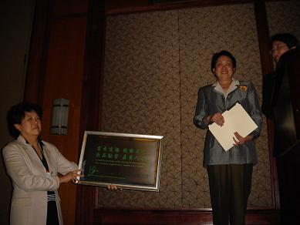

Photos from the annual CLTA conference in Baltimore
November 28-20, 2005

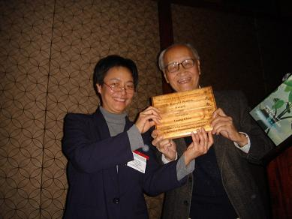
Tthe CLTA Walton Award for lifetime achievement in the field of Chinese language pedagogy was presented to Professor Tsung Chin of the University of Maryland at College Park.

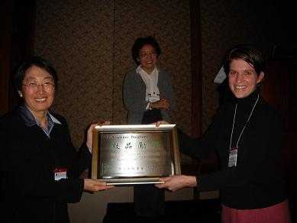
Jocelyn Flint, representing Mark Lenhardt, the director of CET academic programs, receives a plaque from CLTA. Mark Lenhardt donated $2000 to the Jiede Fund.
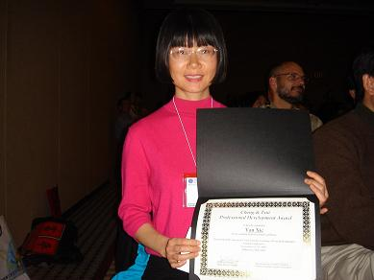
Yan Xie receives the 2005 Cheng & Tsui
Professional Development Award
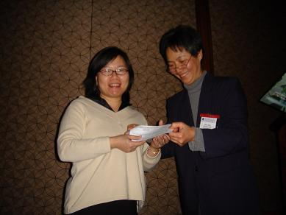

Alice Lee receives the 2004 Walton
Presentation Award
International Conference on Reading in Chinese Convened

On August 24-26, 2005, an interdisciplinary conference entitled ‘Hanzi Renzhi’ was held in Germany to explore ‘How Western learners discover the world of
written Chinese.’ Convened at the School of Applied Linguistics and Cultural Studies in Germersheim, Germany, this conference brought together an international audience of scholars, researchers, and teachers to share research and ideas about how Western learners develop the ability to read in Chinese. Designed to address the growing need for Chinese reading specialists across a host of occupations and disciplines, a report of this memorable and ground-breaking conference will be published in the next Journal of the Chinese Language Teachers Association. ( by Michael Eeverson)

第四届美西地区中文学校教学研讨会在加州举行

第四届美西地区中文学校教学研讨会于十一月十二日至十三日在加州 Burlingame 举行。
参加这次会议的有来自加州、德州、俄勒冈州等地 名教师。来自中国的与会人员有35人，其中包括汉办、安徽省和云南省侨办以及各地大学和出版社的代表。
此次会议召开之时正值全美推广AP中文课程前夕，因此主要内容集中在AP考试及课程有关的题目。旧金山总领事馆总领事彭克玉到会致辞。中国国家汉办办公事副主任马箭飞发表书面讲会。
会议共进行了四场大会发言，六场小组讨论，发言和讨论内容包括：AP课程和考试及其对今后中文教学的影响以及相应的教材和师资培训问题、中文学校教材的使用和编写问题和各种教学理论和方法的介绍和讨论。
本次会议由美国加州中国语言文化教学研究中心主办。会议的发言（全文或摘要，以及中文学校及研究机构的目录和简介）已编印成册。有需要者可与该中心联系：CLERC, 510 Broadway, Suite 500, Millbrae, CA94050. (by Tianwei Xie)

Conference News

Call for Papers
The 2006 Conference of the Chinese Language Teachers' Association of Greater New York (CLTA-GNY) & the Fourth New York International Conference on Teaching Chinese
大紐約地區中文教師學會2006年年會暨第四屆紐約國際中文教學研討會
多方位的中文教學

Date: Saturday, May 6, 2006
Location: Hunter College, 695 Park Avenue, New York, NY 10021
Conference chair: Dr. Derlin Chao

The theme of the conference is "Teaching Chinese in Multiple-Perspective” and will focus on the following topics:

Method and Actualization: Teaching Chinese as a second language and application strategies, including teaching pronunciation, grammar, reading, and writing, and classroom methods.
- Cultural Strategies: Meeting the needs of Chinese language learners of different backgrounds, including teaching culture through language, the language of Chinese culture, and cultural contextual designs for teaching Chinese to heritage and non heritage learners.
- Facing Challenges: Text and materials development, planning innovative lessons, and past experiences and future prospects.
- Outside Models: Learning from how other languages are taught.
- Technology: Multimedia, distance learning, digital technology, computer teaching.
- Practical Application: Chinese in the humanities and practical Chinese, including Business, Legal, and Professional Chinese.
The CLTA-GNY Conference Committee welcomes submissions of one page proposals on subjects relevant to the above themes. Papers can be either in Chinese or English. We will consider proposals for panels as well as individual papers and all proposals will be reviewed anonymously. Individual papers will be grouped into panels by themes. Panels will be 75 minutes long with four presenters. Please note that we will need separate abstracts for each paper on any panel proposal.
Please send your proposals to the below address(es) to be received by us by March 15, 2006. Both paper and electronic forms are acceptable, though we encourage and prefer e-mail submission.
Email submissions should be sent to: secretary@clta-gny.org

Mailing address is:
Chinese Language Teachers Association of Greater New York
125 East 65th Street, New York, NY 10021

Please include the "Attendee's Information Form" downloadable from http://clta-gny.org with your proposal. Notice of acceptance will be sent out by March 31 electronically. Anyone who needs a hard copy of the notice should include a special request with their proposal.
Following the conference, we plan to produce a CD of the conference proceedings. Authors of accepted papers who wish to have their papers considered for inclusion in the proceedings should plan to supply us with a hard copy and a disk copy of their papers. The required format for these papers is: 1” margin on the four sides, 12 point font; English papers should use MS Word with Times New Roman font; Chinese papers should use MS Word with SimSun or PMingLiU font or NJSTAR.
For information about CLTA-GNY, please visit http://clta-gny.org. For details about the conference, including the conference registration form, please visit http://www.clta-gny.org/06conf/invitation.html. The conference registration fee is $20 (made out to CLTA-GNY).
We hope to see you in New York in May!

「第八屆世界華語文教學研討會」
第一號通知

- 宗旨
研討世界華語文教學發展，增進國際學術文化交流。
- 會議內容
除安排專題演講之外，本屆會議內容將分為「論文發表」、「工作坊」、「座談會」、「論文壁報展示」五部分。
- 論文發表：論文發表分為「語文分析」、「教學分析」二組，需先經摘要審查，重點如下：
- 論文分析組：（以教學為主之語文分析）
1.華語語音、文字、詞彙、語法、語意及語用之研究。
2.華語與其他語言之對比分析。
（二）教學研究組：（以華語作為第二語或外語之教學研究）
1. 華語文教材、教法、能力評量及師資培訓之探討。
2. 漢字教學之探討。
3. 多媒體、電腦科技輔助華語教學上之研究。
4. 本土文化與鄉土語文教學之探討。
5. 兩岸華語教學之比較研究。
6. 華語文學習歷程研究。
四、工作坊：需先經計畫審查，內容可包括：
1. 教材、教學或課程設計之介紹與實作。
2. 現代科技在教學上之介紹與應用。
3. 測驗評量系統之製作與介紹。
五、座談會：
海內外華文教學相關問題之探討。
六、論文壁報展示：須先經審查
1. 海外華文學校（含僑校）之介紹。
2. 海內外華語中心和相關機構之介紹。
3. 華語文相關數位科技產品及出版品之介紹。
七、參加辦法：
- 提論文者：請將報名表及摘要於2006年3 月31 日前寄至本會（郵戳為憑）。
（可利用郵寄、電子郵件等方式送達）
- 摘要限中文，字數以1,200字為原則，請以A4或Letter Size紙張橫式打字，手稿恕不接受。
- 摘要內容至少包括：探討主題、取材、研究方法、預期研究成果、相關文獻及評述等。（請勿寄全文）
- 投稿之論文必須未曾公開發表。
- 論文摘要經本會遴聘華語文學者組成學術審議團匿名審查，結果將於2006年5月31日前通知。
- 論文摘要審查通過接獲本會邀請發表者招待會期膳宿，並贈送會前論文集全套。
- 不提論文者：報名表請於2006年3月31日前寄至本會（郵戳為憑）。
- 會議註冊費：每人新台幣3,000元。

八、會議語言：華語
九、會 期：2006年12月28日至12月30日
十、會議地點：台北市
十一、旅遊參訪：2006年12月31日至2007年1月1日（兩日旅遊:中部日月潭/自費參加）。
十二、主辦單位：世界華語文教育學會 中央研究院語言學研究所
地址：100台北市中正區寧波東街1號4樓
電話：886-2-2351-1385;2351-1735
傳真：886-2-2341-7064
電子郵件：wclc8@ms79.hinet.net
Web Site: http://www.wcla.org.tw


（歡迎影印轉知華語文學者、專家）

「第八屆世界華語文教學研討會」報名表
姓名 | 中文 | 性別 |  | 國籍
姓名 | 英文 | 出生日期
通訊地址 |  | 電話 | 公：
通訊地址 |  | 電話 | 宅：
通訊地址 |  | 傳真 | 公：
通訊地址 |  | 傳真 | 宅：
通訊地址 |  | 電子郵件
現職（服務機構及職稱）：

曾否參加本會舉辦之「世界華語文教學研討會」：（請√示）
□第一屆 □第二屆 □第三屆 □第四屆 □第五屆 □第六屆 □第七屆
□未曾參加
參加方式：（請√示）
□提論文 □不提論文
論文題目：

會議分組：（請依所提論文性質先行√示）
□語文分析組 □教學研究組 □工作坊 □座談會 □論文展示
填表須知：（請參閱參加辦法）
1. 本表及摘要（提論文者）請於2006年3月31日前以傳真或電子郵件方式寄至本會。
2. 本表請打字或以正楷書寫 。
3. 合寫論文者請分別填寫報名表並註明合寫者，以便統計人數。

******************************************************************************

The 5th International Conference on Chinese Language Pedagogy
August 7-9, 2006, Shanghai, China
(Announcement#2)

You are cordially invited to attend the 5th International Conference on Chinese Language Pedagogy. If you missed Announcement #1, please visit:
http://eall.hawaii.edu/yao/conf2006/notice1.htm
Please send in your attendee’s form ASAP (The form is at the end of Announcement #1)
Here are some important dates for the conference:
January 31, 2006: Abstract due (if you plan to present a paper)
April 30, 2006: Registration form due (Click here to download the form)
April 30, 2006: Early-bird registration fee due. Personal checks will be accepted. Early-birds will enjoy:
a. Free airport pick-up on August 6, 2006, at Pudong International Airport
b. Guaranteed free copy of the conference proceedings
c. Guaranteed spot for the free Shanghai city tour
d. Guaranteed hotel reservation
May 31, 2006: Paper due (if you wish to have your paper included in the conference proceedings)
May 31, 2006: Last day for paying the registration fee by check. If you don't mail your check by today, you will pay the registration fee at the conference site.
August 6, 2006: On-site registration. Only cash (either in RMB or US dollars) will be accepted.
August 10-12, 2006: Optional tours: #1 Hangzhou, #2 Shaoxing, #3 Qiandaohu, #4 Huangshan
For more information, please visit the conference website: http://eall.hawaii.edu/yao/conf2006/menu.htm

Positions

University of Colorado
The Department of East Asian Languages and Civilizations, the University of Colorado, seeks a CHAIR. Candidates should have a background and doctoral degree (PhD or equivalent) in Chinese or Japanese literature, linguistics or cultural studies, and should establish their eligibility for a senior appointment at the level of Professor by having an outstanding record in teaching and scholarship. The department currently offers B. A. and M.A. degrees in Chinese/Japanese language and literature, and Chinese/Japanese language and civilization, and a non-degree program in Korean language. The Department is expanding its scope to include other geographical areas of Asia, and anticipates being renamed to reflect this expansion; language instruction in Hindi will commence in the 2006-2007 academic year. In addition to continued scholarship and teaching, the Chair will provide leadership for the Department during this transition period. The Chair will also participate in developing doctoral programs in Chinese and Japanese. Candidates should send a letter of interest, curriculum vitae, names of three referees to: Chair, Search Committee, EALC, University of Colorado, 279 UCB, Boulder, CO 80309. Review of applications will begin on October 15, 2005. The University of Colorado at Boulder is committed to diversity and equality in education and employment.

Florida State University.
Chinese language instruction starting Fall 2006: Full-Time Instructor
The Department of Modern Language and Linguistics at The Florida State University invites applications for a full-time instructor in Chinese at the level of Assistant-In (equivalent to lecturer), beginning August 2006.
This position requires an MA or PhD in either Chinese linguistics, Chinese language and literature, second-language acquisition, or other relevant fields. Also required are native or near-native proficiency in Mandarin and English, ability to teach undergraduate Chinese courses at all levels, and long-term commitment to the development of the Chinese Program. Familiarity with the use of multimedia and online technology in language instruction is preferred. Responsibilities include teaching 6 courses (24 credit hours) per academic year and coordinating teaching assistants. Salary is competitive and commensurate with experience.
Send letter of application, curriculum vitae, three letters of recommendation, sample teaching evaluations, and a videotape of classroom teaching to: Dr. William Cloonan, Chair, Department of Modern Language and Linguistics, Florida State University, Tallahassee, Florida 32306-1540. Review of applications will begin December 5, 2005 and continue until the position is filled.
The Florida State University is an equal opportunity employer and encourages applications from women and members of minority groups.

Kalamazoo College
Kalamazoo College invites applications for a two-year position (with third year renewal possibility) in Chinese language and humanities to begin in the fall of 2006. Teaching responsibilities will be focused on Chinese language, literature and/or culture courses. Familiarity with the use of information technology in language instruction is a plus. Native/near native fluency in Chinese and English is required. Candidates are expected to have high aptitude for and interest in undergraduate teaching, a commitment to the liberal arts, and a desire to involve undergraduates in scholarship both in and out of the classroom. PhD or master’s degree in a relevant field required. Salary competitive and consistent with experience. Completed applications received by February 1, 2006, will receive full consideration, with later applications reviewed as needed. Send curriculum vitae (including description of scholarly interests), undergraduate and graduate transcripts (unofficial acceptable), detailed statement of teaching philosophy and goals, and three letters of recommendation to Chinese Search Committee, Center for Asian Studies, Kalamazoo College, 1200 Academy Street, Kalamazoo, MI 49006-3295. For more information about the College, see our home page at www.kzoo.edu. Kalamazoo College encourages candidates who will contribute to the cultural diversity of the College to apply and to identify themselves if they wish. EOE.

Wellesley College
Associate or Full professor Position in Chinese Language
The Department of East Asian Languages and Literatures invites applications for an associate or full professor of Chinese, with a PhD in linguistics and/or second-language acquisition. This position will begin July 2006. Extensive experience in teaching Chinese and research/publications in language pedagogy or linguistics is required. Candidates must have proven ability in the use of putong hua, written and spoken at native or near-native level, as well as broad experience teaching college-level modern Chinese in the United States. We seek excellence in teaching, scholarship, leadership, and administration. The successful candidate will have the ability to work with colleagues in the East Asian languages and studies programs. The application deadline is December 1, however, the search will continue until the position is filled. Interested candidates should send a letter of application, CV, one sample of published research, and three letters of recommendation to: Chair, Search Committee, Department of East Asian Languages and Literatures, Wellesley College, Wellesley, MA 02481-8203, USA.
Wellesley College is an EO/AA educational institution and employer. The College is committed to increasing the diversity of the college community and the curriculum. Candidates who believe they will contribute to that goal are encouraged to apply.

Williams College
CHINESE LANGUAGE FELLOW
Applications are invited by Williams College for a Chinese Language Fellow (Intern) for the 2006-2007 academic year. Applicants should have native or near-native fluency in Mandarin; hold or be candidates for an M.A. in Chinese Language Pedagogy, Linguistics, Literature or a related field; and possess relevant teaching experience. Responsibilities include class preparation, team teaching of language classes in close cooperation with faculty members, and other work in support of the Chinese language program. Fellows receive room and board, insurance, and an annual stipend of $16,000. The application should include cover letter, CV, audio recording with self-introduction and teaching philosophy in Mandarin, and at least one letter of recommendation. Review of applications will begin March 1, 2006 and continue until the position is filled. Applications should be sent to Professor Christopher Nugent, Search Committee, Chinese Program, Dept. of Asian Studies, Williams College, Williamstown, MA 01267, USA.

Book News

Beginner’s Chinese Dictionary

Author: Li Dong
Publisher: Tuttle Publishing
Distributed by: Tuttle Publishing, Airport Business Park, 364 Innovation Drive, North Clarendon, VT 05759-9436
Date: 2004. ISBN: 0-8048-3551-9 (204 pages)

Beginner's Chinese Dictionary is geared exactly to Part A of the Hanyu Shuiping Kaoshi (HSK) vocabulary list （汉语水平考试甲级词）.
It provides characters analysis for the formation of each character to make Chinese character-learning meaningful and interesting. It also analyse the word-formation methods for most words of two or more syllables to aid memory and understanding.
A unique feature of the dictionaries is that for each headword one or more example sentences are provided in characters, pinyin, and English translation.
Many entries contain cultural notes giving essential information on cultural context, pronunciation, grammar and usage to help the student use the words in a correct and idiomatic way.
The dictionaries also list common collocations (with example sentences) and antonyms, whenever appropriate.

Chinese Link: Zhongwen Tiandi 中文天地

Prentice Hall proudly presents the first year text for the series, CHINESE LINK: ZHONGWEN TIANDI by Sue-mei Wu, Yueming Yu, Yanhui Zhang, and Weizhong Tian. This new, communicative, learner-centered approach focuses on the development of the four basic skills language (listening, speaking, reading and writing) and provides an abundance of in-text activities. The Chinese Link section in each chapter exposes the students to Chinese culture and includes further expansion activities and those which require students to make cultural comparisons.

To receive a complementary desk copy (please specify whether you would like the traditional or simplified character version), please contact language_service@prenhall.com.

Traditional Character ISBN# 0-13-193033-8 http://vig.prenhall.com/catalog/academic/product/0,1144,0131930338,00.html
Simplified Character ISBN# 0-13-194604-8 http://vig.prenhall.com/catalog/academic/product/0,1144,0131946048,00.html

Topic Chain: A Discourse Analysis and Applications in Language Teaching

Author: Wendan Li
Publisher: Muenchen, Germany: Lincom Europa
Year: 2005
ISBN: 3-89586-371-8
Chinese is a discourse-oriented language. It has relatively few morphological and syntactic rules, but more constructions and strategies at the discourse level for the organization of text. The topic chain is such a structure at the discourse level in which clauses are linked not by conjunctions, but by co-referential relationships between overt topic noun phrases and unspecified noun phrases in adjacent clauses. Since the topic chain is used frequently in Chinese, the understanding of the structure is important to the understanding of the language. This book analyzes the structural characteristics of topic chains, their functions in discourse organization and their commonly occurring patterns. It demonstrates how the patterns are used either individually or in combination to build up units of text at the discourse level. The analysis also has its practical application in second language teaching. It is shown in the second part of the book that the patterns of topic chains can be used as a transitional measure to lead students' production from the clause to the discourse level. The study is an attempt to investigate how discourse patterns, structures and strategies can be effectively taught in second language classrooms to reflect the discourse-oriented nature of the Chinese language. It bridges the gap between linguistic analysis and language pedagogy.

Tuttle Learner’s Chinese-English Dictionary

Author: Li Dong
Publisher: Tuttle Publishing
Distributed by Tuttle Publishing,
Airport Business Park, 364 Innovation Drive, North Clarendon, VT 05759-9436
Date: 2005. ISBN: 0-8048-3552-7 (348 pages)

Tuttle Learner's Chinese-English Dictionary is complied on the same on the same principles and format as Beginner's Chinese Dictionary, but is geared to both Parts A and B of the HSK vocabulary list （汉语水平考试甲级词和乙级词）. Apart from conventional contents, entries include word-formation analysis, antonyms, measure words for nouns, traditional characters, and common collocations.
With more words to work with, Tuttle Learner's Chinese-English Dictionary is able to provide numerous communicatively effective example sentences written in idiomatic, lively Chinese, relevant to students’ everyday and professional needs.
More cultural notes are provided, covering essential information that correct use of Chinese depends on.
Like Beginner's Chinese Dictionary, Tuttle Learner's Chinese-English Dictionary contains the section “English-Chinese Word Finder”, which is practically an easy-to-use English-Chinese dictionary, enabling the learner to get instantly the Chinese word he wants to use.

Web Resources for Chinese Teaching and Learning

Author: Xie, Tianwei
Publisher: ChinaLang Publishing
Year: 2005
ISBN: 1-4116-5675-X (129 pages)
This annotated bibliography provides links to web sites for teaching and learning Chinese. One can easily find a web site by checking the index. Although the original data can be accessed at the web site ‘www.csulb.edu/~txie/online.htm’, having a hard copy will add convenience to teaching and learning activities. When one may just wants to get a quick idea about some resources or temporarily does not have a direct access to computers, this book can hlep. Due to the dynamic characteristics of the online resources, some web sites or links may have changed or disappeared and some new useful web sites will appear, this book has a cut-off date for collecting data. Any new sites or links that appear after July 2005 will be collected either on the web ‘Learning Chinese Online’ or in the future updated version. The book can be ordered online at http://www.lulu.com/xietianwei
Or contact: info@chinalangpublishing.com

Software and World Wide Web News

EStroke Animated Chinese Character is an economical and effective tool for learning Chinese. Estroke shows stroke by stroke how each and every Chinese character is written. It also shows the corresponding English meaning for each character, commonly used phrases associated with that character as well as pinyin of that character.

Input to eStroke is easy and convenient. If you come across any Chinese character in a document or while browsing a website and you want to know more about that character, simply copy and paste that character onto eStroke. eStroke will show you how that character is written together with all the additional information associated with that character. You can also copy a string of characters and eStroke will animate each character in turn. Alternatively, you can use your favorite Chinese Input Method to input a specific character onto eStroke.

Estroke will pronounce a Chinese character and vary the pronunciation depending on the associated context the character appears in a phrase. Simply double click the phrases or Pinyin and eStroke will pronounce your selection for you. Alternatively, simply copy any Chinese character or sentence and eStroke will pronounce that for you.

You can download a 30 days evaluation copy of eStroke from http://www.eon.com.hk/estroke.

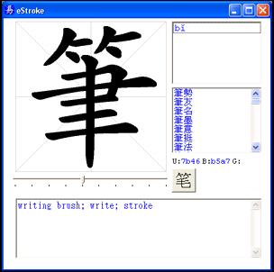

www.lulu.com – a self publishing web site
lulupress (http://www.lulu.com) 是一个新型网上自助出版社，自2002年成立至今已三年。所谓“自助出版”就是任何作者不通过出版社，在该网站上开设一个免费的账号，将自己撰写、排版的文稿包括封面和封底（pdf文件）通过电脑网络上传(upload)到该网站，并且指定开本大小装帧方法，购买书号(ISBN)，完成一系列传统出版社要做的工作。该网站根据作者的要求将书稿生成可印刷的电子文件，并且给该书一个专门的号码，以便作者今后在同一版本内加以少量修改（不改变ISBN）或者出版新的版本（使用新的ISBN）。同时将该书目列入美国出版界的Books in print，以及美国网上书店amazon.com的目录。读者或图书馆在lulu.com， amazon.com或者Books in print看到此书以后可在网上订购。书的价目由lulu.com和作者来决定。lulu.com根据书的页数，纸张开面以及装帧决定成本价，作者决定版税。这两部分加起来就是最后的书价。读者购买时再加上运费。此外还有一些高级的服务，如代客设计封面，市场宣传与推销等服务会收取额外的费用。本人试用了这一自助出版网站，出版了两本书稿，觉得颇为方便，也非常有趣：Web Resources for Teaching and Learning Chinese 和Conversational Mandarin Chinese Online. 有兴趣者可在http://www.lulu.com 的网站上用作者姓名 (tianwei 或 xie)查找，也可以从 http://www.lulu.com/chinalangpublish 直接找到这两本书。建议大家不妨自己尝试感受一下自助出版的经验。（by Tianwei Xie）

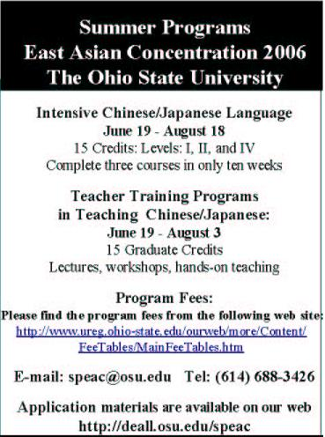

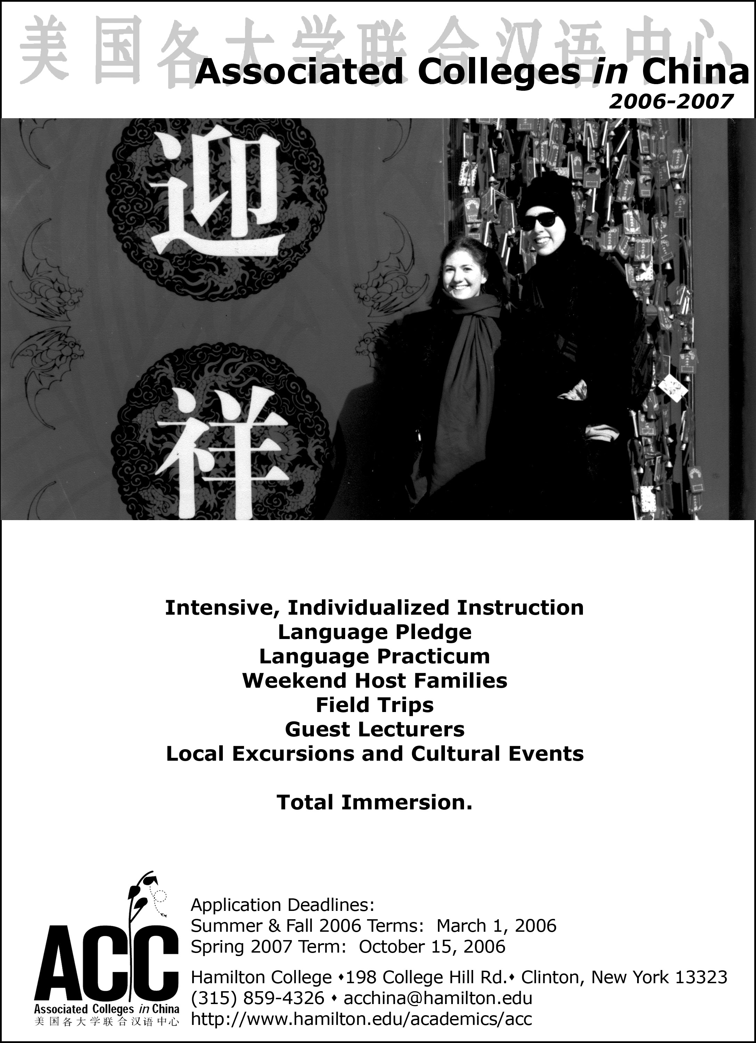

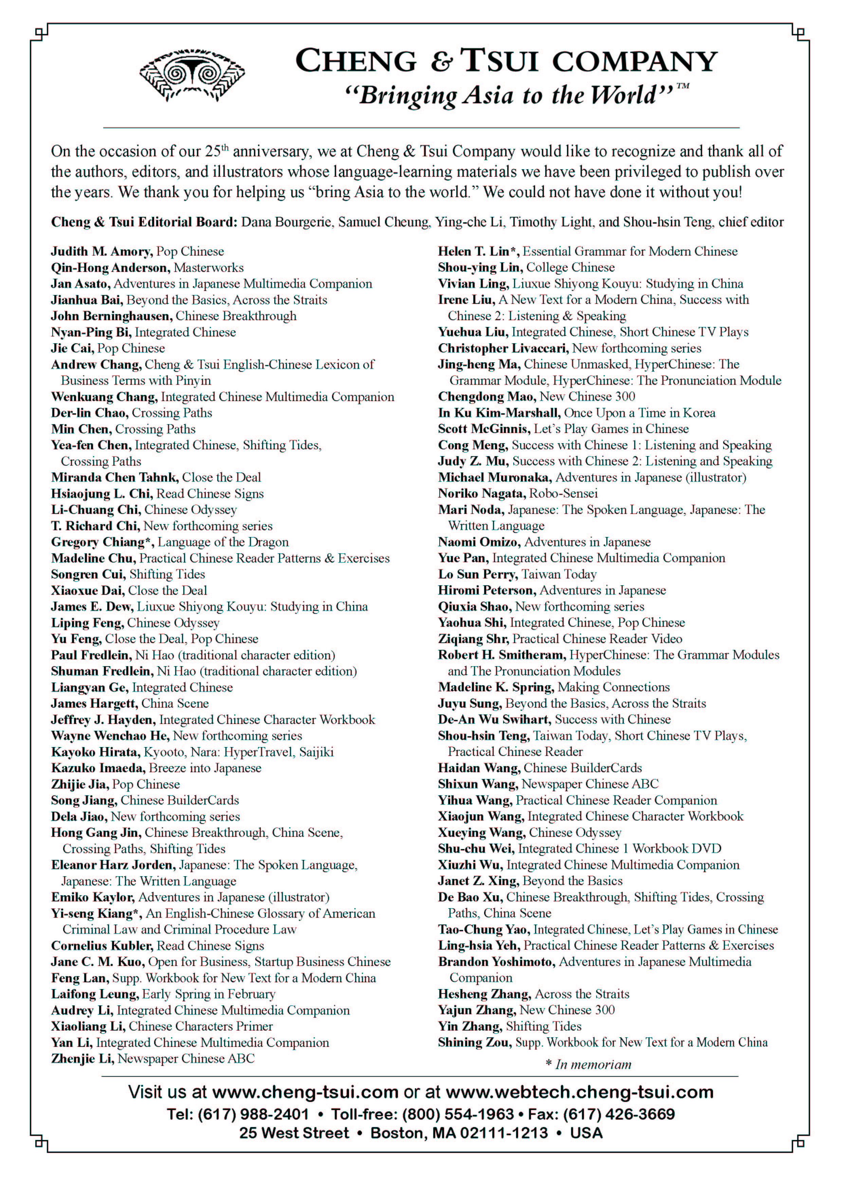

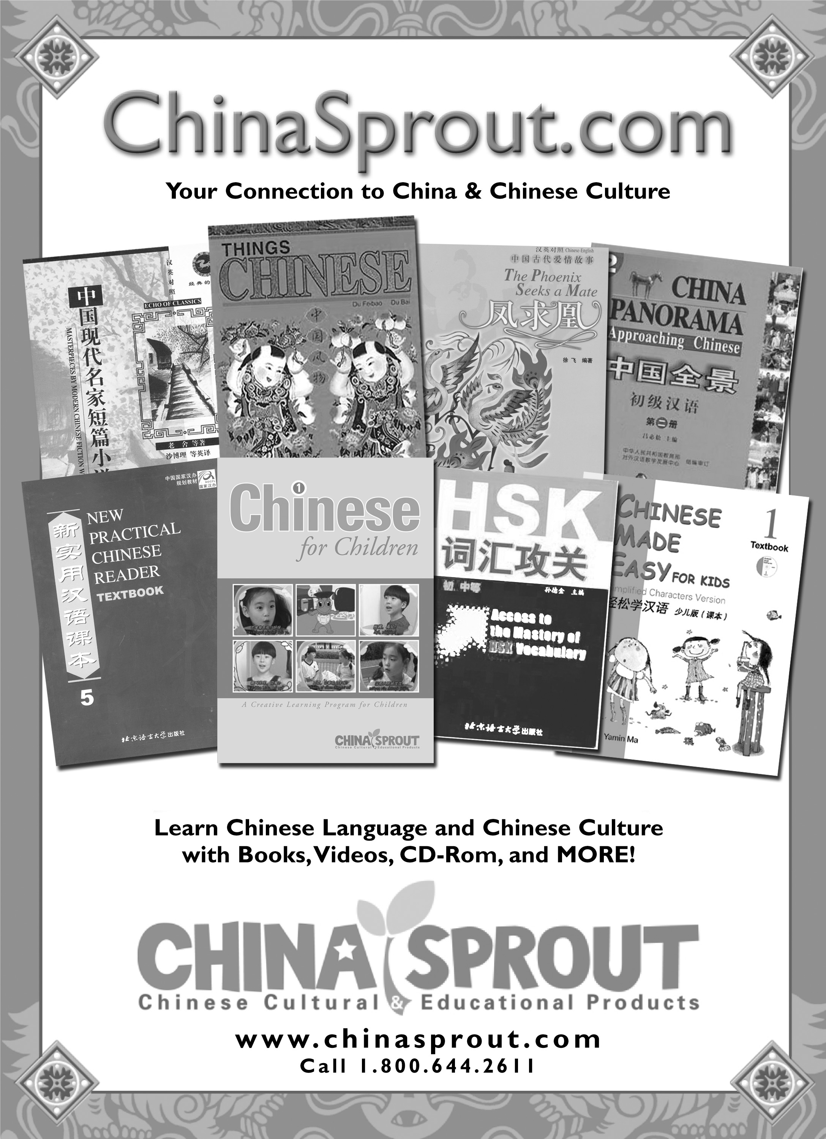

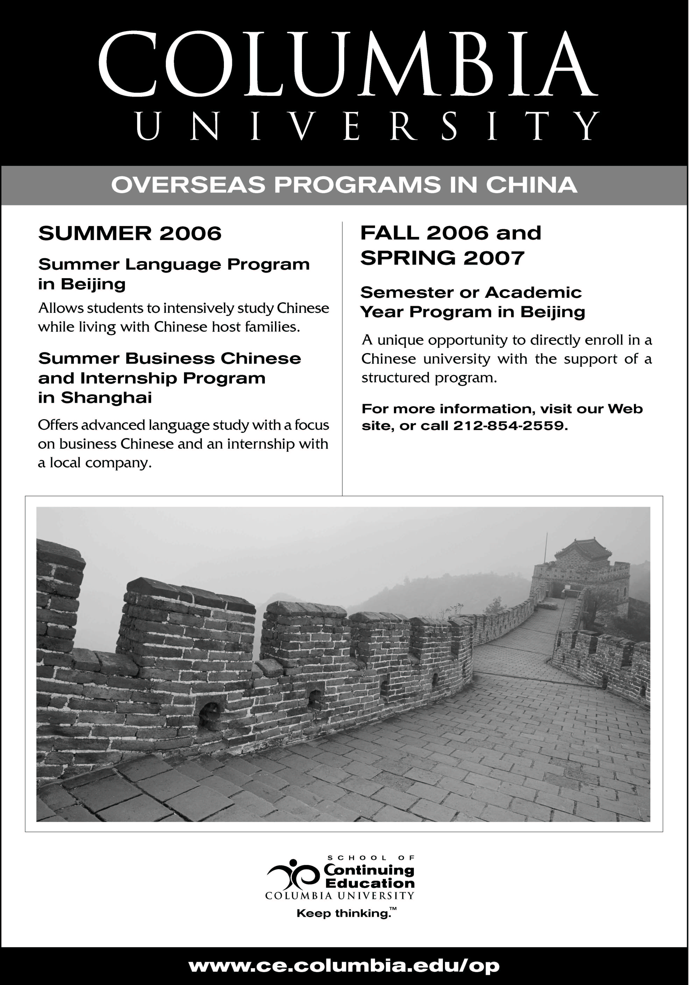

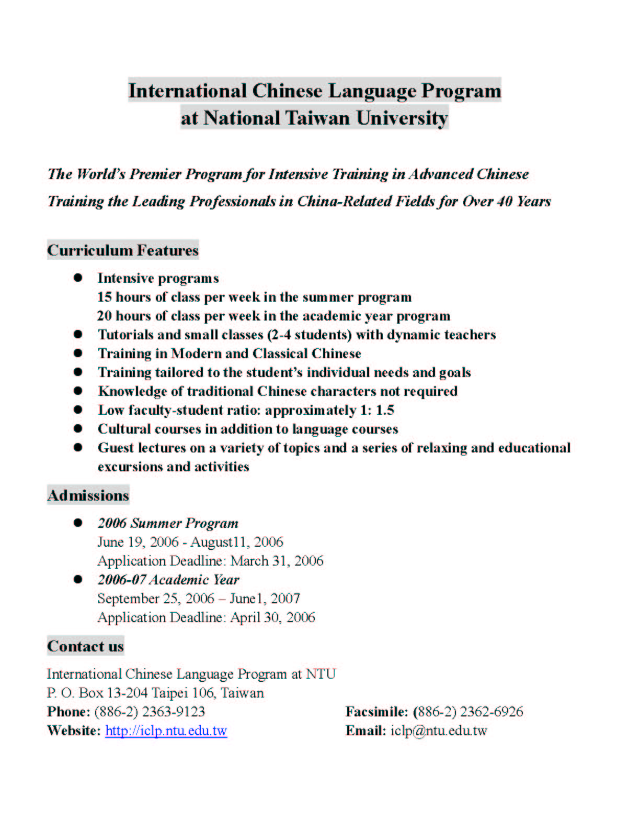

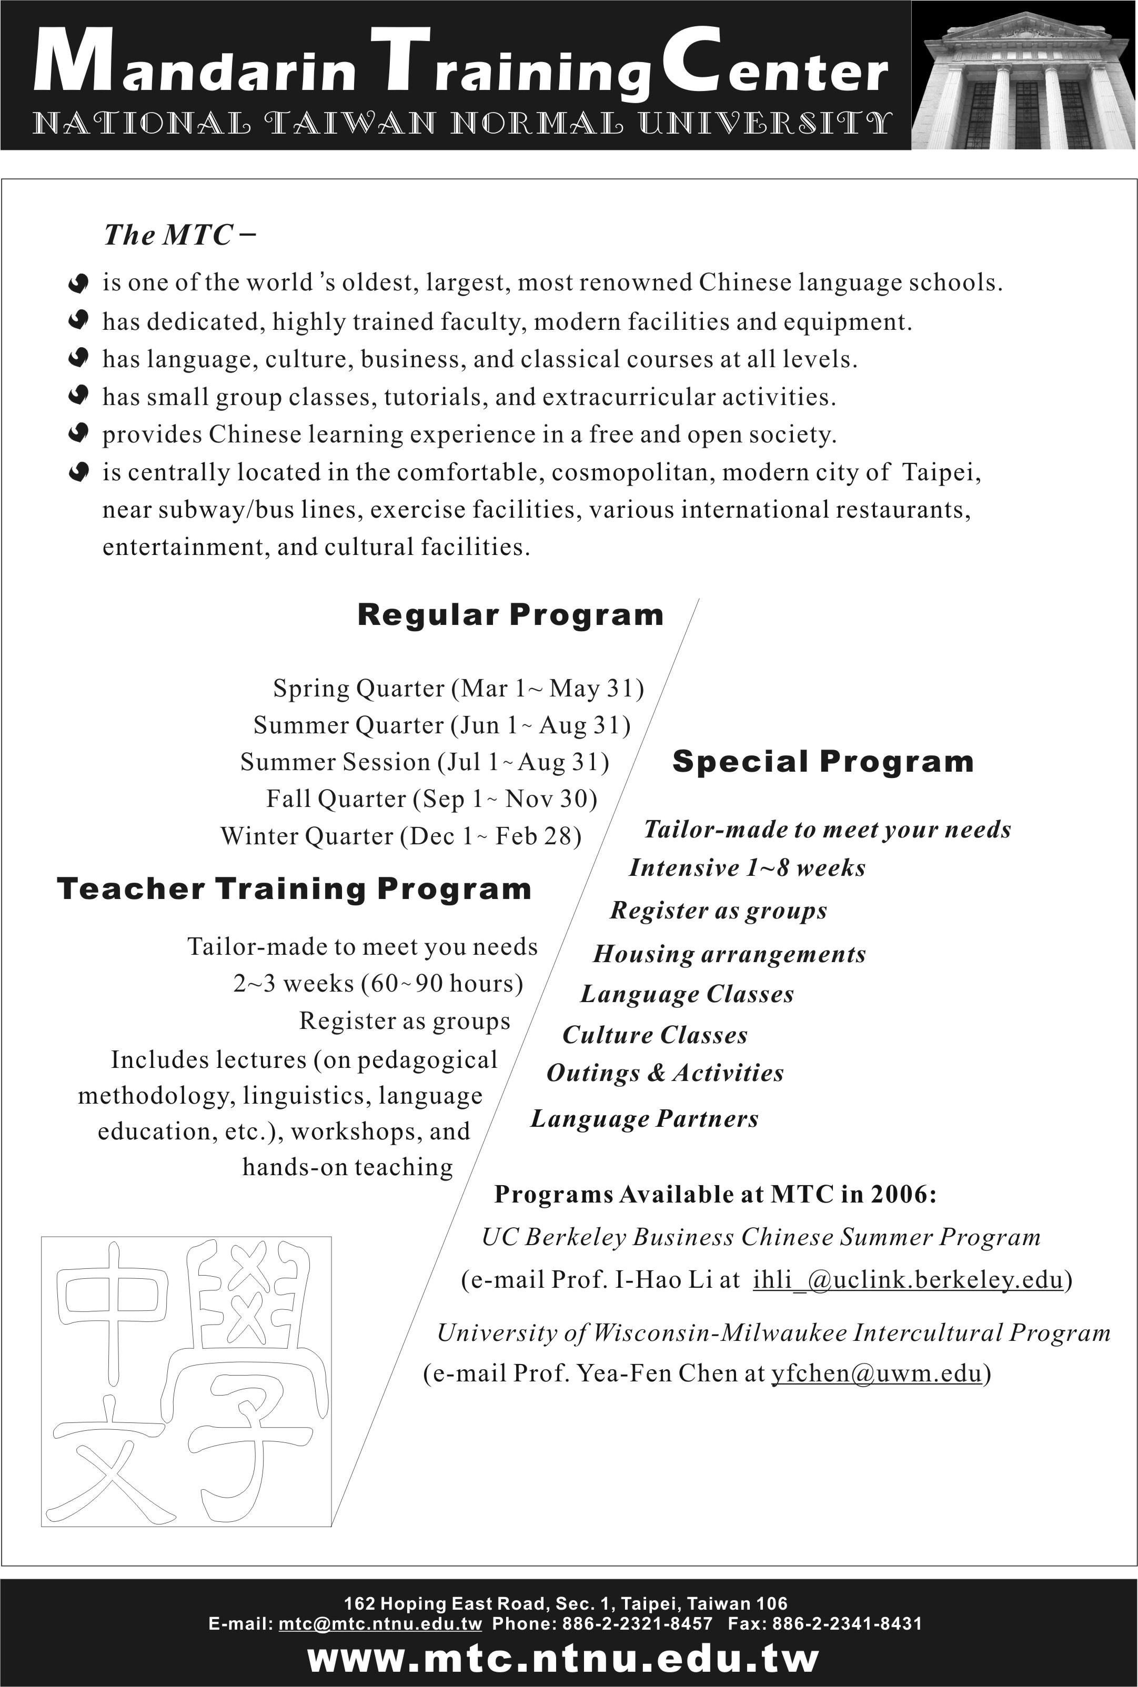
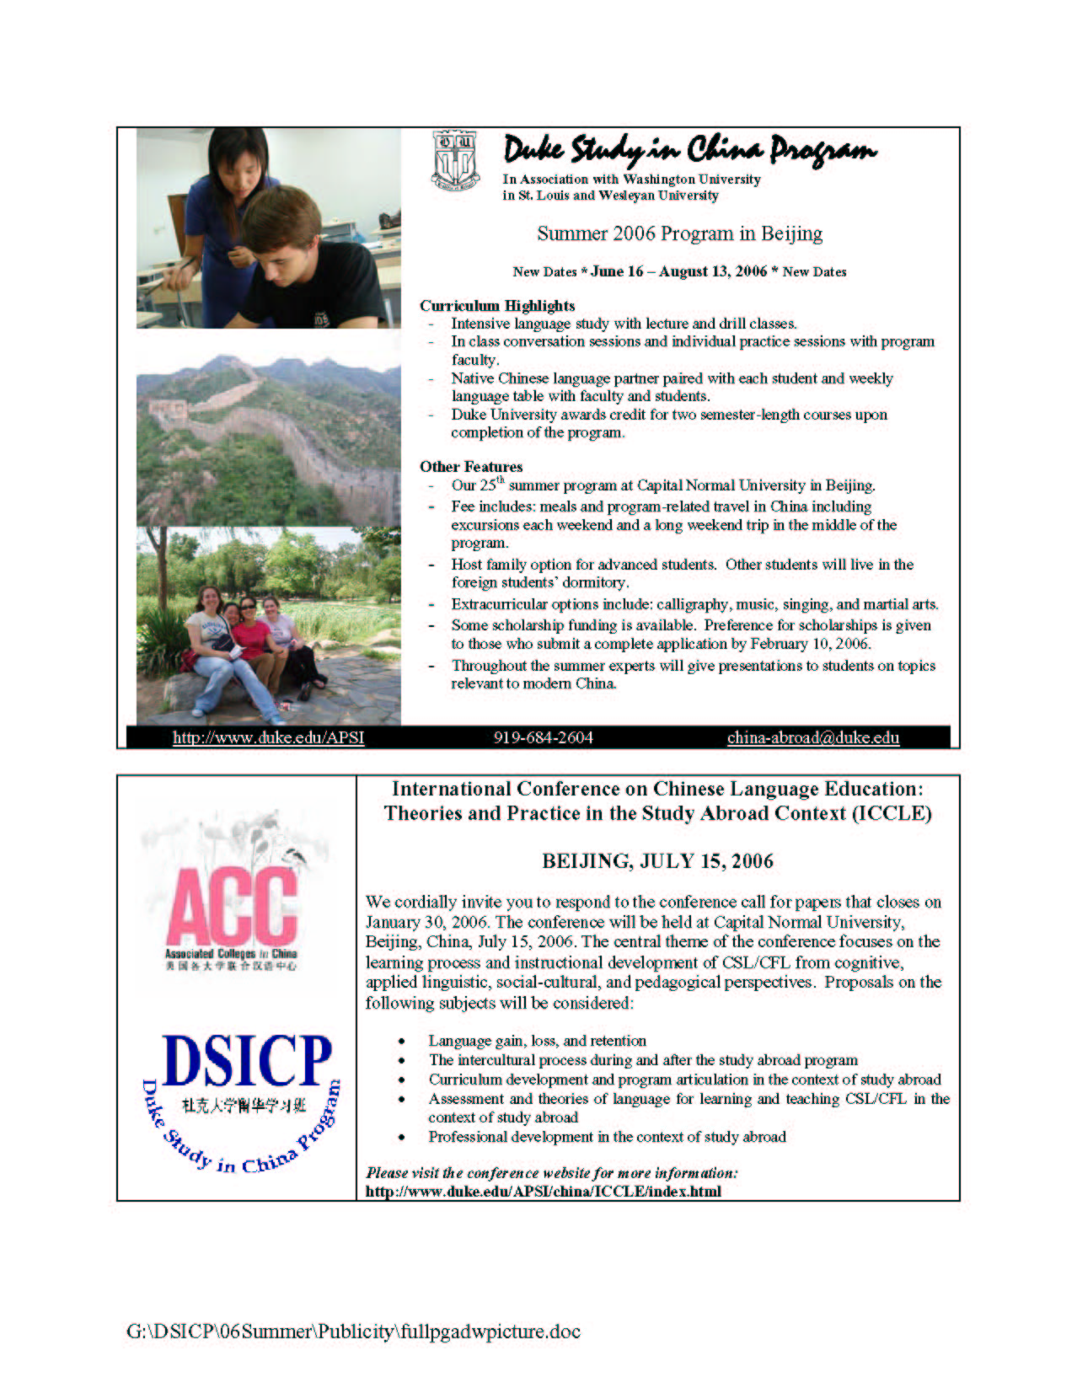

Chinese Language Teachers Association
417 Moore, 1890 East-West Road
University of Hawaii
Honolulu, HI 96822

ADDRESS UPDATE

Please fill out the form below if:

... Your address label is not properly printed
... You encounter a delay in receiving your CLTA journal or newsletter
... You have recently moved or will soon be moving

(Either school OR private address, NOT mixed)

Name: (Last) __________________ (First) _______________________

Dept./Street __________________________________________________

School ______________________________________________________

City ________________________________________________________

State/ Province ________________________________________________

Country _________________________ Zip Code ____________________

Tel. (work) _____________________ (home) ______________________

E-mail __________________________ Fax _________________________

Please mail form to: CLTA Headquarters, 417 Moore Hall, 1890 East-West Road, University of Hawaii, Honolulu, HI 96822

