IR Research Experiments

Thushini Manuweera F’10 | Hashini Wedagedara F’10
 | 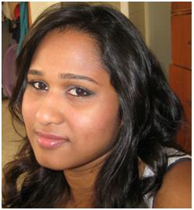

Table of contents
1. Reference Test
Medium Range
Long Range
2. Optical Conditions in front of the IR sensor
Test #1
Results obtained
Discussion
Test #2
Results Obtained
Discussion
3. Target surface properties
Test #1
Results Obtained
Discussion
4. Angle to Target
Test #1
Results obtained
Discussion
Future Work

Our objective of Conducting these experiments is to analyze the behaviour of the IR sensors (both long range and medium range)under different environmental conditions. We will be testing the IR sensors based on the the lighting conditions, method of filtration, surface properties of plaques and angle to the plaques.By conducting such experiment our goal is to come to conclusions on which how the environmental conditions affect our IR sensor readings and by knowing its behaviour under each condition be able to accurately execute our mission accounting for the errors that might be caused.

1. Reference Test
This test was conducted under minimal light conditions. The results obtained by this test will be used as the reference for the other tests.

Medium Range
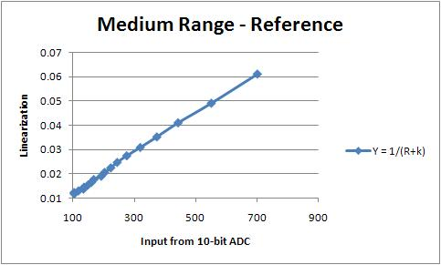

Long Range
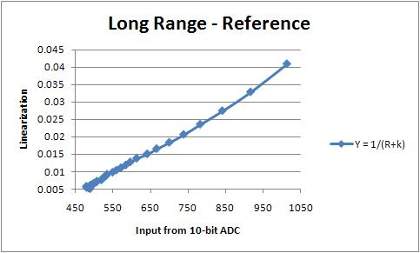

2. Optical Conditions in front of the IR sensor
In this section we will be testing the external disturbing light resistant characteristics of the IR sensor. For this we have conducted tests using methods of filtering, shading and shading tube. When performing these tests it is important to keep in mind not to obstruct the field-of-view of the IR sensors. The following diagrams illustrate the tests that were conducted.

1)Using only the filter- Here the filter that was used was a strip of developed film which was placed in front of the sensor, covering both emitter and receiver, at a distance of about 1mm as indicated in the picture.
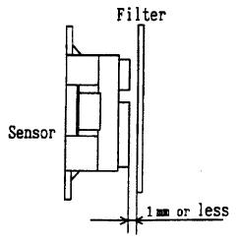
2)Using the filter + shading board - Here apart from the filter a shading board was placed in between the emitter and receiver. This was done in order to prevent unnecessary reflection caused by the filter.
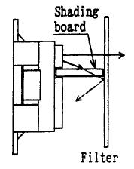
3)Using the filter + shading tube - Here apart from the filter a shading tube was used. This tube was placed over the emitter as shown in the diagram below and similarly as in the previous case was used in order to eliminate unnecessary reflection off of the filter.
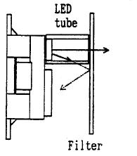
we will now take a look at the experimental results obtained under different lighting conditions.

Filtering devices

filter(developed film) | Tube(long range) | Tube(medium range) | Shade
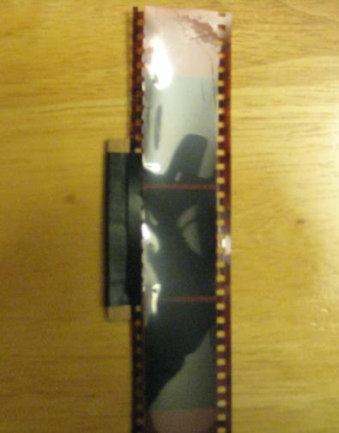 | 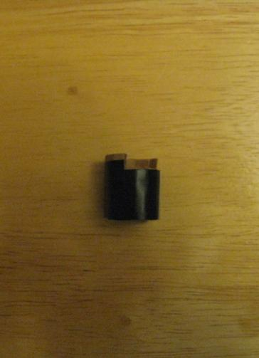 | 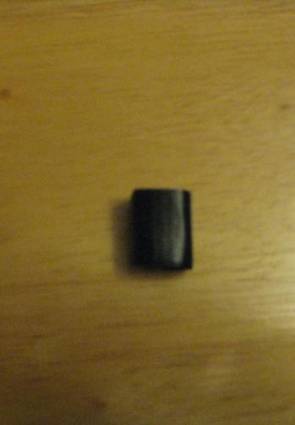 | 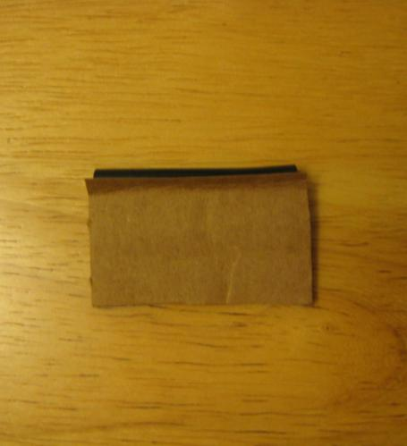

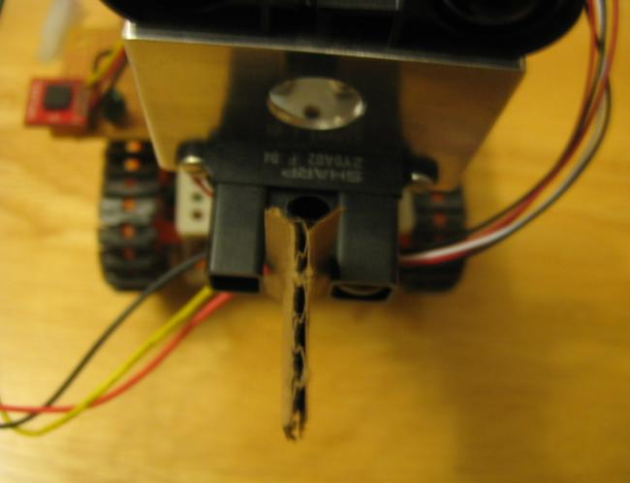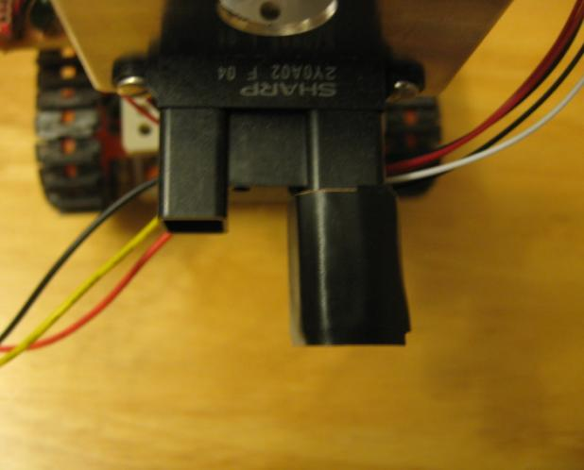

Test #1
- Location - VEC Quad area (out doors)
- Lighting conditions - Test conducted in a shaded area facing sun light.(The sun light does not directly hit the IR sensors.)
- Time - Between 10 a.m. - 12 p.m.
- Plaque - mat finished blue color file cover

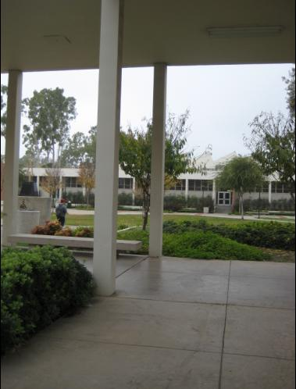

Results obtained
- Medium range IR sensor
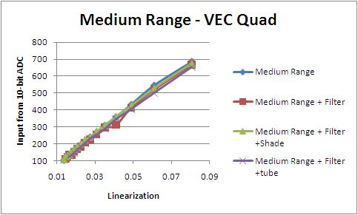

- Long range IR sensor
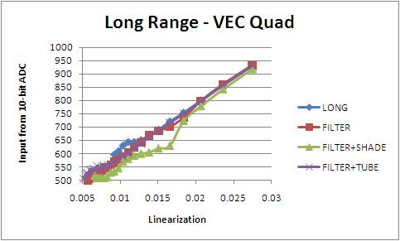

Discussion
Considering the graph obtained from this experiment it can be seen that the use of only a filter did not produce favorable results. The error might have been caused due to reflection off of the filter and in the case at which the filter is not parallel to the plane of the IR sensor then there is a possibility that the beam will change its path to travel at an angle less than 90 degrees to the plane of the IR sensor.
When using the filter + shade even though it seemed to give consistent readings with the medium range IR sensor when looking at the results from the long range IR sensor it can be seen that the readings did not come out to be accurate as much as the readings from the medium range sensor.
Looking at the readings given from the IR sensor when used with the filter + tube is shows to have given consistent readings in both cases. Therefore it can be concluded in this case that by using both the filter and the tube together we are able to eliminate most of the errors which are caused due to reflection and external light effecting the sensor. Also in order to correctly determine the path of the beam it is important to keep track of the direction in which the beam is transmitted. This can be achieved by constantly checking the beam with the use of the camera of a phone for example, in between taking readings.

Test #2
- Location - Outside the Recreation Center
- Lighting conditions - Test conducted under the bright white lights outside of the Recreation Center.
- Time - Between 6 p.m. - 9 p.m.
- Plaque - mat finished yellow color file cover

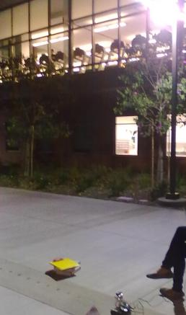

Results Obtained
- Medium range IR sensor
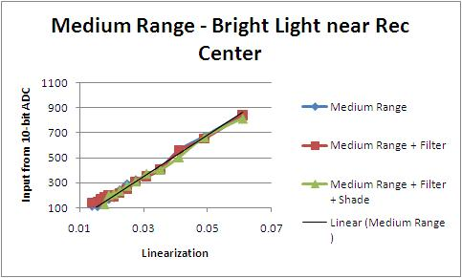

- Long Range IR sensor
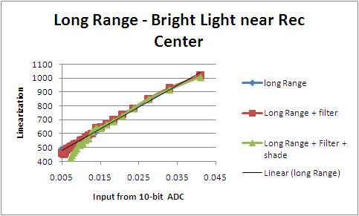

Discussion
Considering the two graphs obtained in this experiment using medium range and long range IR sensors for the medium range even though the results seem to consistent for the instance at which the filter + shade was used, when looking at the results from the long range IR sensor the graph obtained using just the filter seemed to be consistent than the others. But in both cases neither of them showed a considerable difference when compared with case at which only the IR sensor by it self was used.
Some of the errors that might have happened while conducting this experiment are, as mentioned in test #1 if the filter is not parallel to the plane of the IR sensor then there is a possibility that the beam will change its path. And also, if the beam was not directly hitting the plaque the also that might have altered the readings. Therefore it is important to always check the direction of the beam(ex- by using the camera of your phone) in order to determine if the beam directly hits the plaque.

3. Target surface properties
In this section of the research we are attempting to determine the effect of surface properties on the readings given by the IR sensors. For this purpose tests were carried out using different surfaces such as shiny, flat, rough, opaque, semi-transparent and transparent. Then the same test were conducted in a dark environment to test if the any kind of reflection(due to a particular surface property)off of the plaque caused alteration in readings.

Note: The Sharp IR sensor General Application Note includes a discussion done about the case in which a glittering reflective object with no diffused reflective light ingredient is used as the target.
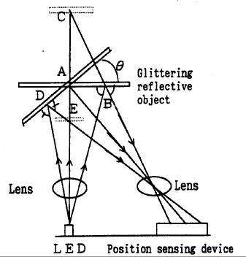
As the note describes if the reflected light comes in to the detector from point B it shall give the same output when there is a diffused lustrous reflective object at point C, therefore resulting an inaccurate reading.

Target materials

1) Flat
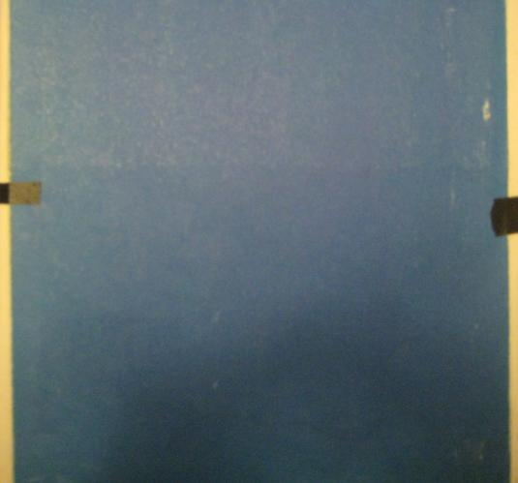

2) Shiny
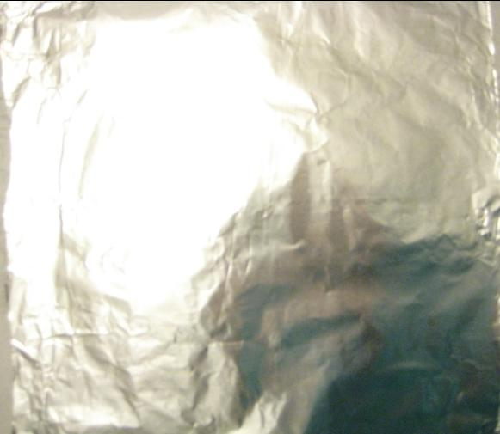

3) Rough
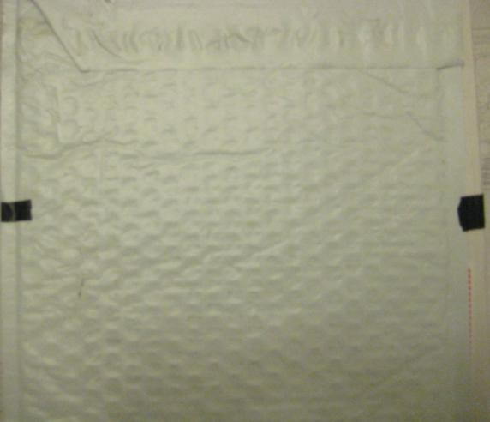

4) Opaque
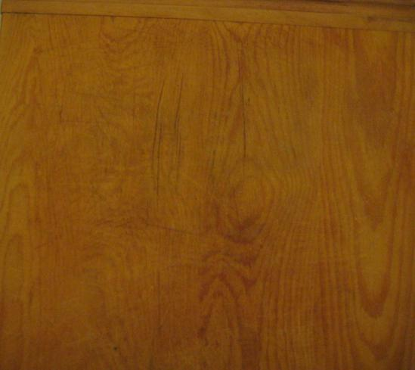

5) Semi-transparent
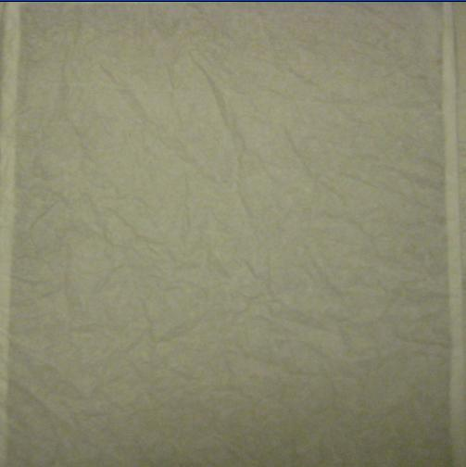

6) Transparent

Test #1
- Location - Indoors(at home)
- Lighting Condition - Under warm white fluorescent light directly facing the IR sensors
- Time - Between 5 p.m. - 9 p.m.

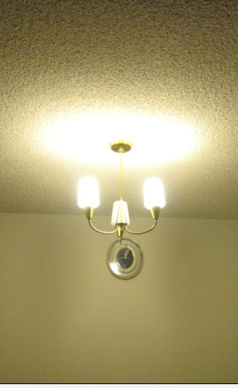

Results Obtained
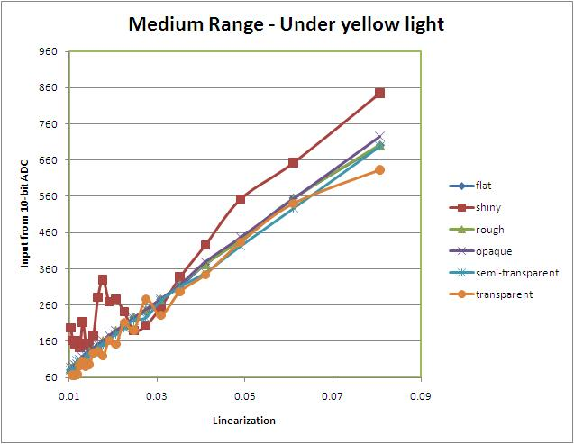

Discussion
In the above shown graph, the “flat” surface stands for the reference reading which we obtained under the mentioned environmental conditions using a regular flat plaque. When comparing the rest of the results obtained using the different kind of plaques it can be seen that readings obtained using the shiny and transparent plaques seem to deviate the most from the reference reading. This is because as explained above in the note, reflection due to the surface may result in the same reading for two different positioning.
And the errors caused by the transparent plaques can be some what explained by the theory of “Refraction of light”, which states that, Refraction is the bending of a wave when it enters a medium where it's speed is different, which this case the beam travels between air and glass(glass speed < air speed). Therefore if a glass or any kind of transparent type of material is used as a plaque it may generate errors in readings due to refraction of the beam.

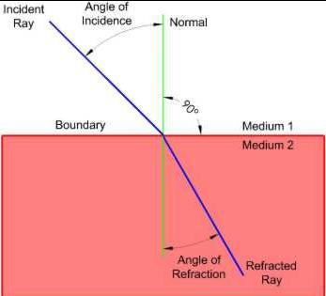

4. Angle to Target
In this section of the research we will be analyzing how the angle at which the beam hits the target effect the readings. A better understanding of this fact is important for the mission at the point at which the rover will be moving from one plaque to another plaque.
For the experiment we positioned the plaque at a certain distance from the rover and then obtained readings while changing the angle it makes with respect to the beam. The following diagram illustrate the test that was performed.
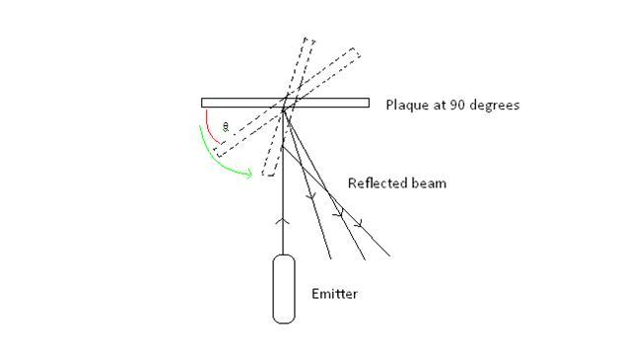
The following diagram shows how the readings were taken while changing the angle θ,
A compass in degrees was traced on to a transparent sheet.
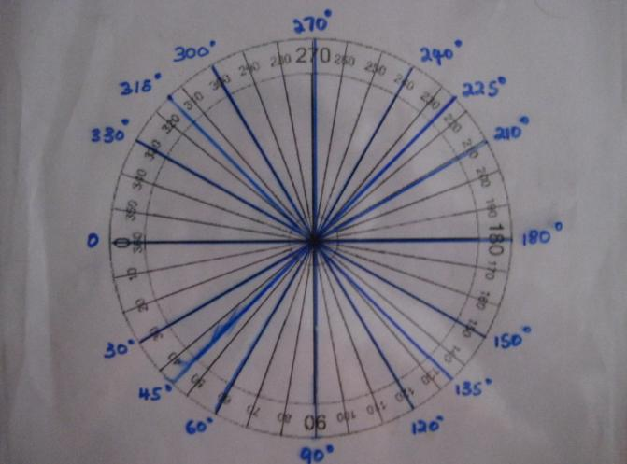
The plaque was placed in the following manner.
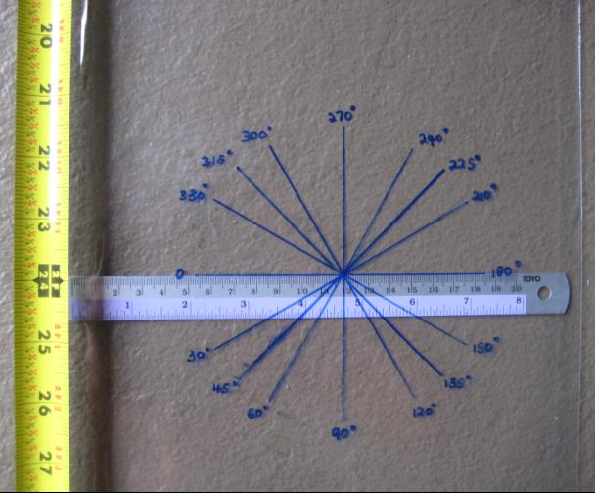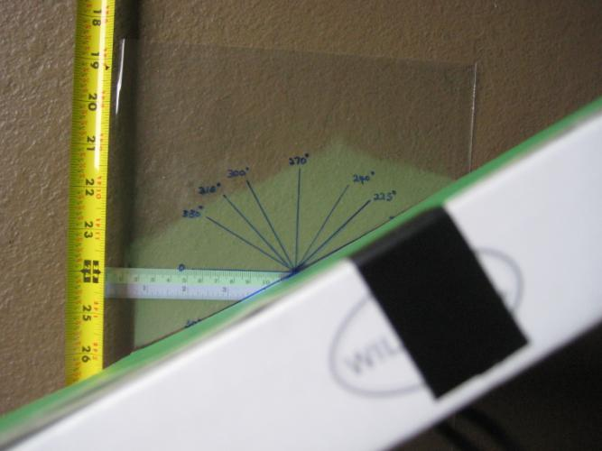

Test #1
- Location - Indoors
- Lighting Condition - Under normal light (no light source was present)
- Time - Between 9 a.m. to 11 a.m.
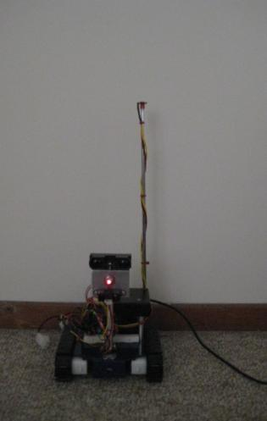

Results obtained
- Medium range IR sensor
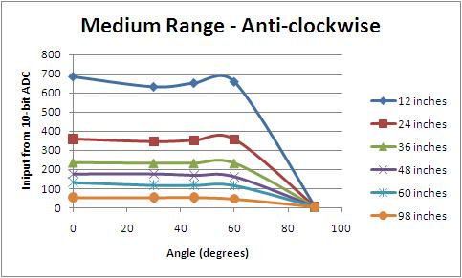

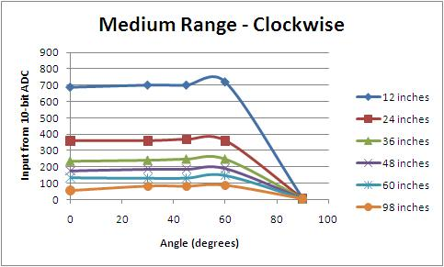

- Long range IR sensor
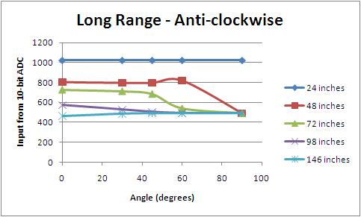

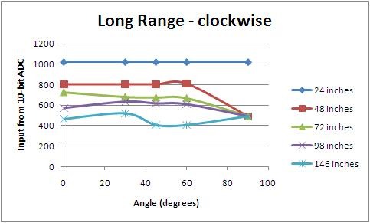

Discussion
Looking at the four graphs obtained from the experiment we can come to certain conclusions regarding the behavior of the beam when the plaque is placed at different angles in both clockwise and anti-clockwise directions.
Medium range
The results from the medium range IR sensor shows that even though the DN values seem to be constant up to about 40 degrees angle and it seems to be more linear as the distance from the rover increases. How ever at 90 degrees the values at all distances will be the same, which is the reading that we would get if there were no plaque. Because here, the plaque that we used is too thin in order to be detected by the sensor.
Long range
The results from the Long range IR sensor shows that even though the DN values seem to be constant up to about 40 degrees angle and it seems to be more linear for distances closer to the rover unlike the medium range results. Similar to the Medium range IR sensor, at 90 degrees the values at all distances will be the same, which is the reading that we would get if there were no plaque. The reading obtained at 24 inches was the same for all angles which is 1023 input from 10-bit DN value.

Future Work
- Observation of the actual signal being returned by the IR sensors and methods for eliminating noise.

