Effect of Two 5E Model Inquiry Lessons on Student Learning

California State University, Long Beach

Chapter I: Introduction
The use of inquiry in the science classroom receives a lot of attention, both good and bad. Both the National Science Education Standards (National Research Council, 1996) and the California Science Content Standards (California Department of Education, 2000) call for students to be able to conduct investigations and experiments. Competing with this desire to educate students in an inquiry rich environment is the demands placed on teachers and students by high-stakes standardized tests (Robertson, 2006). Students have to perform well on these tests or the schools and districts will be held accountable for this failing. Teachers become concerned when students involved in open inquiry appear not to learn the concepts they should; parents become concerned that their students are not learning traditional science; districts become concerned about studies saying unguided inquiry is ineffective and the possible effect that can have on test scores. This can cause teachers to turn from inquiry and use a traditional approach that is very teacher centered. This however does not address inquiry’s importance in teaching students the true nature of science or the importance stressed by the National and California standards. Therefore a method must be found that gives students the opportunity to participate in inquiry and still ensures that they learn the material that they will be held responsible for on standardized tests.
The learning cycle, and specifically the 5E learning cycle, is one such way to achieve both goals. Students are guided five different ways through a science concept, which gives them freedom to explore and discover, but also allows the teacher to guide the students in such a way that they can not help but acquire the target knowledge. The use of the learning cycle addresses important findings of research previously conducted (Center for Science, Mathematics, and Engineering Education, 2000). According to findings highlighted in Inquiry and the National Science Education Standards, three important ideas are that 1) understanding science is more than just knowing the facts, 2) students build new knowledge and understanding on what they already know and believe, and 3) students formulate new knowledge by modifying and refining their current concepts and by adding new concepts to what they already know.
All three of these ideas are incorporated into the 5E learning cycle. The Engage phase calls on students to bring their previous conceptions and knowledge to the forefront and allows the teacher to see which misconceptions might be present and need to be addressed. The Explore phase allows students to confront misconceptions and build new knowledge on top of their existing foundation. The Explain phase has students verbalize their developing knowledge while the teacher is able to address misconceptions that might still be presents as well as begin formalizing terminology and concepts. The Elaborate phase moves students past the factual knowledge stage and calls on them to use and apply what they have learned in a new way. Assessment occurs throughout the cycle, but the ending Evaluation phase takes the form of some type of summative assessment of students’ progress towards the learning goals. These features of the learning cycle make it a great potential tool in the quest to have students understand and be able to do science and still perform well on high-stakes tests.
Purpose of the study
The purpose of this study will be to evaluate the effectiveness of two 5E model inquiry lessons developed and distributed by the Los Angeles Unified School District with 8th grade students at South East Middle School. Given that in class time devoted to some topics can be limited and inquiry focused lessons can require more classroom time, the time devoted to these lessons must produce positive gains for students. In addition, due to the financial issues that the district is facing, it is important that expenditures on curriculum can be justified with results. The model lessons require that teachers attend a training session and be given the materials necessary to implement the lessons. If budget constraints mean that the district is no longer able to fund the training and supplies for the unit, then the science department needs to take on the responsibility as part of our supply requests and professional development meetings. This study is intended to provide evidence as to whether the lessons have a positive academic effect on students and are therefore worth the out of classroom time needed for teachers to go to district sponsored training. It will also determine if it is worth it for the department to devote the in class time to teaching the units and our professional development time and funds to their implementation if district support is no longer available.
The following question will be addressed in this research:
- Is there a significant difference between the content knowledge gained by students experiencing the 5E model lessons and that of students being taught using more traditional teacher centered methods?
Significance of the study
Following the conclusion of this study I hope to be able to make a recommendation to the South East Middle School science department as to what direction we should take in the future in regards to these model lessons. Ideally these sorts of decisions should be data driven, but up to this point, no one in the department has actually collected this data on the effectiveness of the units. This study will provide that information so that decisions can be made based on more than anecdotal experiences.
Chapter II: Literature Review
For this study I began with an ERIC search looking for articles and information specifically related to the development and effectiveness of the 5E method. Many articles were available giving examples of this type of inquiry model, however, not many research-based studies were accessible. This abundance of anecdotal information, while useful as a means for finding lessons to implement with students, was not very useful for the purposes of this study since the lessons that would be put into use with students have already been selected. In order to find more useful information, I expanded my search databases and terms to look for the learning cycle, of which the 5E model is just one form. Using this search term I was able to find more research articles about the learning cycle and the 5E cycle specifically to review. The following information presented in this literature review is what I found to be relevant to the research being conducted. There were more articles returned in my search, however, I chose to limit my review to the ones that were readily obtainable in electronic form and those that were published in the last ten years. The articles fall into two categories. Most of the articles compare the 5E method to traditional teaching, but a few looked at the effect of the method on its own without a comparison group.
Evaluating the 5E Learning Cycle
One article that did not use a control/treatment design looked at the effect of differing levels of implementation of the BSCS 5E model on student achievement (Taylor, Van Scotter, & Coulson, 2007). They presented two studies conducted by BSCS to look at the learning gains of ninth grade students whose teachers successfully implemented the program as designed compared with those whose teachers were less successful at implementing the program. The researchers gave students a pretest, observed the lessons in action to classify the teachers’ fidelity with the program’s inquiry methods as low, medium, or high, and then administered a posttest. Analysis showed a statistical difference between the student performance of teachers who were classified as low fidelity and those who were classified as medium or high. The fact that there was no significant difference between students of teachers classified as medium or high indicates that even basic use of the 5E strategy should positively impact the performance of students in my school and make the effort and possible fiscal requirements of implementing the model lessons worthwhile.
Also indicating a benefit by simply implementing the 5E method was an article by Pecore, Snow, and Lim (2009). The authors conducted a 5E chemistry lesson with 10th grade students studying acids and bases. The pretest showed that most students had a limited understanding of the lesson concepts. After lesson implementation, the posttest revealed that 94% of students mastered the majority of lesson concepts and 68% of students mastered all lesson concepts. The authors felt that this was a very high level of mastery when compared with student performance in previous years the unit was taught.
Comparing Teaching Methods
This proposed study focuses on the effects of the 5E learning cycle on students and attempts to compare that effect to traditional teaching methods. One of the research-based articles I found looked at this idea in relation to the life science concept of circulation (Cardak, Dikmenli, & Saritas, 2008). In this study, the researchers looked at 12 and 13 year old students in Turkey. Students were assigned to the control group, traditional instruction, or the experimental group, 5E instruction, and received instruction on the circulatory system over a period of 4 weeks. Prior to instruction students were given a pretest and following instruction they were given a posttest. The researchers found that both sets of students improved following instruction, but there was a statistically significant difference in performance in favor of the experimental group with them having a 20 point higher average posttest score.
Similar to the research conducted in Turkey, Balci, Cakiroglu, and Tekkaya (2006) conducted research comparing traditional teaching to the 5E method and teaching with conceptual change texts. In this case the population was 8th graders studying photosynthesis and respiration in an urban school. They randomly assigned 101 eighth grade students in three classes being taught by the same teacher to receive one of the instructional methods, traditional instruction acting as a control and the learning cycle and conceptual change model as the experimental groups. Students were given a concept test, Photosynthesis and Respiration in Plants, as a pre-test and post-test as well as a survey, Attitude Scales toward Science as a School Subject to measure attitude as a covariate. After controlling for the two covariates of the pretest scores and attitude towards science, they found there to be a statistically significant difference in improvement between the experimental groups and the control group in favor of the learning cycle and conceptual change text methods.
The first two studies dealt with a different science domains than what I wish to address with my research, though they do show that students of the age group I am interested in show gains with use of the learning cycle when compared to traditional direct instruction. A third study conducted by Ceylan and Geban (2009) looked at the effect of the 5E instructional method with one of the physical science concepts that my research will address, but with an older group of students. They compared the effectiveness of 5E based instruction and traditional chemistry instruction on 10th grade Turkish students’ understanding of state of matter and solubility. The 119 students were randomly assigned to two experimental or control groups. The researcher’s analysis showed that 5E instruction caused better acquisition of the scientific concepts than traditional instruction at a significant level.
Like the previous study, the final comparison study addressed the effectiveness of 5E instruction versus traditional lecture based instruction, but with much older students than those who will be targeted in my research (Ashcraft, 2006). The performance of university students majoring in elementary education on open-ended questions concerning seasons in a university physical science content course was examined to note differences between classes that experienced inquiry using a 5E lesson model and those that experienced the same content with a traditional lesson. The two self-selected groups of students showed no statistically significant differences on the pretest, but there were statistically significant differences between the groups’ posttest scores. Students who participated in inquiry-based activities scored higher. There were no significant differences between the pretest and the posttest scores in the traditional teaching group, but there were significant improvements for the students who experienced the 5E lesson.
The Exception
One action research study did not show the same results as the others (Young, 2009). This study was conducted as part of a required course for the Masters of Science Education program at California State University, Long Beach. In this action research project, the researcher, myself, compared the effect of the 5E learning cycle on 8th grade students’ understanding of astronomy and attitude towards science with the learning and attitudes of students being taught in a traditional teacher-centered way. I designed a two-cycle 5E/conceptual change text lesson to be used with the treatment group that focused on two prevalent earth/space science misconceptions, the causes of moon’s phases and Earth’s seasons. The control group was taught using the textbook, lecture, discussion, and review questions. The students were given a content pretest and a posttest using an instrument I developed from the bank of questions available from their text book and a modified version of an attitude survey given to college physics students. At the end of the research all of the students showed gains in knowledge. Analysis of the work the treatment group produced during the 5E lessons seemed to indicate that they had an understanding of the concepts being taught, however, this was not supported by data from the other content instrument used in the study. The treatment group had more improvement in their attitudes towards science, but the control group showed greater improvement in their scores on the content instrument. However, there were flaws in the content instrument for this study and the process of participant selection. Careful examination of other studies in this literature review have led to changes in the areas that negatively impacted the first study and I am ready to once again move forward in this area of research.
Conclusion
The articles I found all portrayed the 5E learning cycle in a positive light. Taylor, Van Scotter, and Coulson found that students benefit when the teachers utilize the BSCS 5E method. Pecore, Snow, and Lim saw that their chemistry students improved their understanding of acids and bases after engaging in a 5E unit when compared to previous students. The Turkish students studied by Cardak, Dikmenli, & Saritas learned more about the circulatory system with the learning cycle than traditional teaching. Balci, Cakiroglu, and Tekkaya showed benefit with the 5E method and conceptual change texts. Both Celylan and Geban’s research and Ashcraft’s research showed benefit to older students as well. The lone study by Young that did not show better performance with the 5E method versus traditional teaching shill showed students improved their performance. Altogether these studies point out the benefit of 5E and served to help improve the procedure and analysis methods used in my first less that stellar foray into this area of research. Therefore my hypothesis for this study is that students who experience the 5E model lessons will show significant gains in academic performance when compared to students being taught with traditional methods.
Chapter III: Methodology
Participants
Description of the school.
South East MS is located in Local District 6 of LAUSD in the city of South Gate. The school is on a single track, traditional calendar schedule and opened in 2004. The school has an enrollment of approximately 1300 students and around 30% of the population is classified as English Language Learners. Most students at South East MS live within a few miles of the school. According to the most current data available from the U.S. Census Bureau, 92% of resident in the city identify as Hispanic or Latino, closely reflecting the makeup of the school population. More than 93% of our students are classified as socioeconomically disadvantaged.
Description of subjects.
This research study will use nonprobability convenience sampling will be used in this research study. It is not possible to randomly select students for the treatment or control groups given that student scheduling is out of the researcher’s control, therefore intact class units that already exist must be used. Given this situation, the results of this study can not be generalized to a larger population. However the purpose of the study is to make recommendations about these inquiry lessons specifically for this school, therefore the sampling method is suitable. For this study I have chosen to focus on one section of my own 8th grade Physical Science class as the treatment group (N=22) and one section of another teacher’s 8th grade classes as the control (N=25). These classes were chosen because they are well matched in terms of the number of students and academic level. The other teacher was chosen to serve as the control because she is a new teacher and as a result has not received the training and materials to implement the model lessons.
Instruments
The academic outcomes of students in the treatment and control group are what need to be measured in this study. In order to assess this academic growth students will be given a short 7-item exam for the force lesson and a 7-item exam for the matter lesson to measure their knowledge prior to engaging in the lessons and after the lessons have been completed. These instruments were developed for this study using Exam View Pro software. Exam View Pro is a program of test banks specifically developed for use with the state approved textbooks used in California classrooms. The questions in the bank were assessed by a review panel of education experts and teachers prior to their inclusion with the software. This instrument was chosen because 1) I have easy access to the software with the teaching resources that the science department uses and 2) the software allows me to select from a large number of questions that I know will specifically target the standards that will be presented in the 5E lessons, addressing one of the flaws in my previous research experience in this area. To ensure that the instrument is actually measuring students’ content knowledge and not their reading ability, the reading level of both were checked. Both are written at approximately the 6th grade level.
The Lessons
Part 1- Force.
In October, students begin Chapter 2 in their textbook, which covers the standards on forces. Prior to any instruction for either the treatment or control group, the first 7-item instrument developed for this study will be administered as a pretest. No one will be given feedback on the pretest, which is the customary practice, in order to decrease the chance that their scores will improve simply from having taken the test more than once and been given the correct answers. Both groups will learn the first lesson the same way. This lesson sets the foundations of what a force is and the ability of forces to combine. This time gap between the pretest and the target content also decreases the chance that students will perform better on the posttest simply because they have anticipated the material they will be learning and are more focused on the content. The control group will continue with the second lesson as normal, note-taking, read-aloud, review questions, and discussion. The pacing plan schedules this to take 4-5 class periods.
Rather than starting the second lesson, the treatment group will begin the Forces, Forces, Everywhere 5E model lesson, which covers the same standard as the treatment group and is scheduled to take 6 class periods. The Engage lesson uses the example of roller coasters to solicit the information students already know about forces and has them share this information with each other to begin building a common base of knowledge. The Explore lesson has students examine or manipulate multiple static objects and begin identifying the forces acting on these objects. The Explain lesson has students revisit the information from the Engage portion and begin revising their ideas and formalizing the concepts with correct terminology. During the Elaborate phase, students read selections about forces and again revise their previous work to include these new ideas. In the final Evaluate phase, students apply what they have learned to a new image and try to identify the various forces acting on an object.
Immediately following the completion of the lessons by both groups, the posttest will be administered and scored.
Part 2- States of Matter.
In December, students begin Chapter 6 in their textbook, which covers the standards on states of matter. Prior to any instruction for either the treatment or control group, the second 7-item instrument will be administered as a pretest and again, students will not be given feedback on their performance. The control group will take approximately two weeks to go through the entire chapter as normal.
The treatment group will begin the Matter Matters 5E model lesson immediately following the pretest. The unit covers the same content as Chapter 6 and should also take two weeks to complete. The Engage phase activates students’ prior knowledge through the observation of a burning candle and has them share their information with each other. The Explore phase has students observe phases of water to generate a general list of characteristics of the three phases of matter and classify other common items using those definitions. In the Explain phase students use a reading to help them formalize the concepts that they have been building and apply them to a physical model of the different phases. In the Elaborate phase create diagrams linking the information they have learned. In the Evaluate phase students again turn to the initial candle model to apply all the information they have learned about the macroscopic and molecular properties they have learned about the various states of matter.
Immediately following the completion of the lessons by both groups, the posttest will be administered and scored.
Data Analysis
More than one type of analysis will be done on the data generated during this research. First I will look at the overall trends represented in the data by determining the mean scores for each group on the pretest and posttest. These scores will allow me to determine if growth has occurred during the units and how much improvement students have made. The average scores will also allow me to make a comparison of the control group and the treatment group to find out if one method led to a greater improvement than the other. I will also determine the median, mode, and standard deviation of scores for each group to ensure that any outliers are not affecting the mean scores and giving an inaccurate picture of the comparison between the groups.
Then I will need to determine if the differences between the groups are statistically significant. I have set an alpha level of .05 to determine significance. Since students will be given a pretest and a posttest, there is potentially a covariate in the data. Therefore I will need to analyze the results using ANCOVA. This will allow me to more accurately assess the relationship between the independent and dependent variables.

Appendix A
Force Instrument
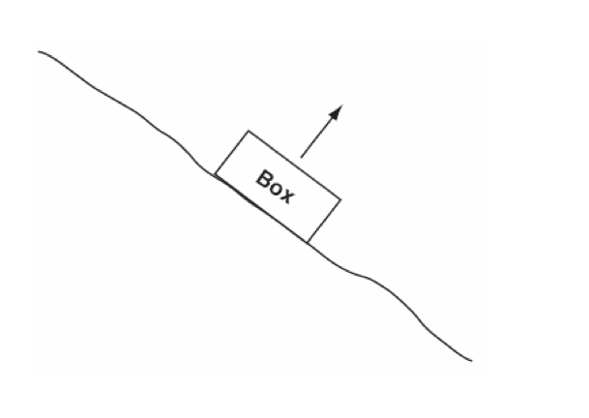
- A box is resting motionless on a hill. What is creating the force that is acting in the direction of the arrow?

A. The hill B. Gravity C. Friction D. The box

- What force opposes your push when you are unable to move a heavy piece of furniture across the floor?
A. Rolling kinetic friction C. Net force
B. Static friction D. Kinetic friction
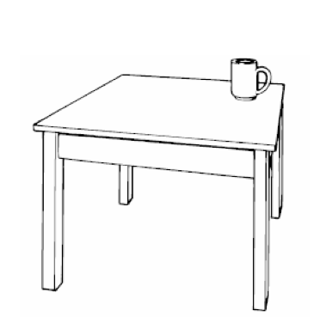
- The picture above shows a mug resting on a table. Why is the mug stationary?

A. Friction is exerting a force that resists gravity.
B. Gravity and friction are acting in the same direction.
C. The table is preventing gravity from acting on the mug.
D. The table is exerting an upward force that opposes gravity.

- Which of the following balances the force of gravity on a hanging light?
A. Compression C. Tension
B. Friction D. Static electricity

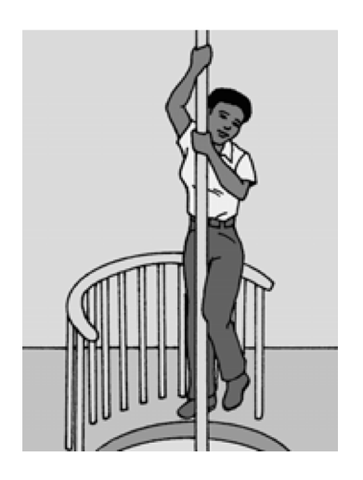
- Susan was training at the fire department. She grabbed the pole, picked up her feet, and hung on so she would not slide down. What force allowed Susan to avoid sliding down the pole?

A. Inertia B. gravity C. friction D. density

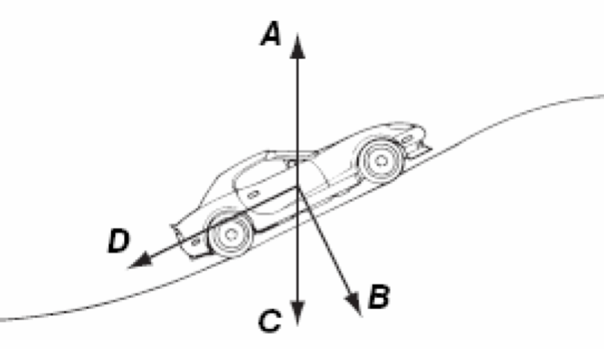
- The diagram above shows a car traveling up a hill. Which arrow in the diagram could represent the force of gravity acting on the car?

A B C D

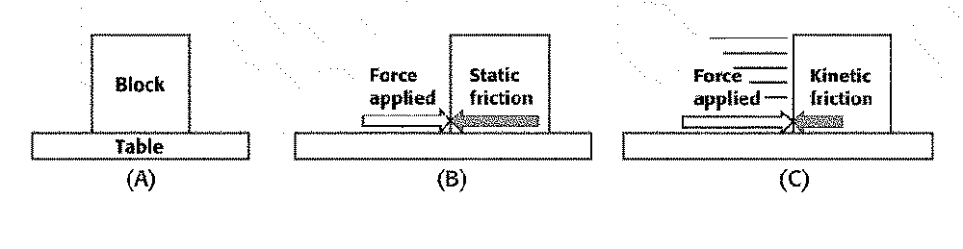
- Why does the box labeled A not move?
A. Because of frictional force
B. Because of kinetic friction
C. Because no forces are applied
D. Because of surface friction

Appendix B
States of Matter Instrument
- Which of the following describes the tiny particles that make up matter?
A. They are sometimes in motion.
B. They are never in motion.
C. They are in constant motion.
D. They are sometimes not in motion.

- Which of the following occurs when a liquid becomes a gas?
A. The particles give off energy.
B. The particles break away from one another.
C. The particles move closer together.
D. The particles slow down.

- Which of the following examples involves the decrease of energy in a substance?
A. Ice melting in a glass of lemonade
B. Water boiling in a large pot
C. Gaseous water particles coming together to form droplets on a cup
D. Air in a bicycle tire gaining pressure on a hot day

- Which of these requires the addition of energy to a solid.
A. Freezing
B. Melting
C. Evaporation
D. Condensation

- In a solid, the particles
A. Overcome the strong attraction between them.
B. Vibrate in place.
C. Slide past one another.
D. Move independently of one another.

- A gas
A. Has a definite volume but no definite shape.
B. Has a definite shape but no definite volume.
C. Has fast-moving particles.
D. Has particles that are always close together.

- Liquid water changes to water vapor through what change of state?
A. Melting
B. Evaporation
C. Freezing
D. Sublimation
References

Ashcraft, P. (2006). A Comparison of Student Understanding of Seasons Using Inquiry and Didactic Teaching Methods. AIP Conference Proceedings, 818(1), 85-88.
Balci, S., Cakiroglu, J., Tekkaya, C. (2006). Engagement, Exploration, Explanation, Extension, and Evaluation (5E) Learning Cycle and Conceptual Change Text as Learning Tools. Biochemistry and Molecular Biology Education, 34(3), 199-203.
California Department of Education. (2000). Science content standards for California public schools: Kindergarten through grade twelve. Sacramento, CA: California Department of Education.
Cardak, O., Dikmenli, M., & Saritas, O. (2008). Effect of 5E Instructional Model in Student Success in Primary School 6th Year Circulatory System Topic. Asia-Pacific Forum on Science Learning and Teaching, 9(2)
Center for Science, Mathematics, and Engineering Education. (2000). Inquiry and the National Science Education Standards: A Guide for Teaching and Learning. Washington, DC: National Academy Press.
Ceylan, E., & Geban, O. (2009). Facilitating Conceptual Change in Understanding State of Matter and Solubility Concepts by Using 5E Learning Cycle Model. Hacettepe University Journal of Education 36 41-50.
National Research Council. (1996). National Science Education Standards. Washington, DC: National Academy Press.
Pecore, J., Snow, M., & Lim, M. (2009). What Happens to Cemetery Headstones? Engaging Students Interest in Acids and Bases. Science Teacher, 76(6), 29-34.
Robertson, B. (2006). Getting Past “Inquiry versus Content”. Educational Leadership, 64(4), 67-70.
Taylor, J., Van Scotter, P., & Coulson, D. (2007). Bridging Research on Learning and Student Achievement: The Role of Instructional Materials. Science Educator, 16(2), 44-50.
Young, N. (2009). Effect of the learning cycle on students’ attitudes toward science and learning: An action research project. Unpublished manuscript, California State University, Long Beach, Long Beach, CA.

