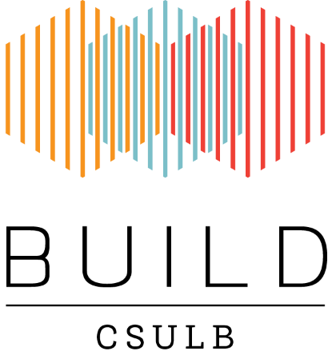
BUILD Low impact speed dynamic testing on hydrogel workshop
Registration
Please complete, sign and return this form to Jesus A. Reyes (Jesus.Reyes@csulb.edu) to register for the Dissecting Microscope/Embryology workshop

Registration form must be received by Friday February 9th 2018. Confirmation of registration will be sent by email.

I hereby register for the low impact dynamic testing on hydrogel workshop,
February 16th, 2018 YOU MUST SPECIFY WHICH SESSION YOU WHICH TO ATTEND: Session 1: 11am-12pm , Session 2: 1230-130pm , Session3: 2-3pm
FULL NAME
Title ____________
First Name ___________________________________________________________________
Last Name ___________________________________________________________________
Suffix _____________
ADDRESS
Street Address 1 ______________________________________________________________
Street Address 2 ______________________________________________________________
City ______________________________________________________________
State ______________
Zip code _______________
E-Mail Address _____________________________________________________________
Phone Number _____________________________________________________________
Name | Signature | Date
Please complete and return this form by email (subject: Hydrogel workshop 2018)
to: jesus.reyes@csulb.edu

Questions
Jesus A. Reyes
Jesus.Reyes@csulb.edu
CSULB BUILD Program
California State University Long Beach
1250 Bellflower Blvd, Long Beach, CA 90840-4501

