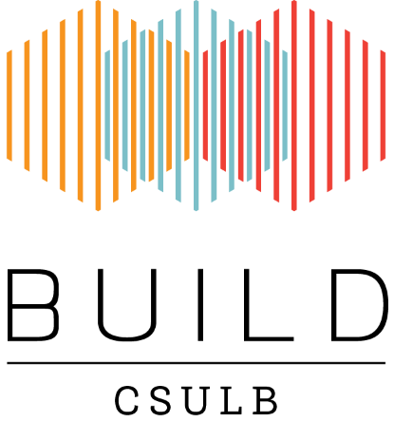
BUILD Gas Chromatrography/Mass Spectrometry (GC/MS) Workshop
Registration
Please complete, sign and return this form to Jesus A. Reyes (Jesus.Reyes@csulb.edu) to register for the GC/MS workshop--* THIS IS A TWO DAY WORKSHOP (WITH OPTION FOR A THIRD)

Registration form must be received by Tuesday July 31st 2018. Confirmation of registration will be sent by email.

I hereby register for the GC/MS workshop,
August 6th- 8th , 2018 from 10pm-430pm each day
FULL NAME
Title ____________
First Name ___________________________________________________________________
Last Name ___________________________________________________________________
Suffix _____________
ADDRESS
Street Address 1 ______________________________________________________________
Street Address 2 ______________________________________________________________
City ______________________________________________________________
State ______________
Zip code _______________
E-Mail Address _____________________________________________________________
Phone Number _____________________________________________________________
Name | Signature | Date
Please complete and return this form by email (subject: GC/MS 2018)
to: jesus.reyes@csulb.edu

Questions
Jesus A. Reyes
Jesus.Reyes@csulb.edu
CSULB BUILD Program
California State University Long Beach
1250 Bellflower Blvd, Long Beach, CA 90840-4501

