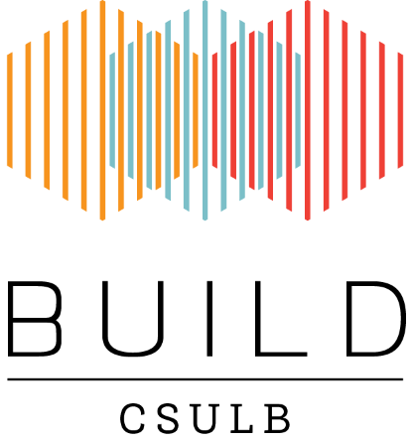
BUILD Matlab Workshop
Registration
Please complete, sign and return this form to Jesus A. Reyes (Jesus.Reyes@csulb.edu) to register for the Matlab workshop

Registration form must be received by Tuesday October 31st 2017. Confirmation of registration will be sent by email.

I hereby register for the Matlab workshop,
November 3rd 2017
FULL NAME
Title ____________
First Name ___________________________________________________________________
Last Name ___________________________________________________________________
Suffix _____________
ADDRESS
Street Address 1 ______________________________________________________________
Street Address 2 ______________________________________________________________
City ______________________________________________________________
State ______________
Zip code _______________
E-Mail Address _____________________________________________________________
Phone Number _____________________________________________________________
Fax Number _____________________________________________________________
DRIVING DIRECTIONS AND PARKING INFORMATION
Please check the website (http://www.csulb.edu/maps/) for directions.
Please check the website (http://www.foundation.csulb.edu/departments/property/documents/parklot.htm or http://daf.csulb.edu/offices/ppfm/parking/) for parking.

Name | Signature | Date
Please complete and return this form by email (subject: Matlab Workshop 2017)
to: jesus.reyes@csulb.edu

Questions
Jesus A. Reyes
Jesus.Reyes@csulb.edu
CSULB BUILD Program
California State University Long Beach
1250 Bellflower Blvd, Long Beach, CA 90840-4501

