Parent PLUS Loan Instructions

To apply for the Parent PLUS Loan, only ONE parent who wishes to borrow the funds should follow the instructions below. Only ONE parent may apply per student per academic year.
Before starting, please note that parent will need to use their own FSA ID to login. The FSA ID is the same login used to sign the student’s FAFSA.
If parent needs to create or retrieve their FSA ID, please go to https://fsaid.ed.gov/npas/index.htm.

Step-by-Step Instructions for Applying
- Parent would need to navigate to https://studentaid.gov/ to access the application. Only ONE parent who is borrowing the funds should sign in to initiate and complete the application.

Click on APPLY FOR AID on the top off the page and click on Apply for a Parent PLUS Loan:
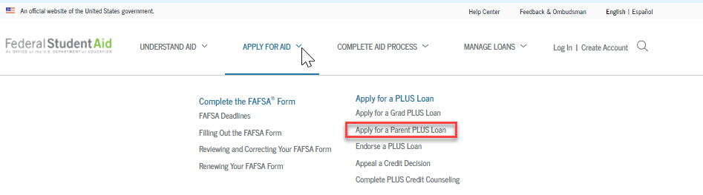

Proceed to the next screen and click Log In to Start under the “I am a Parent of an Undergrad Student” section:
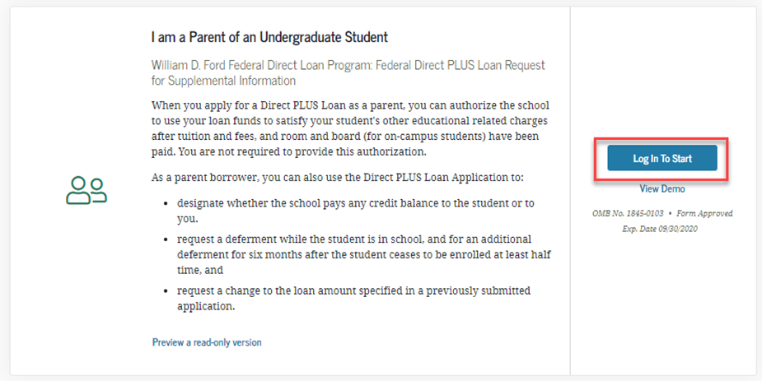

- Parent will then be directed to the Direct PLUS Loan Application for Parents and will need to complete Steps 1 to 4.
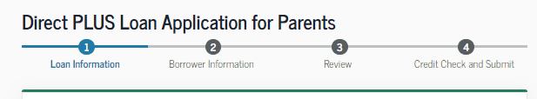
- For the School Information Section – Please select California as a state, and search for California State Univ. Long Beach”. School ID 001139

- After completing Steps 1 to 4, parent will be provided with credit result of either Accepted, Declined, or Pending.
- Accepted
- Declined
- Pending

Next Steps After Obtaining Credit Results
If the credit check is accepted and this is the first PLUS loan the parent is applying on behalf of this student at our institution, the parent will be instructed to complete the PLUS MPN for Parents.
- Parents will need to navigate to the top of the home page and click on COMPLETE AID PROCESS
- Under Complete a Master Promissory Note (MPN)
- Select MPN for Parents
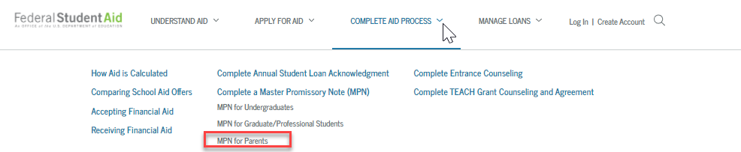
- Select Start in the “I’m a Parent of an Undergraduate Student” section. Parent will need to complete Steps 1 to 5.
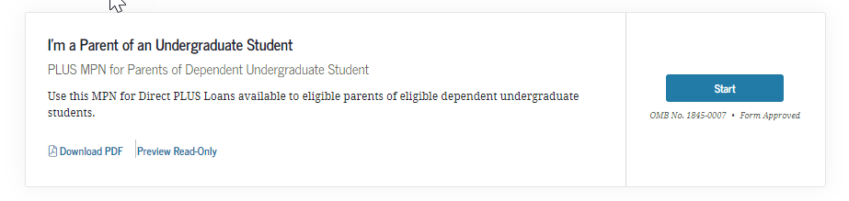

If the credit check is not accepted, parent will be asked to indicate how parent would like to proceed:
- If parent wants to obtain an endorser – parent will be working directly with the U.S. Department of Education, and CSU, Long Beach will be notified once the loan is approved. Please navigate to Credit Endorser to complete the loan application.
  - Please remember that the parent must also complete the PLUS Credit Counseling and the PLUS MPN for Parents.

- If parent wants to appeal credit and provide documentation of extenuating circumstance - parent will be working directly with the U.S. Department of Education, and CSU, Long Beach will be notified once the loan is approved. Please navigate to Credit Decision Appeal to have the U.S. Department of Education review your application.
  - Please remember that the parent must also complete the PLUS Credit Counseling and the PLUS MPN for Parents.

- If parent wants to cancel the PLUS Loan request – the student will be given the option to accept an additional unsubsidized loan of $4,000 or $5,000 dependent on grade level.

- If parent is undecided – CSU, Long Beach will receive the parent’s response with the denial notice and will communicate with the parent via email asking to notify us of a decision if they are going to attempt to resolve the denial.

If the credit check is pending, parent will need to contact Student Loan Support Center at 800-557-7394 or StudentLoanSupport@ed.gov .

When ready to apply, please navigate to https://studentaid.gov/

