Graduate PLUS Loan Instructions

To apply for the Graduate PLUS Loan, please follow the instructions provided below.
Before starting, please note that you will need to use your FSA ID to log in. The FSA ID is the same login you used to log into the FAFSA.
If you need to create or retrieve your FSA ID, please go to https://fsaid.ed.gov/npas/index.htm.

Step-by-Step Instructions for Applying
- You would need to navigate to https://studentaid.gov/ to access the application.

Click on APPLY FOR AID on the top off the page and click on Apply for a Grad PLUS Loan
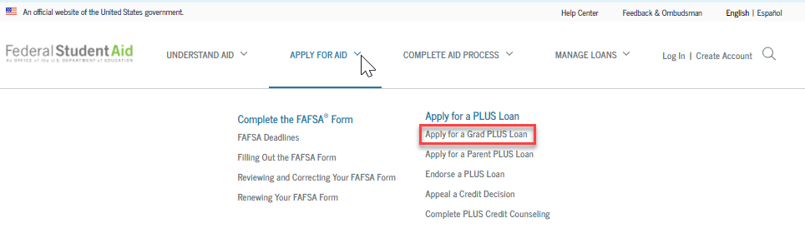
Proceed to the next screen and click Log In To Start under the “I am a Graduate or Professional Student” section:
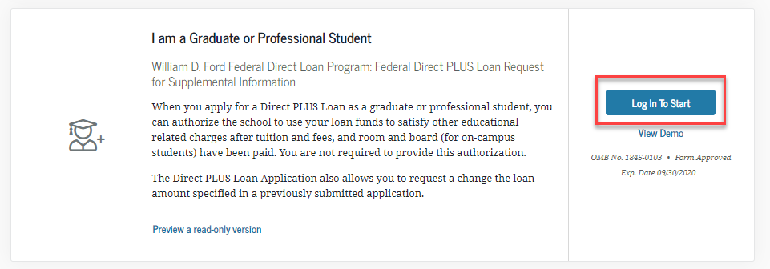

- You will then be directed to the Direct PLUS Loan Application and will need to complete Steps 1 to 4.
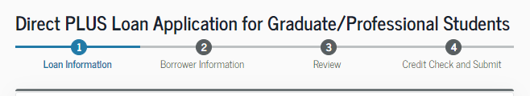
- For the School Information Section – Please select California as a state, and search for “California State Univ. Long Beach”. School ID 001139

- After Completing Steps 1 to 4, you will be provided with credit result of either Accepted, Declined, or Pending.
- Accepted
- Declined
- Pending

Next Steps After Obtaining Credit Results
If the credit check is accepted and this is the first PLUS loan you are applying for at our institution, you will be instructed to complete the Federal Direct Graduate PLUS Master Promissory Note.
- You will need to navigate to the top of the home page and click on COMPLETE AID PROCESS
- Under Complete a Master Promissory Note (MPN)
- Select MPN for Graduate/Professional Students
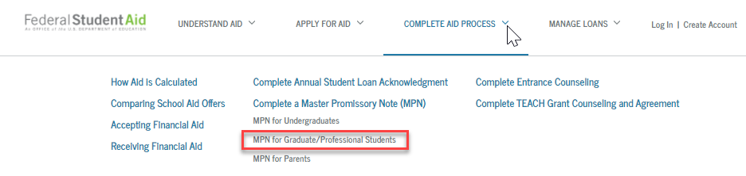

- Select Start in the “MPN for Direct PLUS Loans” section. You will need to complete Steps 1 to 5.
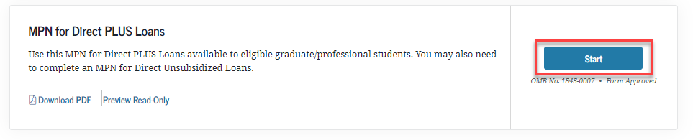

If the credit check is not accepted, you will be asked to indicate how you would like to proceed:
- If you want to obtain an endorser – you will be working directly with the U.S. Department of Education, and CSU, Long Beach will be notified once the loan is approved. Please navigate to Credit Endorser to complete the loan application.
  - Please remember that you must also complete the PLUS Credit Counseling and the PLUS MPN for Graduate/Professional Students.

- If you want to appeal credit and provide documentation of extenuating circumstance - you will be working directly with the U.S. Department of Education, and CSU, Long Beach will be notified once the loan is approved. Please navigate to Credit Decision Appeal to have the U.S. Department of Education review your application.
  - Please remember that you must also complete the PLUS Credit Counseling and the PLUS MPN for Graduate/Professional Students.

- If you are undecided – CSU, Long Beach will receive the denial notice and will communicate with you via email asking to notify us of a decision if you are going to attempt to resolve the denial.

If the credit check is pending, you will need to contact Student Loan Support Center at 800-557-7394 or StudentLoanSupport@ed.gov .

When ready to apply, please navigate to https://studentaid.gov/

