The Most Common Student Questions and Answers about GWAR and GPE

There are two categories for these questions and answers:

A. I have taken the GPE and have a question.

B. I need to take the GPE and have a question.

A. I have taken the GPE and have a question.

Question:
What can I do if the English 301A or GWAR Portfolio class I need is full?

Answer:
GWAR is important, so enroll in an open section if at all possible. If your classes conflict, then put your name on the Waitlist in your My CSULB for the time and section you wish. If you have additional concerns contact GWAR eAdvising by email at GWAR-Advisor@csulb.edu.

Question:
How can I register if I have a GWAR Requirement Hold?

Answer:
You cannot register for any classes until you have contacted the GWAR Advisor. The advisor can review your situation and release the GWAR registration hold. Please contact GWAR eAdvising by email at GWAR-Advisor@csulb.edu.

Question:
How long do I have until I have to complete the GWAR Portfolio course?

Answer:
You must take the course within two semesters after you take the GPE test. However, we encourage you to take your GWAR Portfolio course right away so you don’t delay your graduation.
- CLICK HERE to link to the GWAR website for more information.

Question:
I scored 8, 9, or 10 on the GPE, and I need to enroll in a GWAR Portfolio class.
Can I take any GWAR Portfolio course?

Answer:
Yes and No.
- Yes, all students can take any English 301B (ENGL 301B) section, or Fashion Merchandising and Design (FMD 450) section in the Department of Family and Consumer Sciences.

- No, most GWAR courses are just for specific majors. If your major offers a GWAR Portfolio course, you should take it because it will focus on helping you to write in your major.
- CLICK HERE to see a list of Portfolio classes offered.

Question:
I scored 7 or below on the GPE and need to enroll in English 301A. Where do I find ENGL 301A course offerings?

Answer:
Go to MyCSULB to search for English 301A course offerings during the semester you need to enroll. Click on the “Search” tab. Select the “Term” from the pull down menu to find the course availability for the semester of enrollment. Select the “Subject” from the pull down menu, and select the course offering by name, English, and enter the course number 301A. The Search Result will display the course times and availabilities.

B. I need to take the GPE and have a question.

Question:
How do I register to take the GWAR Placement exam (GPE)?

Answer:
You can register for the GWAR Placement Exam (GPE) online with the link below:
- CLICK HERE for the Testing & Evaluation GPE registration page.

Question:
When is the next GPE offered?

Answer:
- CLICK HERE to visit the Testing & Evaluation webpage, where you will find the current test date offerings.

Question:
Are there any workshops offered to prepare me for the GPE and how much are they?

Answer:
Yes, and they are free! GPE workshops are offered by
- CLICK HERE the Writers’ Resource Lab.
- CLICK HERE the Testing & Evaluation Office.

Question:
I signed up to take the GPE but missed it. Can I reschedule?

Answer:
Yes!
- CLICK HERE to reschedule at the Testing & Evaluation webpage.

Question:
How do I pay for the GPE?

Answer:
Go to the Testing & Evaluation Webpage and complete the GPE registration form. Once you click submit, you will be transferred to a page where you can pay.
- CLICK HERE for the Testing & Evaluation webpage.

Question:
I have a registration hold because I need to take the GWAR Placement Exam (GPE). What can I do?

Answer:
In order to have your hold released, you will need to register for the first upcoming GPE, and contact the Department of Testing & Evaluation to file an “Appeal to have a GWAR Placement Examination Hold Temporarily Removed.”
- CLICK HERE to access the form.

Question:
Do all undergraduate transfer students need to take CSULB’s GWAR Placement Exam (GPE)?

Answer:
All undergraduate transfer students from community colleges must take the GPE. If you transfer from another CSU and have passed its GWAR writing requirement, you have satisfied the GWAR at CSULB.

Question:
How does the GWAR requirement affect graduate students at CSULB?

Answer:
- All graduate students (M.A., M.S., M.B.A) who have earned an undergraduate degree from an accredited U.S. university or college, or earned an undergraduate degree from an accredited university from an English speaking country, have satisfied the GWAR at CSULB.
List of Approved Countries

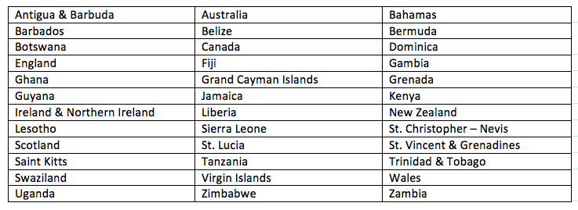

- If you are a graduate student who scored a 4 or higher on the GRE or GMAT, you have satisfied the GWAR at CSULB.
- Note: graduate students can self-place into a GWAR Portfolio class (e.g., ENGL 301B). If they self-place into a GWAR Portfolio class, they do not have to take the GPE. To self-place, contact GWAR eAdvising by email at GWAR-Advisor@csulb.edu.

Question:
Are you a Continuing or Transfer CSULB student needing to know when you should take the GWAR Placement Exam (GPE)?

Answer:
- If you are a Continuing CSULB student, you are required to take the GPE when you have earned between 30 and 50 units.

- If you are a Transfer student to CSULB, you are urged to take the GPE in the summer prior to your enrollment at CSULB. If you miss the summer GPE, you are then required to take the GPE in your first semester of enrollment.

Question:
Can I retake the GPE?

Answer:
No, by CSULB policy you can take the GPE only once.

