Welcome to California State University, Long Beach

Self-Guided Walking Tour

Take a Self-guided Tour

Located three miles from the ocean, CSULB is an idyllic university destination where talented and diverse students come to experience a campus environment that is student-centered, service-oriented and globally engaged. This brochure is designed to help you get acquainted with our campus. University Outreach & School Relations (UOSR) hopes that by the end of the tour, you will choose to attend CSULB. Go Beach!

Stop 1 Brotman Hall
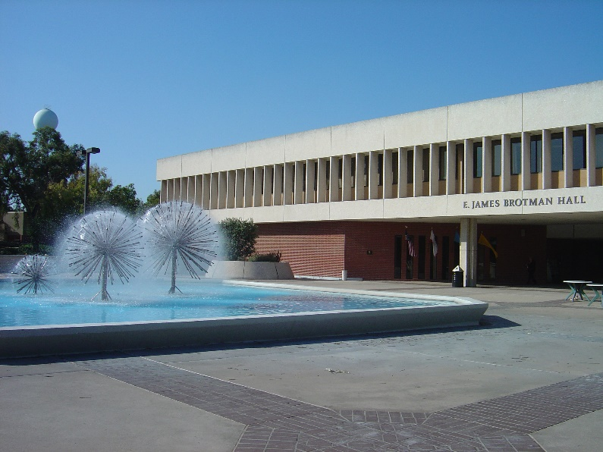
Brotman Hall is the administrative center of the university. Students can find information on admissions and financial aid as well as career and counseling assistance. Visit UOSR for prospective student information.

Stop 2 University Student Union
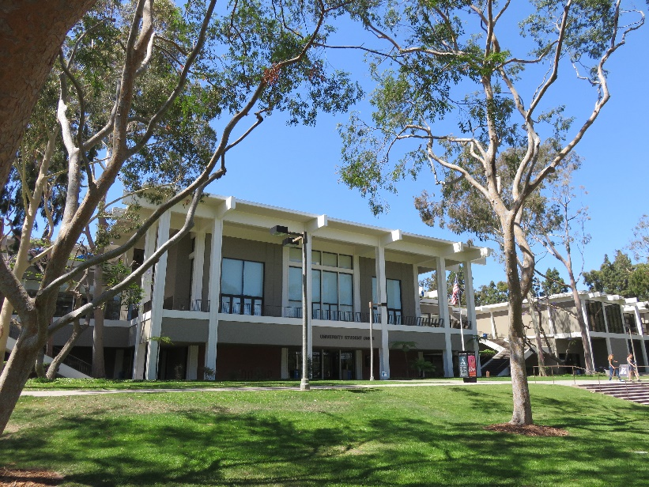
The USU offers dining options, event and recreational facilities such as bowling, swimming and video games as well as free movies and live music. The building also has study areas and meeting spaces for clubs and organizations.

Stop 3 University Bookstore
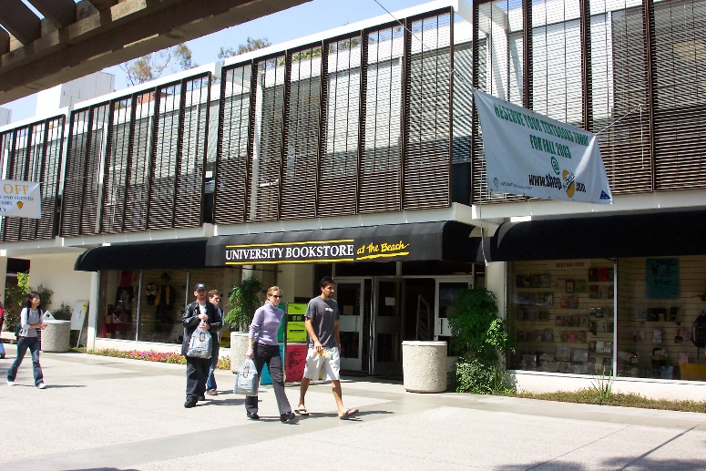
The bookstore is a one-stop shop for students who want to purchase clothing, gifts and textbooks. Inside is a computer store known as Beach Tech. There is also a copy center and a LBS Financial branch.

Stop 4 University Library
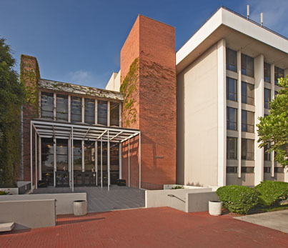

Students have access to more than one million periodicals and books, an online catalog, and digital research databases and resources. The facility houses the Library Tech Hub, Spidell Technology Center and a Starbucks. The Graduate Resource Center and University Honors Program are located here.

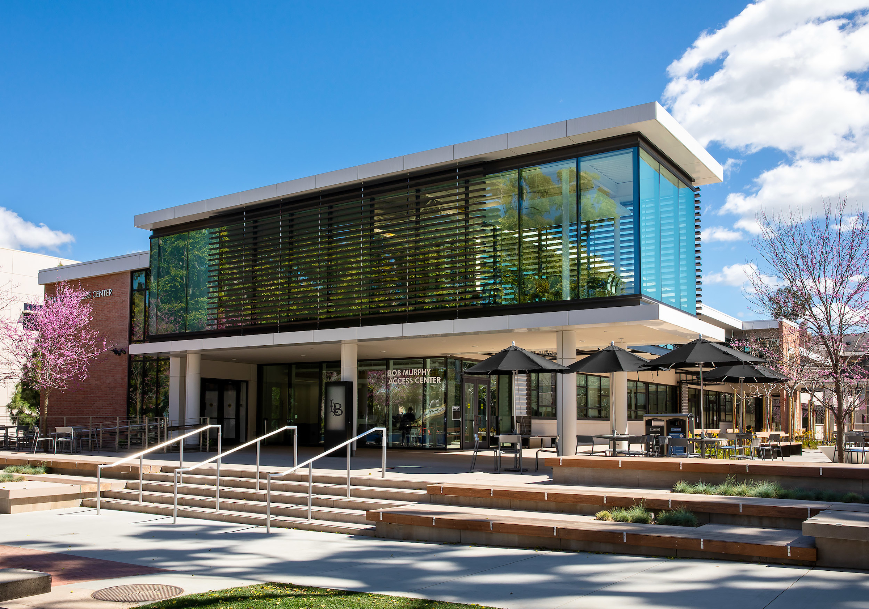Stop 5 Student Success Center
The SSC houses services such as: Bob Murphy Access Center, Education Opportunity Program, Learning Assistance Center, University Center for Undergraduate Advising and Women’s Gender & Equity Center. CSULB is a partner college with TheDream.US and has a Dream Success Center available for students who may need assistance.

Stop 6 Science Complex
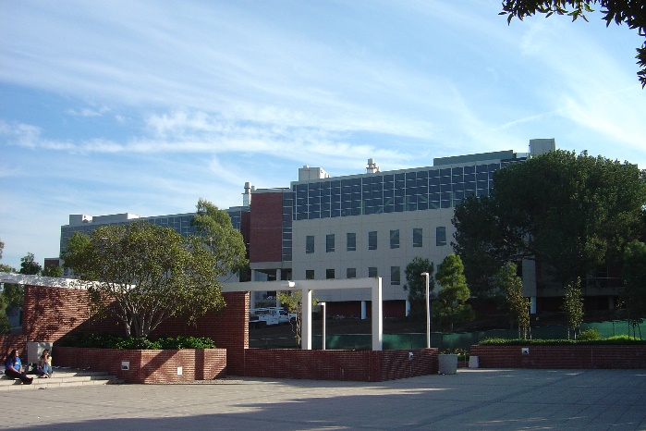

The Molecular & Life Sciences Center won awards for its architecture and houses the biochemistry, biological sciences and chemistry departments. The Hall of Science has greenhouses, a Shark Lab and 22 research facilities.

Stop 7 Student Recreation and Wellness Center
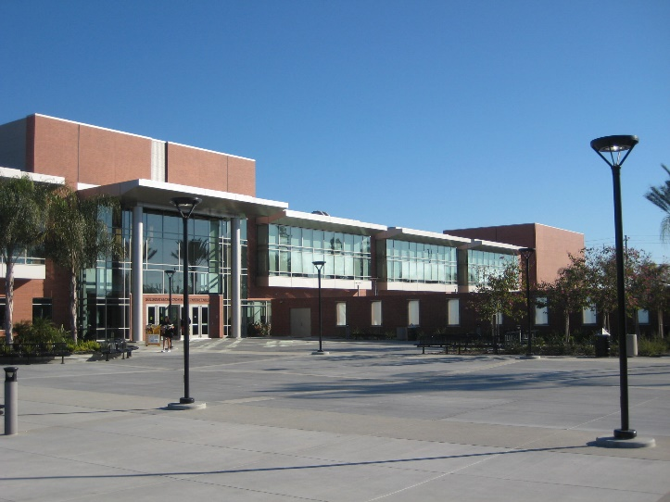
This facility offers fitness programs, rock climbing walls, basketball and volleyball courts and a swimming pool. The center serves as a place for exercise and recreation.

Stop 8 The Horn Center
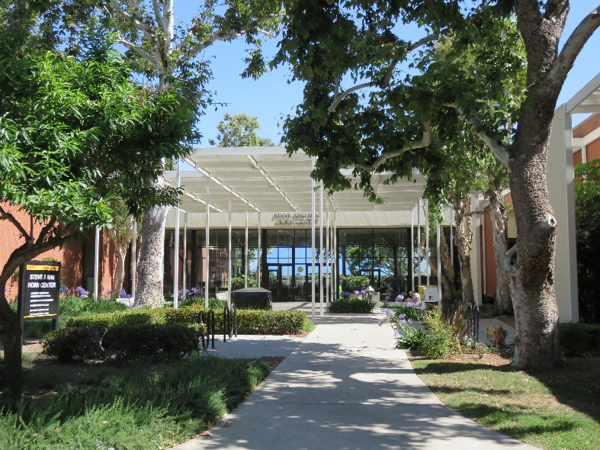
The Horn Center operates the largest open-access computer lab in the CSU system. The facility also houses the Technology Help Desk and accredited art museum.

Stop 9 Kleefeld Contemporary Art Museum
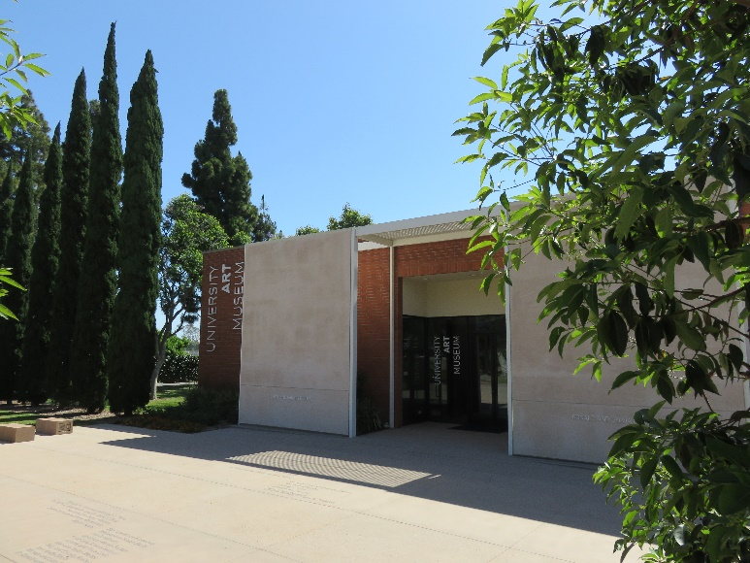
This first accredited art museum in the CSU system is renowned for its groundbreaking exhibitions, award-winning publications and extensive collections of contemporary art.

Stop 10 Carpenter Performing Arts Center
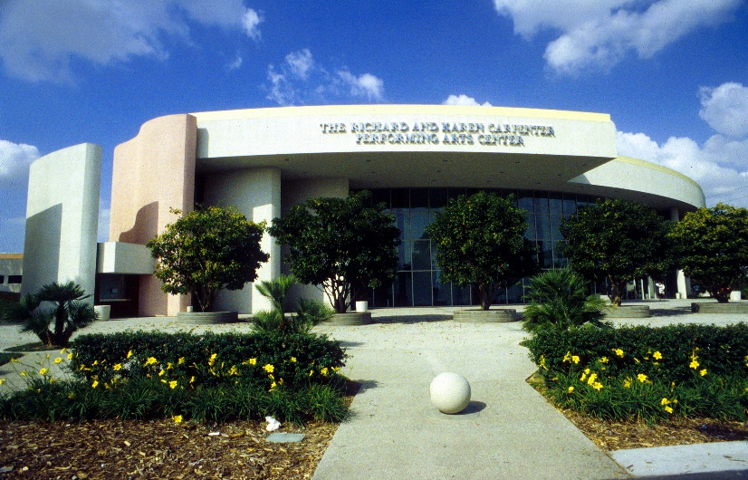
This visually stunning performance venue offers a variety of performances in dance, film, music, theatre and more. The CPAC is part of the College of the Arts and provides students with opportunities to engage with professionals that perform here.

Stop 11 The Walter Pyramid
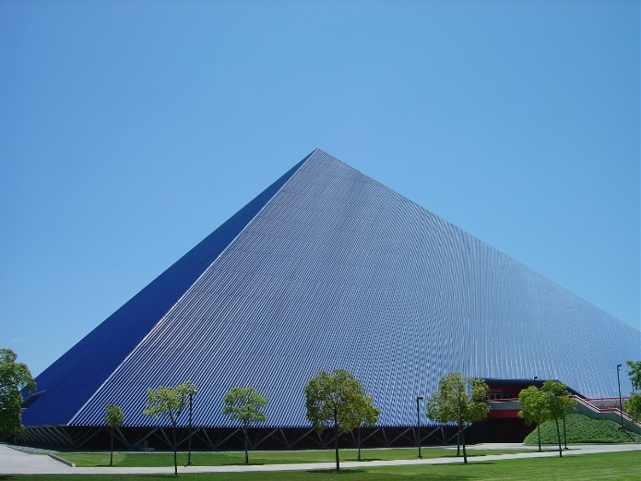
The Walter Pyramid is CSULB’s 18-story event center and home to our Division I men’s and women’s basketball and volleyball teams. Students show their Beach Pride here.

Stop 12 Earl Burns Miller Japanese Gardens
The garden is inspired by the beauty of Japanese landscapes. The garden, koi pond and traditional teahouse are open to students and the public.

Stop 13 University Housing and Residential Life
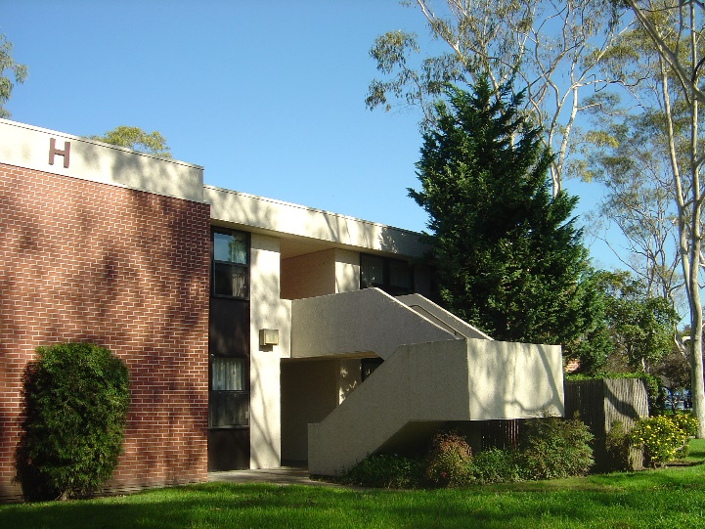
Living on campus is convenient and fun. Housing options include traditional and suite style halls as well as thematic communities and specialized houses. Dining facilities, a coffeehouse, a convenience store, free cable and high-speed internet are available.

FINISH

CSULB Colleges at a Glance
CSULB’s eight colleges house a wide range of majors and programs. We encourage you to visit or contact your college of choice to receive major-specific information.

College of the Arts (COTA)
www.csulb.edu/cota
General Contact: (562) 985-7819
Advising Office: (562) 485-4381

College of Business (COB)
www.csulb.edu/cob
General Contact: (562) 985-5306
Advising Office: (562) 985-4514

College of Education (CED)
www.csulb.edu/ced
General Contact: (562) 985-1609
Advising Office: (562) 985-1105

College of Engineering (COE)
www.csulb.edu/coe
General Contact: (562) 985-5121
Advising Office: (562) 985-1800

College of Health & Human Services (CHHS)
www.csulb.edu/chhs
General Contact: (562) 985-4194
Advising Office: (562) 985-5358

College of Liberal Arts (CLA)
www.csulb.edu/cla
General Contact: (562) 985-5381
Advising Office: (562) 985-7804

College of Natural Sciences & Mathematics (CNSM)
www.csulb.edu/cnsm
General Contact: (562) 985-4707
Advising Office: (562) 985-1587

College of Professional & International Education (CPIE)
www.csulb.edu/cpie
General Contact: (800) 963-2250
Advising Office: (562) 985-4288

Campus Contacts
Campus Information (562) 985-4111
Bob Murphy Access Center (562) 985-5401
Beach Central (562) 985-547
- Enrollment Services
- Financial Aid
- Registration
Center for International Education/ Admissions (562) 985-5555
Center for Student-Athlete Advising Services (562) 985-4777
Earl Burns Japanese Garden (562) 985-8885
Educational Opportunity Program (562) 985-5637
Scholarship Center (562) 985-2549
Student Life & Development (562) 985-4181
Student Recreation & Wellness Center (562) 985-0775
University Bookstore (562) 985-5093
University Center for Undergraduate Advising (562) 985-4837
University Housing & Residential Life (562) 985-4187
University Library (562) 985-8472
University Outreach & School Relations (562) 985-5358
University Student Union (562) 985-4834
Veterans Affairs Services (562) 985-5115

University Outreach & School Relations (UOSR)
The UOSR office is the primary guest relations office at CSULB, where prospective students and counselors can find information and resources on admissions, campus tours, and transfer and adult re-entry workshops.
Visit our UOSR Publications Library for additional information at www.csulb.edu/outreach.

Thank you for visiting our campus!

Contact Us

University Outreach & School Relations
Division of Student Affairs
Brotman Hall, Room 289
1250 Bellflower Boulevard
Long Beach, California 90840
Phone number: (562) 985-5358
www.csulb.edu/outreach
outreach@csulb.edu

