Working Better: How To Make Your Gadgets Work For You
Good (October 15, 2010 • 4:30 pm PDT)
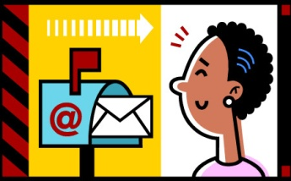
People like to say that they love their iPhone (or BlackBerry or Android) because it makes their life easier. But if we’re being honest with ourselves, we know it’s become hard to tell who is the slave and who is the master in this relationship. Are you checking your smart phone while you’re on a date? Do you leave it on vibrate at the movies, just in case? Does your heart sink a little when it’s time for the plane to take off? More often than not, we are at the mercy of our machines simply because we let ourselves be. It’s a habit—and a bad one. Here’s how to show your gadgets who’s master.
Don’t be too available. This goes for all modes of electronic communication. If you always answer right away, you not only risk saying dumb stuff, but you’re also setting a precedent. By responding immediately—and especially in the off hours—to work emails in particular, you create an expectation of availability that may mean you’ll feel obliged to respond even when busy. Not good.
Set special alerts for the people you want to hear from in the off hours. If you leave your phone on silent with an LED blink or vibrate, then all messages are equal. An easy way to limit your every-five-minutes phone checking is to use those custom ring functions so that you know who you’re hearing from. Not everyone needs his or her own sound effect, but maybe your best friend, partner, and boss do.
Use the reminder features. Set alarms, bells, or whistles to bark orders at you. Water the plants! Follow up with Stacy about the China thing! The only catch is that you must do things exactly when the machine tells you to. This is not you being a slave—you set these reminders, so knock them off your list.
Go back to talking and texting. Ease up on the instant messaging. This applies to work and friends. The beauty of text messages and phone calls is that it’s acceptable not to answer them immediately. Instant messenger, on the other hand, is demanding in the moment—be it on your smart phone or your computer—which can derail even the most productive among us.
Take a lunch hour. Inhaling lunch at your desk does not make you a better employee, and part of the beauty of smart phones is that they offer us freedom from our desks. So take that lunch hour, or that walk, or any break from work that will ultimately leave you more refreshed and productive.
Use it like a notebook. This is a great habit to get into, whether you work in a creative field or not. If a lightbulb goes off in your head, any lightbulb, write it down. If someone mentions a great book, write it down. A new band, do the same. There’s probably an app for that, but you don’t really need it. Send yourself a running email, or keep lists.
http://www.good.is/post/working-better-how-to-make-your-gadgets-work-for-you

