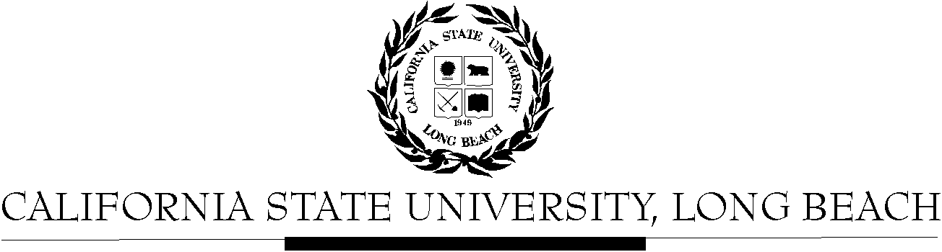

General Education Governing Committee

Agenda
September 22, 2014
2:00pm – 4:00pm – President’s Conference Room, BH-302

Please notify a member of the GEGC Executive Committee (Heather.Rae-Espinoza@csulb.edu, Danny.Paskin@csulb.edu, Hema.Ramachandran@csulb.edu or Vanessa.Red@csulb.edu) if you are unable to attend.

- Call to Order

- Approval of Agenda

- Approval of Minutes: GEGC Minutes posted on BeachBoard

- Announcements
  - Reminder: All GEGC business is conducted electronically via BeachBoard (note you need to enter as a student). Please bring your laptops or printed material for meetings.

- Course Reviews
  - Old Business:
    - KOR 202: Intermediate Korean - Tabled
      - Posted on BeachBoard/GE Course Proposals Fall 2014, AY 2014-2015
      - New to General Education
      - Request for Explorations: Humanities – Foreign Language
      - Discussion
        - Why does the course have a pre-requisite of KOR 201, which does not seem to be a GE course?
      - Recommendations:
        - Pre-requisite on the course is KOR 201, but KOR 201 has not been brought forth to the committee to be reviewed for GE.
        - Course grade breakdown does not match on sample syllabus (quizzes, homework etc.)
  - New Business
    - KOR 201: Intermediate Korean
      - Posted on BeachBoard/GE Course Proposals Fall 2014, AY 2014-2015
      - New to General Education
      - Request for Explorations: Humanities – Foreign Language
    - JOUR 311: Reporting and Information Gathering
      - Posted on BeachBoard/GE Course Proposals Fall 2014, AY 2014-2015
      - Decertify from General Education
    - CWL 210: Erotica, Love, Romance: Literary and Cultural Representations
      - Posted on BeachBoard/GE Course Proposals Fall 2014, AY 2014-2015
      - New to General Education
      - Request for Explorations: Humanities – Literature; Lifelong Learning & Self Development; Global Issues
    - CWL 300: Representing the World: Literature and Culture in Contact and Conflict
      - Posted on BeachBoard/GE Course Proposals Fall 2014, AY 2014-2015
      - New to General Education
      - Request for Capstone: Interdisciplinary, Writing Intensive; Humanities – Literature; Global Issues
    - POSC 362: Society and National Politics of China
      - Posted on BeachBoard/GE Course Proposals Fall 2014, AY 2014-2015
      - New to General Education
      - Request for Capstone: Writing Intensive
    - LING 472: Language and Social Justice
      - Posted on BeachBoard/GE Course Proposals Fall 2014, AY 2014-2015
      - New to General Education
      - Request for Capstone: Interdisciplinary, Writing Intensive; Human Diversity
    - LING 425/ANTH 421: Education Across Cultures
      - Posted on BeachBoard/GE Course Proposals Fall 2014, AY 2014-2015
      - New to General Education
      - Request for Capstone: Interdisciplinary; Human Diversity

- Adjournment

- Future Agenda/Discussion Items
  - Pending Course Reviews:
    - ANTH 329: Cultural Diversity in California
      - Request to continue Human Diversity and add Capstone: Writing Intensive (Inquire about keeping Social Science & Citizenship designation)
    - E SP 400: Environmental Science and Policy Capstone Project
      - Request for Capstone: Writing Intensive; Integrative Learning
    - GEOG 486: Field Methods in Landscape Analysis
      - Request for Capstone: Writing Intensive; Integrative Learning
    - ITAL 345: Italian American Culture
      - Request to continue Capstone: Interdisciplinary; Social Sciences & Citizenship and add Writing Intensive; Human Diversity
    - C E 325: Transportation Safety and Sustainability
      - Request for Humanities: Social Sciences & Citizenship

