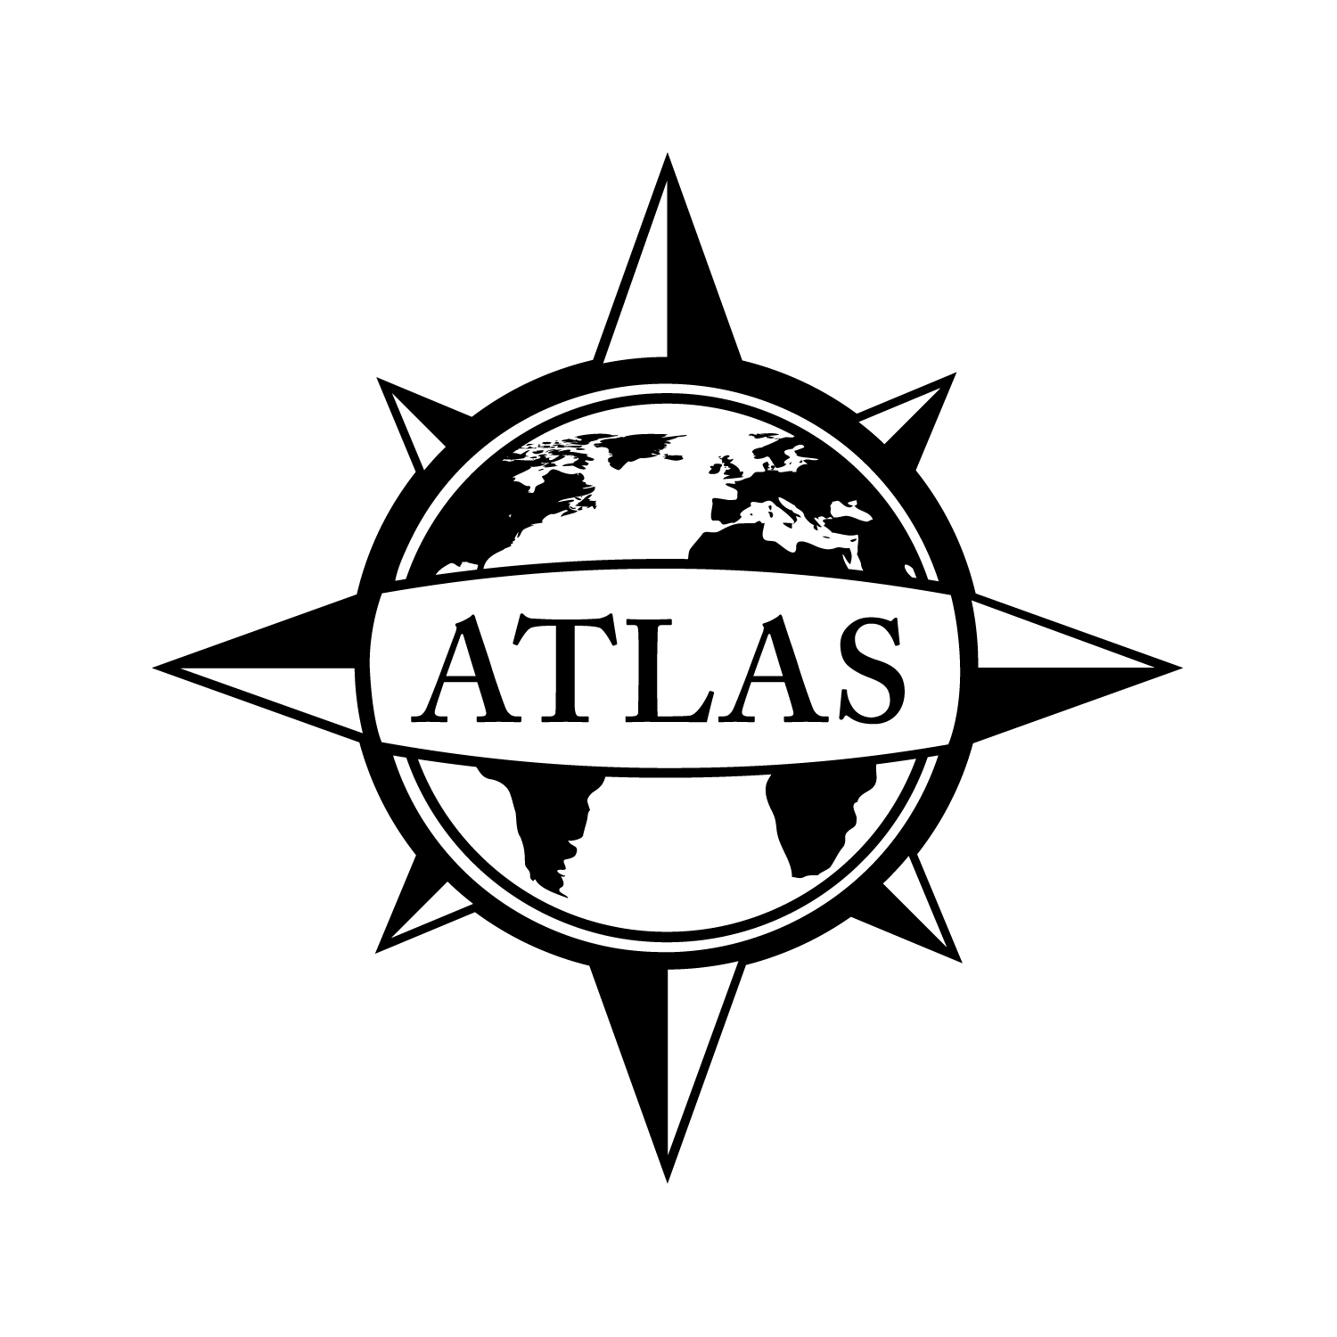
2014-2015 Bachelor of Arts in English
College of Liberal Arts
CSULB
Option in English Education
52 Units
This checklist is not intended to replace advising from the department. Consult with the department advisor for appropriate course sequencing. Use this checklist in combination with the Academic Requirements Report, which is the official graduation verification.

 |  |  | Prerequisites
Complete ONE of the following courses with a grade of “C” or better (4 units total):
 | ENGL 250A: Survey of English Literature (4)  GE: Humanities (C2) |  | GE Foundations
 | ENGL 250B: Survey of English Literature (4)  GE: Humanities (C2) |  | GE Foundations
Complete ONE of the following courses with a grade of “C” or better (4 units total):
 | ENGL 270A: Survey of American Literature (4)  GE: Humanities (C2) |  | GE Foundations
 | ENGL 270B: Survey of American Literature (4)  GE: Humanities (C2) |  | GE Foundations

Complete the following course by the FIRST semester of the junior year with a grade of “C” or better (4 units total):
 | ENGL 380: Approaches to English Studies (4) | ENGL 180 or Equivalent
Complete ALL of the following courses with a grade of “C” or better (25 units total):
 | ENGL 310: Applied Composition (4)
 | ENGL 320: English Grammar (4)
 | ENGL 363: Shakespeare I (4)  GE: Humanities (C2) | GE Foundations
 | ENGL 375: U.S. Ethnic Writers (3)  GE: Human Diversity; Capstone (F) or (C2) | Upper Division Standing
 | ENGL 410: Theories of Writing and Literacy (3) | ENGL 309 or 310 or Consent of Instructor
 | ENGL 482: Literature for Adolescents (4) | One Literature Course
 | LING 339: Linguistics for Crosscultural Academic Development in Secondary School Settings (3)
Complete ONE of the following courses with a grade of “C” or better (3 units total):
 | CLSC 101: Greek Mythology (3)  GE: Humanities (C2) | Corequisite: One GE Foundation
 | CWL 100: Introduction to World Literature (3)  GE: Humanities (C2) | Corequisite: One GE Foundation
 | CWL 124: Introduction to World Theatre and Drama (3)  GE: Global Issues; Arts (C1) | Corequisite: One GE Foundation
 | CWL 132: Folklore and Mythology (3)  GE: Humanities (C2) | Corequisite: One GE Foundation
 | CWL 320: Comic Spirit (3)  GE: Global Issues; Capstone (F) or (C2) | Upper Division Standing
 | CWL 346: Readings in World Poetry (3) | One Literature Course or Consent of Instructor
 | CWL 404: Selected Topics - Women in World Literature (3) | One Literature Course or Consent of Instructor
 | CWL 452: Selected Topics - Mythology (3) | One Literature Course or Consent of Instructor

Complete the requirements in ONE of the following emphases with grades of “C” or better (12 units total):
Africana Studies Emphasis
Complete ALL of the following courses (6 units total):
 | AFRS 140: Introduction to African American Literature (3)  GE: Humanities (C2) |  | Corequisite: One GE Foundation
AFRS 415: International Africana Children's Literature (3)
GE: Global Issues; Humanities (C2)
Complete ONE of the following courses (3 units total):
 | AFRS 343A: African Literature (3)  GE: Global Issues; Humanities (C2) |  | GE Foundations
 | AFRS 343B: Caribbean Literature (3)  GE: Global Issues; Humanities (C2) |  | GE Foundations
Complete ONE of the following courses (3 units total):
 | AFRS 180: African American Language in America (3)
 | AFRS 205: Modern Black South African Literature (3)  GE: Humanities (C2) |  | GE Foundations
 | AFRS 240: African and African American Folklore and Culture (3)
 | AFRS 346: Africana Theatre (3)  GE: Global Issues; Humanities (C2) |  | GE Foundations
Communication Studies Emphasis
Complete the following course (3 units total):
 | COMM 355: Communication in the Classroom (3)
Complete THREE of the following courses (9 units total):
 | COMM 309: Language and Behavior (3)
 | COMM 331: Argumentation and Debate (3) |  | GE Foundations
 | COMM 335: Persuasive Speaking (3)  GE: Lifelong Learning and Self-Development (E) |  | GE Foundations
 | COMM 352: Story Telling (3)
 | COMM 358: Speech Arts for Children (3)
 | COMM 411: Communication in Conflict Resolution (3)  GE: Capstone (F) or (E) |  | Upper Division Standing
Creative Writing Emphasis
Complete TWO of the following courses (6 units total):
 | ENGL 404: Creative Writing: Creative Nonfiction (3) |  | ENGL 204 or Consent of Instructor
 | ENGL 405: Creative Writing: Short Story (3) |  | ENGL 205 or Consent of Instructor
 | ENGL 406: Creative Writing: Poetry (3) |  | ENGL 206 or Consent of Instructor
 | ENGL 407: Creative Writing: Novel (3) |  | Consent of Instructor
Complete TWO of the following courses (6 units total):
 | ENGL 385: The Short Story (3)  GE: Humanities (C2) |  | GE Foundations
 | ENGL 386: Poetry (3)  GE: Humanities (C2) |  | GE Foundations
 | ENGL 459: English Literature of the Twentieth Century (3)
 | ENGL 463: Shakespeare II (3) |  | ENGL 363
 | ENGL 467A/B: The English Novel (3)
 | ENGL 474: Twentieth-Century American Literature (3)
 | ENGL 475: The American Short Story (3)
 | ENGL 476A/B: American Poetry (3)
 | ENGL 477A/B: The American Novel (3)
 | ENGL 478: American Drama (3)
Journalism Emphasis
Complete ALL of the following courses (9 units total):
 | JOUR 120: Writing Across the Media (3)
 | JOUR 305: Media Design (3) | JOUR 120 with a Grade of “C” or Better
 | JOUR 311: Reporting and Information Gathering (3) | JOUR 120 with a Grade of “C” or Better
Complete ONE of the following courses (3 units total):
 | JOUR 430: Law of Mass Communications (3) | Upper Division Standing
 | JOUR 431: Mass Media Ethics (3) | Upper Division Standing
Language and Linguistics Emphasis
Complete ALL of the following courses (12 units total):
 | LING 420: Phonology (3) |  | LING/ANTH 170 or Consent of Instructor
 | LING 425/ ANTH 421: Education Across Cultures (3) |  | Upper Division Standing
 | LING 460: TESOL Composition (3) |  | LING/ENGL 325 or Consent of Instructor
 | LING 486: Second Language Teaching Methods (3) |  | LING/ENGL 325 or Consent of Instructor
Literature Emphasis
Complete 3 UNITS from the ENGL 450 series (3 units total)
 | Course:
Complete 3 UNITS from the ENGL 470 series (3 units total)
 | Course:
Complete ONE of the following courses (3 units total):
 | ENGL/FEA 318: Theory of Fiction and Film (3)  GE: Capstone (F) or (C3) |  | Upper Division Standing
 | ENGL 385: The Short Story (3)  GE: Humanities (C2) |  | GE Foundations
 | ENGL 386: Poetry (3)  GE: Humanities (C2) |  | GE Foundations
 | ENGL 398: Modern Drama (3)
Complete 3 UNITS from one of the following (3 units total):
Any course from the ENGL 440 series
Any course from the ENGL 450 series (different from above)
Any course from the ENGL 460 series
Any course from the ENGL 470 series (different from above)
Any course from the ENGL 480 series other than ENGL 482 or 498
 | Course:
Rhetoric and Composition Emphasis
Complete ALL of the following courses (6 units total):
 | ENGL 435: Teaching Composition (3) |  | Consent of Instructor
 | ENGL 436: Theories and Practices of Reading (3)
Complete TWO of the following courses (6 units total):
 | ENGL 300: Advanced Composition (3)  GE: Capstone (F) or (C3) |  | Upper Division Standing
 | ENGL 309: Applied Composition: Explorations in Children's Writing (4)
 | ENGL 317: Technical Communication (3) |  | Upper Division Standing
 | ENGL 404: Creative Writing: Creative Nonfiction (3) |  | ENGL 204 or Consent of Instructor
 | ENGL 405: Creative Writing: Short Story (3) |  | ENGL 205 or Consent of Instructor
 | ENGL 406: Creative Writing: Poetry (3) |  | ENGL 206 or Consent of Instructor
 | ENGL 407: Creative Writing: Novel (3) |  | Consent of Instructor
 | ENGL 417: Proposal Writing (3) |  | GE Foundations
 | ENGL 418: Manual Writing (3) |  | GE Foundations
 | ENGL 497: Directed Studies in Composition (3) |  | Upper Division Writing Course in English or Consent
 | LING 460: TESOL Composition (3) |  | LING/ENGL 325 or Consent of Instructor
Theatre Arts Emphasis
Complete ALL of the following courses (12 units total):
 | THEA 101: Fundamentals of Script Analysis (3)
 | THEA 114A: Fundamentals of Acting (3)
 | THEA 221: History of Theatre and Drama to 1660 (3)  GE: Global Issues |  | Corequisite: THEA 101 or Consent of Instructor
 | THEA 374: Fundamentals of Directing (3) |  | THEA 101 and 114A or Consent of Instructor
World Literature Emphasis
Complete ONE of the following courses (3 units total):
 | CLSC 101 Greek Mythology (3)  GE: Humanities (C2) |  | Corequisite: One GE Foundation
 | CWL 101: Introduction to Comparative World Literature (3)  GE: Humanities (C2) |  | Corequisite: One GE Foundation
 | CWL 132: Folklore and Mythology (3)  GE: Humanities (C2) |  | Corequisite: One GE Foundation
 | CWL 452: Selected Topics - Mythology (3) |  | One Literature Course or Consent of Instructor
Complete ONE of the following courses (3 units total):
 | CWL 330A: Masterpieces of European Literature (3) |  | One Literature Course or Consent of Instructor
 | CWL 330B: Masterpieces of European Literature (3) |  | One Literature Course or Consent of Instructor
Complete ONE of the following courses (3 units total):
 | CWL 103: Introduction to Comparative Asian Literature and Culture (3)  GE: Global Issues; Humanities (C2) |  | Corequisite: One GE Foundation
 | CWL 104: Literature and Culture of the Middle East (3)  GE: Global Issues; Humanities (C2) |  | Corequisite: One GE Foundation
 | CWL 334: Introduction to East Asian Literatures and Cultures (3)  GE: Humanities (C2) |  | GE Foundations
 | CWL 402: Selected Topics - Middle Eastern Literature and Culture (3) |  | One Literature Course or Consent of Instructor
 | CWL 403: Selected Topics - Asian Literature (3) |  | One Literature Course or Consent of Instructor
 | CWL 406: Selected Topics - East European Literature and Culture (3) |  | One Literature Course or Consent of Instructor
 | CWL 440: Selected Topics - Latin American Literary Studies (3) |  | One Literature Course or Consent of Instructor
Complete ONE of the following courses (3 units total):
 | CLSC 311/HIST 310: Greek World (3)  GE: Capstone (F) or (C2) or (D2) |  | Upper Division Standing
 | CLSC/HIST 312: Roman World (3)  GE: Capstone (F) or (C2) or (D2) |  | Upper Division Standing
 | CLSC 420: Classical Drama (3)  GE: Capstone (F) or (C2) |  | Upper Division Standing
 | CWL 414: Medieval World (3)  GE: Capstone (F) or (C3) or (D2) |  | Upper Division Standing
 | CWL 422: Renaissance Theatre and Drama (3)  GE: Capstone (F) or (C2) |  | Upper Division Standing
 | CWL 431: Medieval Literature (3) |  | One Literature Course or Consent of Instructor
 | CWL 432: Continental Renaissance Literature (3) |  | One Literature Course or Consent of Instructor

Recommended (but not required) GE courses that meet CA Commission for Teacher Credentialing:
Complete ONE of the following courses (3 units total):
 | THEA 113: Introduction to Acting (3)  GE: Arts (C1) | Corequisite: One GE Foundation
 | THEA 122: Theatre for the 21st Century (3)  GE: Arts (C1) | Corequisite: One GE Foundation
 | THEA/CWL 324: Theatre Today (3)  GE: Capstone (F) or (C1) | Upper Division Standing
Complete ONE of the following courses (3 units total):
COMM 130: Essentials of Public Speaking (3)
GE: Oral Communication (A2)
 | COMM 335: Persuasive Speaking (3)  GE: Lifelong Learning and Self-Development (E) | GE Foundations

See online Catalog for additional course information, limitations, and requirements.

GPA Requirements  Minimum 2.0 for ALL of the following:  - Overall GPA  - CSULB GPA  - Cumulative Major/Minor GPA | Unit Requirements  120 Overall units  40 Upper Division units  30 CSULB units  24 Upper Division CSULB units | Class Unit Levels  0-29 units = Freshmen  30-59 units = Sophomore  60-89 units = Junior/Upper Division Standing  90+ units = Senior
Graduate Writing Assessment Requirement (GWAR)
Attempt the Writing Proficiency Exam (WPE) before 50 units. Transfer students must take the WPE during their first semester.

Additional Information
- Visit the Enrollment Services website to review Major Specific Declaration Requirements: csulb.edu/enrollment.
- 13 units from the major department can double count with GE requirements. Courses in bold indicate GE requirements. Visit the GE website for course selection: csulb.edu/ge.
- The GE Composition requirement is a prerequisite for all upper division courses.
- English Education majors are required to save all graded work for their Summative Assessment Portfolio, which is due the semester prior to student teaching.
- ENGL 435 may be used as a substitute course for ENGL 410 except in Rhetoric and Composition Emphasis.
- Students wishing to pursue the Single Subject Credential in addition to the major must see the English Education Credential advisor as classes can count in the major and for GE. Students must meet the grade point average requirement to be accepted in the Single Subject Program.

Department of English Location: MHB-419 Phone Number: (562) 985-4223
ATLAS Network/College of Liberal Arts Advising Center Location: PH1-104 Phone Number: (562) 985-7804

File by 90!
File to graduate before your last semester.
See the Enrollment Services website for deadlines: csulb.edu/enrollment.

